Supplementary Materials

Table S1. Comparison of HbR ROI averages in the NT group for each time window of analysis
ROI | Live Language  vs Baseline |  |  | Recorded Language  vs Baseline |  |  | Live Language  vs Recorded Language
ROI | t | p | n | t | p | n | t | p | d | n
0 to 6 seconds
Left IMFG | 1.930 | .073 | 16 NT | 1.740 | .102 | 16 NT | -.400 | .695 | -.100 | 16 NT
Left SMTG | -1.214 | .245 | 15 NT | .154 | .880 | 15 NT | -1.514 | .152 | -.391 | 15 NT
Left TPJ | 1.498 | .156 | 15 NT | -.502 | .623 | 16 NT | 1.383 | .188 | .357 | 15 NT
Right IMFG | 1.019 | .325 | 16 NT | 1.510 | .152 | 16 NT | -.874 | .396 | -.218 | 16 NT
Right SMTG | -1.142 | .274 | 14 NT | -1.224 | .241 | 15 NT | -.609 | .554 | -.169 | 13 NT
Right TPJ | -.259 | .799 | 16 NT | 1.800 | .092 | 16 NT | -1.622 | .126 | -.406 | 16 NT
6 to 12 seconds
Left IMFG | 1.603 | .130 |  | .741 | .470 |  | 1.042 | .314 | .261
Left SMTG | -1.194 | .252 |  | .198 | .846 |  | -1.817 | .091 | -.469
Left TPJ | 1.724 | .107 |  | -.511 | .617 |  | 1.212 | .246 | .313
Right IMFG | -.567 | .579 |  | 1.062 | .305 |  | -1.799 | .092 | -.450
Right SMTG | -1.121 | .283 |  | -2.533* | .024 |  | .583 | .571 | .162
Right TPJ | -.275 | .787 |  | 1.303 | .212 |  | -1.544 | .143 | -.386
12 to 18 seconds
Left IMFG | .714 | .486 |  | -.289 | .777 |  | .922 | .371 | .230
Left SMTG | -.964 | .352 |  | 2.560* | .023 |  | -2.763*  RL>LL | .015 | -.713
Left TPJ | .162 | .873 |  | -.663 | .518 |  | .104 | .919 | .027
Right IMFG | -2.535* | .023 |  | -.097 | .924 |  | -1.421 | .176 | -.355
Right SMTG | 1.085 | .298 |  | -.926 | .370 |  | 1.495 | .161 | .415
Right TPJ | -.232 | .819 |  | -.939 | .362 |  | .273 | .789 | .068
Note. * p<.05, before correction for multiple comparisons. No findings survived correction for multiple comparisons. Sample sizes for analysis (n) apply to all three epochs. IMFG=Inferior and Middle Frontal Gyrus, LL=Live Language, NT=Neurotypical, RL=Recorded Language, ROI=Region of Interest, SMTG=Superior and Middle Temporal Gyrus, TPJ=Temporal Parietal Junction

Table S2. Comparison of HbR ROI averages in the ASD group for each time window of analysis
ROI | Live Language  vs Baseline |  |  | Recorded Language  vs Baseline |  |  | Live Language  vs Recorded Language
ROI | t | p | n | t | p | n | t | p | d | n
0 to 6 seconds
Left IMFG | .187 | .854 | 15 ASD | -1.015 | .328 | 15 ASD | .545 | .594 | .141 | 15 ASD
Left SMTG | -1.205 | .250 | 14 ASD | -.586 | .568 | 14 ASD | .479 | .640 | .133 | 13 ASD
Left TPJ | .400 | .696 | 13 ASD | 1.598 | .134 | 14 ASD | -1.490 | .162 | -.413 | 13 ASD
Right IMFG | .661 | .519 | 15 ASD | .909 | .379 | 15 ASD | -.355 | .728 | -.092 | 15 ASD
Right SMTG | 1.076 | .307 | 11 ASD | 1.628 | .142 | 9 ASD | -.548 | .599 | -.183 | 9 ASD
Right TPJ | -1.486 | .163 | 13 ASD | -.390 | .704 | 12 ASD | -.999 | .339 | -.288 | 12 ASD
6 to 12 seconds
Left IMFG | .979 | .344 |  | -1.134 | .276 |  | 1.118 | .282 | .289
Left SMTG | -1.728 | .108 |  | -.409 | .689 |  | .170 | .868 | .047
Left TPJ | -1.247 | .236 |  | .970 | .350 |  | -1.792 | .098 | -.497
Right IMFG | -.260 | .799 |  | .833 | .419 |  | -.792 | .442 | -.204
Right SMTG | 1.843 | .095 |  | .170 | .869 |  | .754 | .473 | .251
Right TPJ | .283 | .782 |  | 1.395 | .191 |  | -1.179 | .263 | -.340
12 to 18 seconds
Left IMFG | -.199 | .845 |  | -.981 | .343 |  | .388 | .704 | .100
Left SMTG | .573 | .577 |  | -.179 | .861 |  | .627 | .542 | .174
Left TPJ | -1.485 | .163 |  | -.056 | .956 |  | -1.486 | .163 | -.412
Right IMFG | -.505 | .622 |  | 1.197 | .251 |  | -1.296 | .216 | -.335
Right SMTG | .278 | .786 |  | -.097 | .925 |  | .267 | .796 | .089
Right TPJ | 1.268 | .229 |  | 1.683 | .121 |  | -1.012 | .333 | -.292
Note. Sample sizes for analysis (n) apply to all three epochs. ASD=Autism Spectrum Disorder, IMFG=Inferior and Middle Frontal Gyrus, LL=Live Language, RL=Recorded Language, ROI=Region of Interest, SMTG=Superior and Middle Temporal Gyrus, TPJ=Temporal Parietal Junction

Table S3. Comparison of HbR ROI averages between the NT group and the ASD group for each time window of analysis
ROI | Live Language |  |  |  | Recorded Language
ROI | t | p | d | n | t | p | d | n
0 to 6 seconds
Left IMFG | .298 | .769 | .110 | 16 NT,  15 ASD | 1.782 | .085 | .640 | 16 NT,  15 ASD
Left SMTG | -.448 | .658 | -.166 | 15 NT,  14 ASD | .614 | .544 | .228 | 15 NT,  14 ASD
Left TPJ | .454 | .654 | .172 | 15 NT,  13 ASD | -1.712 | .098 | -.626 | 16 NT,  14 ASD
Right IMFG | .471 | .641 | .169 | 16 NT,  15 ASD | .728 | .472 | .262 | 16 NT,  15 ASD
Right SMTG | -1.583 | .127 | -.638 | 14 NT,  11 ASD | -1.685 | .106 | -.711 | 15 NT,  9 ASD
Right TPJ | 1.246 | .224 | .465 | 16 NT,  13 ASD | 1.029 | .313 | .393 | 16 NT,  12 ASD
6 to 12 seconds
Left IMFG | .130 | .898 | .047 |  | 1.369 | .181 | .492
Left SMTG | .061 | .952 | .023 |  | .464 | .646 | .172
Left TPJ | 2.001 | .056 | .758 |  | -1.120 | .272 | -.410
Right IMFG | -.268 | .791 | -.096 |  | .419 | .679 | .150
Right SMTG | -2.070*  ASD>NT | .050 | -.834 |  | -1.502 | .147 | -.633
Right TPJ | -.399 | .693 | -.149 |  | -.446 | .659 | -.170
12 to 18 seconds
Left IMFG | .587 | .562 | .211 |  | .527 | .602 | .189
Left SMTG | -1.103 | .280 | -.410 |  | 1.023 | .321 | .391
Left TPJ | 1.368 | .183 | .518 |  | -.403 | .690 | -.148
Right IMFG | -1.331 | .194 | -.478 |  | -.957 | .347 | -.344
Right SMTG | .476 | .638 | .192 |  | -.179 | .861 | -.092
Right TPJ | -.868 | .393 | -.324 |  | -2.113*  ASD>NT | .044 | -.807
Note. * p≤.05, before correction for multiple comparisons. No findings survived correction for multiple comparisons. Sample sizes for analysis (n) apply to all three epochs. ASD=Autism Spectrum Disorder, IMFG=Inferior and Middle Frontal Gyrus, NT=Neurotypical, LL=Live Language, RL=Recorded Language, ROI=Region of Interest, SMTG=Superior and Middle Temporal Gyrus, TPJ=Temporal Parietal Junction

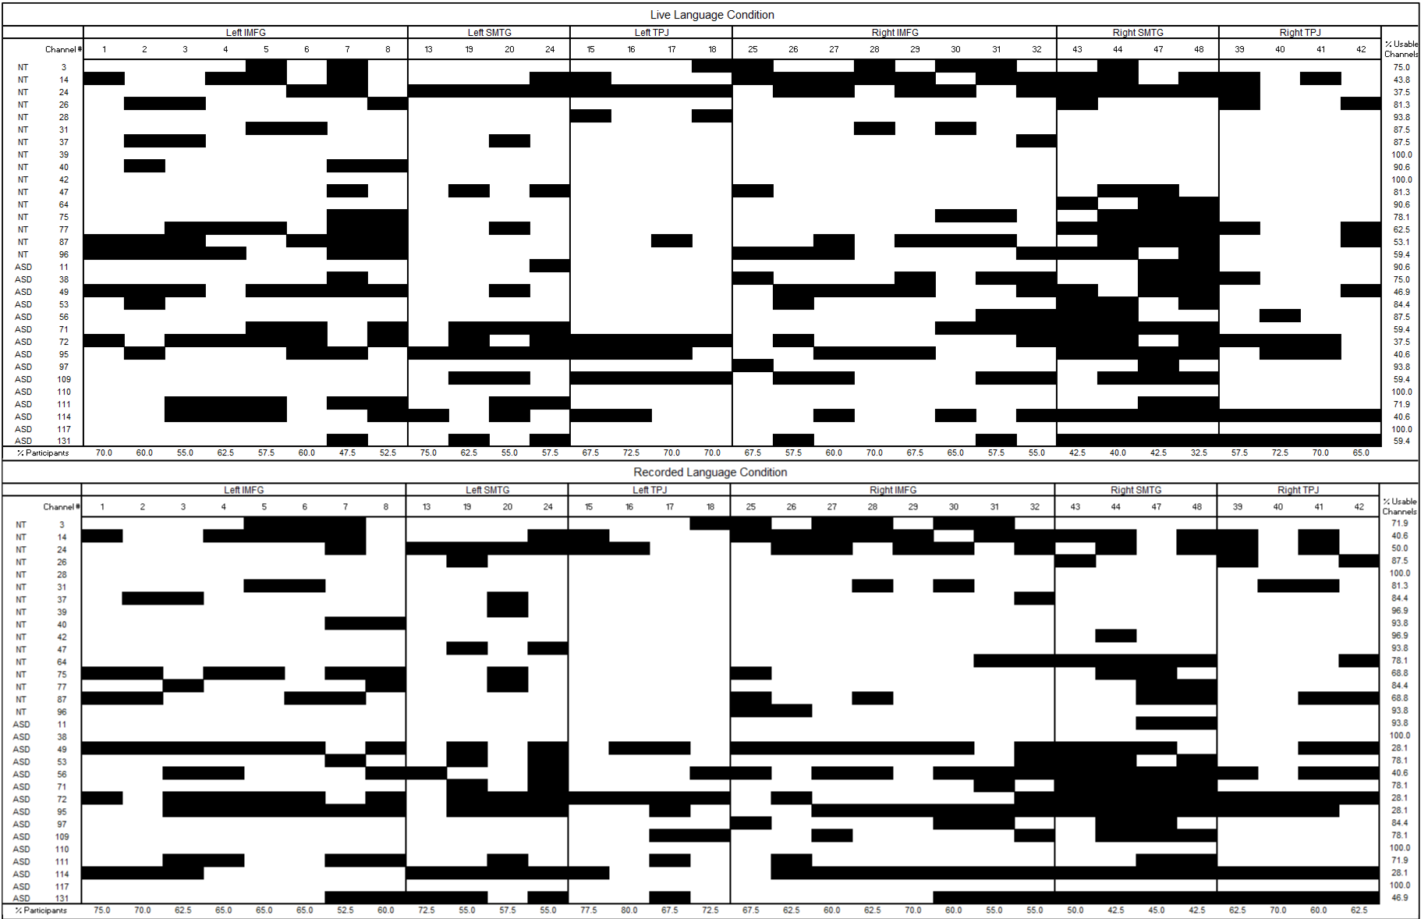
Note. Channels within regions of interest that were “pruned” or removed from analyses based on criteria outlined in the methods section are represented in black. Channels that were included in analyses are represented in white. Each row represents one participant and each column represents one channel. The percentage of usable channels per participant out of the 32 channels analyzed are shown in the column on the right for each condition. The percentage of participants who had usable data from each channel analyzed are shown in the bottom row for each condition. ASD=Autism Spectrum Disorder, IMFG=Inferior and Middle Frontal Gyrus, NT=Neurotypical, ROI=Region of Interest, SMTG=Superior and Middle Temporal Gyrus, TPJ=Temporal Parietal Junction

Figure S1.
Channels removed from analyses due to poor signal quality by participant

Note. HbO concentration values are shown in red and HbR concentration values are shown in blue. Error bars represent standard error values every 2 seconds. The y-axis shows a range of concentration values from -1.5x10⁻⁴ to 1.5x10⁻⁴ M*mm. Channels that are greyed out did not cover brain regions of interest. Channels covering the IMFG are labeled in purple, channels cover the SMTG are labeled in orange, and channels covering the TPJ are labeled in green. ASD=Autism Spectrum Disorder, NT=Neurotypical
Figure S2.
Average hemodynamic response from -2 to 18 seconds during the live language condition by channel

Note. HbO concentration values are shown in pink and HbR concentration values are shown in cyan. Error bars represent standard error values every 2 seconds. The y-axis shows a range of concentration values from -1.5x10⁻⁴ to 1.5x10⁻⁴ M*mm. Channels that are greyed out did not cover brain regions of interest. Channels covering the IMFG are labeled in purple, channels cover the SMTG are labeled in orange, and channels covering the TPJ are labeled in green. ASD=Autism Spectrum Disorder, NT=Neurotypical
Figure S3.
Average hemodynamic response from -2 to 18 seconds during the recorded language condition by channel
Note. Average change in HbO concentration values from -2 to 18 seconds is depicted in red for the live language condition and pink for the recorded language condition. Error bars represent standard error values every 2 seconds. Note that standard error did differ between groups for some channels. The y-axis shows a range of HbO concentration values from -1.5x10⁻⁴ to 1.5x10⁻⁴ M*mm. Channels that are greyed out did not cover brain regions of interest. Channels covering the IMFG are labeled in purple, channels covering the SMTG are labeled in orange, and channels covering the TPJ are labeled in green. ASD=Autism Spectrum Disorder, NT=Neurotypical
Figure S4.
Comparison of HbO during the live language condition and recorded language condition by channel

