Flexible Nonlinear Modeling Reveals Age-related Differences in Resting-State Functional Brain Connectivity in Autistic Males from Childhood to Mid-Adulthood
Daniel Feldman^{1,2}, Molly Prigge², Andrew Alexander ^{3,4,5}, Brandon Zielinski^{2,6}, Janet Lainhart^{3,4}, Jace King^{1,2}

Supplementary Materials

Supplementary Table 1. Model Diagnostics
Connection | Residual Shapiro-Wilk Normality (W) | Residual Skewness | Residual Kurtosis
Dorsal SMN – Ventral SMN | 0.998 | 0.140 | 2.989
Ventral SMN – Posterior DAN | 0.997 | 0.213 | 3.104
Ventral SMN – MT Limbic | 0.999 | 0.077 | 2.922
Ventral SMN – MSP CEN | 0.996 | 0.221 | 3.293
Ventral SMN – Lateral Temporal DMN | 0.997 | 0.188 | 2.951
Posterior DAN – Anterior VAN | 0.998 | 0.112 | 3.023
Posterior DAN – MSP CEN | 0.998 | 0.107 | 2.987
SMN Association – Posterior VAN | 0.999 | 0.022 | 3.087
SMN Association – MSP CEN | 0.997 | 0.180 | 3.067
MSP CEN – Posterior VAN | 0.996 | 0.205 | 3.339
Anterior VAN – MT Limbic | 0.997 | 0.157 | 3.077
Anterior VAN – MSP CEN | 0.996 | 0.236 | 3.271
Anterior VAN – Lateral Temporal DMN | 0.998 | 0.106 | 3.107
Ventral DMN– MSP CEN | 0.992 | 0.351 | 3.285
Dorsal DMN– MSP CEN | 0.996 | 0.230 | 3.305

Supplementary Table 2. Stratified 5-fold Split-Sample Model Validation
Connection | TD Model Correlation | ASD Model Correlation
Dorsal SMN – Ventral SMN | 0.983 ± 0.019 | 0.957 ± 0.024
Ventral SMN – Posterior DAN | 0.969 ± 0.033 | 0.971 ± 0.023
Ventral SMN – MT Limbic | 0.978 ± 0.028 | 0.963 ± 0.042
Ventral SMN – MSP CEN | 0.948 ± 0.027 | 0.946 ± 0.030
Ventral SMN – Lateral Temporal DMN | 0.959 ± 0.016 | 0.949 ± 0.027
Posterior DAN – Anterior VAN | 0.915 ± 0.045 | 0.966 ± 0.019
Posterior DAN – MSP CEN | 0.950 ± 0.031 | 0.962 ± 0.018
SMN Association – Posterior VAN | 0.992 ± 0.007 | 0.984 ± 0.006
SMN Association – MSP CEN | 0.981 ± 0.017 | 0.965 ± 0.034
MSP CEN – Posterior VAN | 0.977 ± 0.017 | 0.961 ± 0.010
Anterior VAN – MT Limbic | 0.968 ± 0.034 | 0.921 ± 0.069
Anterior VAN – MSP CEN | 0.977 ± 0.010 | 0.981 ± 0.017
Anterior VAN – Lateral Temporal DMN | 0.970 ± 0.033 | 0.967 ± 0.035
Ventral DMN– MSP CEN | 0.968 ± 0.021 | 0.970 ± 0.027
Dorsal DMN– MSP CEN | 0.972 ± 0.020 | 0.960 ± 0.038

Abbreviations: ASD: autism spectrum disorder; TD: typically developing; DMN: default mode network; CEN: central executive network; MSP: medial superior parietal; DAN: dorsal attention network; VAN: ventral attention network; SMN: somatomotor network; SMNa: somatomotor association network

Supplementary Figures S1-S15: Diagnostic Plots of GAMs.
Top left: QQ-plot of model residuals. Top right: Histogram of residuals to display distribution. Middle left: Residuals (y-axis) plotted against fitted values (x-axis). Middle right: The square root of the residuals (y-axis) plotted against fitted values (x-axis). Together with middle left, these plots can visual evaluate heteroskedasticity of residuals. Bottom left: TD vs ASD group comparison of residual distributions.

S1: Dorsal SMN – Ventral SMN
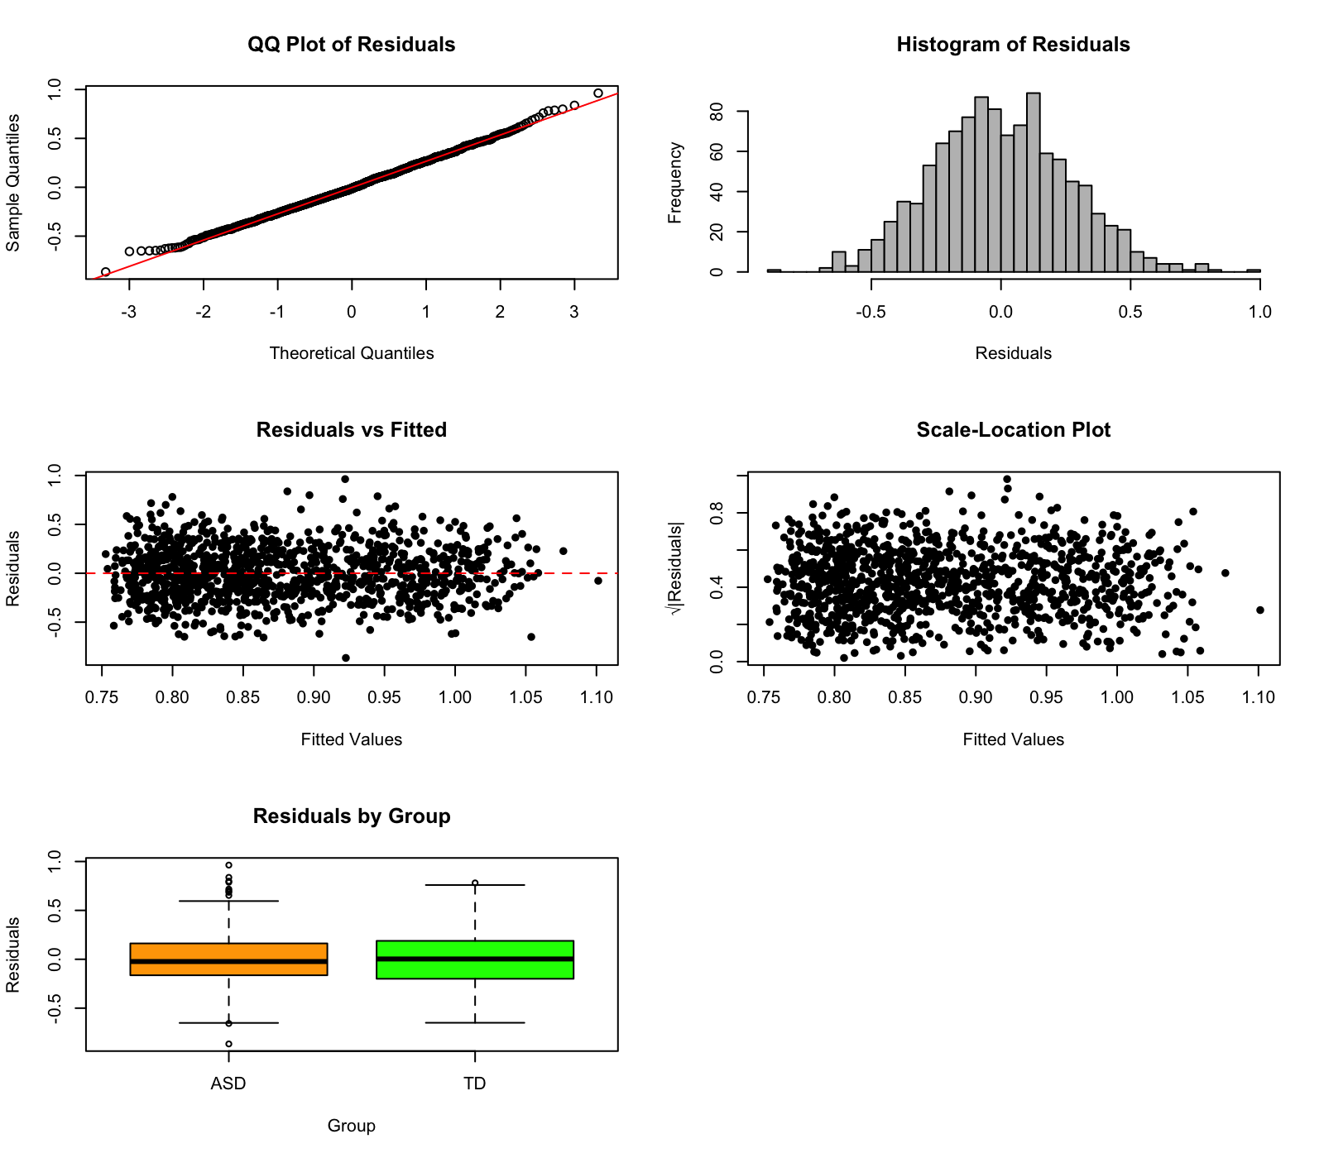

S2: Ventral SMN – Posterior DAN
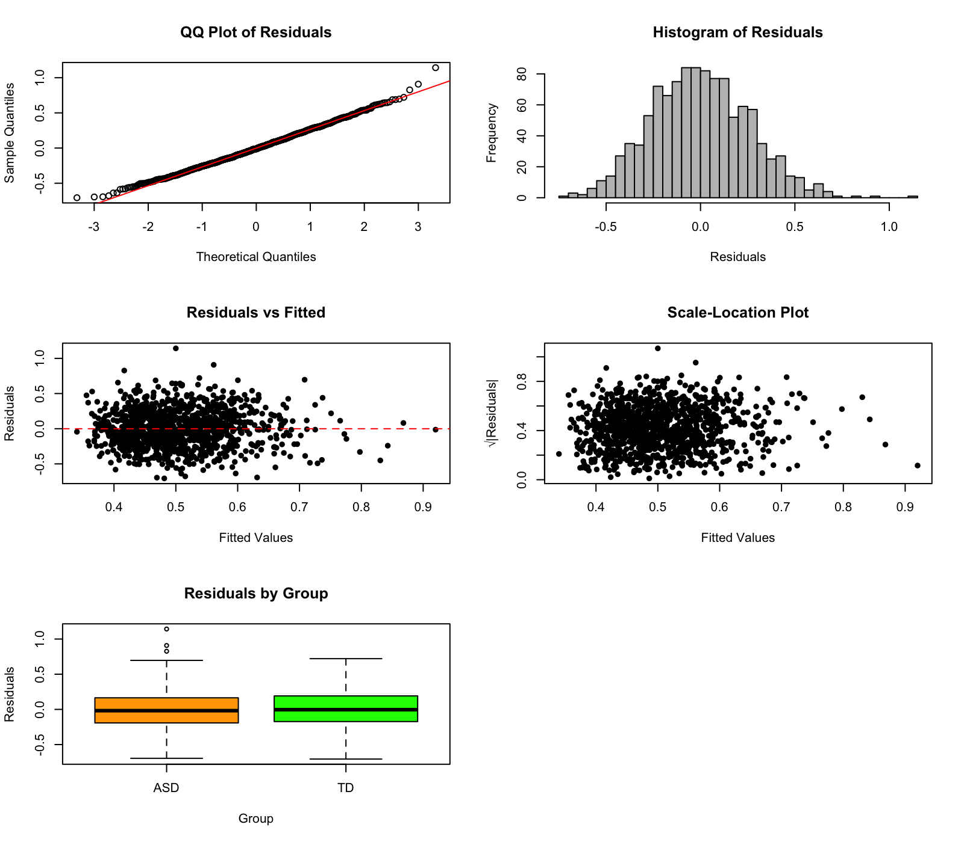

S3: Ventral SMN – MT Limbic
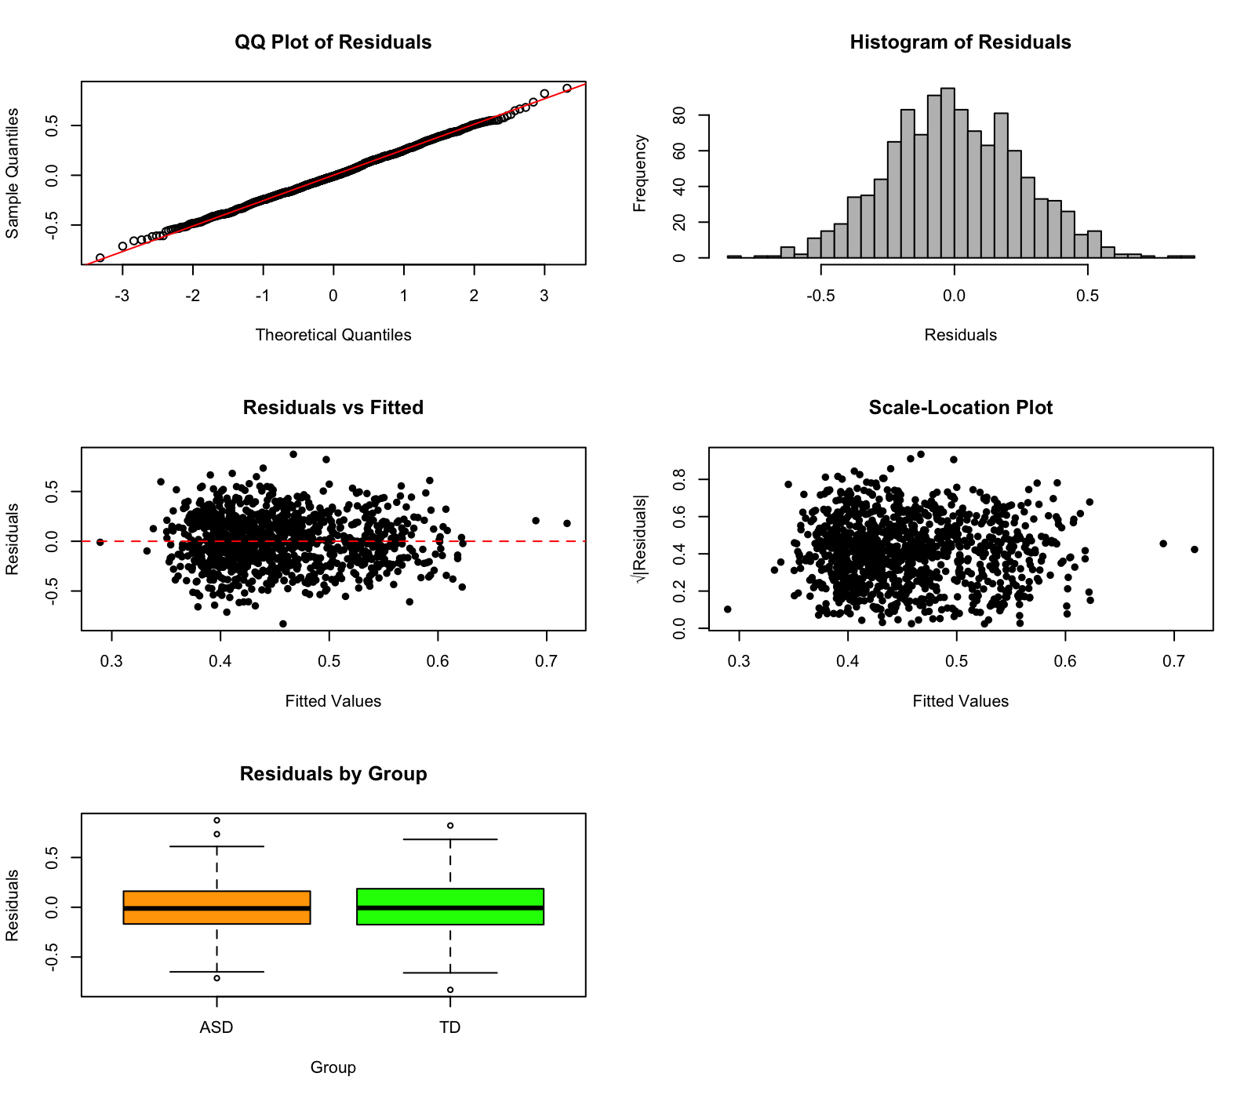

S4: Ventral SMN – MSP CEN
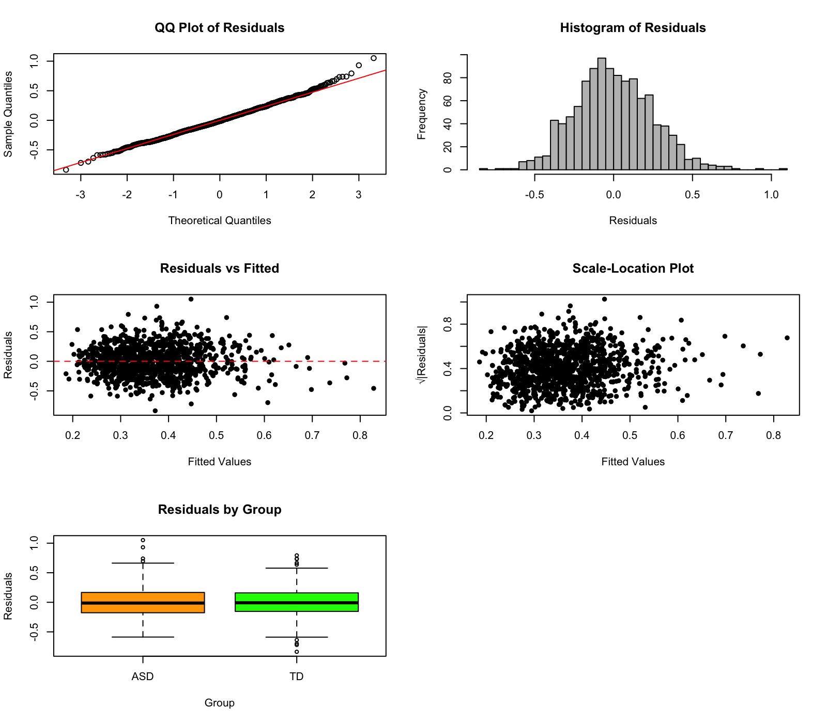

S5: Ventral SMN – Lateral Temporal DMN
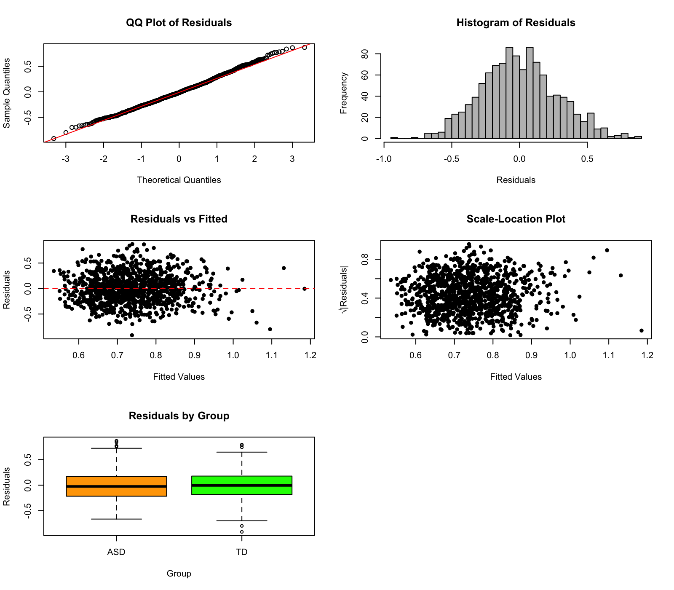

S6: Posterior DAN – Anterior VAN

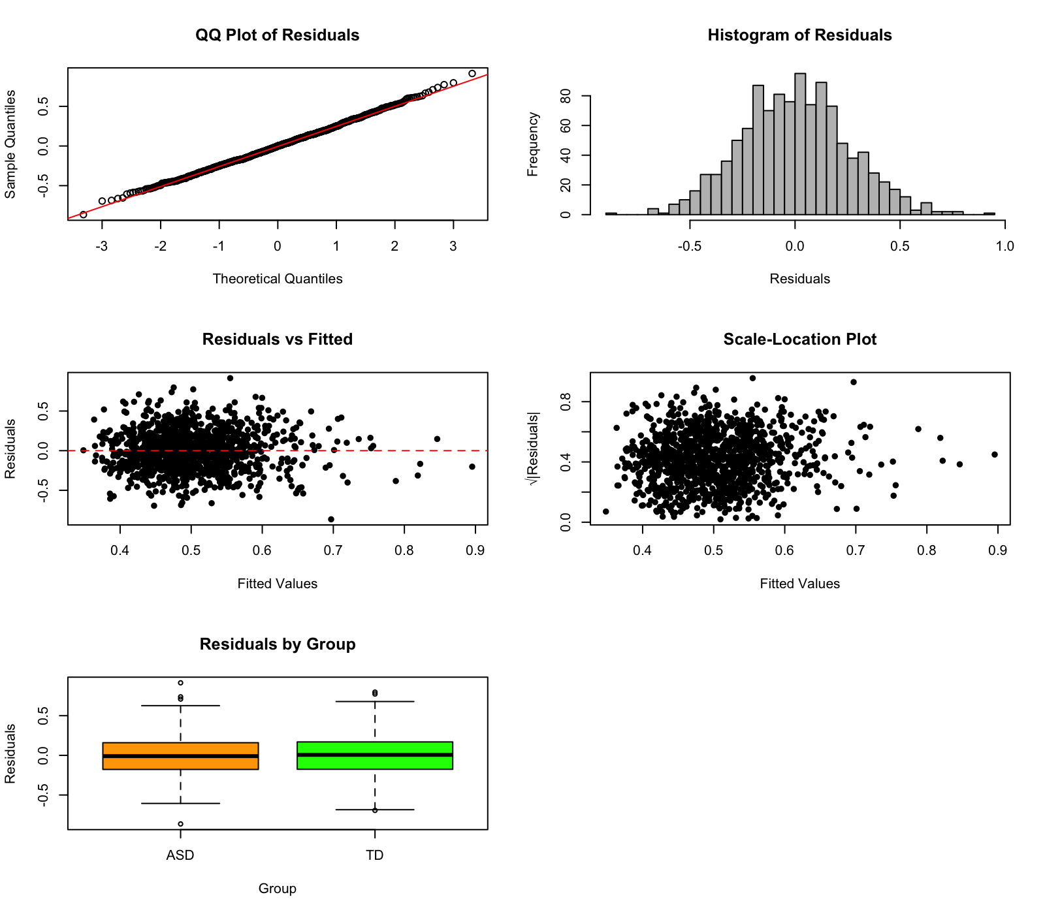

S7: Posterior DAN – MSP CEN

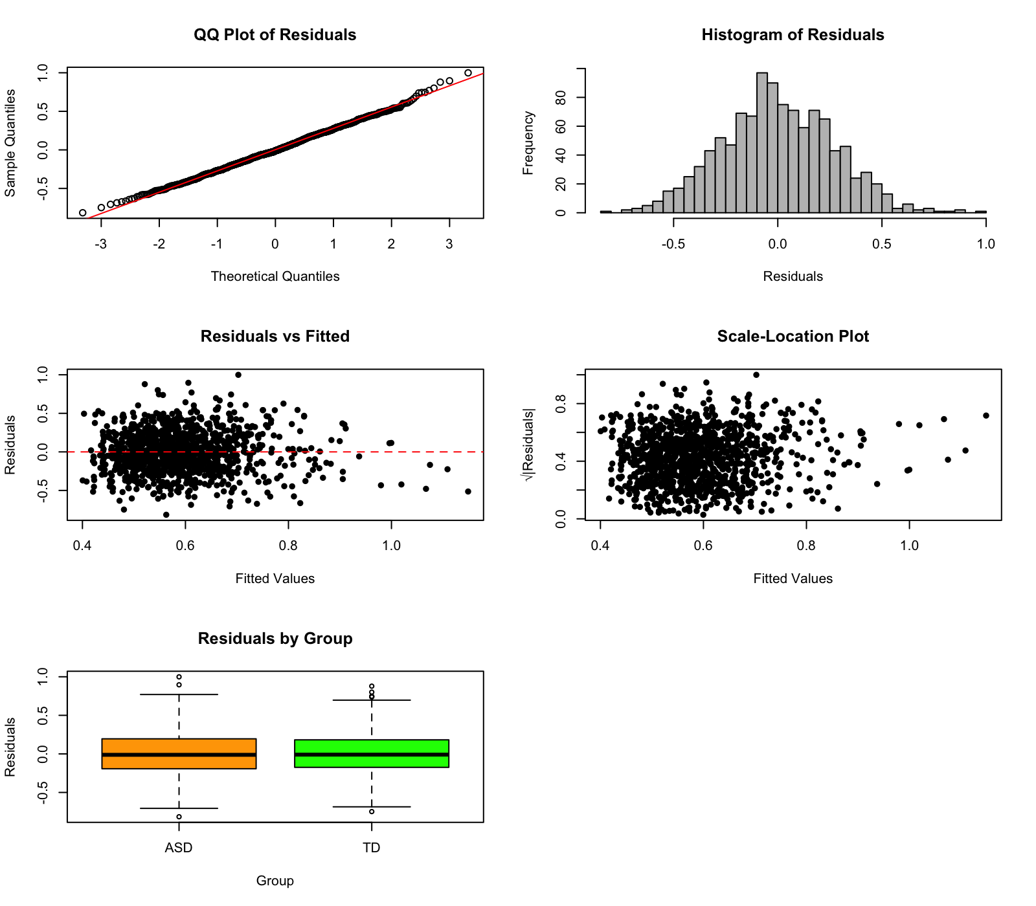

S8: SMN Association – Posterior VAN
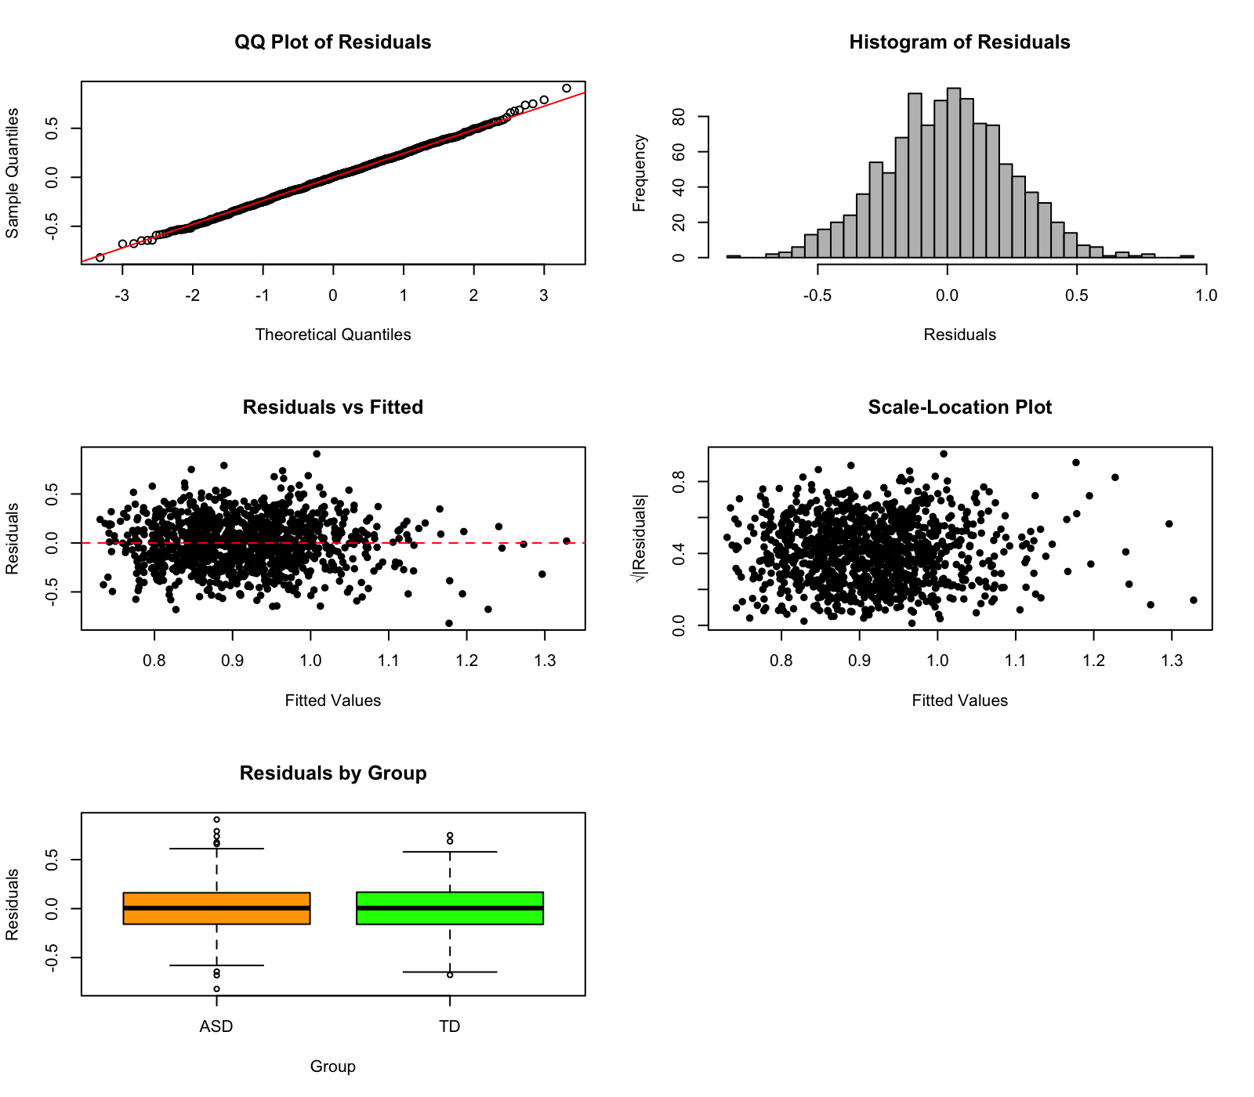

S9: SMN Association – MSP CEN
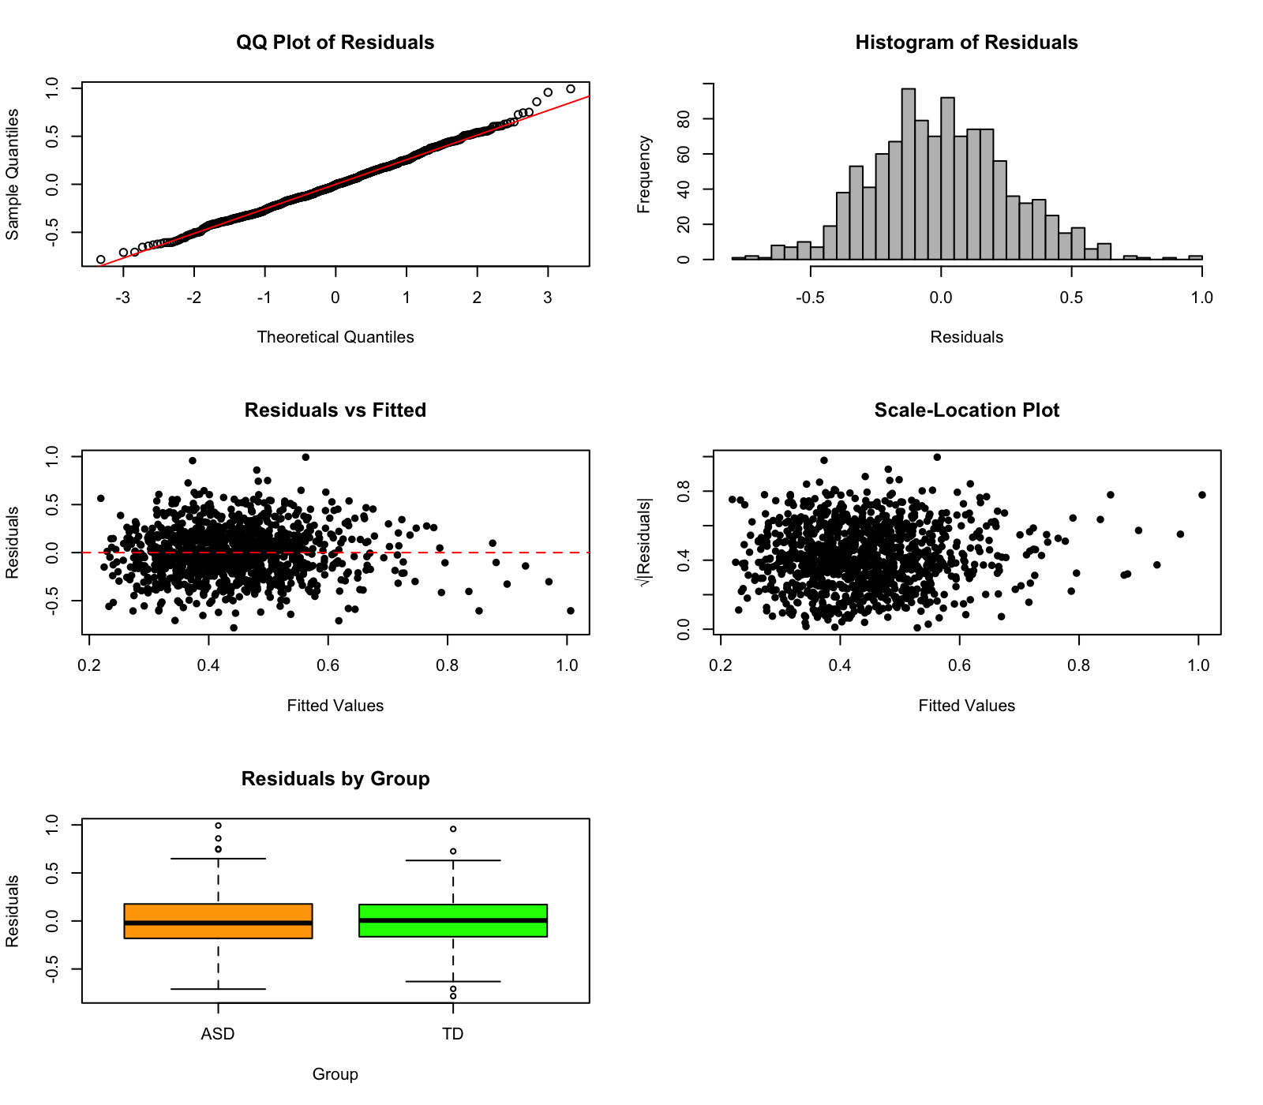

S10: MSP CEN – Posterior VAN
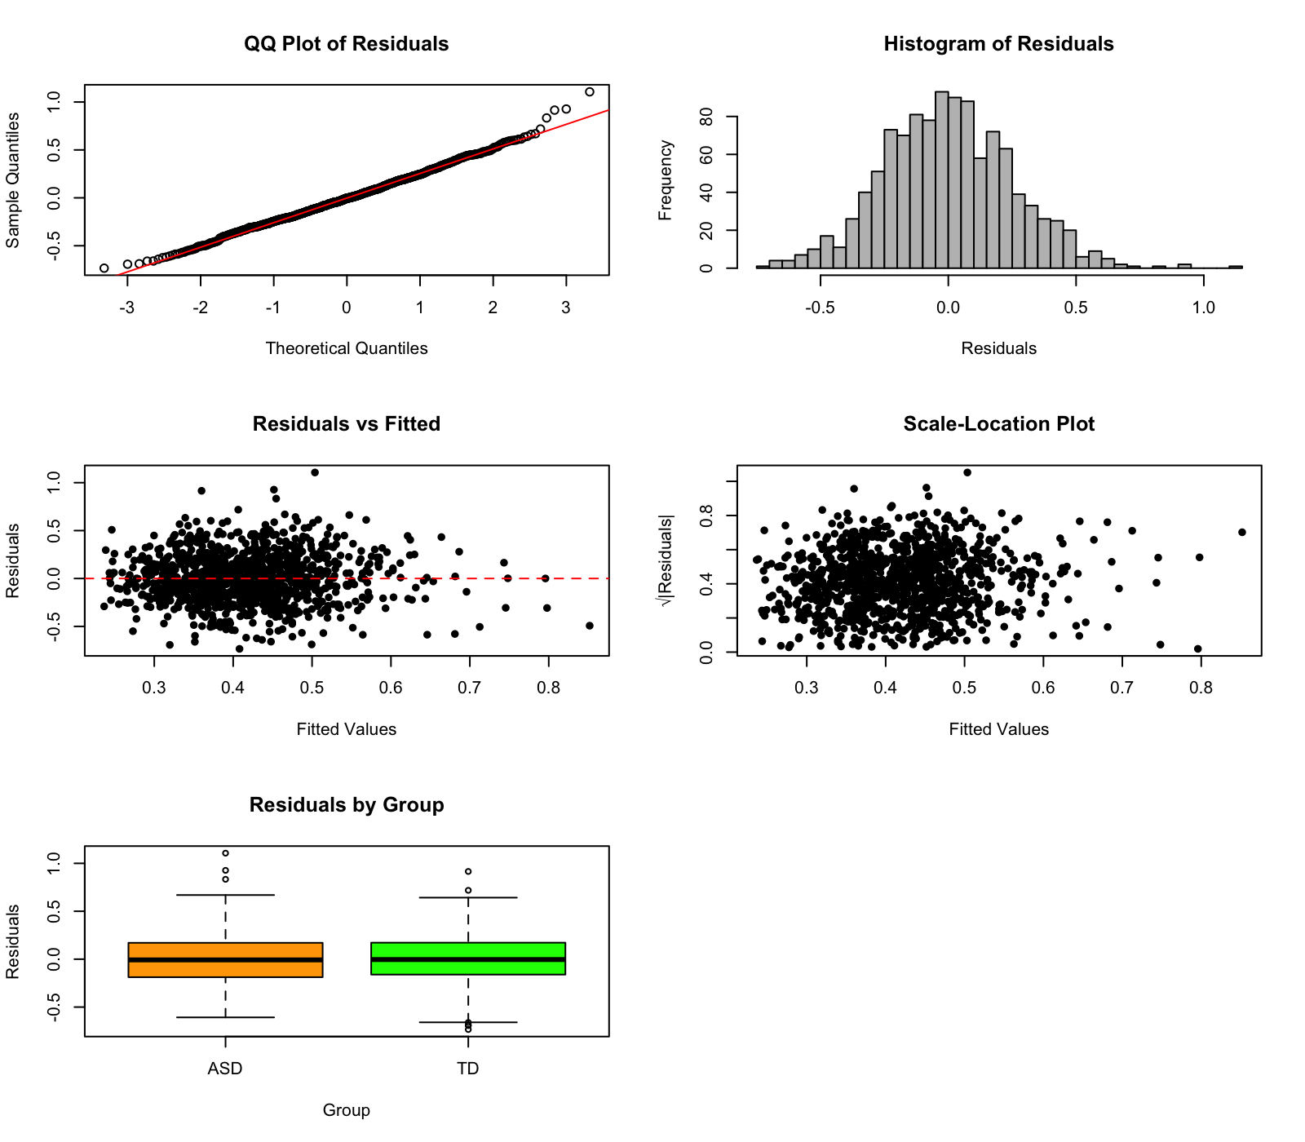

S11: Anterior VAN – MT Limbic
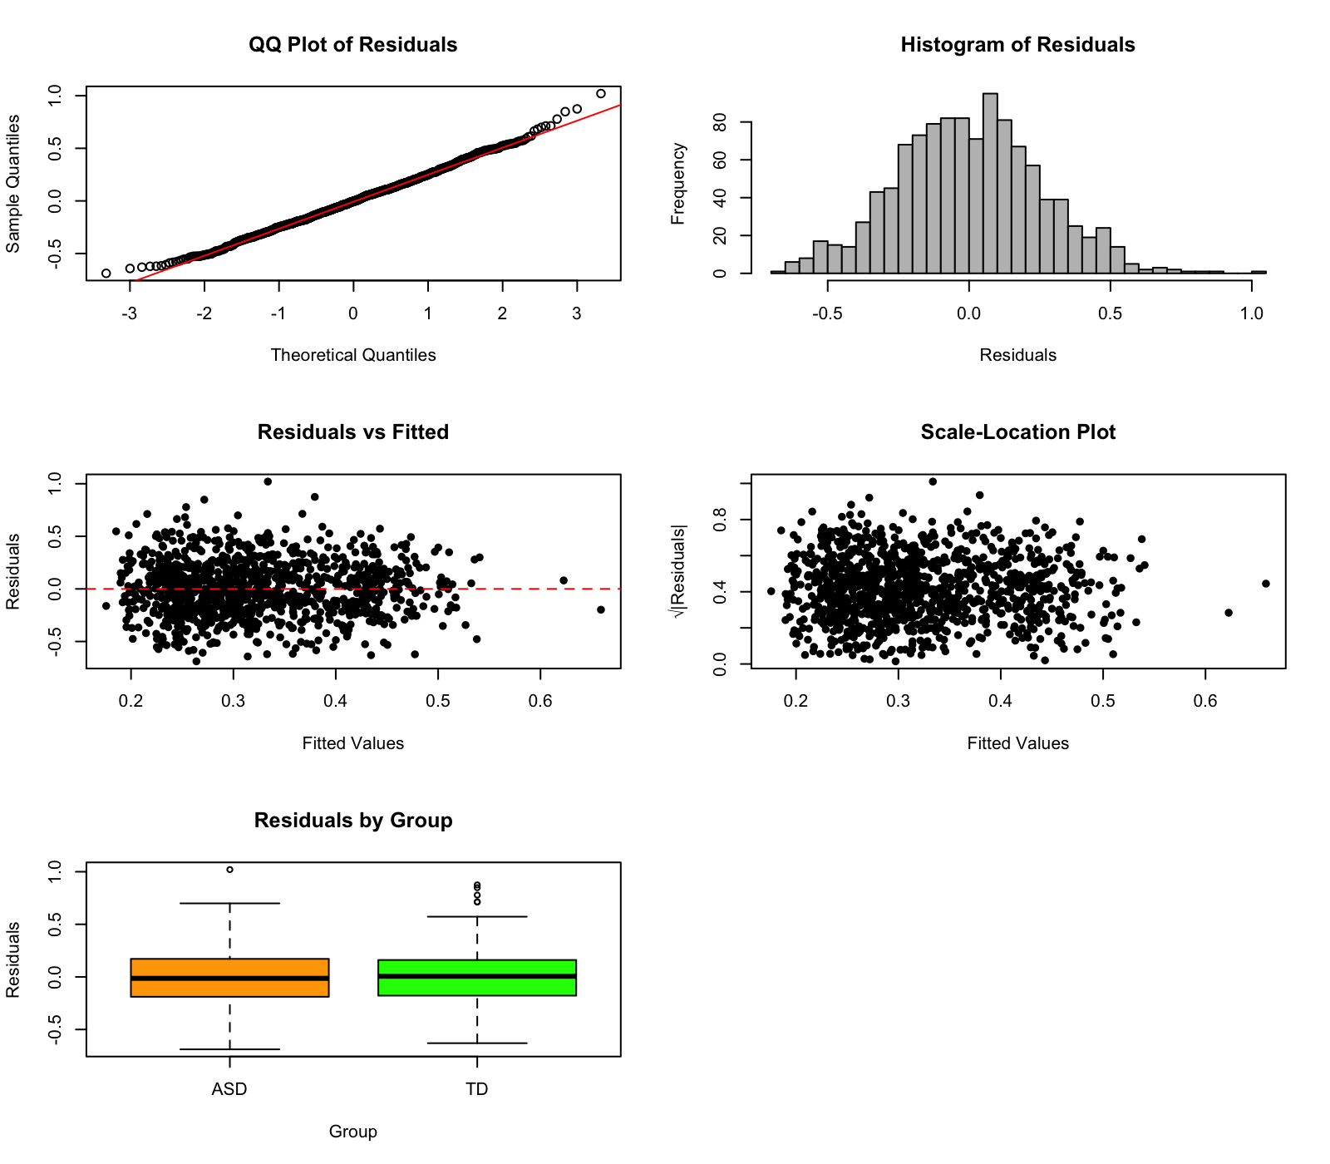

S12: Anterior VAN – MSP CEN
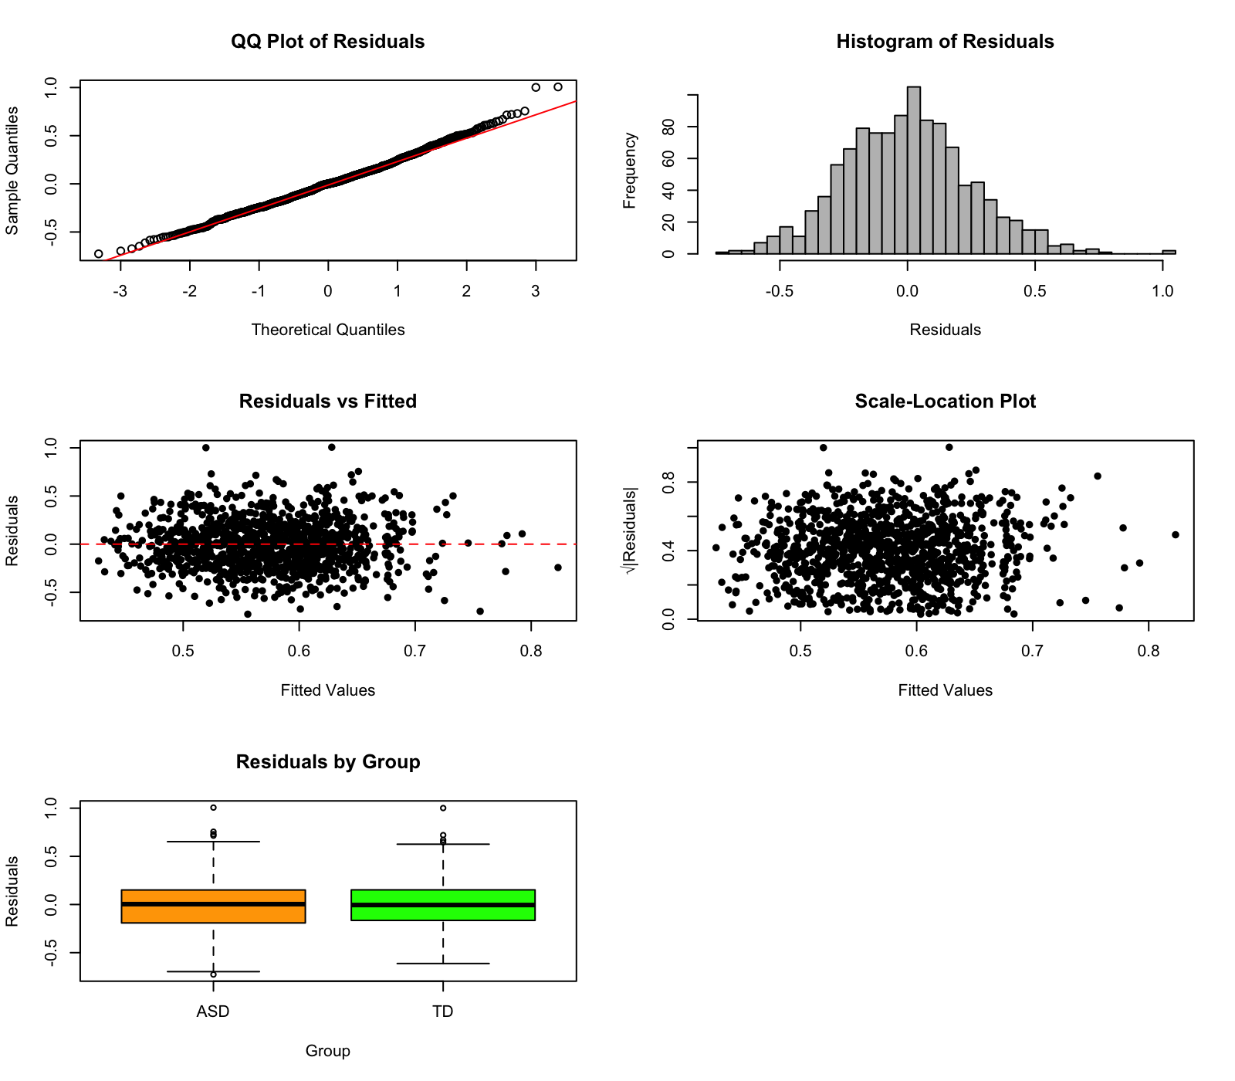

S13: Anterior VAN – Lateral Temporal DMN
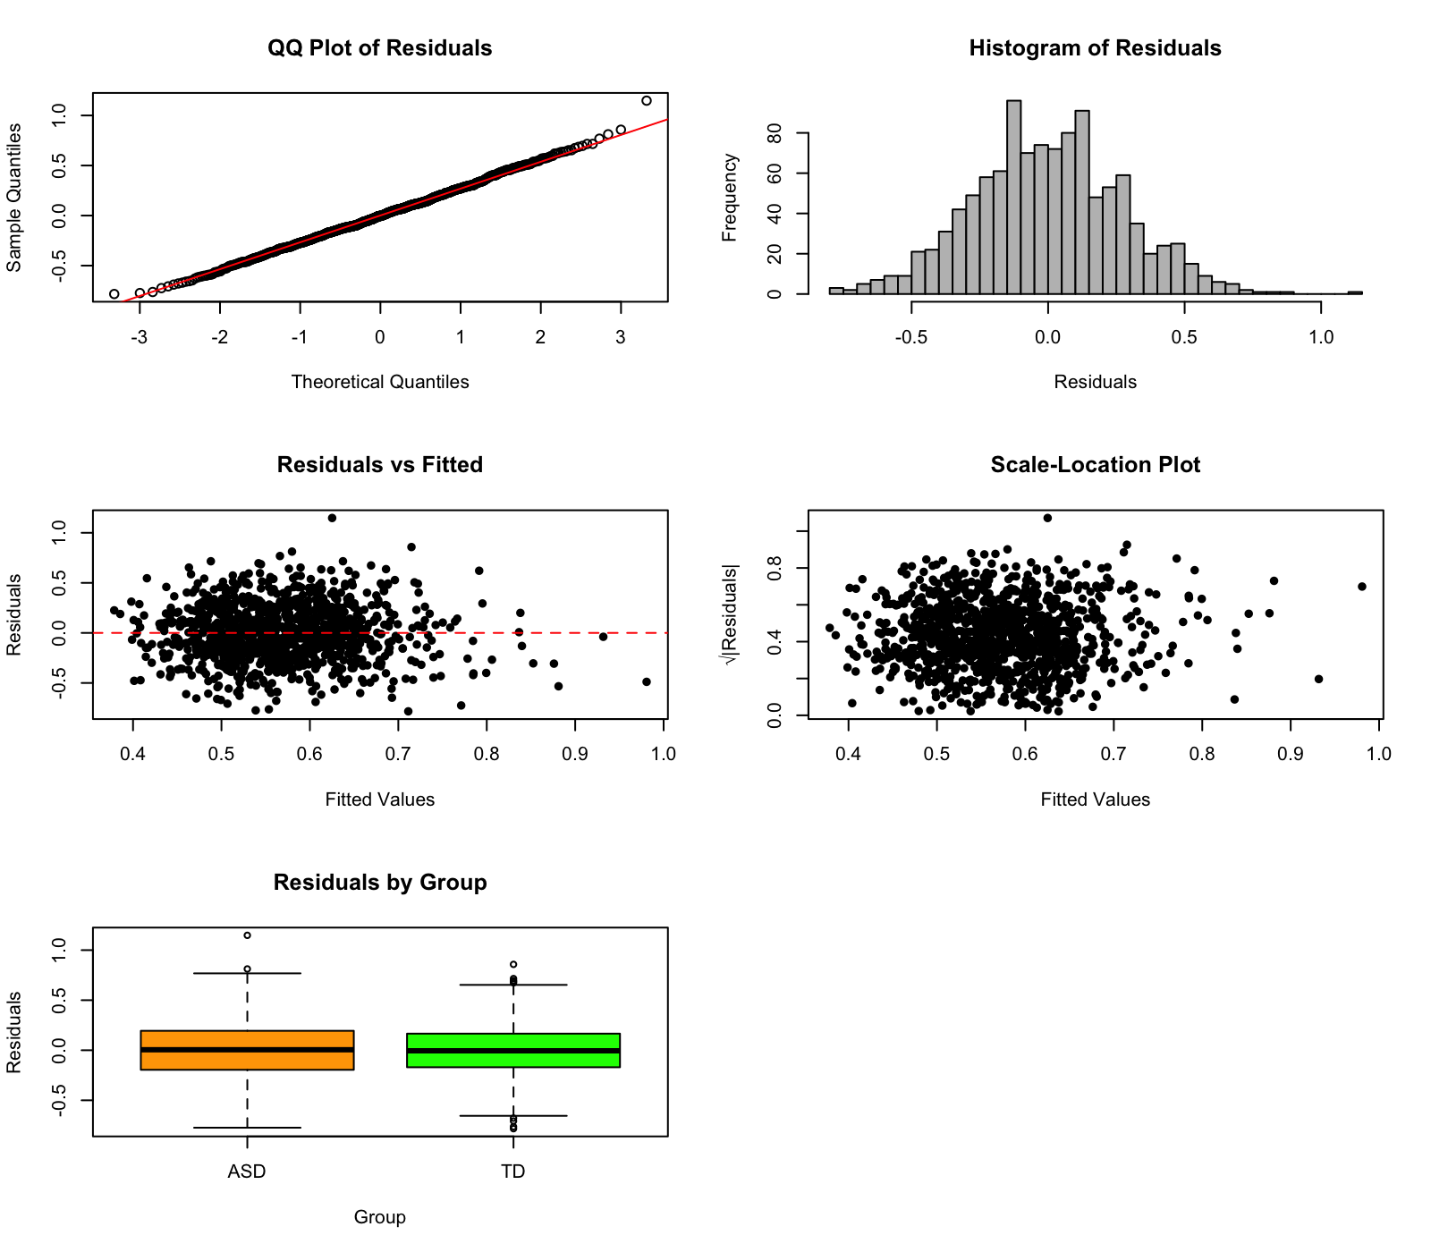

S14: Ventral DMN– MSP CEN

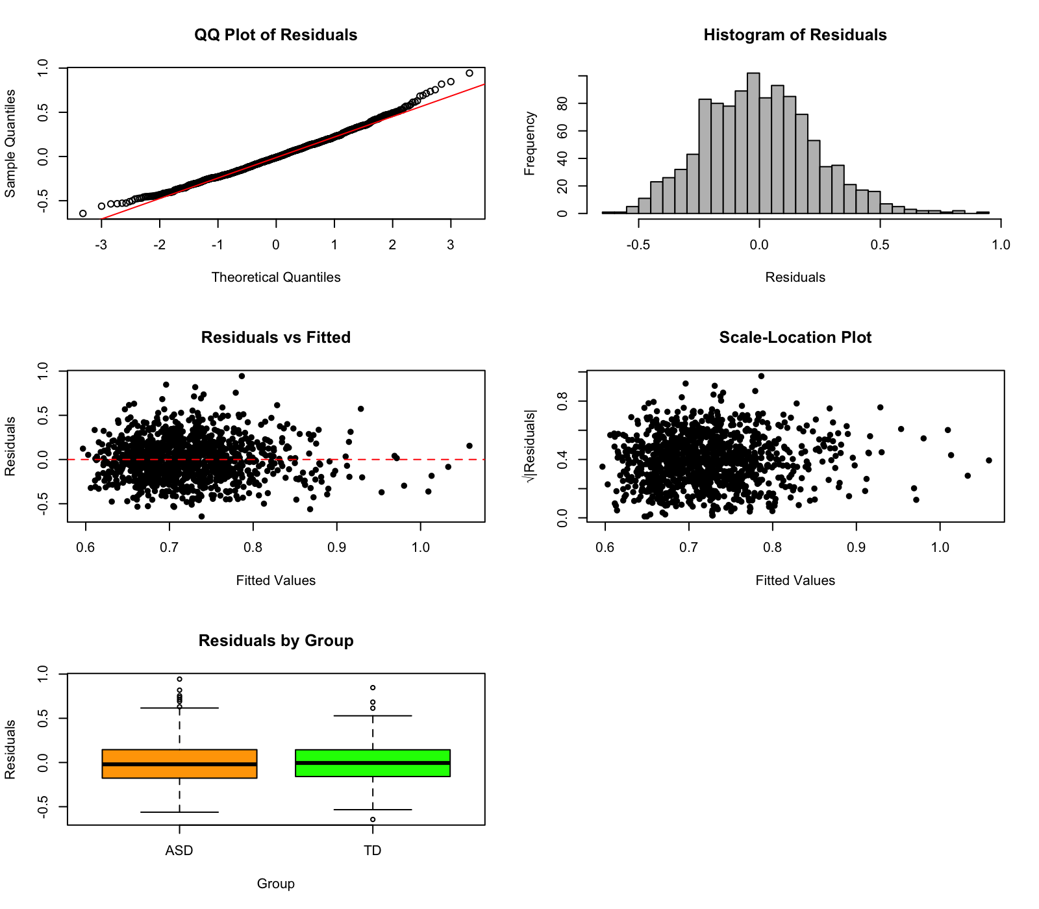

S15: Dorsal DMN– MSP CEN
