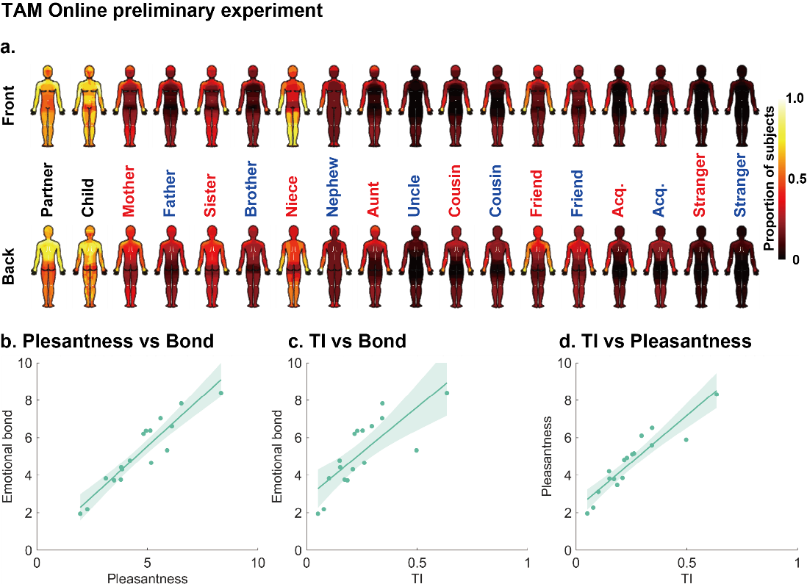
Supplementary Figure 1. Online preliminary experiment. Results for 70 adults (AQ total score = 24.4 ± 7.8, mean ± SD) are shown. a. Relation-specific TAMs. b-d. Correlations among touchable area, emotional bonding and pleasantness. Each dot represents the mean response for one member of the social network, with a linear regression line and confidence interval. TI indicates the touchability index (TI), which ranged from 0 to 1.

Supplementary Figure 2. Unthresholded statistical maps for the touch allowance differences between the groups. Red and blue fonts indicate female and male network members, respectively; Acq. indicates acquaintances. The data are presented without any statistical threshold. See Figure 2 for thresholded statistical maps.

Supplementary Table 1 Numbers of social network members
 | ASD |  |  | TD |  |  | Two-proportion z-test
 | Male | Female | Total | Male | Female | Total | Z value | pFDR
Partner | 8 | 10 | 18 | 23 | 19 | 42 | -4.10 | <0.001
Child | 1 | 2 | 3 | 10 | 5 | 15 | -3.03 | 0.01
Mother | 44 | 23 | 67 | 42 | 25 | 67 | 0 | 1
Father | 41 | 26 | 67 | 35 | 24 | 59 | 2.25 | 0.06
Sister | 24 | 19 | 43 | 29 | 14 | 43 | 0 | 1
Brother | 25 | 12 | 37 | 20 | 16 | 36 | 0.169 | 0.99
Niece | 10 | 3 | 13 | 14 | 7 | 21 | -1.58 | 0.20
Nephew | 14 | 5 | 19 | 15 | 9 | 24 | -0.92 | 0.52
Aunt | 37 | 18 | 55 | 34 | 19 | 53 | 0.40 | 0.85
Uncle | 36 | 18 | 54 | 34 | 18 | 52 | 0.39 | 0.85
Female Cousin | 37 | 24 | 61 | 32 | 20 | 52 | 1.93 | 0.11
Male Cousin | 39 | 19 | 58 | 30 | 16 | 46 | 2.32 | 0.06
Female Friend | 10 | 20 | 30 | 41 | 26 | 67 | -6.78 | <0.001
Male Friend | 25 | 13 | 38 | 43 | 20 | 63 | -4.71 | <0.001
Female Acq | 31 | 26 | 57 | 40 | 25 | 65 | -2.02 | 0.10
Male Acq | 40 | 19 | 59 | 41 | 23 | 64 | -1.29 | 0.31
pFDR, p-values FDR-corrected for multiple comparisons over social network members (16).

Supplementary Table 2 Emotional bonding, pleasantness, and touchability index (TI)
Social network | Emotional Bond |  |  | Pleasantness |  |  | Touchability Index (TI)
Social network | ASD | TD | pFDR | ASD | TD | pFDR | ASD | TD | pFDR
Partner | 8.61  ±0.33 | 8.88  ±0.24 | 0.4489 | 7.78  ±0.45 | 8.95  ±0.19 | 0.0423 | 0.59  ±0.09 | 0.87  ±0.04 | 0.0356
Child | 10.00  ±0 | 9.27  ±0.54 | 1 | 8.00  ±0.58 | 9.27  ±0.3 | 0.1265 | 0.91  ±0.04 | 0.78  ±0.07 | 0.4975
Mother | 7.84  ±0.23 | 8.66  ±0.17 | 0.0591 | 5.88  ±0.31 | 6.76  ±0.25 | 0.0738 | 0.40  ±0.03 | 0.61  ±0.04 | 0.0008
Father | 6.21  ±0.32 | 7.12  ±0.29 | 0.0626 | 4.15  ±0.32 | 5.31  ±0.29 | 0.0423 | 0.30  ±0.04 | 0.48  ±0.04 | 0.0037
Sister | 6.77  ±0.36 | 7.84  ±0.27 | 0.0626 | 5.14  ±0.41 | 6.37  ±0.3 | 0.0423 | 0.32  ±0.04 | 0.54  ±0.05 | 0.0037
Brother | 5.49  ±0.39 | 6.92  ±0.31 | 0.0591 | 3.89  ±0.36 | 5.06  ±0.31 | 0.0738 | 0.25  ±0.04 | 0.48  ±0.06 | 0.0037
Niece | 5.00  ±0.51 | 5.76  ±0.47 | 0.4501 | 4.92  ±0.61 | 6.33  ±0.45 | 0.0886 | 0.30  ±0.08 | 0.69  ±0.06 | 0.0037
Nephew | 5.26  ±0.35 | 6.25  ±0.45 | 0.0626 | 5.32  ±0.59 | 5.71  ±0.44 | 0.2817 | 0.31  ±0.06 | 0.54  ±0.07 | 0.0365
Aunt | 4.09  ±0.27 | 4.92  ±0.27 | 0.0626 | 3.58  ±0.27 | 4.25  ±0.27 | 0.1154 | 0.20  ±0.03 | 0.41  ±0.04 | 0.0008
Uncle | 3.72  ±0.26 | 4.62  ±0.29 | 0.0626 | 2.87  ±0.24 | 3.73  ±0.29 | 0.0738 | 0.13  ±0.02 | 0.29  ±0.04 | 0.001
Female  Cousin | 3.64  ±0.27 | 4.56  ±0.28 | 0.0591 | 3.20  ±0.24 | 4.27  ±0.26 | 0.0365 | 0.15  ±0.02 | 0.39  ±0.04 | 0.0001
Male  Cousin | 3.43  ±0.30 | 4.76  ±0.30 | 0.0403 | 2.90  ±0.27 | 4.11  ±0.28 | 0.0229 | 0.13  ±0.03 | 0.38  ±0.04 | 0
Female  Friend | 6.47  ±0.39 | 6.55  ±0.20 | 0.9345 | 5.50  ±0.44 | 5.70  ±0.23 | 0.8774 | 0.28  ±0.05 | 0.39  ±0.04 | 0.0657
Male  Friend | 5.89  ±0.33 | 7.06  ±0.22 | 0.0555 | 4.08  ±0.36 | 5.03  ±0.26 | 0.0886 | 0.18  ±0.04 | 0.4  ±0.04 | 0.0008
Female  Acquaintance | 4.07  ±0.25 | 4.49  ±0.23 | 0.4489 | 3.35  ±0.26 | 4.20  ±0.24 | 0.0705 | 0.13  ±0.02 | 0.24  ±0.03 | 0.0031
Male  Acquaintance | 3.98  ±0.27 | 4.30  ±0.25 | 0.4845 | 2.80  ±0.25 | 3.42  ±0.24 | 0.1154 | 0.11  ±0.02 | 0.18  ±0.02 | 0.0356
Female  stranger | 1.46  ±0.13 | 1.70  ±0.15 | 0.0626 | 1.81  ±0.15 | 2.44  ±0.23 | 0.0853 | 0.05  ±0.01 | 0.13  ±0.02 | 0.0044
Male  stranger | 1.37  ±0.12 | 1.60  ±0.15 | 0.2116 | 1.51  ±0.13 | 1.67  ±0.16 | 0.2874 | 0.04  ±0.01 | 0.07  ±0.01 | 0.0882
Each value is shown as mean ± SEM. pFDR indicates the FDR-corrected p value of a Wilcoxon rank sum test.

