Appendix A
Table 1
Effect of ICAR scores on the relationship between distance from the previous click and previously observed reward
Coefficient | b | SE | t | p
(Intercept) | 2.08 | 0.02 | 89.42 | < .001***
previous reward | -1.51 | 0.02 | -69.48 | < .001***
ICAR | 0.03 | 0.02 | 1.22 | .222
gender | 0.02 | 0.02 | 0.77 | .444
age | -0.04 | 0.02 | -1.90 | .057
previous reward:ICAR | -0.10 | 0.02 | -4.41 | < .001***
previous reward:gender | 0.06 | 0.02 | 2.88 | .004**
previous reward:age | 0.01 | 0.02 | 0.40 | .690
ICAR:gender | 0.00 | 0.02 | 0.01 | .990
ICAR:age | -0.02 | 0.02 | -0.84 | .404
gender:age | 0.03 | 0.02 | 1.61 | .107

Table 2
Individual difference predictors of autism group
Coefficient | b | SE | z | p
(Intercept) | -2.57 | 0.22 | -11.84 | < .001***
ICAR | 0.27 | 0.20 | 1.37 | .171
depression | 0.67 | 0.23 | 2.88 | .004**
ADHD | 0.51 | 0.25 | 2.02 | .043*
alexithymia | 0.62 | 0.23 | 2.73 | .006**
age | -0.43 | 0.14 | -3.03 | .002**
gender | -0.35 | 0.15 | -2.26 | .024*
ICAR:depression | 0.01 | 0.20 | 0.04 | .972
ICAR:ADHD | 0.15 | 0.19 | 0.78 | .435
ICAR:alexithymia | -0.04 | 0.17 | -0.24 | .810
depression:ADHD | -0.04 | 0.20 | -0.18 | .857
depression:alexithymia | -0.17 | 0.23 | -0.75 | .456
ADHD:alexithymia | 0.19 | 0.20 | 0.94 | .348

Table 3
Individual difference predictors of autism traits
Coefficient | b | SE | z | p
(Intercept) | 0.01 | 0.04 | 0.25 | .803
ICAR | 0.02 | 0.04 | 0.54 | .588
depression | 0.36 | 0.05 | 7.83 | < .001***
ADHD | 0.20 | 0.05 | 4.40 | < .001***
alexithymia | 0.22 | 0.04 | 5.19 | < .001***
age | -0.02 | 0.04 | -0.66 | .507
gender | -0.03 | 0.04 | -0.69 | .493
ICAR:depression | 0.00 | 0.05 | 0.02 | .987
ICAR:ADHD | 0.00 | 0.04 | 0.03 | .974
ICAR:alexithymia | 0.06 | 0.04 | 1.47 | .141
depression:ADHD | -0.05 | 0.04 | -1.16 | .248
depression:alexithymia | 0.02 | 0.05 | 0.40 | .691
ADHD:alexithymia | 0.04 | 0.05 | 0.77 | .442

Appendix B
Table 4
Autism group analysis novel clicks
Coefficient | b | SE | z | p
(Intercept) | 1.02 | 0.14 | 7.30 | < .001***
group | -0.41 | 0.14 | -2.89 | .004**
trial | -1.29 | 0.07 | -19.05 | < .001***
depression | 0.22 | 0.11 | 1.91 | .056
ADHD | 0.18 | 0.12 | 1.50 | .133
alexithymia | -0.03 | 0.11 | -0.29 | .776
gender | 0.17 | 0.05 | 3.21 | .001**
age | -0.01 | 0.05 | -0.13 | .895
group:trial | -0.23 | 0.07 | -3.24 | .001**
group:depression | 0.09 | 0.09 | 0.97 | .332
group:ADHD | 0.12 | 0.09 | 1.24 | .214
group:alexithymia | -0.24 | 0.09 | -2.64 | .008**
trial:depression | 0.11 | 0.06 | 1.98 | .048*
trial:ADHD | 0.07 | 0.06 | 1.09 | .275
trial:alexithymia | 0.04 | 0.05 | 0.80 | .426
depression:ADHD | 0.00 | 0.07 | 0.07 | .940
depression:alexithymia | 0.01 | 0.07 | 0.17 | .865
ADHD:alexithymia | 0.07 | 0.07 | 1.04 | .300

Table 5
Autism trait analysis novel clicks
Coefficient | b | SE | z | p
(Intercept) | 1.41 | 0.09 | 16.30 | < .001***
traits | 0.02 | 0.11 | 0.17 | .867
trial | -1.12 | 0.05 | -23.75 | < .001***
depression | 0.09 | 0.11 | 0.80 | .425
ADHD | 0.01 | 0.11 | 0.13 | .898
alexithymia | 0.17 | 0.10 | 1.72 | .086
gender | 0.21 | 0.06 | 3.75 | < .001***
age | 0.02 | 0.05 | 0.47 | .638
traits:trial | -0.08 | 0.06 | -1.26 | .207
traits:depression | -0.23 | 0.07 | -3.12 | .002**
traits:ADHD | 0.22 | 0.08 | 2.72 | .007**
traits:alexithymia | -0.01 | 0.08 | -0.14 | .888
trial:depression | 0.11 | 0.06 | 1.66 | .097
trial:ADHD | 0.07 | 0.06 | 1.18 | .237
trial:alexithymia | 0.04 | 0.06 | 0.70 | .484
depression:ADHD | -0.03 | 0.07 | -0.40 | .686
depression:alexithymia | 0.16 | 0.08 | 1.95 | .051
ADHD:alexithymia | -0.07 | 0.08 | -0.88 | .379
Table 6
Autism group analysis high-value clicks
Coefficient | b | SE | z | p
(Intercept) | -1.27 | 0.16 | -8.12 | < .001***
group | 0.48 | 0.16 | 3.00 | .003**
trial | 1.21 | 0.07 | 16.37 | < .001***
depression | -0.23 | 0.13 | -1.78 | .075
ADHD | -0.21 | 0.14 | -1.53 | .126
alexithymia | 0.02 | 0.13 | 0.16 | .870
gender | -0.18 | 0.06 | -3.13 | .002**
age | -0.01 | 0.06 | -0.12 | .906
group:trial | 0.27 | 0.08 | 3.48 | < .001***
group:depression | -0.09 | 0.10 | -0.89 | .373
group:ADHD | -0.14 | 0.10 | -1.42 | .155
group:alexithymia | 0.26 | 0.10 | 2.67 | .008**
trial:depression | -0.13 | 0.06 | -2.06 | .040*
trial:ADHD | -0.08 | 0.07 | -1.19 | .234
trial:alexithymia | -0.06 | 0.06 | -1.02 | .306
depression:ADHD | -0.03 | 0.07 | -0.40 | .686
depression:alexithymia | 0.01 | 0.08 | 0.14 | .889
ADHD:alexithymia | -0.08 | 0.08 | -1.08 | .280

Table 7
Autism trait analysis high-value clicks
Coefficient | b | SE | z | p
(Intercept) | -1.71 | 0.10 | -17.46 | < .001***
traits | -0.00 | 0.12 | -0.00 | .999
trial | 1.00 | 0.05 | 19.35 | < .001***
depression | -0.09 | 0.13 | -0.72 | .470
ADHD | -0.02 | 0.12 | -0.18 | .859
alexithymia | -0.20 | 0.11 | -1.75 | .080
gender | -0.22 | 0.06 | -3.69 | < .001***
age | -0.04 | 0.06 | -0.64 | .523
traits:trial | 0.08 | 0.07 | 1.20 | .231
traits:depression | 0.24 | 0.08 | 2.99 | .003**
traits:ADHD | -0.23 | 0.09 | -2.64 | .008**
traits:alexithymia | -0.00 | 0.08 | -0.04 | .965
traits:depression | -0.11 | 0.07 | -1.62 | .105
trial:ADHD | -0.10 | 0.07 | -1.44 | .149
trial:alexithymia | -0.05 | 0.06 | -0.80 | .423
depression:ADHD | 0.00 | 0.08 | 0.04 | .971
depression:alexithymia | -0.15 | 0.09 | -1.69 | .092
ADHD:alexithymia | 0.08 | 0.08 | 0.97 | .333

Table 8
Autism group analysis distance from high-value cells
Coefficient | b | SE | t | p
(Intercept) | 0.31 | 0.01 | 32.21 | < .001***
group | -0.03 | 0.01 | -3.40 | .001***
logtrial | -0.11 | 0.01 | -20.59 | < .001***
round | -0.01 | 0.00 | -4.53 | < .001***
depression | 0.02 | 0.01 | 2.16 | .031*
ADHD | 0.01 | 0.01 | 1.30 | .193
alexithymia | 0.00 | 0.01 | 0.01 | .992
gender | 0.00 | 0.00 | 0.87 | .386
age | -0.00 | 0.00 | -0.49 | .627
group:logtrial | -0.02 | 0.01 | -3.48 | .001***
group:round | -0.00 | 0.00 | -0.81 | .419
group:depression | 0.01 | 0.01 | 0.91 | .363
group:ADHD | 0.00 | 0.01 | 0.42 | .675
group:alexithymia | -0.00 | 0.01 | -0.63 | .531
logtrial:round | -0.03 | 0.00 | -16.89 | < .001***
logtrial:depression | 0.01 | 0.00 | 1.83 | .067
logtrial:ADHD | 0.01 | 0.00 | 1.69 | .091
logtrial:alexithymia | -0.00 | 0.00 | -0.05 | .962
round:depression | -0.00 | 0.00 | -0.39 | .699
round:ADHD | 0.01 | 0.00 | 2.38 | .018*
round:alexithymia | -0.00 | 0.00 | -0.25 | .806
depression:ADHD | -0.00 | 0.00 | -0.72 | .475
depression:alexithymia | 0.01 | 0.01 | 1.36 | .176
ADHD:alexithymia | 0.00 | 0.01 | 0.28 | .780

Table 9
Autism trait analysis distance from high-value cells
Coefficient | b | SE | t | p
(Intercept) | 0.35 | 0.01 | 58.85 | < .001***
traits | -0.00 | 0.01 | -0.20 | .843
logtrial | -0.09 | 0.00 | -25.28 | < .001***
round | -0.01 | 0.00 | -5.39 | < .001***
depression | 0.01 | 0.01 | 1.28 | .202
ADHD | 0.00 | 0.01 | 0.53 | .597
alexithymia | 0.00 | 0.01 | 0.50 | .617
gender | 0.01 | 0.00 | 1.30 | .194
age | -0.00 | 0.00 | -0.24 | .809
traits:logtrial | -0.00 | 0.00 | -0.52 | .602
traits:round | -0.00 | 0.00 | -0.69 | .494
traits:depression | -0.02 | 0.01 | -3.52 | < .001***
traits:ADHD | 0.01 | 0.01 | 1.29 | .199
traits:alexithymia | 0.00 | 0.01 | 0.90 | .370
logtrial:round | -0.03 | 0.00 | -16.24 | < .001***
logtrial:depression | 0.01 | 0.01 | 1.65 | .100
logtrial:ADHD | 0.01 | 0.00 | 1.36 | .174
logtrial:alexithymia | -0.00 | 0.00 | -0.07 | .941
round:depression | 0.00 | 0.00 | 0.17 | .863
round:ADHD | 0.00 | 0.00 | 1.64 | .102
round:alexithymia | 0.00 | 0.00 | 0.13 | .894
depression:ADHD | -0.00 | 0.01 | -0.04 | .966
depression:alexithymia | 0.01 | 0.01 | 2.23 | .026*
ADHD:alexithymia | -0.01 | 0.01 | -1.06 | .290

Table 10
Autism group analysis distance from previous click
Coefficient | b | SE | t | p
(Intercept) | -1.19 | 0.08 | -14.85 | < .001***
group | -0.29 | 0.08 | -3.50 | .001***
logtrial | -0.82 | 0.04 | -19.06 | < .001***
round | -0.21 | 0.02 | -8.28 | < .001***
depression | 0.14 | 0.07 | 2.18 | .030*
ADHD | 0.13 | 0.07 | 1.81 | .070
alexithymia | -0.01 | 0.06 | -0.14 | .891
gender | 0.04 | 0.02 | 1.62 | .106
age | -0.03 | 0.02 | -1.48 | .139
group:logtrial | -0.14 | 0.04 | -3.21 | .001**
group:round | 0.02 | 0.02 | 0.88 | .381
group:depression | 0.05 | 0.04 | 1.29 | .198
group:ADHD | 0.04 | 0.04 | 0.89 | .372
group:alexithymia | -0.04 | 0.04 | -1.05 | .294
logtrial:round | -0.18 | 0.01 | -16.35 | < .001***
logtrial:depression | 0.06 | 0.04 | 1.64 | .102
logtrial:ADHD | 0.06 | 0.04 | 1.71 | .088
logtrial:alexithymia | 0.02 | 0.03 | 0.49 | .627
round:depression | -0.01 | 0.02 | -0.55 | .582
round:ADHD | 0.04 | 0.02 | 1.94 | .053
round:alexithymia | -0.01 | 0.02 | -0.39 | .694
depression:ADHD | -0.01 | 0.03 | -0.43 | .670
depression:alexithymia | -0.00 | 0.03 | -0.14 | .890
ADHD:alexithymia | 0.02 | 0.03 | 0.54 | .589

Table 11
Autism trait analysis distance from previous click
Coefficient | b | SE | t | p
(Intercept) | -0.92 | 0.05 | -17.74 | < .001***
traits | 0.00 | 0.06 | 0.04 | .965
logtrial | -0.69 | 0.03 | -23.36 | < .001***
round | -0.22 | 0.02 | -11.39 | < .001***
depression | 0.08 | 0.07 | 1.19 | .233
ADHD | 0.05 | 0.06 | 0.75 | .454
alexithymia | 0.03 | 0.06 | 0.54 | .589
gender | 0.04 | 0.02 | 1.82 | .069
age | -0.03 | 0.02 | -1.43 | .154
traits:logtrial | -0.02 | 0.04 | -0.42 | .671
traits:round | 0.00 | 0.02 | 0.03 | .977
traits:depression | -0.06 | 0.03 | -1.99 | .048*
traits:ADHD | 0.04 | 0.03 | 1.22 | .222
traits:alexithymia | 0.00 | 0.03 | 0.14 | .891
logtrial:round | -0.17 | 0.01 | -15.66 | < .001***
logtrial:depression | 0.05 | 0.04 | 1.29 | .199
logtrial:ADHD | 0.05 | 0.04 | 1.27 | .203
logtrial:alexithymia | 0.02 | 0.04 | 0.47 | .639
round:depression | -0.00 | 0.02 | -0.14 | .892
round:ADHD | 0.03 | 0.02 | 1.66 | .097
round:alexithymia | -0.00 | 0.02 | -0.16 | .869
depression:ADHD | -0.01 | 0.03 | -0.42 | .674
depression:alexithymia | 0.04 | 0.03 | 1.39 | .167
ADHD:alexithymia | -0.02 | 0.03 | -0.66 | .508

Appendix C
Table 12
Predictors of autism group
Coefficient | b | SE | z | p
(Intercept) | -2.68 | 0.22 | -11.96 | < .001***
depression | 0.73 | 0.23 | 3.16 | .002**
ADHD | 0.58 | 0.24 | 2.42 | .015*
alexithymia | 0.55 | 0.22 | 2.51 | .012*
gender | -0.28 | 0.16 | -1.80 | .072
age | -0.46 | 0.14 | -3.19 | .001**
logl | -0.10 | 0.16 | -0.66 | .506
logb | -0.41 | 0.16 | -2.54 | .011*
logt | -0.21 | 0.17 | -1.24 | .216
depression:ADHD | -0.05 | 0.20 | -0.23 | .818
depression:alexithymia | -0.11 | 0.22 | -0.50 | .615
ADHD:alexithymia | 0.16 | 0.18 | 0.85 | .393

Table 13
Predictors of autism traits
Coefficient | b | SE | z | p
(Intercept) | 0.01 | 0.04 | 0.26 | .796
depression | 0.36 | 0.05 | 7.82 | < .001***
ADHD | 0.19 | 0.05 | 4.06 | < .001***
alexithymia | 0.23 | 0.04 | 5.40 | < .001***
gender | -0.03 | 0.04 | -0.68 | .499
age | -0.02 | 0.04 | -0.53 | .593
logl | -0.00 | 0.04 | -0.05 | .959
logb | -0.02 | 0.04 | -0.46 | .643
logt | 0.02 | 0.04 | 0.55 | .585
depression:ADHD | -0.04 | 0.04 | -1.02 | .309
depression:alexithymia | 0.01 | 0.04 | 0.19 | .847
ADHD:alexithymia | 0.02 | 0.04 | 0.52 | .606

Supplementary material

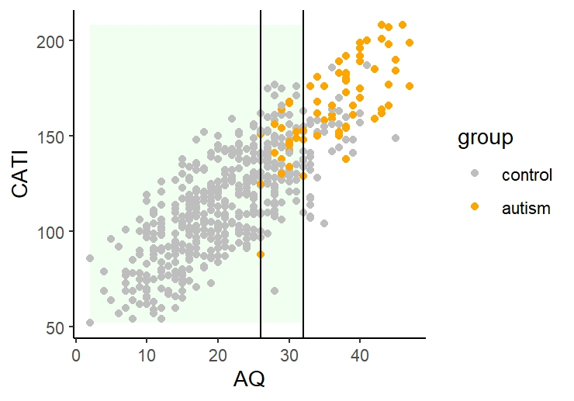
Figure S1: Spread of autism trait measures and group assignment. Each dot represents one participant, colored based on group (autism for participants with a self-reported formal autism diagnosis, control for participants without an autism diagnosis). The two vertical lines represent (from left to right) the lower cut-off for the autism group (at AQ = 26) and the upper cut-off for the control participants included in the between-group comparison (at AQ = 32). All control participants are included in the within-group analyses.
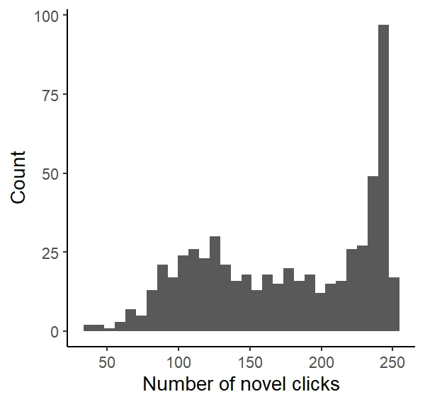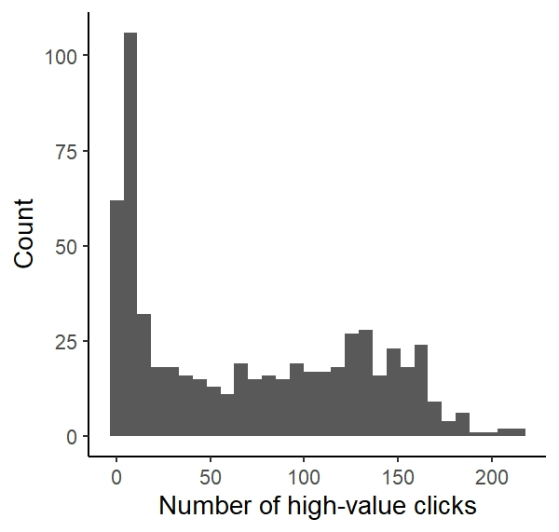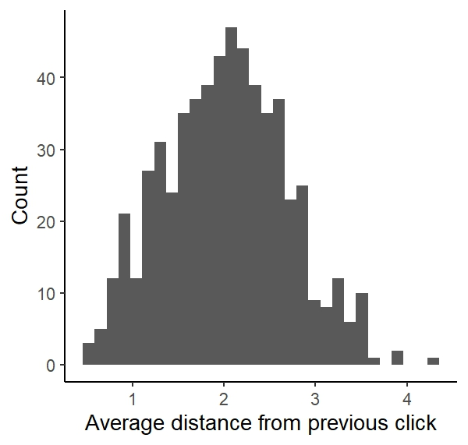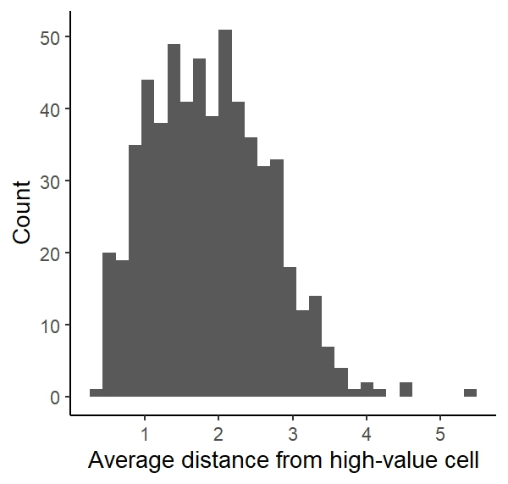
Figure S2: Distribution of behavioral measures of exploration over participants.

