Supplementary materials

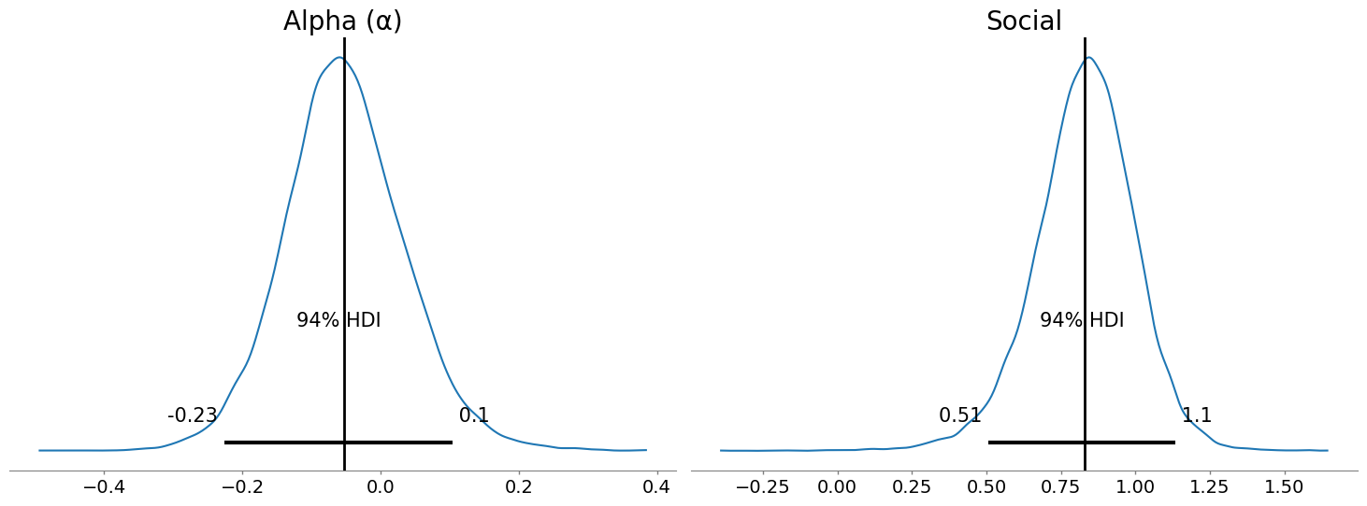
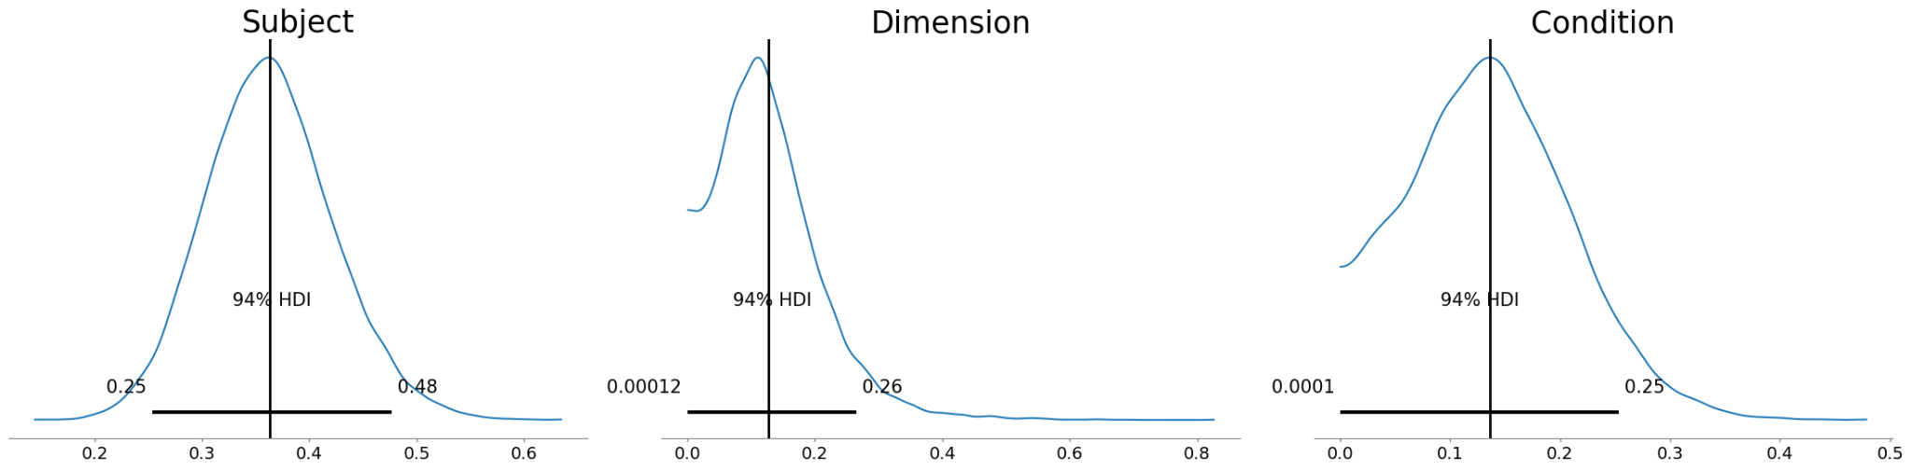

Figure S1: Posterior probability distributions of each of the factors in the Bayesian hierarchical model. Shown are the posterior density estimates for fixed effects: alpha, social and the random effects: subject, dimension (e.g., size, faces, brightness) condition (specific tasks). Vertical lines indicate posterior medians; shaded bands indicate the central confidence interval.

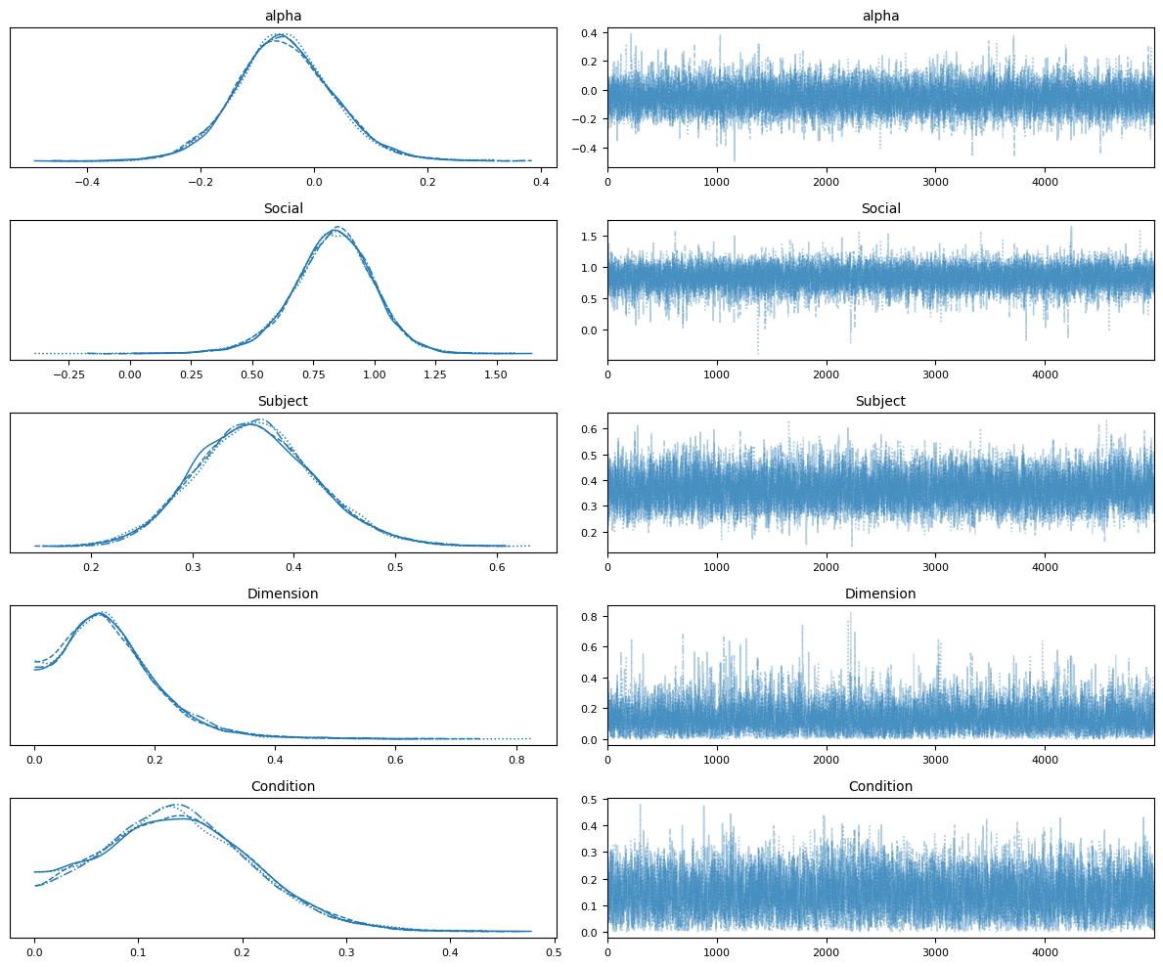
Figure S2: Diagnostics for the Bayesian hierarchical model. Trace plots and rank plots for key parameters indicate good mixing across chains. All reported parameters had R^=1.00 and large effective sample sizes (Bulk effective sample size: Alpha = 6668; Social=7474, Subject=6208; Dimension= 4439; Condition = 3477).
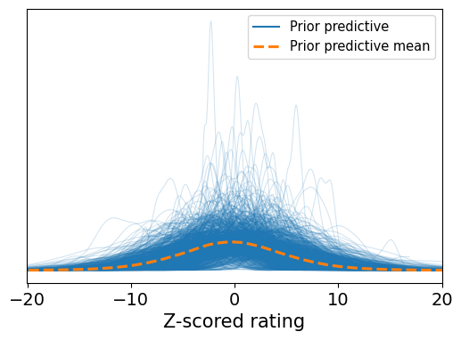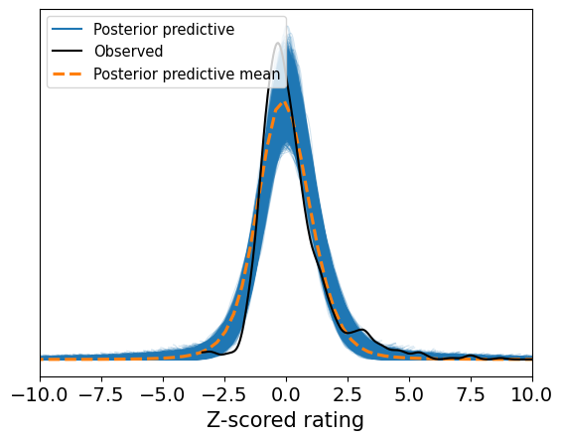
Figure S3: Prior and posterior predictive checks: Top Panel: Prior predictive distribution of simulated outcomes generated from the model priors. Bottom Panel: Posterior predictive distribution generated from posterior draws, overlaid on the observed data.

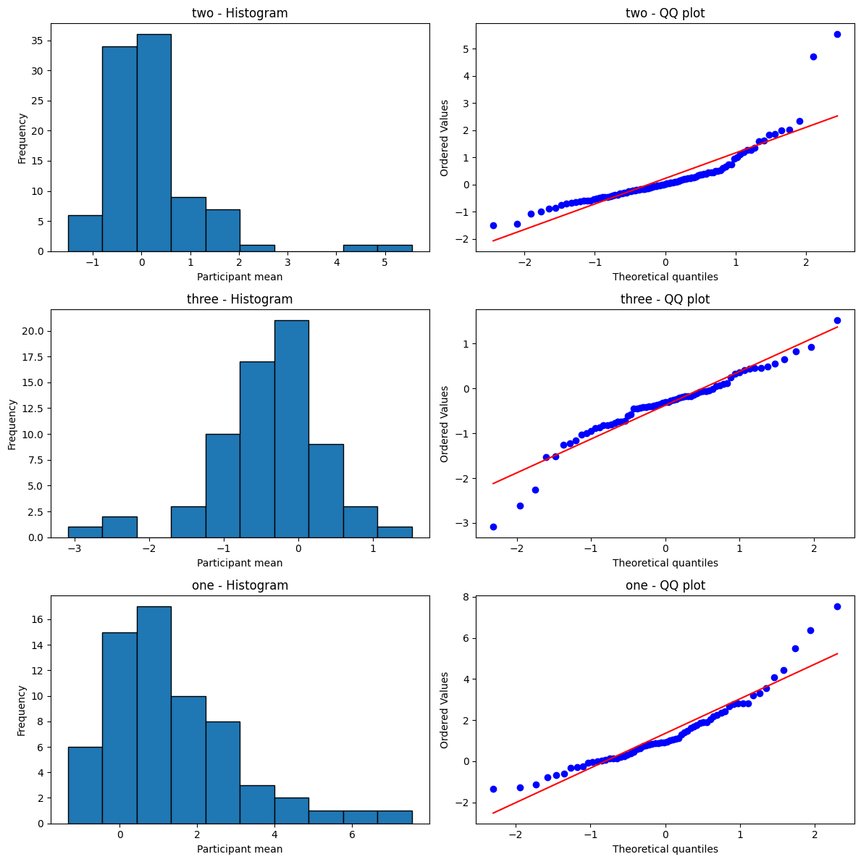
Figure S4: normality checks for each segment separately.

Table S1 Table including relevant details regarding each experiment and condition.

Experiment (condition number) | No. of autistic participants (female) | No. of non-autistic participants (female) | No. of Trials | Duration of experiment (approx) | Stimuli | Task | Psychophysical procedure
Size perception (1) | 50 (6) | 62 (34) | 456 | 20 min | Two squares varying in sizes | Which stimuli is larger? | Constant stimuli
Size perception (2) | 50 (6) | 62 (34) | 456 | 20 min | Two squares varying in sizes with low blur | Which stimuli is larger? | Constant stimuli
Size perception (3) | 50 (6) | 62 (34) | 456 | 20 min | Two squares varying in size with high blur | Which stimuli is larger? | Constant stimuli
Size perception (4) | 31 (6) | 40 (21) | 136 | 15 min | Two circles appearing one after the other | Is the second circle bigger than the first one? | Constant stimuli
Size perception (5) | 31 (6) | 28 (17) | 240 | 30 min | One square | Estimate the size of the square. | Within-subject standard deviations of aperture for each size
Size perception (6) | 21 (5) | 21 (12) | 50 | 15 min | Two circles appearing one after the other | Which circle is larger? | Constant stimuli
Weight perception | 12 (1) | 12 (8) | 576 | 30 min | Plastic water containers of the same size | Which container is heavier? | Constant stimuli
Brightness perception | 26 (9) | 27 (19) | 320 | 25min | Two bright squares | Which of the two squares are brighter? | Constant stimuli
Orientation perception (1) | 36 (8) | 40(22) | 400 | 30 min | Two lines varying in orientation | Which line is more tilted clockwise? | Constant stimuli
Orientation perception (2) | 37 (8) | 40(22) | 400 | 30 min | Two lines varying in orientation | Which line is more tilted clockwise? | Constant stimuli
Orientation perception (3) | 35 (5) | 49 (37) | 280 | 20 min | Gabor | Does the stimuli belong to clockwise (category A) or counter clockwise( category B) | Constant stimuli
Pitch perception | 23 (7) | 19 (13) | 50 | 15 min | Two sequential sounds varying in pitch | Which pitch is higher? | Constant stimuli
Size perception in illusory displays (1) | 33 (6) | 37 (5) | 144 | 20 min | Two lines embedded in Ponzo display | Which line is longer? | Constant stimuli
Size perception in illusory displays (2) | 38 (7) | 38 (5) | 144 | 20 min | Ebinghouse display | Which circle is bigger? | Constant stimuli
Size perception in illusory displays (3) | 32 (6) | 35 (4) | 144 | 20 min | Two squares | Which square is wider? | Constant stimuli
Temporal interval perception (1) | 37 (15) | 38 (23) | 50 | 10 min | Two circles varying in duration | Which circle appears for longer? | QUEST
Temporal interval perception (2) | 36 (14) | 38 (23) | 50 | 10 min | Two sounds varying in duration | Which sound appears for longer? | QUEST
Visual search (1) | 31 (7) | 37(21) | 480 | 20 min | 48 lines; one line with different orientation.  Threshold in SOA. | On which side of the screen does the line with the different orientation appear? | Constant stimuli
Visual search (2) | 31 (7) | 37(21) | 480 | 20 min | 48 lines; one line with different orientation. | On which side of the screen does the line with different orientation appear? | Constant stimuli
Visual search (3) | 23 (5) | 22 (17) | 77 | 10 min | An array of colored polygons with one as the target color | Where was the target? | Accuracy
Ensemble coding | 28 (6) | 40 (21) | 408 | 30 min | Display of discs followed by target disc | Is the target disk bigger than the average size of the display | Constant stimuli
Facial Expression | 26 (4) | 26 (12) | 960 | 60 min | Two faces appear sequentially  varying in facial expression | Same / different task | Constant stimuli
Facial identity (1) | 17 (3) | 19 (9) | 600 | 40 min | Two faces appear sequentially  varying in identity.  Own-race faces. | Same / different task | Constant stimuli
Facial identity (2) | 18 (3) | 19 (9) | 600 | 40 min | Two faces appear sequentially  varying in identity.  Other-race faces. | Same or different | Constant stimuli
Facial age judgements (1) | 35 (10) | 34 (17) | 72 | 10 min | Faces of same ages | What was the age of the face you saw? | Estimation
Facial age judgements (2) | 35 (10) | 34 (17) | 72 | 10 min | Faces of different ages. | What was the age of the face you saw? | Estimation
Speech discrimination (1) | 12 (1)* | 14 (6) | 220 | 10 min | One word appears on a continuum between tam and ta’am, spoken at a slow rate. | Was the word that you heard tam or ta’am? | Constant stimuli
Speech discrimination (2) | 12 (1)* | 14 (6) | 220 | 10 min | One word appears on a continuum between tam and ta’am, spoken at a fast rate. | Was the word that you heard tam or ta’am? | Constant stimuli
Speech discrimination (3) | 12 (1)* | 15 (8) | 220 | 10 min | One sound appears on a continuum between ‘s’ and ‘sh’, with lexical context. | Was the sound that you heard ‘s’ or ‘sh’? | Constant stimuli
Speech discrimination (4) | 12 (1)* | 15 (8) | 440 | 10 min | One sound appears on a continuum between ‘s’ and ‘sh’, with a lexical context. | Was the sound that you heard ‘s’ or ‘sh’? | Constant stimuli
Speech discrimination (5) | 10 (1)* | 16 (9) | 300 | 10 min | One sound appears on a continuum between ‘s’ and ‘sh’ rate, with acoustic context. | Was the sound that you heard ‘s’ or ‘sh’? | Constant stimuli
Speech discrimination (6) | 10 (1)* | 16 (9) | 300 | 10 min | One sound appears on a continuum between ‘s’ and ‘sh’ rate, with lexical context. | Was the sound that you heard ‘s’ or ‘sh’? | Constant stimuli

