Supplementary Materials
Figure S1.
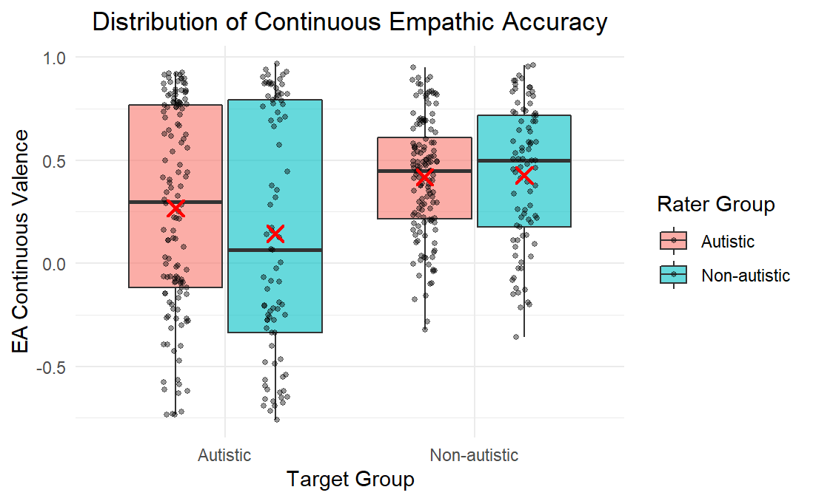

Figure S1. Distribution of Continuous Valence Empathic Accuracy by Target and Rater’s Group
Note. Each dot represents a single trial (a rater’s continuous EA score for one target). Boxes show the interquartile range (IQR); horizontal lines indicate the median; whiskers extend to 1.5 × IQR. Red Xs mark the mean for each target × rater-group cell.

To test whether variability in continuous valence EA differed between autistic and non-autistic raters, F-tests were conducted. Results showed a significant variance difference (F_{(265,169)}=0.66, p=.0029, 95% CI [0.50, 0.87]), indicating lower variability among autistic raters.
Emotion Valence Over Time – Non-Autistic Targets. For non-autistic targets, the valence ratings alignment over time show that raters’ continuous valence traces generally tracked the targets’ self-reported valence with positive alignment, alongside apparent between-target variability. Several non-autistic storytellers yielded higher mean continuous EA (M_{EA}=.63; M_{EA}=.52; M_{EA}=.48), whereas one target exhibited near-zero alignment (M_{EA}=.04), suggesting lower readability.
Emotion Valence Over Time – Autistic Targets. For autistic targets, the valence ratings alignment over time showed positive alignment for some storytellers (M_{EA}=.70; M_{EA}=.78), alongside pronounced between-target heterogeneity, including near-zero alignment (M_{EA}=0.04; M_{EA}=−0.04). One target was generally unreadable (M_{EA}=-0.49). Nonetheless, autistic raters showed slightly higher alignment with this target’s self-reported valence compared to non-autistic raters. Here too, small target-specific differences emerged between rater groups: for one target, non-autistic raters exceeded autistic raters; for one target, ratings of both rater groups were quite comparable; and for the other three targets, autistic raters exceeded non-autistic raters.

Figure S2.
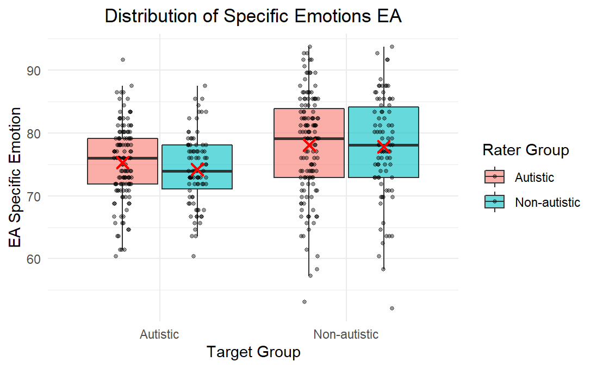

Figure S2. Distribution of Specific Emotion Empathic Accuracy by Target and Rater Group.
Note. Each dot represents a single trial (a rater’s specific-emotion EA score for one target) and is jittered for legibility. Boxes show the interquartile range (IQR); the horizontal line is the median; whiskers follow Tukey’s rule (±1.5 × IQR). Red Xs mark the mean for each target × rater-group cell. Fill colors indicate rater group (Autistic vs. Non-autistic). Higher values reflect greater EA.

Variance did not differ significantly between autistic and non-autistic raters (F_{(263, 171)}=1.03, p=.833, 95% CI [0.78, 1.35]), indicating comparable overall variability in specific emotion empathic accuracy across rater groups.

Further Exploratory Analyses by Specific Emotions. To further explore group differences in specific emotion empathic accuracy, independent t-tests were conducted to compare groups on the match between empathizers' and targets' ratings of each of the 12 discrete emotions. This analysis revealed that most differences between autistic and non-autistic raters did not reach statistical significance. There were two differences that initially reached statistical significance: autistic raters demonstrated significantly higher empathic accuracy for anger (p=.037; d=0.205) and alertness (p=.009, d=0.253) (Table 6). For anger, autistic raters achieved the highest accuracy when rating non-autistic targets (M=91.15, SD=14.15), followed by non-autistic raters rating non-autistic targets (M=89.96, SD=17.28). Lower scores were observed among autistic raters rating autistic targets (M=82.44, SD=21.54), and the lowest among non-autistic raters rating autistic targets (M=76.10, SD=25.66). For alertness, autistic raters achieved the highest accuracy when rating autistic targets (M=74.91, SD=19.92), followed by non-autistic raters rating autistic targets (M=70.60, SD=21.28), autistic raters rating non-autistic targets (M=68.80, SD=25.33), and non-autistic raters rating non-autistic targets (M=61.30, SD=26.38). However, these differences did not hold after correction for multiple comparisons using the Benjamini–Hochberg False Discovery Rate (FDR) procedure.

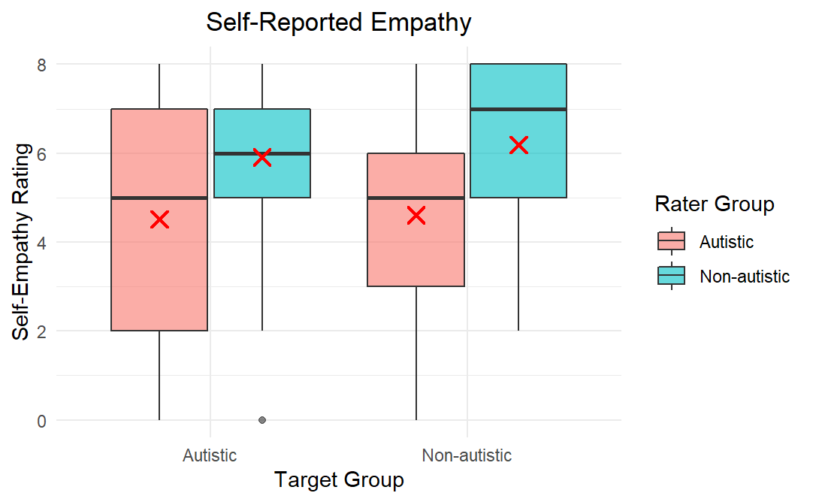
Figure S3.

Figure S3. Self-Reported Empathy Ratings by Target and Rater Group.
Boxes indicate the interquartile range (IQR); the horizontal line represents the median; whiskers follow Tukey’s rule (±1.5 × IQR). Red Xs mark the mean for each target × rater-group cell. Fill colors denote rater group (Autistic vs. Non-autistic). Higher values indicate greater self-reported empathy.

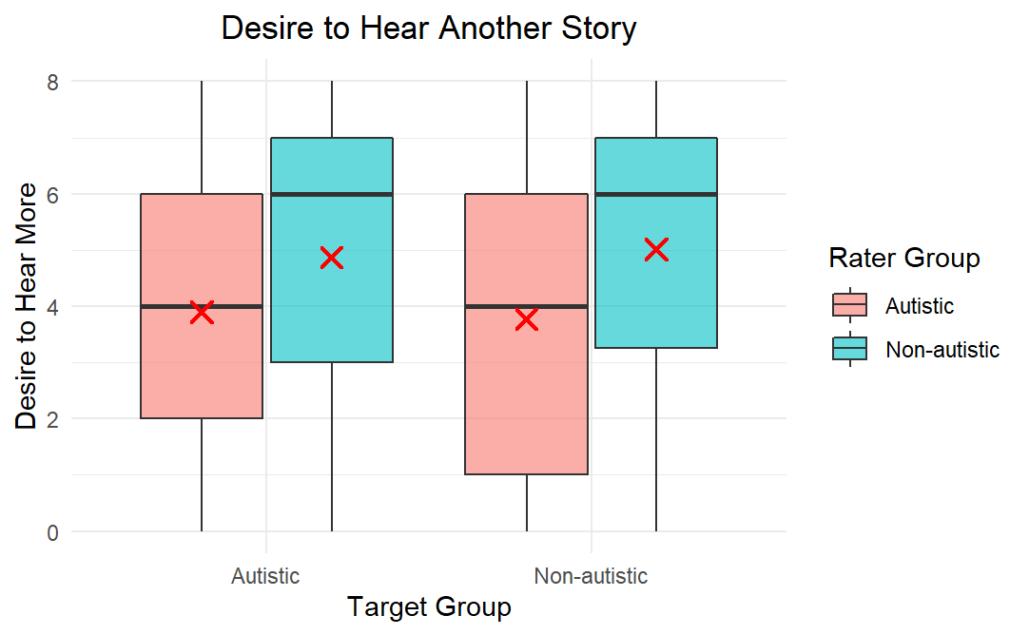
Figure S4.

Figure S4. Self-Reported Empathic Interest Ratings by Target and Rater Group.
Boxes indicate the interquartile range (IQR) of the desire to hear another story from a given target; the horizontal line represents the median; whiskers follow Tukey’s rule (±1.5 × IQR). Red Xs mark the mean for each target × rater-group cell. Fill colors denote rater group (Autistic vs. Non-autistic). Higher values indicate stronger desire to hear additional stories.

Table S1.
Fixed Effects EA Continuous Valence Model
Effect | Estimate | Std. Error | df | t value | p value | d
Intercept | 0.303 | 0.1298 | 8.016 | 2.337 | 0.0476 * | 1.345
Rater Group (N) | 0.018 | 0.0119 | 219.383 | 1.511 | 0.1321 | -0.08
Target Group (N) | -0.115 | 0.1297 | 7.999 | -0.884 | 0.4024 | 0.51
Rater × Target Group | 0.0212 | 0.0112 | 217.327 | 1.894 | 0.0595 · | 0.13

Table S2.
Random Effects EA Continuous Valence Model
Group | Effect | Variance | Std. Dev.
Rater (ID) | Intercept | 0.0039 | 0.063
Target | Intercept | 0.1671 | 0.408
Residual | - | 0.0508 | 0.225

Table S3.
Mean and Standard Deviation of Continuous EA Toward Each Target, by Rater Group
Target ID | Target Group | Overall EA |  | Autistic Raters EA |  | Non-Autistic Raters EA
 |  | Mean | SD | Mean | SD | Mean | SD
10 | Non-Autistic | 0.629 | 0.302 | 0.593 | 0.291 | 0.683 | 0.318
13 | Non-Autistic | 0.427 | 0.125 | 0.427 | 0.127 | 0.429 | 0.125
16 | Non-Autistic | 0.515 | 0.232 | 0.484 | 0.244 | 0.562 | 0.211
17 | Non-Autistic | 0.478 | 0.286 | 0.505 | 0.248 | 0.443 | 0.334
53 | Non-Autistic | 0.037 | 0.166 | 0.066 | 0.173 | -0.007 | 0.148
24 | Autistic | 0.043 | 0.188 | 0.039 | 0.189 | 0.052 | 0.195
27 | Autistic | -0.043 | 0.309 | 0.047 | 0.314 | -0.218 | 0.214
28 | Autistic | 0.697 | 0.251 | 0.689 | 0.215 | 0.709 | 0.300
29 | Autistic | 0.783 | 0.155 | 0.801 | 0.11 | 0.754 | 0.208
34 | Autistic | -0.493 | 0.237 | -0.433 | 0.286 | -0.549 | 0.172

Table S4.
Fixed Effects Specific Emotions Empathic Accuracy
Effect | Estimate | Std. Error | df | t value | p value | d
Intercept | 76.3246 | 0.8685 | 8.4998 | 87.881 | 7.08e-14 *** | 12.21
Rater Group (N) | 0.3543 | 0.3544 | 211.09 | 1.000 | 0.319 | -0.056
Target Group (N) | -1.5414 | 0.8512 | 7.856 | -1.811 | 0.108 | 0.246
Rater × Target Interaction | 0.1793 | 0.3097 | 206.155 | 0.579 | 0.563 | 0.029

Table S5.
Random Effects Specific Emotions Empathic Accuracy
Group | Effect | Variance | Std. Dev.
Rater (ID) | Intercept | 6.575 | 2.564
Target | Intercept | 6.294 | 2.509
Residual | - | 39.078 | 6.251

Table S6.
Emotion-Specific Mean EA Scores by Rater Group for each of the 12 Discrete Emotions
Emotion | Mean (Autistic) | Mean  (non-autistic) | t Statistic | df | p Value | p (FDR )
Anger | 86.81 | 82.63 | 2.07 | 343.12 | 0.038 | 0.234
Disgust | 90.48 | 90.74 | -0.16 | 411.14 | 0.869 | 0.87
Embarrassment | 76.14 | 75.81 | 0.17 | 389.37 | 0.863 | 0.87
Sadness | 74.86 | 76.15 | -0.67 | 402.54 | 0.499 | 0.75
Happiness | 79.26 | 78.92 | 0.23 | 354.16 | 0.82 | 0.87
Pride | 71.84 | 74.59 | -1.31 | 407.81 | 0.189 | 0.502
Fear | 77.61 | 78.11 | -0.24 | 377.08 | 0.806 | 0.87
Excitement | 77.98 | 75.54 | 1.18 | 368.51 | 0.236 | 0.502
Contentment | 73.08 | 69.86 | 1.45 | 390.48 | 0.147 | 0.502
Nervousness | 70.83 | 73.11 | -1.07 | 406.47 | 0.283 | 0.502
Calmness | 69.23 | 71.62 | -1.05 | 408.65 | 0.293 | 0.502
Alertness | 71.84 | 65.88 | 2.63 | 378.89 | 0.008 | 0.107
Table S7.
Specific Emotion EA for Anger and Alertness Across Rater and Target Groups
Emotion | Rater Group | Target Group | Mean EA | SD | n
Anger | Autistic | Autistic | 82.44 | 21.54 | 136
Anger | Autistic | non-autistic | 91.15 | 14.15 | 137
Anger | non-autistic | Autistic | 76.1 | 25.66 | 91
Anger | non-autistic | non-autistic | 89.96 | 17.28 | 94
Alertness | Autistic | Autistic | 74.91 | 19.92 | 136
Alertness | Autistic | non-autistic | 68.80 | 25.33 | 137
Alertness | non-autistic | Autistic | 70.6 | 21.28 | 91
Alertness | non-autistic | non-autistic | 61.3 | 26.38 | 94

Table S8.
Fixed Effects Self-Reported Empathy
Effect | Estimate | Std. Error | df | t value | p-value | d
Intercept | 5.3019 | 0.2225 | 11.866 | 23.827 | 2.19e-11*** | 3.52
Rater Group (N) | -0.72244 | 0.1295 | 231.97 | -5.575 | 6.84e-08*** | 0.48
Target Group (N) | -0.09299 | 0.1948 | 7.091 | -0.477 | 0.648 | 0.06
Rater × Target Group | 0.07721 | 0.0724 | 219.16 | 1.066 | 0.288 | 0.05

Table S9.
Random Effects Self-Reported Empathy
Group | Effect | Variance | Std. Dev.
Rater (ID) | Intercept | 2.605 | 1.614
Target | Intercept | 0.327 | 0.572
Residual | — | 2.272 | 1.507

Table S10.
Fixed Effects Empathic Interest (Wanting to Hear More)
Effect | Estimate | Std. Error | df | t value | p-value | Significance
Intercept | 4.3867 | 0.1664 | 28.866 | 26.236 | < 2e-16*** | 2.70
Rater Group (N) | -0.546 | 0.1523 | 232.87 | -3.584 | 0.00041*** | 0.34
Target Group (N) | -0.002 | 0.1028 | 4.6777 | -0.017 | 0.9872 | 0.00
Rater × Target Group | 0.073 | 0.0778 | 223.28 | 0.938 | 0.3491 | 0.04

Table S11.
Random Effects Empathic Interest (Wanting to Hear More)
Group | Effect | Variance | Std. Dev.
Rater (ID) | Intercept | 3.865 | 1.966
Target | Intercept | 0.045 | 0.213
Residual | — | 2.637 | 1.624

Sensitivity analyses: rater–target sex match. To address whether dyadic rater–target sex pairing could account for the pattern of findings, we refitted all primary linear mixed models, including an additional fixed factor indexing whether the rater and target were classified as the same versus different sex for Male/Female pairings, with dyads involving ‘Other’ classifications retained in a separate category. The models preserved the same outcomes and the same random-effects structure as the primary models ((1 | rater) + (1 | target)). For continuous valence EA, the added factor was not statistically significant, F_{(2, 335.23)}=0.23, p=.796. Parallel sensitivity specifications for the self-reported empathy, specific emotions EA, and empathic interest were also not statistically significant for the match factor, Fs_{(2, 40.60–79.42)}= 0.19–1.18, ps=.339–.830. Likelihood-ratio comparisons of nested models (maximum-likelihood refits) indicated that adding the match factor did not significantly improve model fit for any outcome, χ²₍₂₎=0.30–2.67, ps=.263–.863. Finally, to mirror the primary planned comparisons, we estimated marginal means for the rater group×target group interaction on continuous valence; results were averaged across levels of the match factor as implemented in emmeans. The simple effect comparing autistic vs. non-autistic raters within autistic targets was virtually unchanged from the primary model (estimate=0.079, p=.017, compared with estimate=0.079, p=.018 in the primary model), and the simple effect within non-autistic targets remained negligible in both models. Overall, these analyses suggest that the reported pattern of findings for the main analyses is not explained by rater-target sex match operationalized in the experimental design.

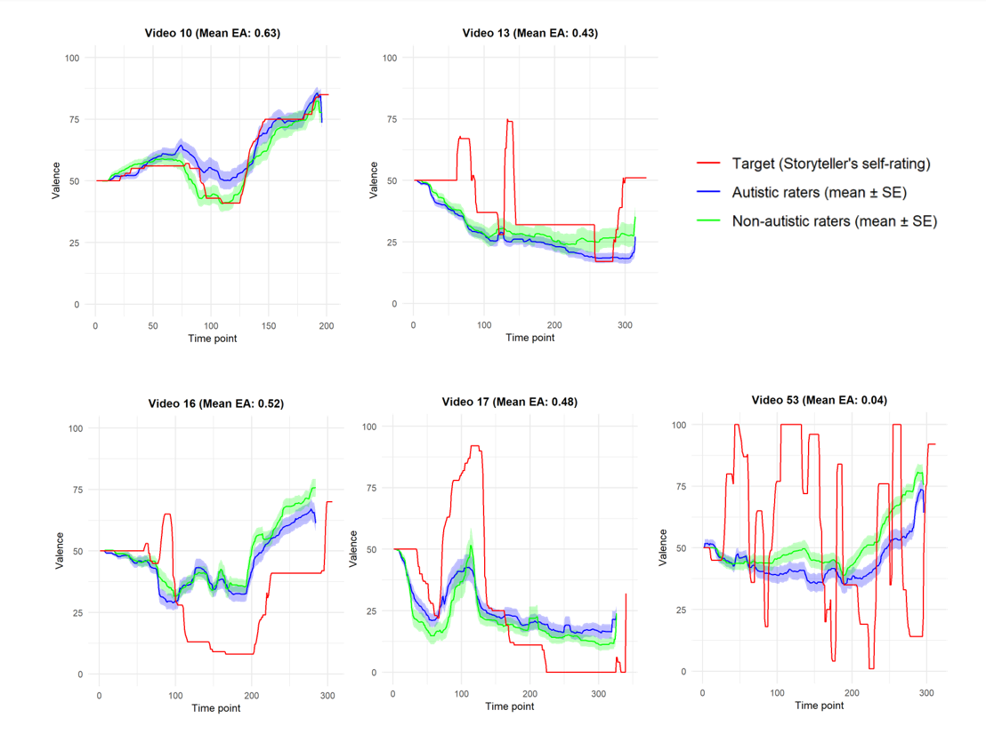
Figure S5.

Figure S5. Continuous Emotion Valence Trajectories Over Time for Non-Autistic Targets.
The time-series plots depict the alignment between storytellers’ self-reported valence (red line) and the mean continuous valence ratings of autistic (blue) and non-autistic (green) raters over time. Shaded areas represent ±1 standard error around each group’s mean.

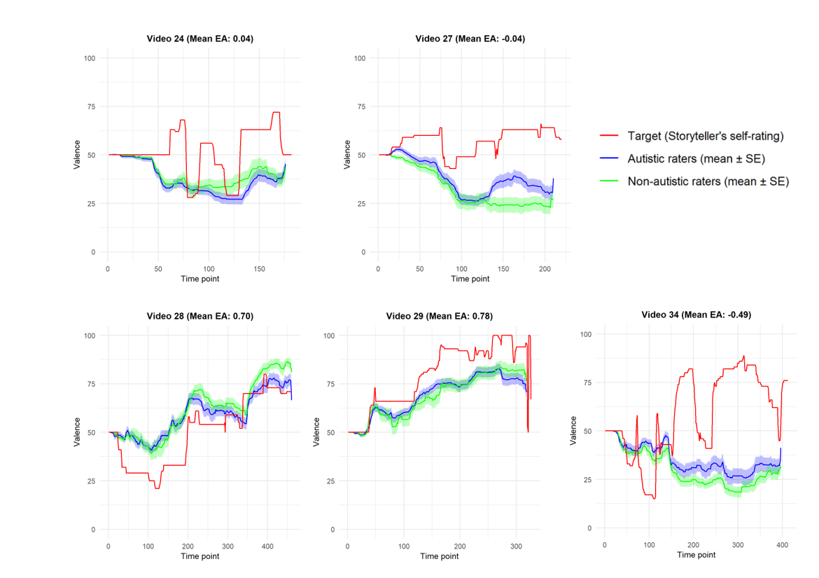
Figure S6.

Figure S6. Continuous Emotion Valence Trajectories Over Time for Autistic Targets.
The time-series plots depict the alignment between storytellers’ self-reported valence (red line) and the mean continuous valence ratings of autistic (blue) and non-autistic (green) raters over time. Shaded areas represent ±1 standard error around each group’s mean.

