Supplementary Material

Breakdown of Participants with Valid EEG Data by Site
Table S1. Number of participants with valid EEG recordings at baseline (week 0) and endpoint (week 16) for each study site.
SITE | BASELINE (WEEK 0) | ENDPOINT (WEEK 16)
Madrid | 45 | 41
Paris | 21 | 20
Barcelona | 16 | 15
Salamanca | 10 | 10
Glasgow | 2 | 1
Newcastle | 2 | -

Number of artefact-free trials included in the analyses

Table S2.1. Descriptive statistics of artefact-free trial counts included in the N170 analysis. Mean and standard deviation (SD) of the number of retained artefact-free trials included in the analyses, presented separately by treatment group and visit. Trial counts were calculated after artefact rejection and exclusion procedures described in the Methods section.
Treatment group | Visit | n | Mean artefact-free trials | SD
Placebo | Pre | 33 | 54.1 | 12.5
Placebo | Post | 25 | 57.2 | 11.1
Arbaclofen | Pre | 28 | 55.4 | 10.0
Arbaclofen | Post | 28 | 58.3 | 13.4

Table S2.2. A linear mixed-effects model was fitted with the number of retained artefact-free trials as the dependent variable. Treatment group, visit, and the group × visit interaction were included as fixed effects, with participant included as a random intercept to account for repeated measurements across visits.
Outcome | Factor | Estimate | SE | df | t-value | p-value
Artifact-free trials | Intercept (placebo, post) | 57.137 | 2.361 | 109.96 | 24.197 | <0.001
Artifact-free trials | Treatment (arbaclofen vs placebo) | 0.839 | 3.252 | 110.00 | 0.258 | 0.797
Artifact-free trials | Visit (pre vs post) | -2.970 | 2.955 | 69.72 | -1.005 | 0.318
Artifact-free trials | Treatment × Visit | 0.324 | 4.184 | 67.37 | 0.077 | 0.938

Assessment of hemispheric differences in N170 latency
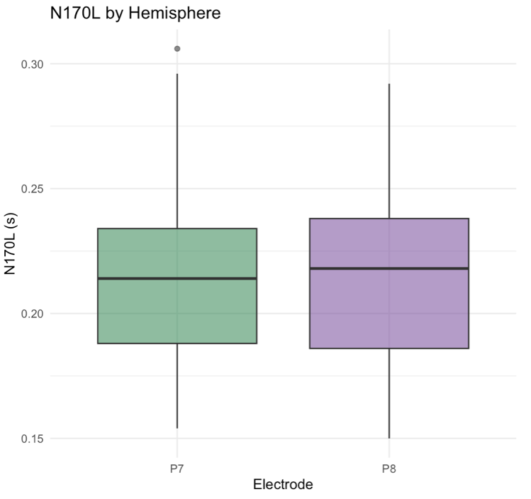
Figure S3. Hemispheric comparison of N170L. Boxplots showing N170L at electrodes P7 and P8. Visual inspection indicates no systematic hemispheric differences in latency, supporting the averaging of P7 and P8 in the main analyses.

Table S3. Statistical comparison of baseline N170L between P7 and P8 (paired-samples t-test and linear mixed-effects model).
Analysis | Result
Paired-samples t-test | t(58) = −0.33, p = 0.74; mean difference = −1.4 ms  (95% CI [−9.8, 7.0] ms)
Linear mixed-effects model | Electrode effect: β = 2.1 ms, SE = 3.7 ms, p = 0.56

Baseline associations of N170L with age and study site
Table S4. Baseline exploratory analyses were conducted to characterise the relationship between N170L, age, and study site. These analyses were performed to provide additional context for the inclusion of age as a covariate, and study site as a random effect in the primary models, respectively. No inferential claims beyond descriptive interpretation are made.
Analysis | Test | Statistic | df | Estimate | p-value | Interpretation
N170L vs Age | Pearson correlation | r | 59 | -0.50 | < 0.001 | Negative association: older participants tend to show shorter (faster) N170L
Site differences in N170L | One-way ANOVA | F | (5, 55) | 1.47 | 0.214 | No evidence of systematic differences across sites

Deviation from Pre-registration: Removal of N170L as Normalised Baseline
In our pre-registration [1], we proposed to include normalised baseline N170L in linear mixed models. Including this factor changed several measures of treatment response from non-significant to significant (Table S2). For several reasons, we believe this an artefact and not representative of the true patterns in our data.
Table S5. Results from linear mixed-effects model examining change in N170L from baseline to week 16, with fixed-effect estimates for each treatment group, the age covariate, and Normalised Baseline. Estimates include standard errors, degrees of freedom (df), t-values, and raw p-values.
Outcome | Factor |  | Estimate | Std. Error | df | t-value | p-value
N170L Change |  | Placebo | 0.028 | 0.010 | 77 | 2.694 | 0.009 **
 |  | Arbaclofen | 0.026 | 0.010 | 77 | 2.540 | 0.013 *
 |  | Normalised Baseline | -0.741 | 0.102 | 77 | -7.243 | 0.000 ***
 |  | Age | -0.003 | 0.001 | 77 | -3.112 | 0.003 **

First, these effects were present in the placebo and treatment arms, which is incompatible with arbaclofen driving treatment response. Second, the model excluding normalised baseline, showed no evidence of treatment response across groups–in other words, we would have concluded that baseline differences alone turned a null result into a significant result. Third, plotting Normalised Baseline N170L against change in N170L over time revealed patterns suggestive of regression to the mean in both the treatment and placebo groups (Figure S2). Namely, participants with slower normalised baseline latencies showed faster responses at follow-up, and vice versa, irrespective of treatment.
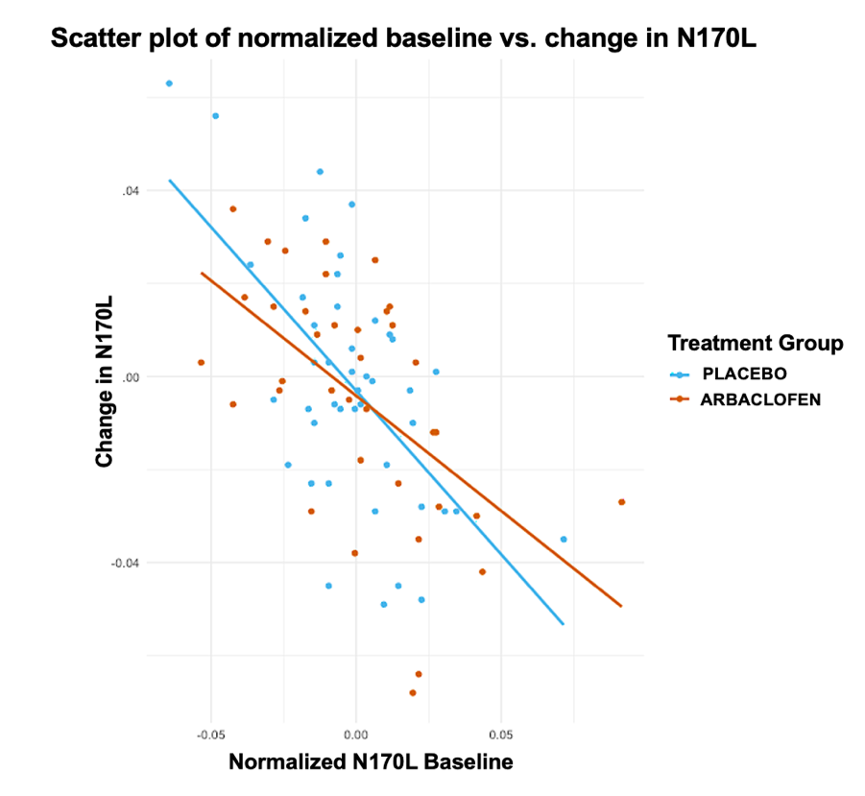
Figure S5. Scatter plot showing the relationship between Normalised N170L baseline and change in N170L over time across treatment groups. Each point represents an individual participant.
For these reasons, we believe the inclusion of normalised baseline in the linear mixed models produced an artefactual effect that was not supported by the patterns in the raw data and may have led to misattributing change to treatment.

Deviation from Pre-registration: Inclusion of a Fixed Intercept
In our pre-registration [1], we stated that models would be fitted without a fixed intercept. We deviated from this plan by including a fixed intercept to enable direct estimation of group-specific mean changes and formal comparison between the arbaclofen and placebo arms in this placebo-controlled trial. This modification allows explicit calculation of between-group differences, which are central to interpreting treatment effects, aligns with standard clinical trial reporting practices, and improves the interpretability of estimated mean changes for each treatment group, without affecting the validity of statistical inference.

Exploratory Analysis: Global Change in N170L over 16 Weeks
To examine overall change in N170L across the study period, irrespective of treatment group, we conducted an exploratory linear mixed-effects analysis:
$y_{ijk}= β_{0}+β_{1}V_{ijk}+β_{2}A_{ijk}+ u_{k}+v_{j(k)}+ε_{ijk}$
Where $y_{ijk}$represents N170 latency to upright faces for observation $i$ within participant $j$ at site $k$; $β_{0}$ is the fixed intercept; $V_{ijk}$ is a categorical factor indexing visit timepoint (week 16 vs. week 0 (baseline)); $A_{ijk}$ represents baseline age, included as a covariate; $u_{k}$ is a random intercept for site $k$; $v_{j(k)}$ is a random intercept for participant $j$ nested within site $k$ ; and $ε_{ijk}$is the residual error. See Table S4 for model output.
Table S7. Results from the linear mixed-effects model examining N170L at week 0 and week 16. The intercept represents the estimated mean N170L at week 0, and the visit coefficient represents the estimated difference in N170L between week 16 and week 0. Age was included as a covariate. Estimates are reported with standard errors, degrees of freedom (df), t-values, and raw p-values. Significance is indicated as ***p < 0.001. To address convergence issues, the random intercept for participant was removed.
Outcome | Factor | Estimate | Std. Error | df | t-value | p-value
N170 Latency | Intercept (week 0) | 267.342 | 11.289 | 83 | 23.682 | <0.001***
N170 Latency | Visit (week 16 vs week 0) | 5.393 | 5.990 | 83 | 0.900 | 0.371
N170 Latency | Age | -4.732 | 0.953 | 83 | -4.964 | <0.001***

Treatment Modulation of N170L Results
Table S8.1. Results from the linear mixed-effects model examining change in N170L from baseline to week 16. The intercept represents the estimated mean N170L change in the placebo group, and the treatment coefficient represents the difference in N170L change between the arbaclofen and placebo groups. Models include age as a covariate. Estimates are reported with standard errors, degrees of freedom (df), t-values, and raw p-values. To address convergence issues, the random intercept for participant was removed.
Outcome | Factor | Estimate | Std. Error | df | t-value | p-value
N170L  Change | Intercept (placebo) | -6.576 | 11.894 | 78 | -0.553 | 0.582
N170L  Change | Treatment (arbaclofen vs placebo) | -1.962 | 5.822 | 78 | -0.337 | 0.737
N170L  Change | Age | 0.365 | 0.922 | 78 | 0.395 | 0.694

Table S8.2. Descriptive statistics for N170L at baseline and endpoint, together with observed pre–post change scores (ΔN170L) by treatment group. Values are presented as mean (SD) in milliseconds. Age-adjusted linear mixed-effects models with participant included as a random effect were used to assess pre–post changes in N170L using all available EEG observations. Neither treatment group showed evidence of a significant change in N170L over the trial.

Treatment | Baseline N170L, mean (SD) | Endpoint N170L, mean (SD) | ΔN170L, mean (SD) | Linear mixed-effects model estimates of change (post − pre)
Placebo | 216.0 (31.7) ms | 213.0 (20.9) ms | −2.4 (34.3) ms | −3.25 ms, SE = 7.17, p = 0.652
Arbaclofen | 212.0 (33.5) ms | 216.0 (31.3) ms | −3.3 (39.4) ms | 4.93 ms, SE = 7.22, p = 0.497

Associations between Baseline N170L and Clinical Change
Table S9. Results from linear mixed-effects models examining the association between baseline N170L and changes in clinical outcomes following treatment (placebo vs. Arbaclofen). Estimates include 95% confidence intervals (CIs), degrees of freedom (df), t-values, raw p-values (reported for reference), and Bonferroni-corrected p-values, which were used to determine statistical significance within each predefined thematic domain (see Section 3.5.4). Statistically significant results, based on these Bonferroni-corrected p-values, are indicated by asterisks. Dependent variables that did not meet normality assumptions were transformed using log, square root, or Yeo-Johnson transformations, as indicated in the table. To address convergence issues, the random intercept for participant was removed.

Clinical Outcome | Factor | Estimate | 95% CI | df | t-value | Raw p-value | Corrected p-value
VABS-Socialisation Domain | Intercept (placebo) | 49.044 | [12.076, 86.012] | 86 | 2.637 | 0.010 | 0.030*
VABS-Socialisation Domain | Treatment (arbaclofen vs placebo) | -0.058 | [-42.128, 42.011] | 86 | -0.003 | 0.998 | 1.000
VABS-Socialisation Domain | Baseline N170L | 2.410 | [-146.618, 151.439] | 86 | 0.032 | 0.974 | 1.000
VABS-Socialisation Domain | Age | -0.318 | [-1.278, 0.642] | 86 | -0.658 | 0.512 | 1.000
VABS-Socialisation Domain | Treatment: BaselineN170L | -7.240 | [-208.091, 193.612] | 86 | -0.072 | 0.943 | 1.000
VABS- Play and Leisure Time | Intercept (placebo) | 98.975 | [34.036, 163.914] | 86 | 3.030 | 0.003 | 0.010 *
VABS- Play and Leisure Time | Treatment (arbaclofen vs placebo) | -20.884 | [-94.785, 53.017] | 86 | -0.562 | 0.576 | 1.000
VABS- Play and Leisure Time | Baseline N170L | -56.567 | [-318.355, 205.221] | 86 | -0.430 | 0.669 | 1.000
VABS- Play and Leisure Time | Age | -0.358 | [-2.045, 1.328] | 86 | -0.422 | 0.674 | 1.000
VABS- Play and Leisure Time | Treatment: BaselineN170L | 110.485 | [-242.337, 463.307] | 86 | 0.623 | 0.535 | 1.000
VABS-Interpersonal Relationships | Intercept (placebo) | 49.770 | [8.270, 91.270] | 86 | 2.384 | 0.019 | 0.058
VABS-Interpersonal Relationships | Treatment (arbaclofen vs placebo) | -0.765 | [-47.992, 46.462] | 86 | -0.032 | 0.974 | 1.000
VABS-Interpersonal Relationships | Baseline N170L | -33.881 | [-201.179, 133.416] | 86 | -0.403 | 0.688 | 1.000
VABS-Interpersonal Relationships | Age | -0.220 | [-1.297, 0.858] | 86 | -0.405 | 0.686 | 1.000
VABS-Interpersonal Relationships | Treatment: BaselineN170L | -0.659 | [-226.133, 224.815] | 86 | -0.006 | 0.995 | 1.000
VABS-Coping Skills | Intercept (placebo) | 53.703 | [-1.370, 108.776] | 86 | 1.939 | 0.056 | 0.168
VABS-Coping Skills | Treatment (arbaclofen vs placebo) | 18.536 | [-43.787, 80.859] | 86 | 0.591 | 0.556 | 1.000
VABS-Coping Skills | Baseline N170L | 50.594 | [-170.979, 272.168] | 85 | 0.454 | 0.651 | 1.000
VABS-Coping Skills | Age | -0.312 | [-1.769, 1.145] | 86 | -0.426 | 0.671 | 1.000
VABS-Coping Skills | Treatment: BaselineN170L | -93.743 | [-391.176, 203.690] | 84 | -0.627 | 0.533 | 1.000
SRS-Social Cognition  Square root | Intercept (placebo) | 5.295 | [1.988, 8.602] | 81 | 3.185 | 0.002 | 0.006 *
SRS-Social Cognition  Square root | Treatment (arbaclofen vs placebo) | 0.117 | [-3.576, 3.809] | 80 | 0.063 | 0.950 | 1.000
SRS-Social Cognition  Square root | Baseline N170L | -1.739 | [-15.383, 11.904] | 81 | -0.254 | 0.800 | 1.000
SRS-Social Cognition  Square root | Age | -0.048 | [-0.131, 0.035] | 82 | -1.147 | 0.255 | 0.765
SRS-Social Cognition  Square root | Treatment: BaselineN170L | -0.826 | [-18.589, 16.938] | 80 | -0.092 | 0.927 | 1.000
SRS-Social Awareness  Yeo-Johnson | Intercept (placebo) | 1.464 | [-1.599, 4.527] | 82 | 0.951 | 0.345 | 1.000
SRS-Social Awareness  Yeo-Johnson | Treatment (arbaclofen vs placebo) | 1.829 | [-1.595, 5.254] | 82 | 1.063 | 0.291 | 0.873
SRS-Social Awareness  Yeo-Johnson | Baseline N170L | -1.200 | [-13.828, 11.428] | 82 | -0.189 | 0.851 | 1.000
SRS-Social Awareness  Yeo-Johnson | Age | -0.088 | [-0.164, -0.012] | 82 | -2.308 | 0.024 | 0.071
SRS-Social Awareness  Yeo-Johnson | Treatment: BaselineN170L | -10.579 | [-27.055, 5.897] | 82 | -1.277 | 0.205 | 0.615
ABCC-Lethargy/Social Withdrawal  Yeo-Johnson | Intercept (placebo) | 19.274 | [-3.367, 41.914] | 83 | 1.693 | 0.094 | 0.283
ABCC-Lethargy/Social Withdrawal  Yeo-Johnson | Treatment (arbaclofen vs placebo) | -7.234 | [-32.989, 18.522] | 83 | -0.559 | 0.578 | 1.000
ABCC-Lethargy/Social Withdrawal  Yeo-Johnson | Baseline N170L | -3.449 | [-96.266, 89.369] | 83 | -0.074 | 0.941 | 1.000
ABCC-Lethargy/Social Withdrawal  Yeo-Johnson | Age | 0.096 | [-0.479, 0.671] | 83 | 0.332 | 0.741 | 1.000
ABCC-Lethargy/Social Withdrawal  Yeo-Johnson | Treatment: BaselineN170L | 20.391 | [-102.716, 143.499] | 83 | 0.329 | 0.743 | 1.000
AIM-Peer Interaction | Intercept (placebo) | 30.959 | [12.042, 49.876] | 74 | 3.261 | 0.002 | 0.005 *
AIM-Peer Interaction | Treatment (arbaclofen vs placebo) | -18.413 | [-39.286, 2.460] | 74 | -1.758 | 0.083 | 0.249
AIM-Peer Interaction | Baseline N170L | -46.027 | [-121.034, 28.979] | 74 | -1.223 | 0.225 | 0.676
AIM-Peer Interaction | Age | -0.228 | [-0.741, 0.286] | 74 | -0.884 | 0.380 | 1.000
AIM-Peer Interaction | Treatment: BaselineN170L | 71.418 | [-28.178, 171.014] | 74 | 1.429 | 0.157 | 0.472
AIM-Social Reciprocity | Intercept (placebo) | 32.706 | [10.553, 54.860] | 74 | 2.942 | 0.004 | 0.013 *
AIM-Social Reciprocity | Treatment (arbaclofen vs placebo) | 2.158 | [-22.331, 26.647] | 74 | 0.176 | 0.861 | 1.000
AIM-Social Reciprocity | Baseline N170L | -21.233 | [-108.762, 66.296] | 74 | -0.483 | 0.630 | 1.000
AIM-Social Reciprocity | Age | -0.573 | [-1.180, 0.034] | 74 | -1.882 | 0.064 | 0.191
AIM-Social Reciprocity | Treatment: BaselineN170L | -17.384 | [-134.045, 99.277] | 74 | -0.297 | 0.767 | 1.000
CGI-S | Intercept (placebo) | 1.059 | [-0.311, 2.429] | 90 | 1.536 | 0.128 | 0.256
CGI-S | Treatment (arbaclofen vs placebo) | -0.441 | [-1.972, 1.091] | 90 | -0.572 | 0.569 | 1.000
CGI-S | Baseline N170L | -5.147 | [-10.692, 0.398] | 90 | -1.844 | 0.069 | 0.137
CGI-S | Age | -0.001 | [-0.036, 0.035] | 90 | -0.040 | 0.968 | 1.000
CGI-S | Treatment: BaselineN170L | 1.983 | [-5.339, 9.306] | 90 | 0.538 | 0.592 | 1.000

Associations between ΔN170L and Clinical Change
Table S10. Results from linear mixed-effects models examining the association between ΔN170L and changes in clinical outcomes following treatment (placebo vs. Arbaclofen). Estimates include 95% confidence intervals (CIs), degrees of freedom (df), t-values, raw p-values (reported for reference), and Bonferroni-corrected p-values, which were used to determine statistical significance within each predefined thematic domain (see Section 3.5.4). Statistically significant results, based on these Bonferroni-corrected p-values, are indicated by asterisks. Dependent variables that did not meet normality assumptions were transformed using log, square root, or Yeo-Johnson transformations, as indicated in the table. To address convergence issues, the random intercept for participant (ID) was removed.
Clinical Outcome | Factor | Estimate | 95% CI | df | t-value | Raw p-value | Corrected p-value
VABS-Socialisation Domain | Intercept (placebo) | 50.701 | [39.324, 62.076] | 75 | 8.879 | 0.000 | 0.000 *
VABS-Socialisation Domain | Treatment (arbaclofen vs placebo) | -2.669 | [-8.251, 2.913] | 75 | -0.953 | 0.344 | 1.000
VABS-Socialisation Domain | ΔN170L | 62.521 | [-80.838, 205.880] | 75 | 0.869 | 0.388 | 1.000
VABS-Socialisation Domain | Age | -0.298 | [-1.178, 0.583] | 75 | -0.673 | 0.512 | 1.000
VABS-Socialisation Domain | Treatment: ΔN170L | 29.176 | [-188.015, 246.367] | 75 | 0.268 | 0.790 | 1.000
VABS- Play and Leisure Time | Intercept (placebo) | 71.873 | [30.314, 113.432] | 5 | 4.366 | 0.006 | 0.019 *
VABS- Play and Leisure Time | Treatment (arbaclofen vs placebo) | -0.773 | [-9.006, 7.461] | 69 | -0.187 | 0.852 | 1.000
VABS- Play and Leisure Time | ΔN170L | 96.944 | [-112.592, 306.479] | 69 | 0.923 | 0.359 | 1.000
VABS- Play and Leisure Time | Age | 0.009 | [-1.381, 1.400] | 70 | 0.013 | 0.989 | 1.000
VABS- Play and Leisure Time | Treatment: ΔN170L | 21.983 | [-297.405, 341.371] | 69 | 0.137 | 0.891 | 1.000
VABS-Interpersonal Relationships | Intercept (placebo) | 41.197 | [28.256, 54.138] | 75 | 6.342 | 0.000 | 0.000 *
VABS-Interpersonal Relationships | Treatment (arbaclofen vs placebo) | -2.295 | [-8.645, 4.055] | 75 | -0.720 | 0.474 | 1.000
VABS-Interpersonal Relationships | ΔN170L | 10.862 | [-152.227, 173.951] | 75 | 0.133 | 0.895 | 1.000
VABS-Interpersonal Relationships | Age | 0.018 | [-0.983, 1.020] | 75 | 0.036 | 0.971 | 1.000
VABS-Interpersonal Relationships | Treatment: ΔN170L | -15.199 | [-262.282, 231.884] | 75 | -0.123 | 0.903 | 1.000
VABS-Coping Skills | Intercept (placebo) | 65.044 | [45.603, 84.485] | 34 | 6.799 | 0.000 | 0.000 *
VABS-Coping Skills | Treatment (arbaclofen vs placebo) | -1.794 | [-10.322, 6.733] | 73 | -0.419 | 0.676 | 1.000
VABS-Coping Skills | ΔN170L | 40.226 | [-178.314, 258.766] | 72 | 0.367 | 0.715 | 1.000
VABS-Coping Skills | Age | -0.206 | [-1.603, 1.191] | 71 | -0.294 | 0.769 | 1.000
VABS-Coping Skills | Treatment: ΔN170L | 76.075 | [-255.755, 407.905] | 73 | 0.457 | 0.649 | 1.000
SRS-Social Cognition  Square root | Intercept (placebo) | 4.869 | [3.853, 5.885] | 70 | 9.560 | 0.000 | 0.000 *
SRS-Social Cognition  Square root | Treatment (arbaclofen vs placebo) | -0.183 | [-0.674, 0.308] | 70 | -0.743 | 0.460 | 1.000
SRS-Social Cognition  Square root | ΔN170L | 13.476 | [0.474, 26.479] | 70 | 2.067 | 0.042 | 0.127
SRS-Social Cognition  Square root | Age | -0.036 | [-0.115, 0.043] | 70 | -0.920 | 0.361 | 1.000
SRS-Social Cognition  Square root | Treatment: ΔN170L | -26.668 | [-45.935, -7.402] | 70 | -2.761 | 0.007 | 0.022 *
SRS-Social Awareness  Yeo-Johnson | Intercept (placebo) | 0.660 | [-0.310, 1.629] | 70 | 1.357 | 0.179 | 0.537
SRS-Social Awareness  Yeo-Johnson | Treatment (arbaclofen vs placebo) | -0.223 | [-0.691, 0.246] | 70 | -0.948 | 0.347 | 1.000
SRS-Social Awareness  Yeo-Johnson | ΔN170L | 1.127 | [-11.283, 13.538] | 70 | 0.181 | 0.857 | 1.000
SRS-Social Awareness  Yeo-Johnson | Age | -0.050 | [-0.126, 0.025] | 70 | -1.334 | 0.186 | 0.559
SRS-Social Awareness  Yeo-Johnson | Treatment: ΔN170L | 6.025 | [-12.364, 24.414] | 70 | 0.653 | 0.516 | 1.000
ABCC-Lethargy/Social Withdrawal  Yeo-Johnson | Intercept (placebo) | -0.128 | [-1.037, 0.782] | 75 | -0.280 | 0.780 | 1.000
ABCC-Lethargy/Social Withdrawal  Yeo-Johnson | Treatment (arbaclofen vs placebo) | -0.367 | [-0.816, 0.083] | 75 | -1.625 | 0.108 | 0.325
ABCC-Lethargy/Social Withdrawal  Yeo-Johnson | ΔN170L | 3.199 | [-8.301, 14.699] | 75 | 0.554 | 0.581 | 1.000
ABCC-Lethargy/Social Withdrawal  Yeo-Johnson | Age | 0.020 | [-0.051, 0.090] | 75 | 0.559 | 0.578 | 1.000
ABCC-Lethargy/Social Withdrawal  Yeo-Johnson | Treatment: ΔN170L | -7.142 | [-24.622, 10.338] | 75 | -0.814 | 0.418 | 1.000
AIM-Peer Interaction | Intercept (placebo) | 19.757 | [13.621, 25.892] | 65 | 6.431 | 0.000 | 0.000 *
AIM-Peer Interaction | Treatment (arbaclofen vs placebo) | -4.125 | [-7.018, -1.233] | 65 | -2.848 | 0.006 | 0.018*
AIM-Peer Interaction | ΔN170L | 100.787 | [24.348, 177.225] | 65 | 2.633 | 0.011 | 0.032 *
AIM-Peer Interaction | Age | -0.055 | [-0.527, 0.416] | 65 | -0.235 | 0.815 | 1.000
AIM-Peer Interaction | Treatment: ΔN170L | -136.290 | [-254.322, -18.259] | 65 | -2.306 | 0.024 | 0.073
AIM-Social Reciprocity | Intercept (placebo) | 23.506 | [13.621, 25.892] | 65 | 6.937 | 0.000 | 0.000 *
AIM-Social Reciprocity | Treatment (arbaclofen vs placebo) | -0.970 | [-4.173, 2.232] | 65 | -0.605 | 0.547 | 1.000
AIM-Social Reciprocity | ΔN170L | 99.706 | [18.358, 181.054] | 65 | 2.448 | 0.017 | 0.051
AIM-Social Reciprocity | Age | -0.169 | [-0.693, 0.354] | 65 | -0.646 | 0.521 | 1.000
AIM-Social Reciprocity | Treatment: ΔN170L | -93.635 | [-221.907, 34.638] | 65 | -1.458 | 0.150 | 0.449
CGI-I  Log-transformed | Intercept (placebo) | 1.710 | [1.589, 1.831] | 76 | 28.125 | 0.000 | 0.000 *
CGI-I  Log-transformed | Treatment (arbaclofen vs placebo) | -0.008 | [-0.068, 0.051] | 76 | -0.276 | 0.784 | 1.000
CGI-I  Log-transformed | ΔN170L | -2.685 | [-4.218, -1.153] | 76 | -3.490 | 0.001 | 0.002 *
CGI-I  Log-transformed | Age | 0.008 | [-0.001, 0.018] | 76 | 1.737 | 0.087 | 0.173
CGI-I  Log-transformed | Treatment: ΔN170L | 2.468 | [0.146, 4.789] | 76 | 2.117 | 0.038 | 0.075
CGI-S | Intercept (placebo) | -0.522 | [-1.569, 0.524] | 5 | -1.288 | 0.255 | 0.510
CGI-S | Treatment (arbaclofen vs placebo) | 0.008 | [-0.159, 0.174] | 71 | 0.092 | 0.927 | 1.000
CGI-S | ΔN170L | 0.743 | [-3.511, 4.996] | 71 | 0.348 | 0.729 | 1.000
CGI-S | Age | 0.016 | [-0.012, 0.044] | 71 | 1.120 | 0.266 | 0.533
CGI-S | Treatment: ΔN170L | 0.088 | [-6.396, 6.572] | 71 | 0.027 | 0.979 | 1.000

- Baseline N170L as a covariate
Table S11. Model fit indices (AIC, BIC, Deviance), variance explained (Marginal and Conditional R²), model-estimated treatment coefficients (β) and standardised effect sizes (Cohen’s d) are reported for each clinical outcome, with and without baseline N170L. Lower AIC, BIC and Deviance values indicate better model fit. Marginal R² reflects variance explained by fixed effects. Conditional R² accounts for both fixed and random effects. LRT p-value assesses statistical significance. To address convergence issues, the random intercept for participant was removed. Significant findings are indicated with asterisks: *p<0.05.
Clinical Outcome | Treatment Effect (β) | Cohen’s d (Treatment) | AIC | BIC | Deviance | Marginal R² | Conditional R² | p-value LRT
VABS-Soc (+ N170L) | -1.563 | -0.128 | 725.530 | 740.596 | 713.530 | 0.010 | 0.010 | 0.988
VABS-Soc (- N170L) | -1.561 | -0.128 | 723.531 | 736.085 | 713.531 | 0.010 | 0.010 | 0.988
VABS-Pla (+ N170L) | 2.075 | 0.097 | 828.473 | 843.538 | 816.473 | 0.006 | 0.006 | 0.952
VABS-Pla (- N170L) | 2.086 | 0.097 | 826.477 | 839.031 | 816.476 | 0.006 | 0.006 | 0.952
VABS-Cop (+ N170L) | -0.992 | -0.055 | 800.771 | 815.836 | 788.771 | 0.003 | 0.064 | 0.905
VABS-Cop (- N170L) | -1.007 | -0.056 | 798.785 | 811.339 | 788.785 | 0.003 | 0.065 | 0.905
VABS-Int (+ N170L) | -0.902 | -0.066 | 746.571 | 761.637 | 734.571 | 0.004 | 0.004 | 0.597
VABS-Int (- N170L) | -0.843 | -0.061 | 744.851 | 757.406 | 734.852 | 0.001 | 0.001 | 0.597
SRS-Cog (+ N170L) | -0.272 | -0.031 | 636.266 | 651.061 | 624.266 | 0.022 | 0.042 | 0.471
SRS-Cog (- N170L) | -0.226 | -0.026 | 634.784 | 647.114 | 624.784 | 0.017 | 0.034 | 0.471
SRS-Aw (+ N170L) | -4.105 | -0.404 | 662.260 | 677.055 | 650.260 | 0.086 | 0.086 | 0.174
SRS-Aw (- N170L) | -4.021 | -0.392 | 662.104 | 674.434 | 652.104 | 0.066 | 0.066 | 0.174
ABCC-Soc (+ N170L) | -3.000 | -0.415 | 609.933 | 624.797 | 597.933 | 0.043 | 0.043 | 0.854
ABCC-Soc (+ N170L) | -3.010 | -0.416 | 607.967 | 620.353 | 597.967 | 0.043 | 0.043 | 0.854
AIM-SRec (+ N170L) | -1.460 | -0.214 | 539.618 | 553.834 | 527.618 | 0.052 | 0.052 | 0.385
AIM-SRec (- N170L) | -1.333 | -0.194 | 538.372 | 550.219 | 528.372 | 0.043 | 0.043 | 0.385
AIM-PInter (+ N170L) | -3.572 | -0.607 | 516.253 | 530.470 | 504.253 | 0.090 | 0.090 | 0.659
AIM-PInter (- N170L) | -3.520 | -0.597 | 514.447 | 526.295 | 504.447 | 0.088 | 0.088 | 0.659
CGI-I (+ N170L) | -0.116 | -0.134 | 254.808 | 270.131 | 242.808 | 0.029 | 0.048 | 0.419
CGI-I (- N170L) | -0.126 | -0.145 | 253.461 | 266.230 | 243.461 | 0.024 | 0.037 | 0.419
CGI-S (+ N170L) | -0.029 | -0.064 | 132.593 | 147.916 | 120.593 | 0.054 | 0.054 | 0.048 *
CGI-S (- N170L) | -0.017 | -0.036 | 134.494 | 147.264 | 124.494 | 0.014 | 0.014 | 0.048 *

- ΔN170L as a covariate
Table S12. Model fit indices (AIC, BIC, Deviance), variance explained (Marginal and Conditional R²), model-estimated treatment coefficients (β) and standardised effect sizes (Cohen’s d) are reported for each clinical outcome, with and without baseline N170L. Lower AIC, BIC, Deviance values indicate better model fit. Marginal R² reflects variance explained by fixed effects. Conditional R² accounts for both fixed and random effects. The LRT p-value assesses statistical significance. To address convergence issues, the random intercept for participant was removed. Significant findings are indicated with asterisks: *p<0.05.
 | Clinical Outcome | Treatment Effect (β) | Cohen’s d (Treatment) | AIC | BIC | Deviance | Marginal R² | Conditional R² | p-value LRT
 | VABS-Soc (+ΔN170L) | -2.760 | -0.230 | 636.345 | 650.637 | 624.345 | 0.043 | 0.043 | 0.151
 | VABS-Soc (-ΔN170L) | -2.904 | -0.239 | 636.409 | 648.320 | 626.409 | 0.017 | 0.017 | 0.151
 | VABS-Pla (+ΔN170L) | -0.984 | -0.056 | 712.651 | 726.943 | 700.651 | 0.009 | 0.661 | 0.166
 | VABS-Pla (-ΔN170L) | -1.217 | -0.068 | 712.574 | 724.485 | 702.574 | 0.001 | 0.656 | 0.166
 | VABS-Cop (+ΔN170L) | -2.432 | -0.132 | 706.175 | 720.467 | 694.175 | 0.0139 | 0.020 | 0.404
 | VABS-Cop (-ΔN170L) | -2.642 | -0.142 | 704.871 | 716.782 | 694.871 | 0.005 | 0.005 | 0.404
 | VABS-Int (+ΔN170L) | -2.247 | -0.165 | 656.915 | 671.208 | 644.915 | 0.007 | 0.007 | 0.944
 | VABS-Int (-ΔN170L) | -2.255 | -0.166 | 654.920 | 666.830 | 644.920 | 0.007 | 0.007 | 0.944
 | SRS-Cog (+ΔN170L) | -0.748 | -0.082 | 555.912 | 569.817 | 543.912 | 0.033 | 0.033 | 0.505
 | SRS-Cog (-ΔN170L) | -0.872 | -0.096 | 554.357 | 565.944 | 544.357 | 0.027 | 0.027 | 0.505
 | SRS-Aw (+ΔN170L) | -2.979 | -0.294 | 572.186 | 586.091 | 560.186 | 0.053 | 0.053 | 0.331
 | SRS-Aw (-ΔN170L) | -3.180 | -0.312 | 571.132 | 582.719 | 561.132 | 0.041 | 0.041 | 0.331
ABCC-Soc (+ΔN170L) |  | -2.618 | -0.357 | 558.021 | 572.313 | 546.021 | 0.034 | 0.034 | 0.960
ABCC-Soc (-ΔN170L) |  | -2.622 | -0.357 | 556.023 | 567.933 | 546.023 | 0.034 | 0.034 | 0.960
 | AIM-SRec (+ΔN170L) | -0.613 | -0.095 | 471.774 | 485.265 | 459.774 | 0.061 | 0.061 | 0.047*
 | AIM-SRec (-ΔN170L) | -0.537 | -0.081 | 473.708 | 484.950 | 463.708 | 0.006 | 0.006 | 0.047*
 | AIM-PInter (+ΔN170L) | -3.678 | -0.615 | 460.965 | 474.456 | 448.965 | 0.113 | 0.113 | 0.139
 | AIM-PInter (-ΔN170L) | -3.670 | -0.604 | 461.156 | 472.398 | 451.156 | 0.084 | 0.084 | 0.139
 | CGI-I (+ΔN170L) | -0.095 | -0.120 | 204.717 | 219.083 | 192.717 | 0.132 | 0.132 | 0.005*
 | CGI-I (-ΔN170L) | -0.075 | -0.090 | 210.683 | 222.655 | 200.683 | 0.042 | 0.042 | 0.005*
 | CGI-S (+ΔN170L) | 0.006 | 0.015 | 92.676 | 107.043 | 80.676 | 0.005 | 0.785 | 0.613
 | CGI-S (-ΔN170L) | 0.004 | 0.011 | 90.932 | 102.905 | 80.932 | 0.005 | 0.786 | 0.613

References
[1] Del Bianco T, Haartsen R, Jones E. A Phase II Randomised, Double Blind, Placebo-Controlled Study of Effects of Arbaclofen on Periodic, Aperiodic and Event-Related Measures of EEG in Autistic Children and Adolescents: Pre-Registration of Processing and Analysis Plan [Internet]. OSF; 2023. Available from: osf.io/tbgz9

