ELECTRONIC SUPPLEMENTARY MATERIAL
Figure S1. Typical hematoxylin-eosin staining slides with different magnifications (4×,10×,20×,40×) from four patients with WHO/ISUP grade I-IV. (A) Grade I. (B) Grade II. (C) Grade III. (D) Grade IV.

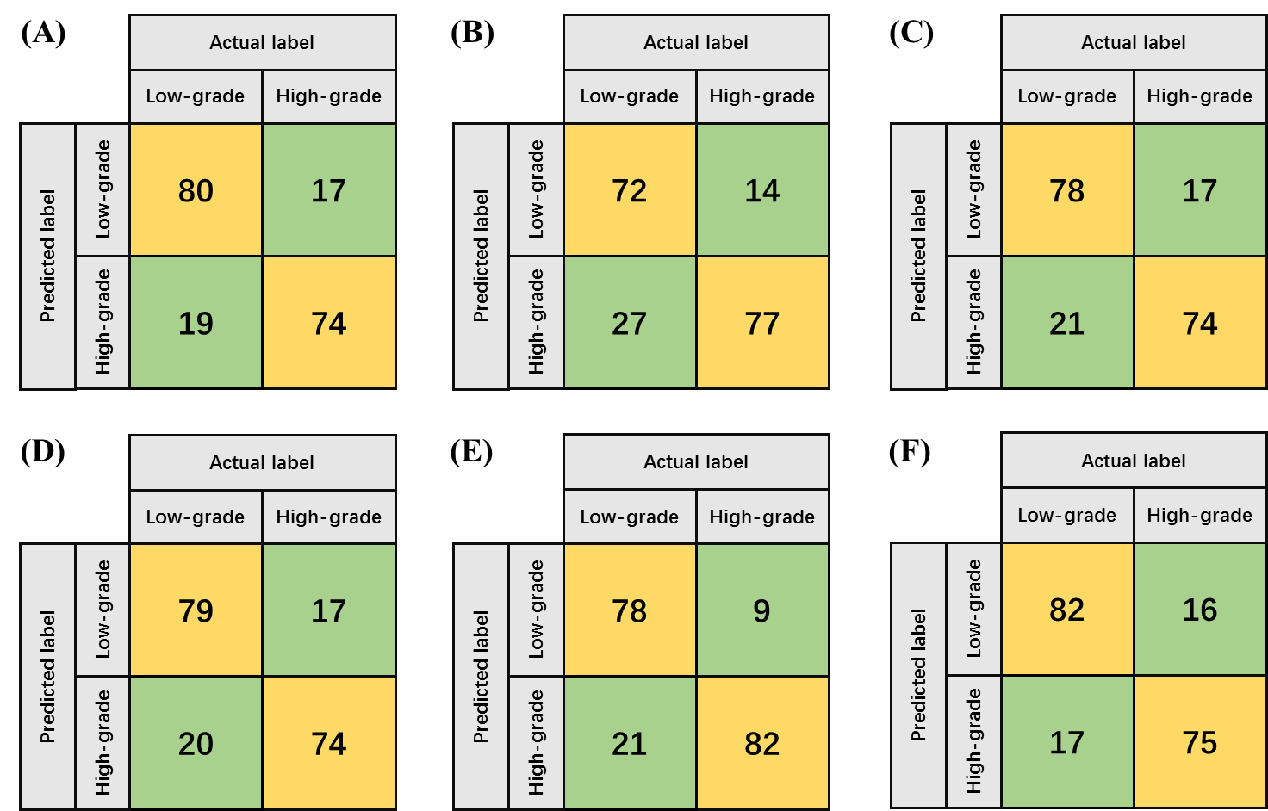
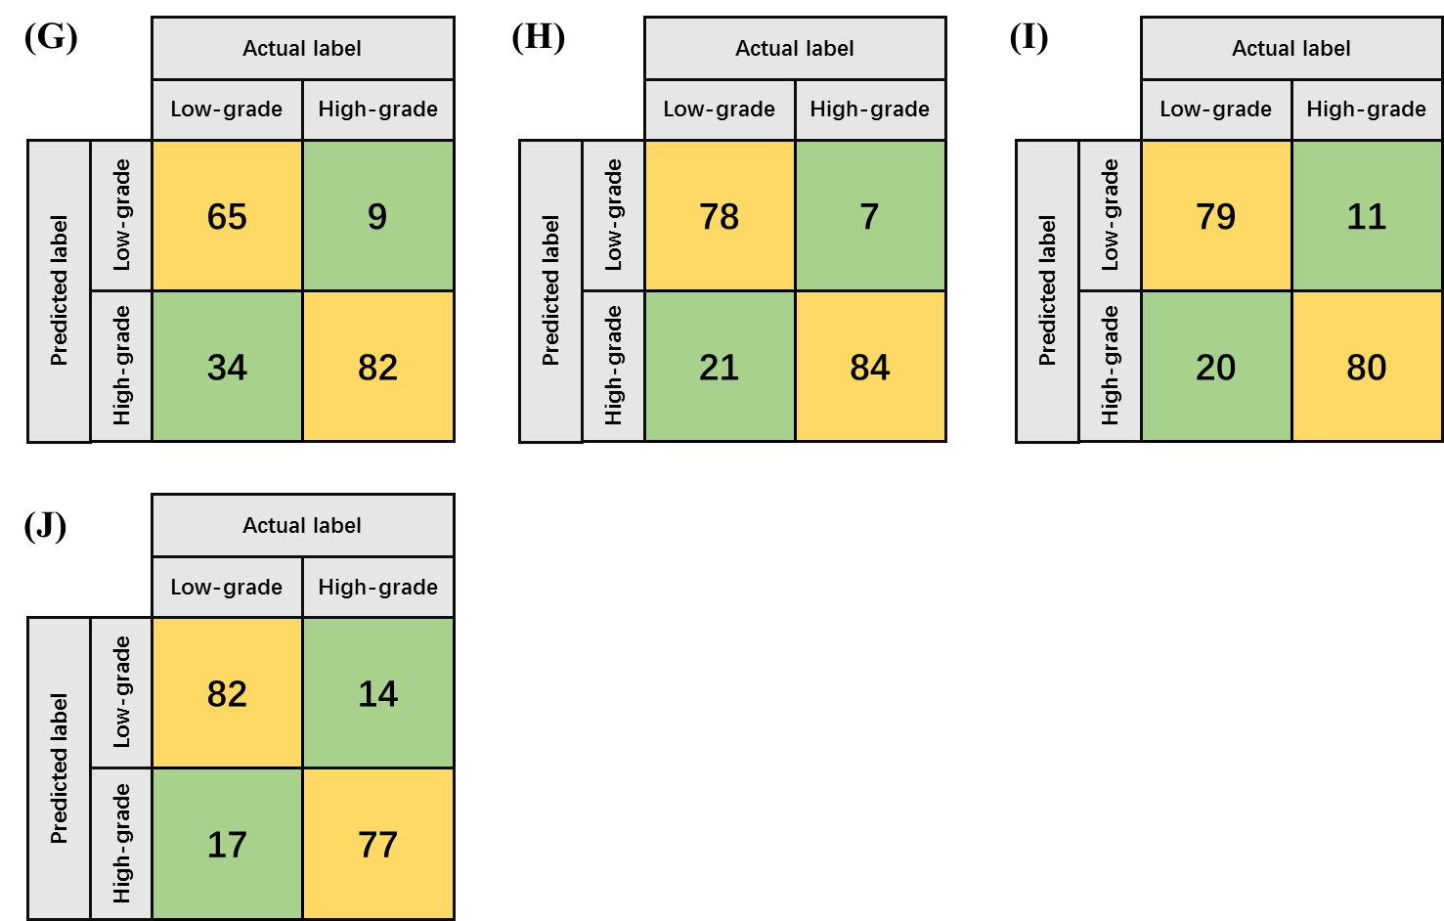

Figure S2. The Confusion Matrices of combined model in testing cohorts for the random splitting process of 10-times runs.

