ELECTRONIC SUPPLEMENTARY MATERIAL

Changes of radiological examination volumes over the course of the COVID-19 pandemic. Analyzing the waves.

Figure S1: LOESS estimate for the development of median age over the study period, along with 95% CI. Median age was higher in the first two waves of the pandemic when compared to previous years.
Wave 1: 16-03-2020 – 19-04-2020; Wave 2: 11-12-2020 – 29-01-2021; Wave 3: 21-04-2021 – 31-05-2021; CI: confidence interval; LOESS: locally weighted scatterplot smoothing.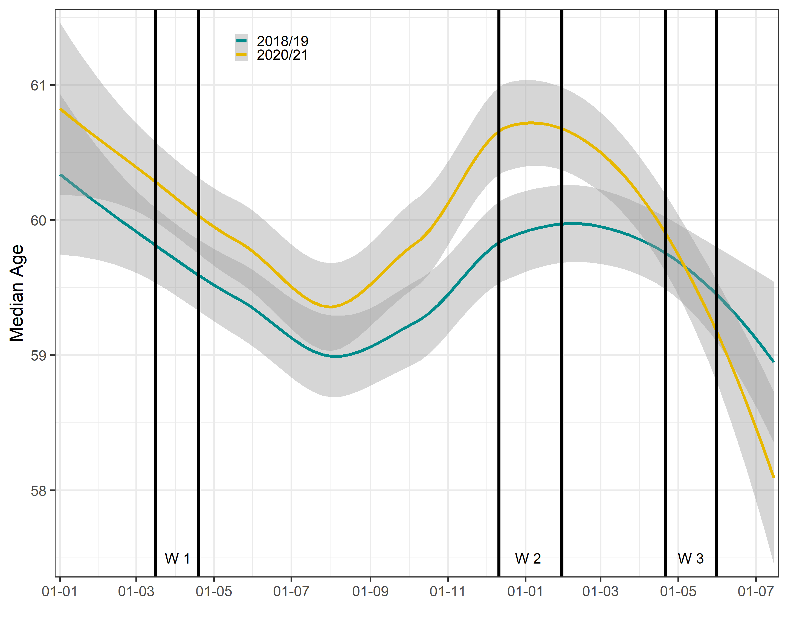

Figure S2: LOESS estimate for the development of the ratio men/women over the study period, along with 95% CI. It shows a higher ratio during all waves as compared to the inter-year control period.
Wave 1: 16-03-2020 – 19-04-2020; Wave 2: 11-12-2020 – 29-01-2021; Wave 3: 21-04-2021 – 31-05-2021; CI: confidence interval; LOESS: locally weighted scatterplot smoothing.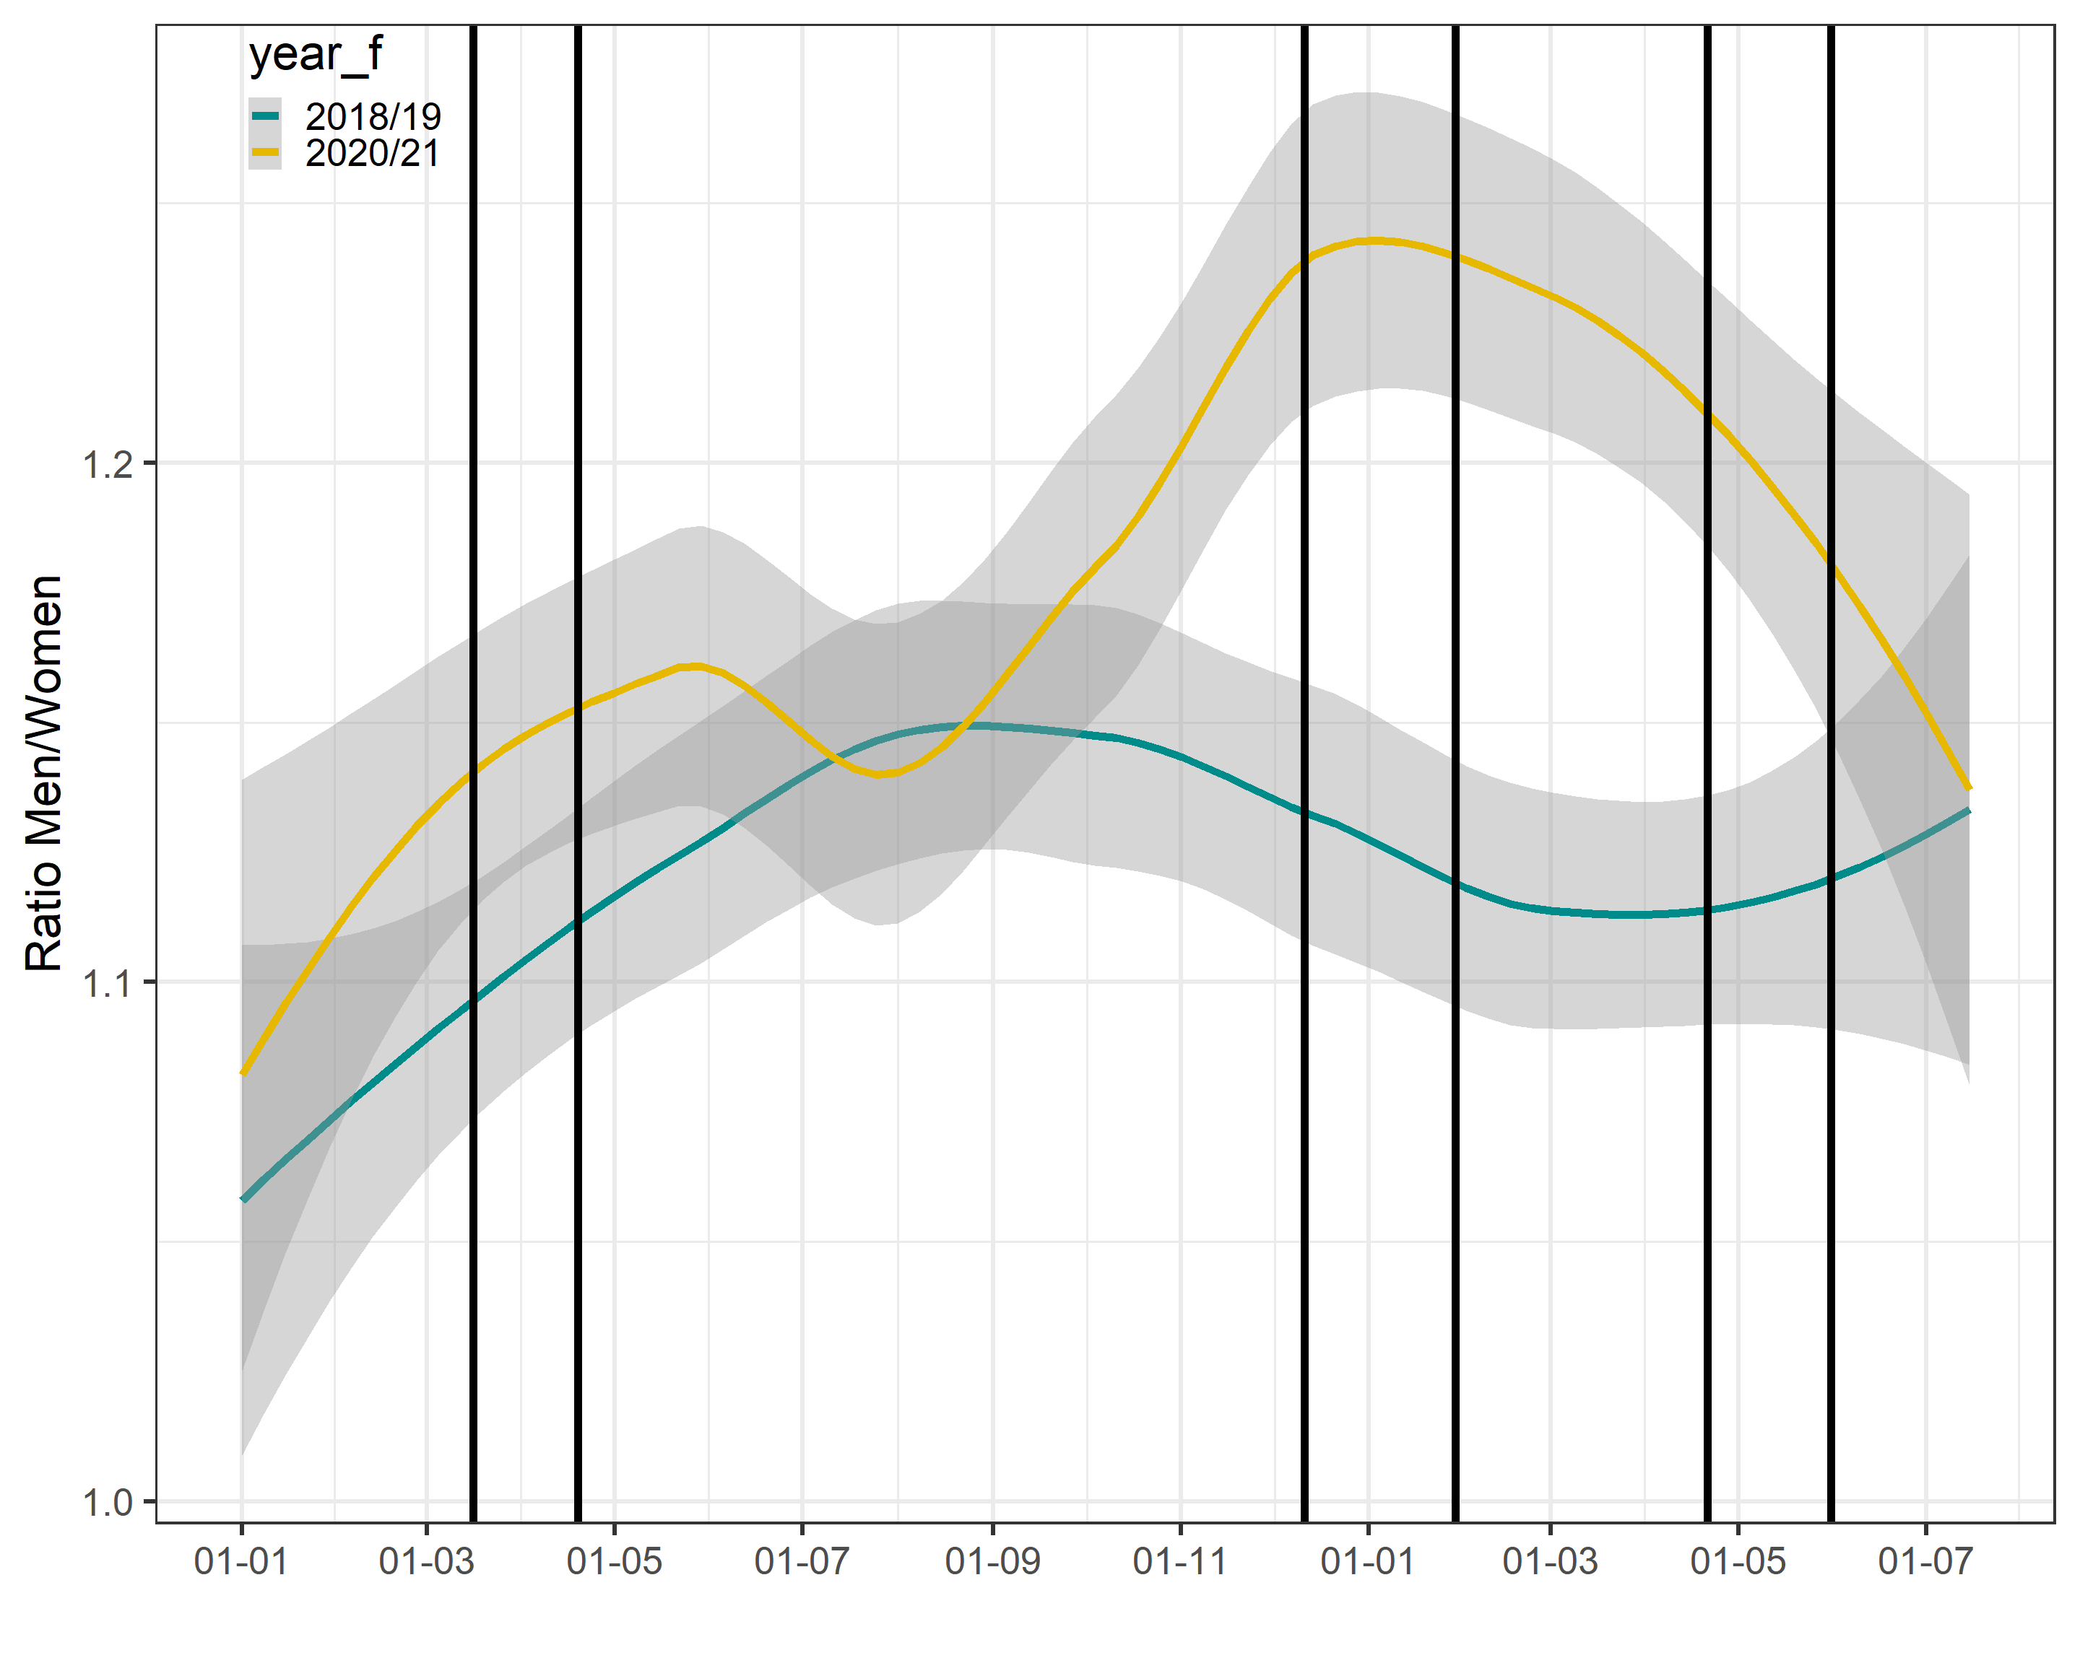

Figure S3: Incidence Rate Ratios stratified by regular working hours vs. night shift / weekend / holiday for inter- and intra-year comparison of the study periods, along with 95% CI, derived from the negative binominal regression. Additional analyses stratified by regular working hours compared to night shifts, weekends or holidays, shows confirm the trend of higher examination volumes in latter infection waves.
(CI: confidence intervals).

