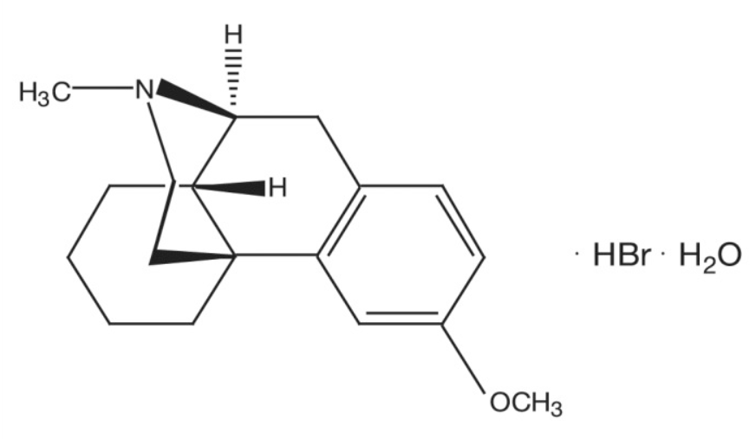
Supplementary Information

Figure 2 – Structural formula of dextromethorphan¹⁵
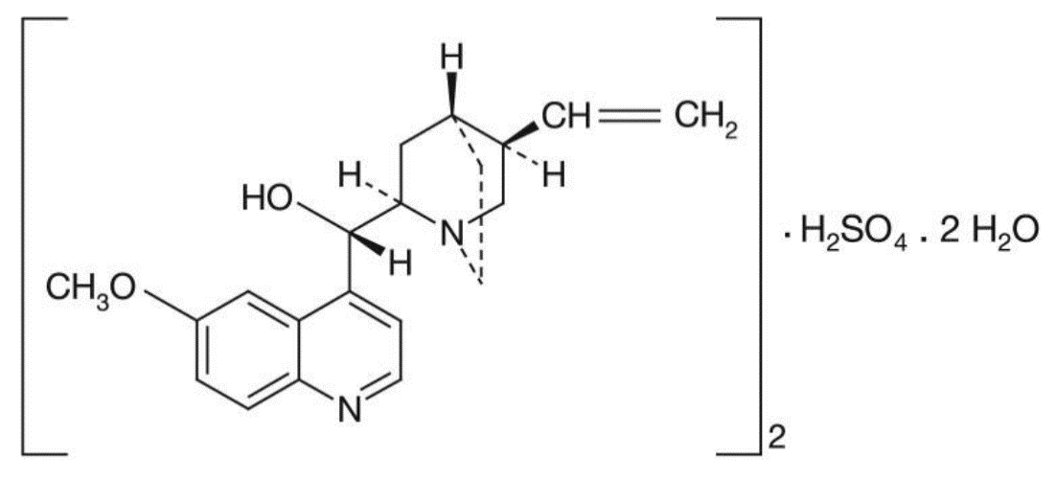

Figure 3 – Structural formula of quinidine sulfate¹⁶

Past Medical History | Past Surgical History
Pseudobulbar affect (PBA) | Craniotomy & partial brain resection
Essential hypertension | Appendectomy
Hyperlipidemia | Tracheostomy
Cerebrovascular disease | Cholecystectomy
Obesity (BMI 40 - 44.9)
Major Depressive Disorder
Hypothyroidism
Gout
Nuedexta 30mg PO BID | Coreg 12.5mg PO BID
Amitriptyline hydrochloride 100mg PO QHS | HCTZ-Lisinopril 25mg-20mg PO QD
Amlodipine besylate 10mg PO QD | Levothyroxine sodium 0.112mg PO QD
Atorvastatin calcium 40mg PO QHS
Patient information at start of DM/Q pharmacotherapy
Table 1 – Concurrent Medications
Table 2 – History

¹⁶ National Center for Biotechnology Information. PubChem Database. Quinidine sulphate, CID=441326, https://pubchem.ncbi.nlm.nih.gov/compound/Quinidine-sulphate (accessed on May 27, 2020)
¹⁷ Haiman, Guy, Hillel Pratt, and Ariel Miller. "Brain responses to verbal stimuli among multiple sclerosis patients with pseudobulbar affect." Journal of the neurological sciences 271.1-2 (2008): 137-147.

