Figures

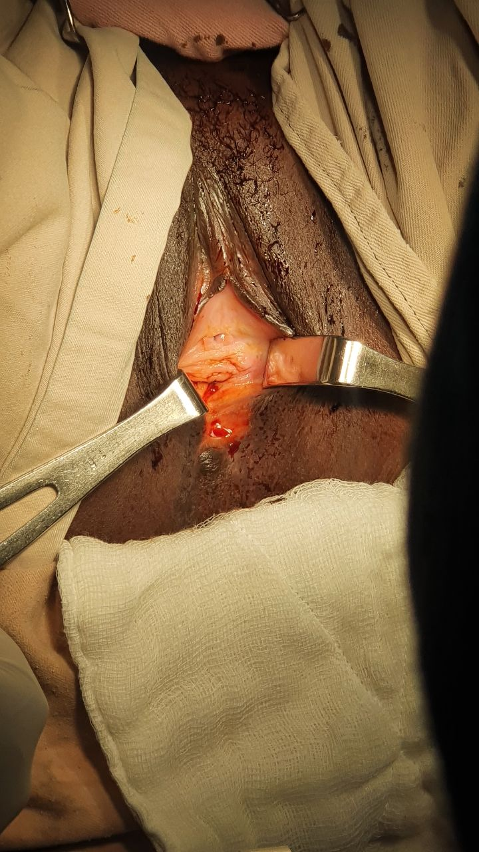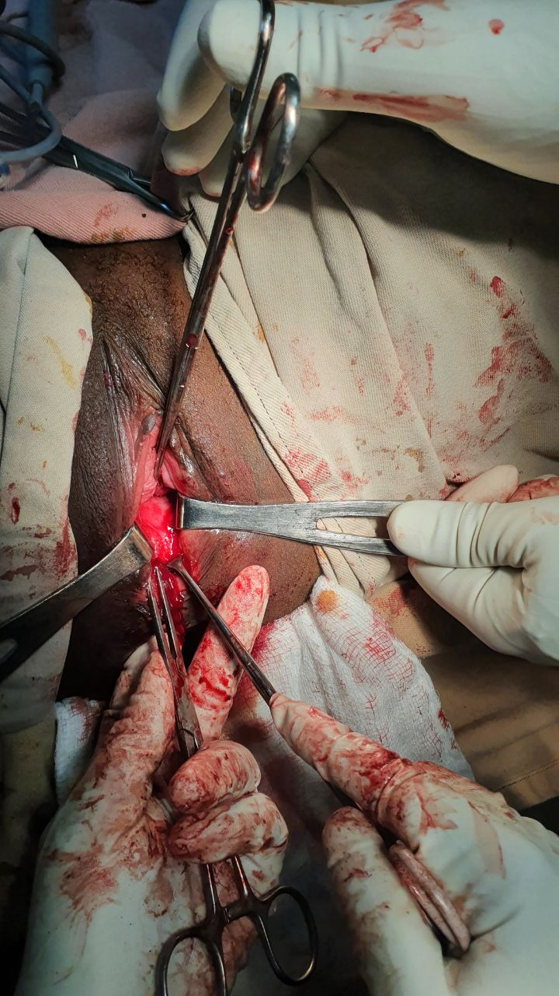
figure1- s1(A & B): A closed lower third of vagina with thick inflammatory scar before the procedure and a successfully reconstructed vagina(accommodated 2 fingers) after adhesion excision

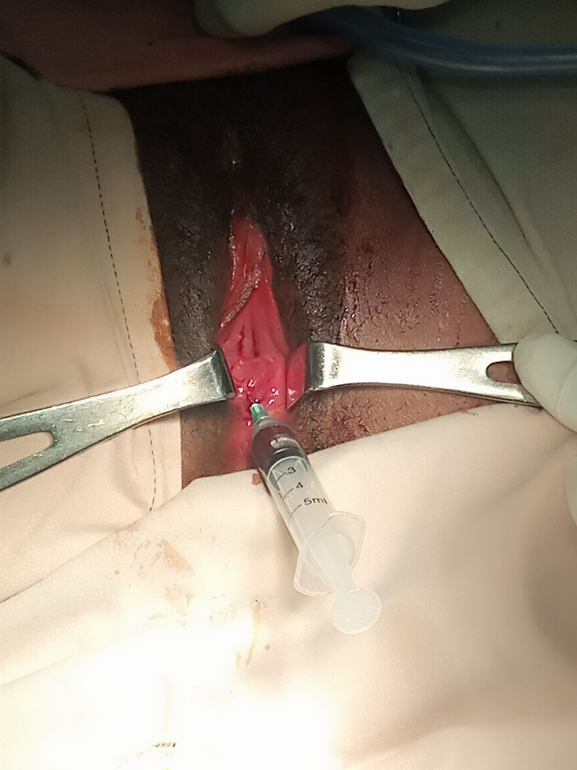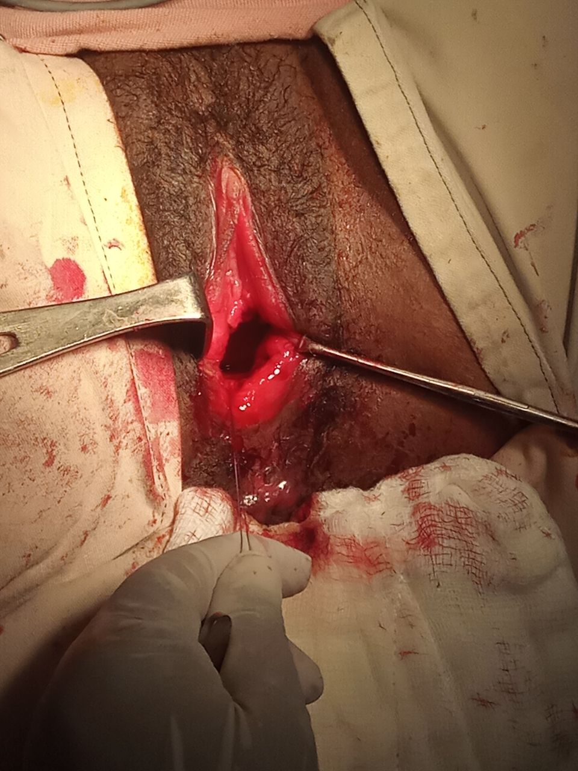
Figure1-S2(A &B): Note a totally closed vaginal introitus before the procedure and a successfully reconstructed vagina (accommodated 2 fingers) after adhesion excision

