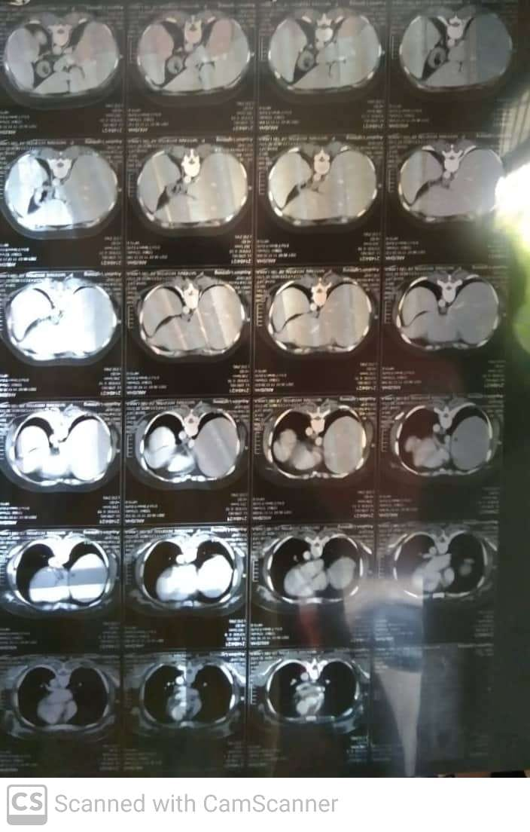

Supplementary Figure 1. Hepatosplenomegaly

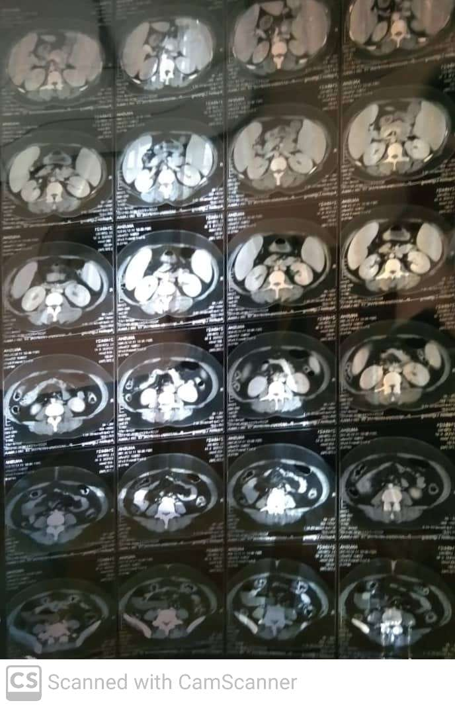

Supplementary Figure 2. Abdomen

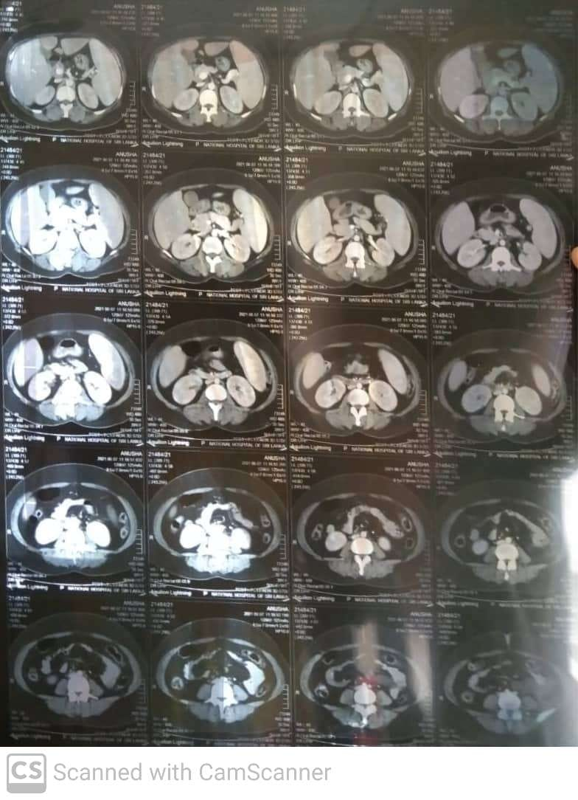

Supplementary Figure 3. Abdomen
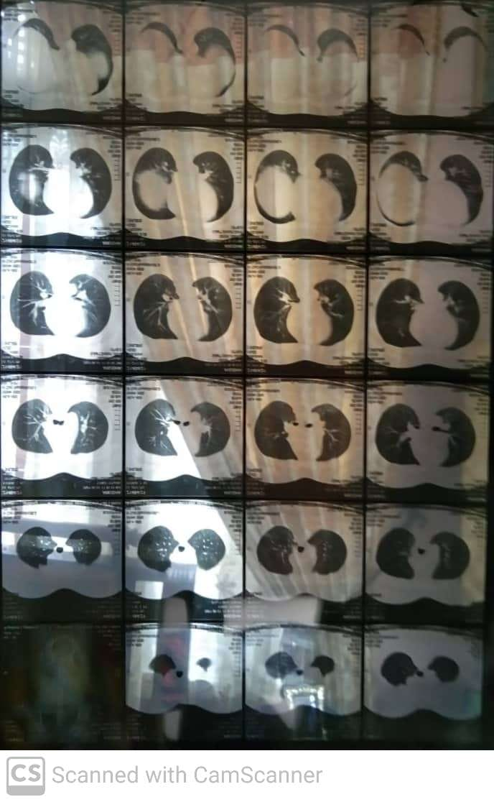

Supplementary Figure 4. Chest
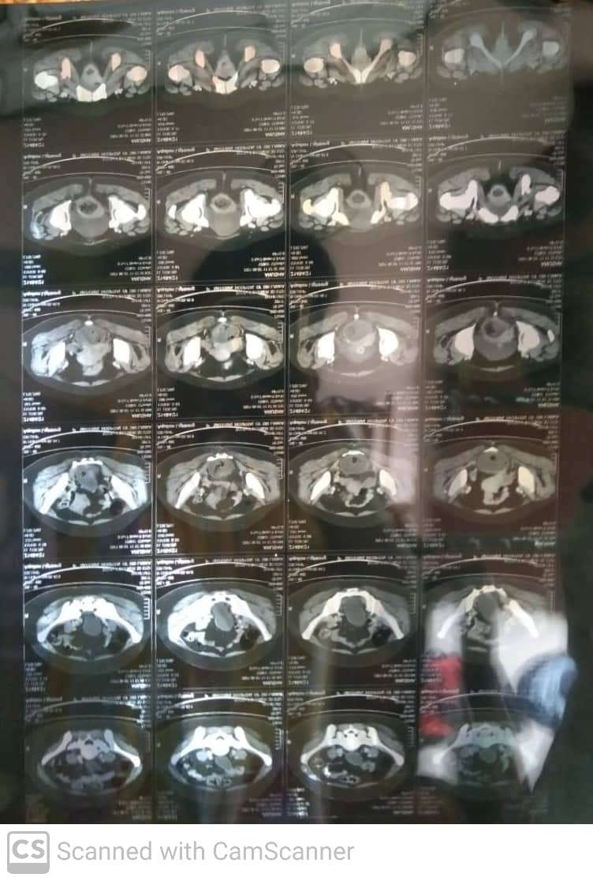

Supplementary Figure 5. Pelvis

