Figures S1 (a-f). Magnetic Resonance Imaging images (MRI) before and after tumor resection. (a-c) Evidence of a large heterogeneous structure measuring about 50 x 51 x 55 ‎mm in cerebellum, high-intense in T2 and iso- to low-intense in T1 with cystic change ‎with compression effect over 4th ventricle with enhancement and restricted in ‎DWI, suggestive of medulloblastoma (a: Flair, b: TW1, and c: TW2, respectively). (d-f) Corresponding MR images 25 weeks after treatment. Evidence of post-op change including occipital craniotomy and ‎also encephalomalacia is noted in anterior medial aspect of ‎occipital lobe and medial aspect of right cerebellar hemisphere.

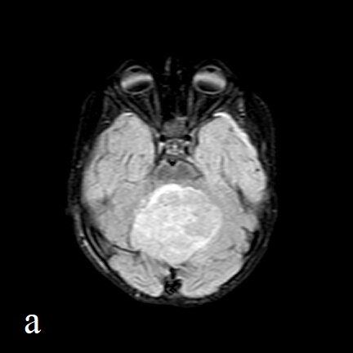

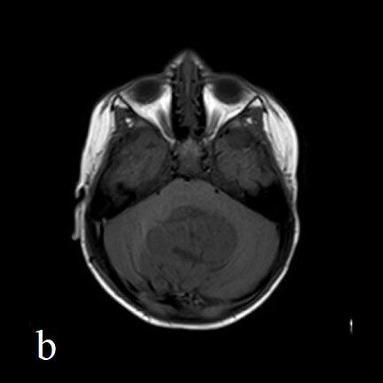

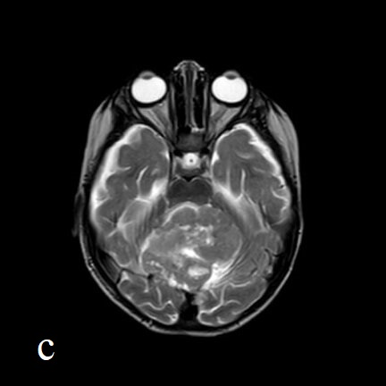

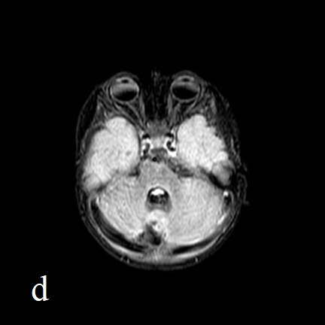

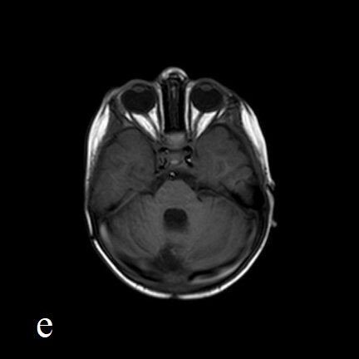

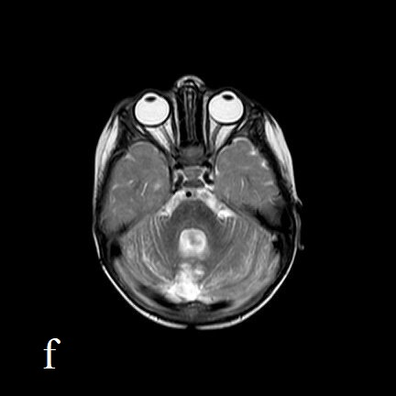

Figures S2 (a-i). Full-thickness skin defect at the surgical site of medulloblastoma in a 25-month-old girl. The wound was developed secondary to the opening of surgical skin sutures. Serial images show the gradual wound healing during treatment with Taurolock. The patient did not use oral antibiotics due to oral intolerance, and the purulent discharge of the wound improved with daily local Taurolock use which was applied by topical gel 2% on the wound.

