Figure 1: Initial 24-hour urine protein level
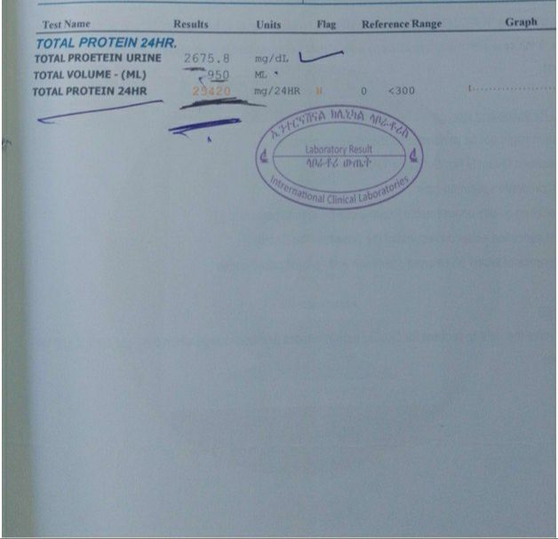

Figure 2: 24 hour urine protein -after 3 months of treatment
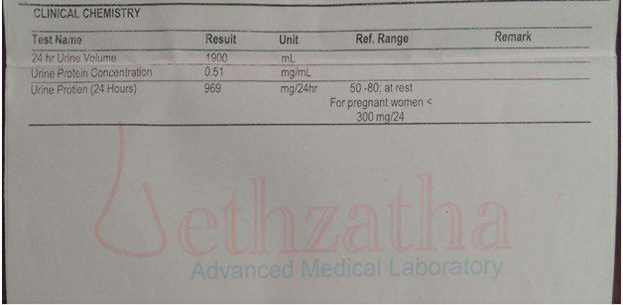

Figure 3:24 hour urine protein after 4 months of treatment
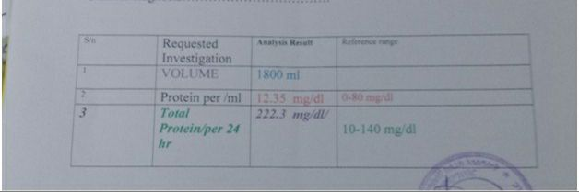

Figure 4: Renal biopsy; gross and microscopic description
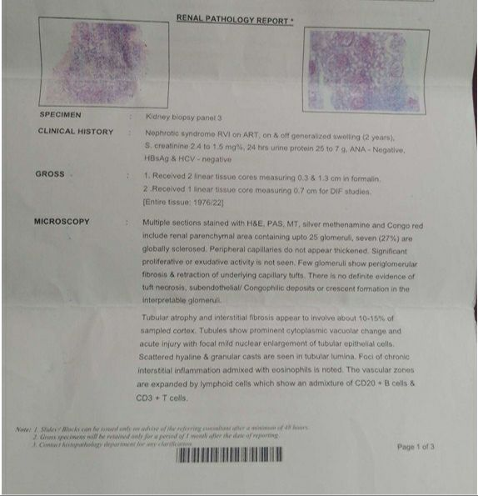

Figure 5: Renal biopsy; light microscopy and direct IF studies
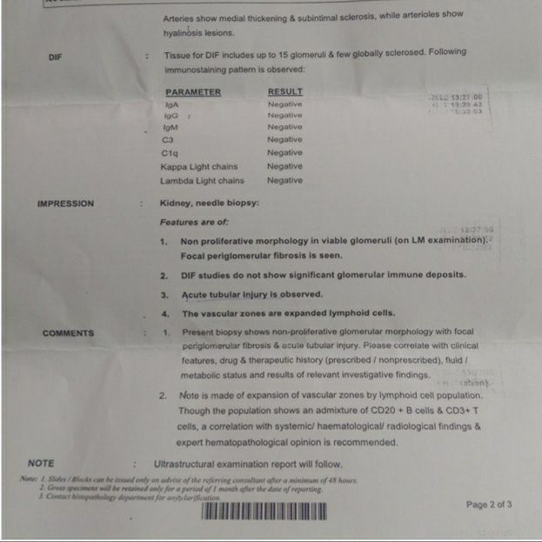

Figure 6: Renal biopsy; electron microscopy
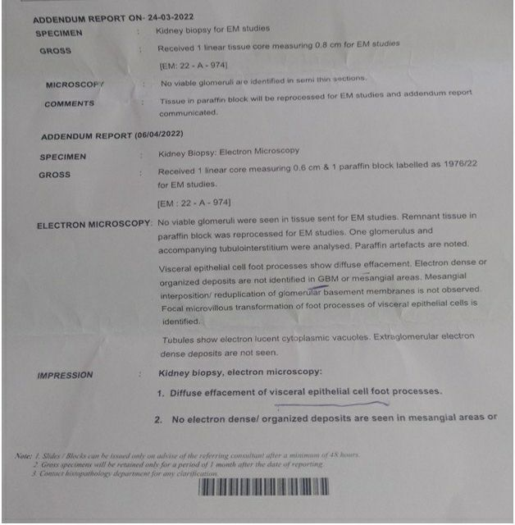

Figure 7: Renal biopsy; final conclusion
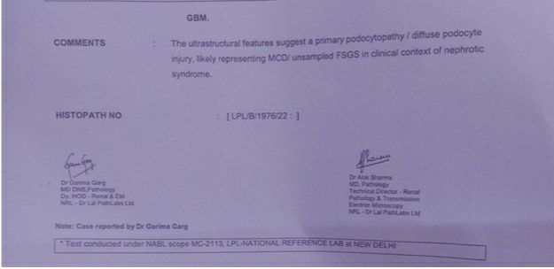

Table 1: Investigation Summary
Investigations | Baseline | After 3 months of Therapy | After 4 months of Therapy
Urinalysis | +4 proteinuria | +3 proteinuria | +1 proteinuria
24hr urine protein | 25.42gm/dl | 969mg/dl | 222.3mg/dl
Creatinine | 2.4mg/dl | 1.7mg//dl | 0.9mg/dl
Albumin | 1.8g/dl | 2.5g/dl | 3.7g/dl
Renal Biopsy | Minimal Change Disease/Unsampled FSGS

