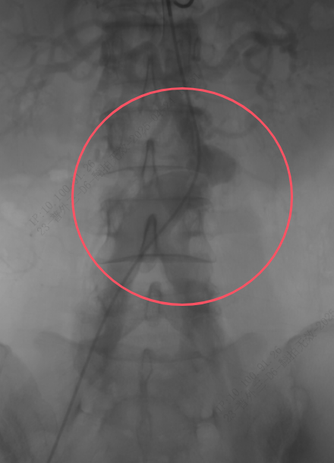
The distal abdominal aorta showed luminal stenosis, with aneurysmal dilation of the distal lumen and the right common iliac artery.

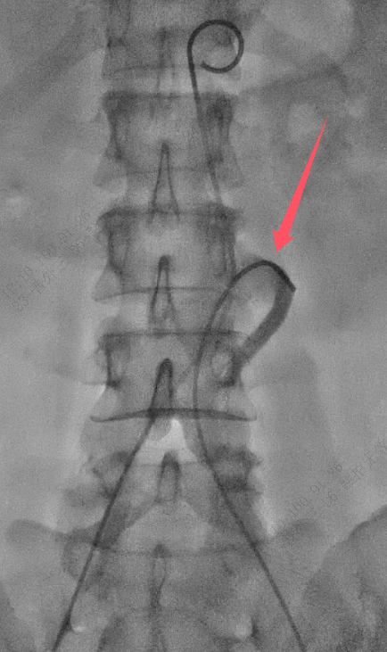
Super-selectively catheterize the inferior mesenteric artery and insert a single-curve catheter.

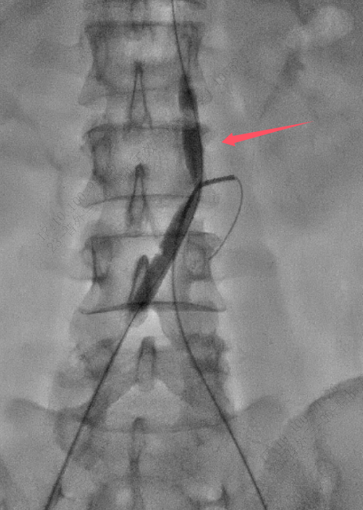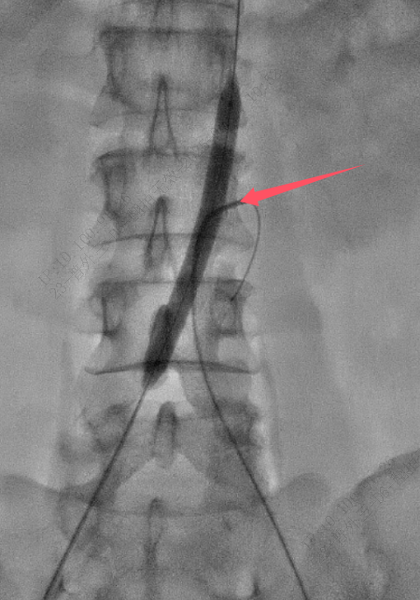

An 8 mm × 80 mm balloon (Mustang, Boston Scientific) was used to pre-dilate the stenotic segment of the abdominal aorta.
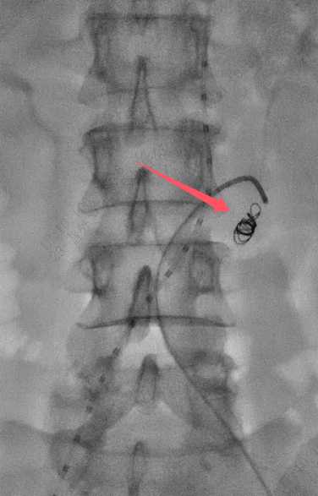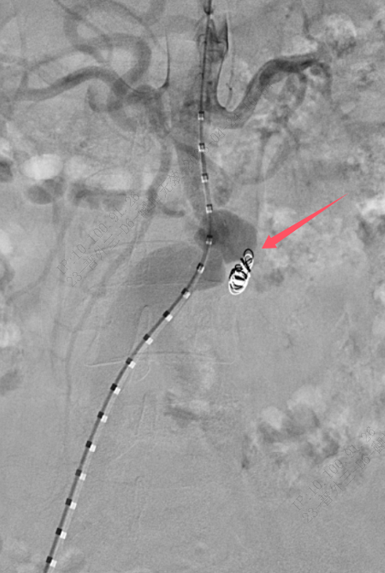
"One 6 mm × 20 cm coil (Interlock, Boston Scientific) was used to embolize the inferior mesenteric artery."
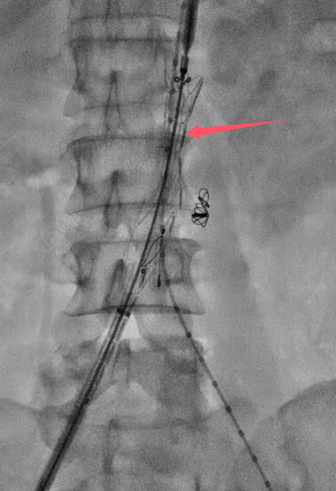
A main stent (G-iliac™: LifeTech IB-1412-060-13) was deployed via the right femoral artery approach.

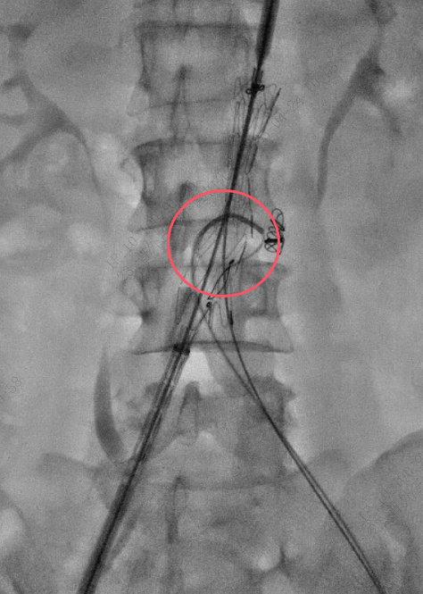
After the main stent was deployed, a single-curve catheter was pre-positioned (or pre-placed).
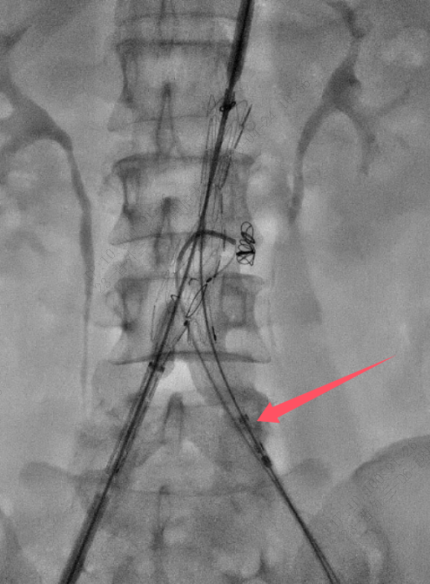
A branch stent (SilverFlow™: LifeTech PS-C-10060-XL) was introduced from the left side.

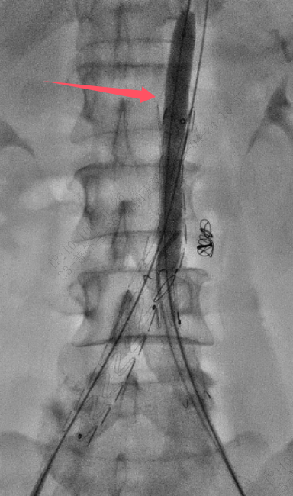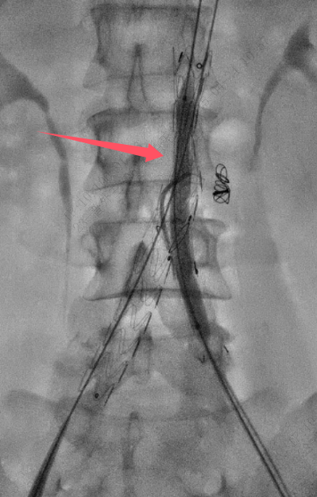
A 10 mm × 80 mm balloon (Mustang) was used to dilate the proximal and distal portions of the stent overlap zone to increase the luminal diameter.

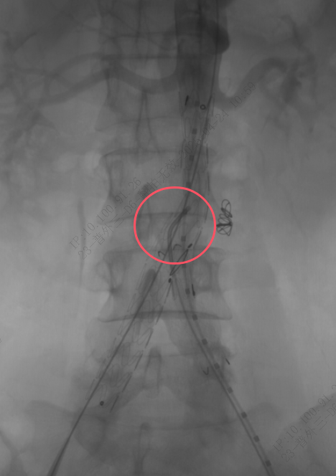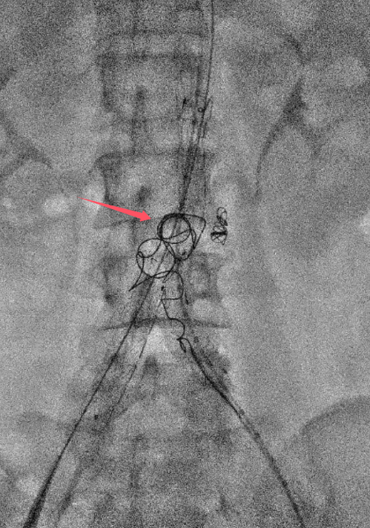
Insert a 15mm × 40cm coil into the aneurysm sac to prevent long-term type II leakage

