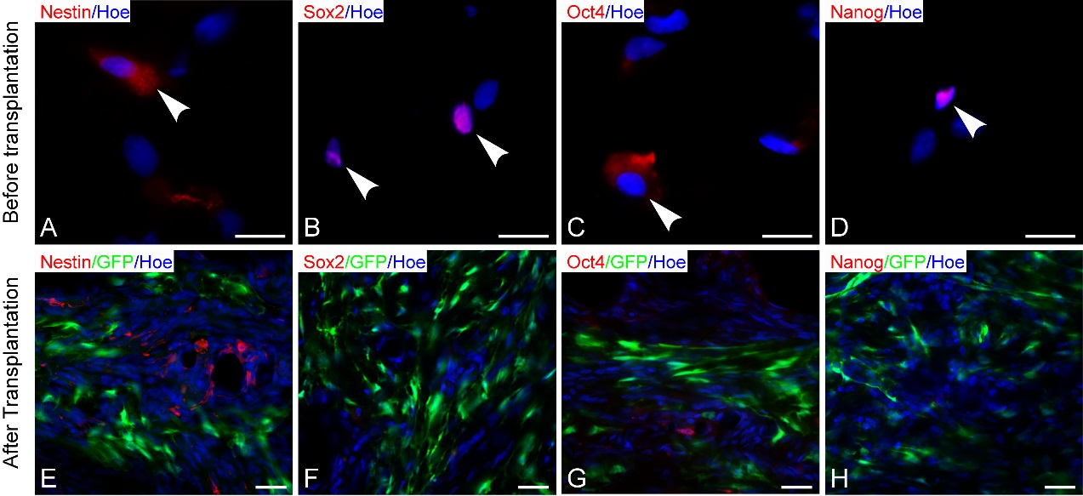
Additional figure 3. The pluripotency marker expression was displayed before or
after differentiated MSCs were transplanted. (A-D) Show that expression of the
pluripotency markers, namely, Nestin, Sox2, Oct4 and Nanog expression in the
MSCs of the MN+MT group after genetically modified MSCs were cultured in
3D GS scaffold for 14 days. (E-H) Differentiated MSCs lost the expression of
pluripotency markers after they being transplanted into injured spinal cord at 8
weeks. Scale bars = 20 μm in (A-D), 40 μm in (E-F).

