(A.i) DAPI | (A.ii) CD31 | (A.iii) vWF | (A.iv) MERGE
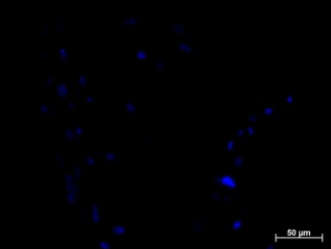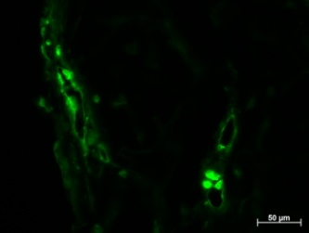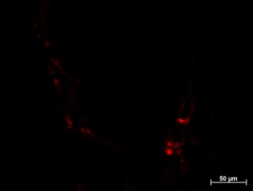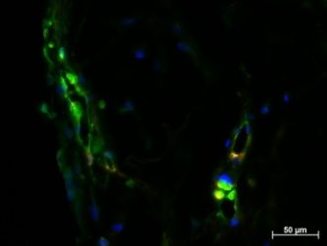
HAMECs:MSCs
Lumens
Lumens
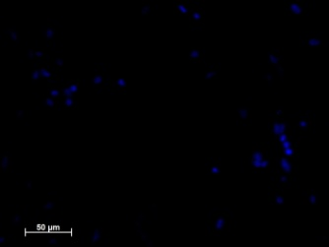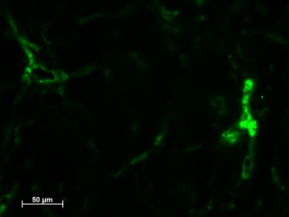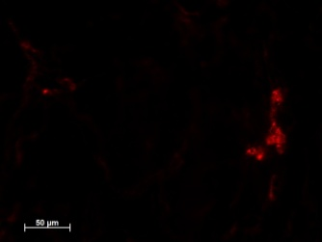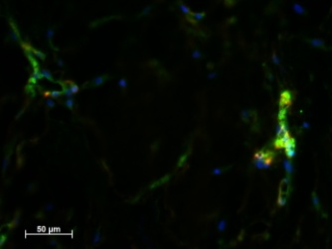
Lumens
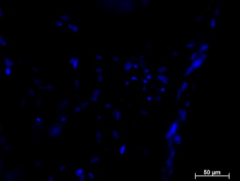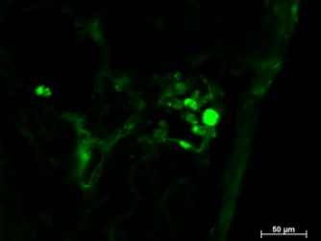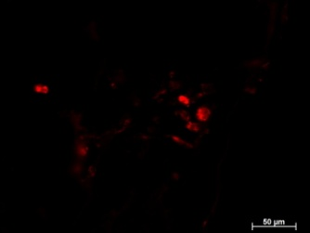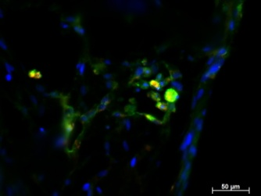
HUVECs:HNDFs
Lumens
Lumens
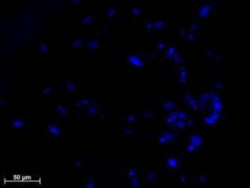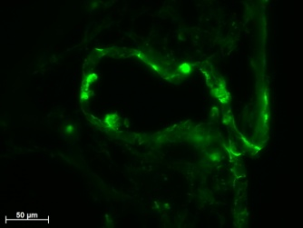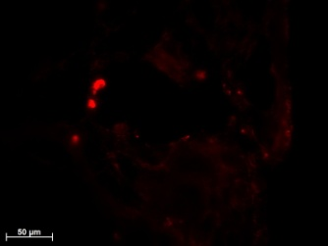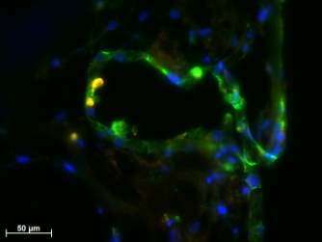
Lumens
Additional Figure 2. CD31 vs. vWF distribution in ECs of different origins. (A.i) Paraffin-embedded sections (5µm) of HAMECs:MSCs and HUVECs:HNDFs cultured for 7 days on PLLA/PLGA scaffolds, were stained for DAPI (blue); (A.ii) vWF (Red) and (A.iii) CD31 (Green) (Bar=50μm). (A.iv) A merged image of the DAPI, vWF and CD31 staining is presented (Bar=50μm). Lumens are pointed with white arrows.

