Supplementary Materials for
Human amnion cells reverse acute and chronic pulmonary damage in experimental neonatal lung injury
Dandan Zhu, Jean Tan, Amina S. Maleken, Ruth Muljadi, Siow T. Chan, Sin N. Lau, Kirstin Elgass, Bryan Leaw, Joanne Mockler, Daniel Chambers, Kristen T. Leeman, Carla F. Kim, Euan M. Wallace, Rebecca Lim*
*Corresponding author Email: Rebecca.lim@hudson.org.au

This File includes:
Figure. S1. Representative images of lung structure on PND7 as shown by H&E staining.
Figure. S2. Representative images of pro-SPC and CC10 immunofluorescent staining on mouse lung tissues.
Figure. S3. BASCs and AT2s in vitro culture.

Supplementary Figures
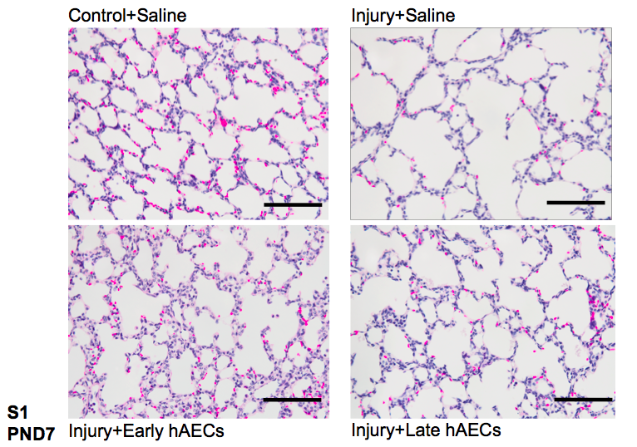
S1: Representative images of lung structure on PND7 as shown by H&E staining. Scale bar = 200μm

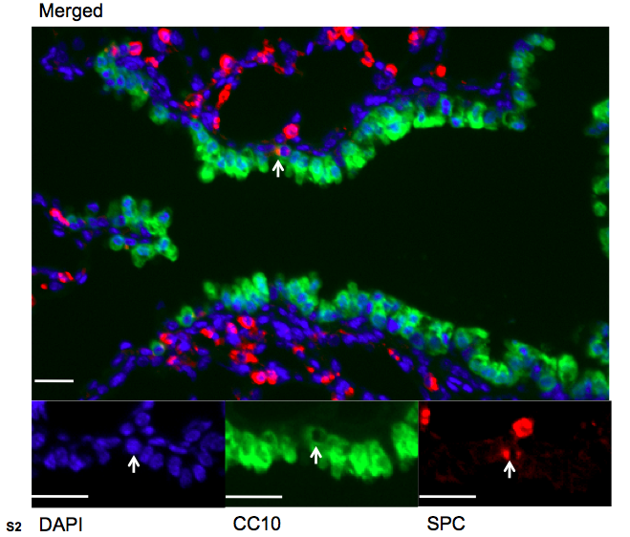
S2: Representative images of pro-SPC and CC10 immunofluorescent staining on mouse lung tissues. Arrows indicate BASCs (scale bars = 20μm).

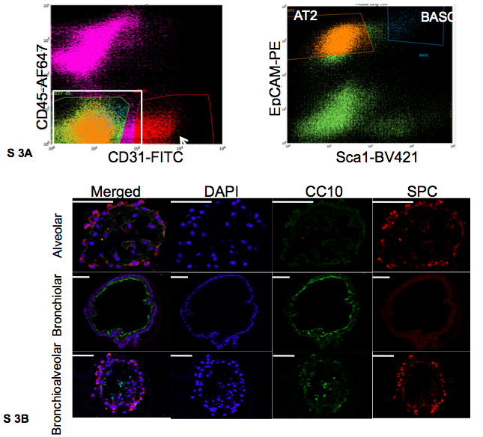
S3: BASCs and AT2s in vitro culture. (A) Representative FACS gates for BASCs and AT2s are provided where BASCs are CD45^{neg}CD31^{neg}Sca-1^{pos}EpCAM^{pos}, and AT2s are CD45^{neg}CD31^{neg}Sca-1^{neg}EpCAM^{pos}. (B) Representative images of pro-SPC and CC10 immunohistochemical staining on the alveolar, bronchiolar and bronchioalveolar organoids. Scale Bar=50μm.

