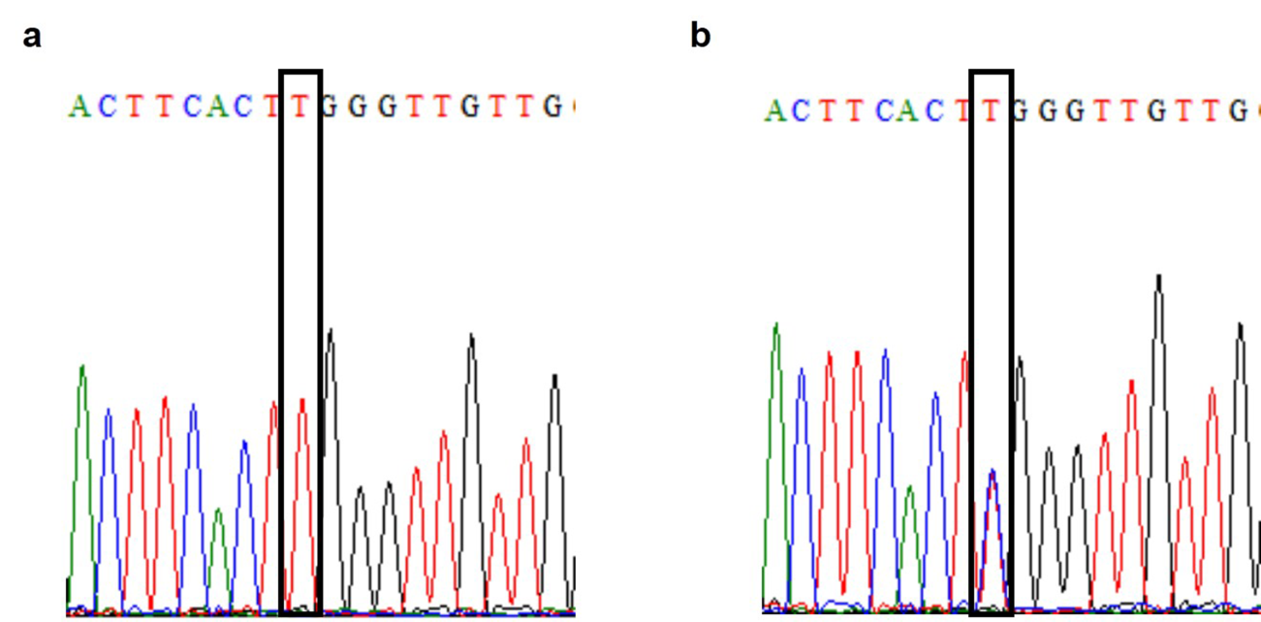Additional file 3: Figure S1. The sequencing results of the parental and inserted iPSCs. a. The parental iPSCs has a known mutation of F9 gene: c.676C>T, p.Arg226Trp. b. The inserted iPSCs (colony 5) has a heterozygous mutation of c.676C>T, p.Arg226Trp.

