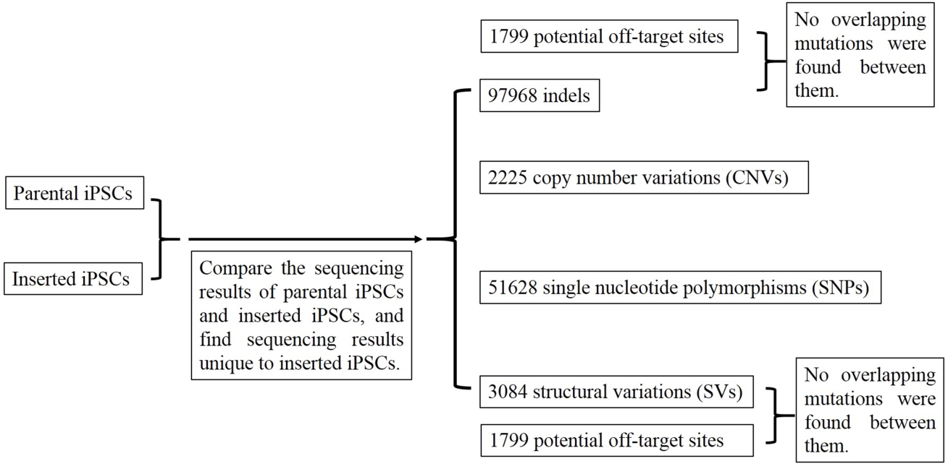Additional file 6: Figure S3. Off-target effects detection in the successful inserted iPSCs. Using Cas-OFFinder, 1799 potential off-target sites that differed from the sgRNA sequence by up to five nucleotides in the genome were found. We found 97968 indels, 3084 structural variations (SVs), 51628 single nucleotide polymorphisms (SNPs), and 2225 copy number variations (CNVs) unique to the inserted iPSCs compared to that in the parental iPSCs. Since indels and SVs comprise virtually all of the mutations introduced by CRISPR/Cas9, we focused solely on indels and SVs. Through comparison of potential off-target sites, and indels and SVs unique to the inserted iPSCs, we did not find any overlapping mutation between them.

