Additional file 1
Figures
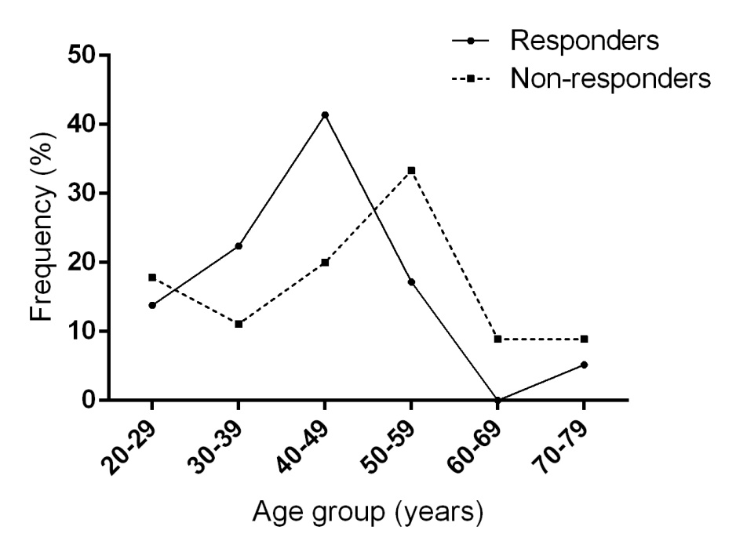
Figure S1. Frequency plots with connecting lines showing the distribution trends of age in the responders and non-responders, respectively.

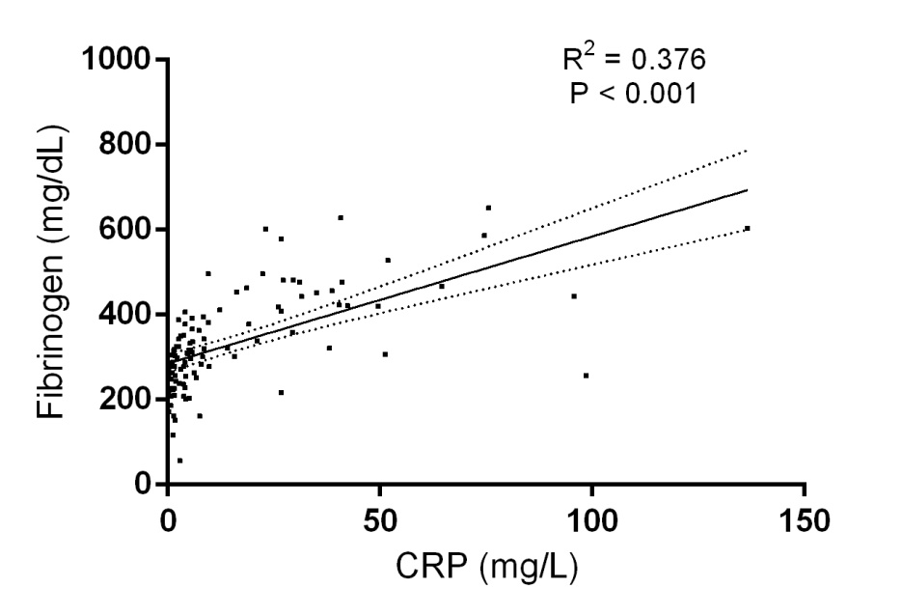
Figure S2. Linear regression plot with the fitting line and standard error bars showing relationship between the value of fibrinogen and CRP (R² = 0.711, P<0.001).
CRP: C-reaction protein

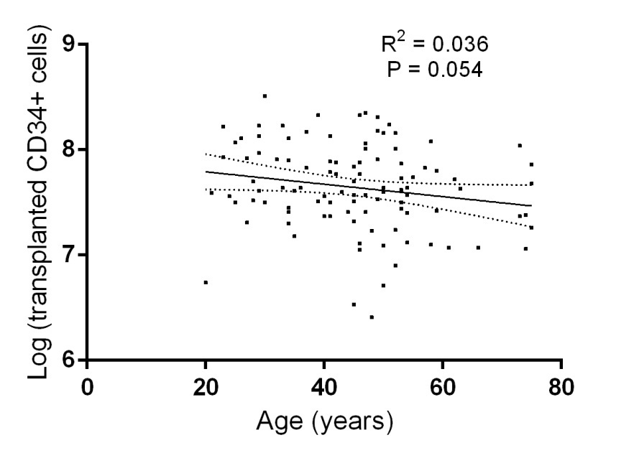
Figure S3. Linear regressionplot with the fitting line and standard error bars showing relationship between the ageand Log (transplanted CD34⁺ cells) (R² = 0.036, P=0.054).

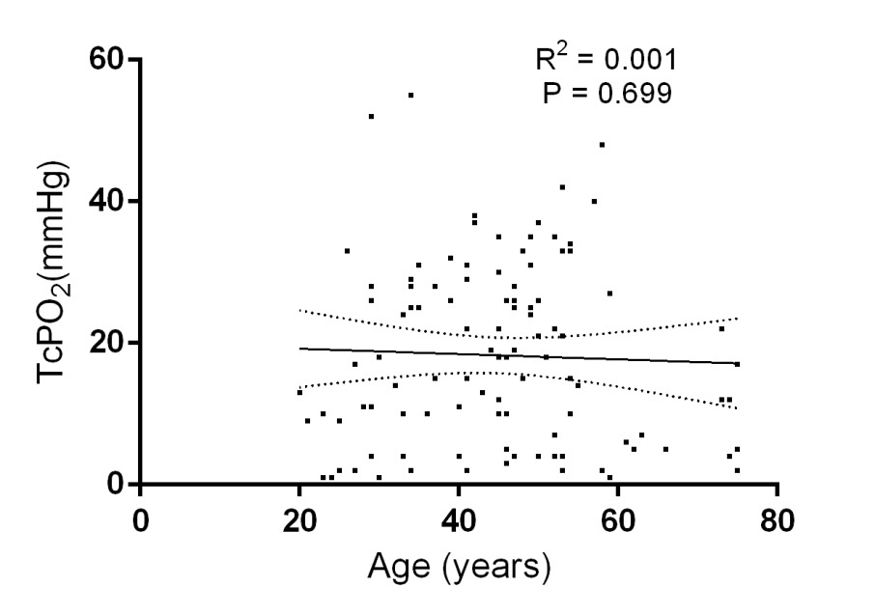
Figure S4. Linear regression plot with the fitting line and standard error bars showing relationship between the ageand TcPO₂ (R² = 0.001, P=0.699).

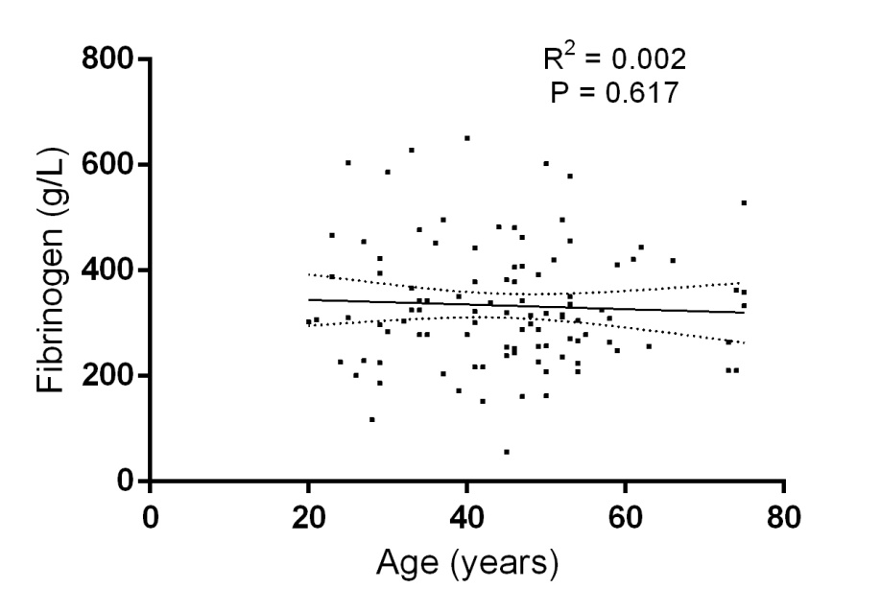
Figure S5. Linear regression plot with the fitting line and standard error bars showing relationship between the ageand fibrinogen (R² = 0.002, P=0.617).

Table S1.Correlation between the age and the etiology of ASO
 | Etiology=ASO |  | χ2 | P value
 | Yes | No | χ2 | P value
Age < 50 years | 0 | 67 | 17.565 | <0.001
Age≥50 years | 10 | 26 | 17.565 | <0.001
ASO, arteriosclerotic obliterans

Table S2.Correlation between the age and the highest level of arterial occlusion
 | Highest level of arterial occlusion |  | χ2 | P value
 | above the knee/elbow | below the knee/elbow | χ2 | P value
Age < 50 years | 41 | 26 | 0.080 | 0.777
Age≥50 years | 21 | 15 | 0.080 | 0.777

Table S3. Multivariate logistic regression incorporating factor of C-reaction protein
Variable | Multivariate Analysis
Variable | OR (95% CI) | P value
Age≥50 years | 0.201 (0.069-0.589) | 0.003
CRP > 3mg/L | 0.293 (0.093-0.922) | 0.036
Arterial occlusion above the knee or elbow* | 0.190 (0.063-0.573) | 0.003
TcPO₂ (mmHg) | 1.050 (1.007-1.095) | 0.022
Log (total transplanted CD34+ cell counts)** | 3.677 (1.052-12.861) | 0.041
* defined as the highest occlusion level located at common iliac artery, external iliac artery, common femoral artery, superficial femoral artery, popliteal artery, axillary artery or brachial artery.
**Base-10 logarithm of total transplanted CD34⁺ cell counts
OR, odds ratio; CI, confidential interval; CRP, C-reaction protein; TcPO₂: transcutaneous pressure of oxygen; CD, cluster of differentiation

