Hsa-miR-335 regulates cardiac mesoderm and progenitor cell differentiation

Maryam Kayª, Bahram Mohammad Soltaniª*, Fahimeh Hosseini Aghdaeiª, Hassan Ansari^{b}, Hossein Baharvand^{b,c*}

a: Department of Genetics, Faculty of Biological Sciences, Tarbiat Modares University, Tehran, Iran
b: Department of Stem Cells and Developmental Biology, Cell Science Research Center, Royan Institute for Stem Cell Biology and Technology, ACECR, Tehran, Iran
c. Department of Developmental Biology, University of Science and Culture, Tehran, Iran
Email: Maryam_kay2001@yahoo.com, hoseiny6965@gmail.com, hassanansaritat@yahoo.com

*Correspondences:
Bahram M. Soltani, Department of Molecular Genetics, Faculty of Biological Sciences, Tarbiat Modares University, Tehran, Iran, 111-14115, Phone: +98-21-82884703, Fax: +98-21-82883463, Email: soltanib@modares.ac.ir
Hossein Baharvand, Royan Institute, Banihashem Sq., Banihashem St., Ressalat highway, Tehran, Iran. Postal Code: 1665659911, P.O. Box: 16635-148, Tel: +98 21 22306485, Fax: +98 21 23562507 ; E-Mail: Baharvand@RoyanInstitute.org

A
B

Figure S1) RT-qPCR results of C-MYC and CCND1 after mimics and siRNA treatment for miR-335-3p (A) and miR-335-5p (B). All experiments were done in three biological replicates and presented as mean ± SEM.

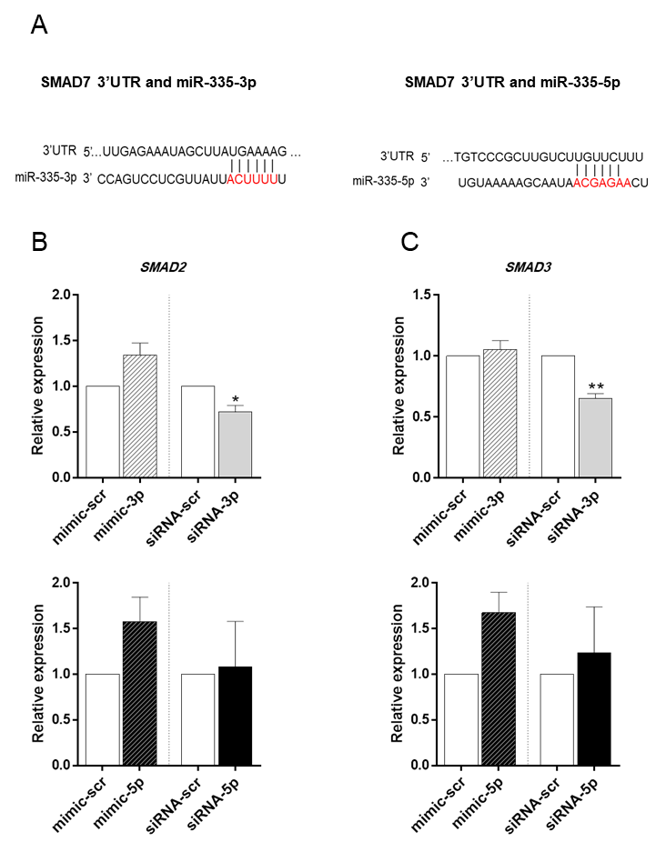

Figure S2) RT-qPCR results of SMAD2 and SMAD3 expression. A) Pairing status of miR-335-3p (left) and miR-335-5p (right), with 3'UTR of SMAD7 gene. B) SMAD2 expression was not significantly changed followed by miR-335-3p (TOP) and miR-335-5p (bottom) overexpression. C) RT-qPCR data also showed no significant alterations in SMAD3 expression following miR-335-3p (TOP) and miR-335-5p (bottom) overexpression. All data are presented as mean ± SEM normalized against mimic-scr and siRNA-scr. GAPDH was used as a housekeeping gene.

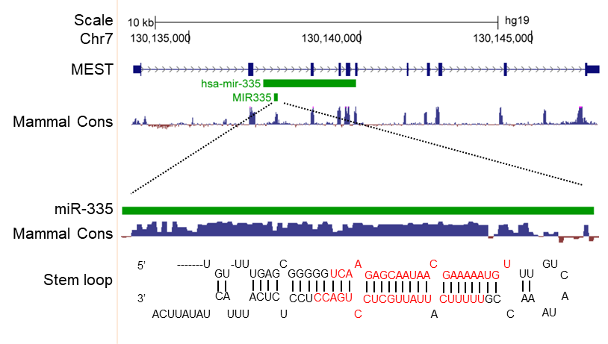

Figure S3) Genomic location of mir-335 presented in UCSC genome bowser. miR-335 is located within the second intron of MEST gene, containing two conserved mature miRNAs (highlighted in red) including miR-335-3p and miR-335-5p.

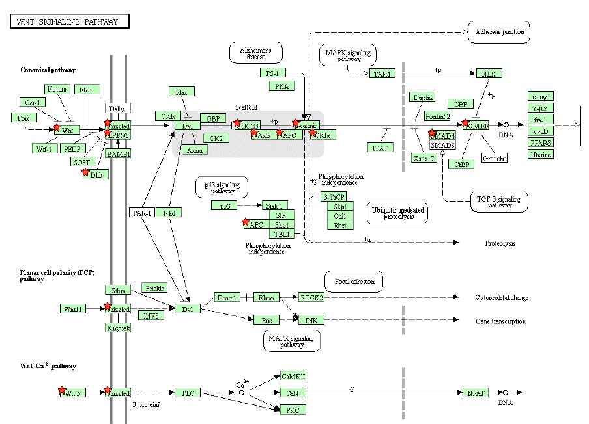
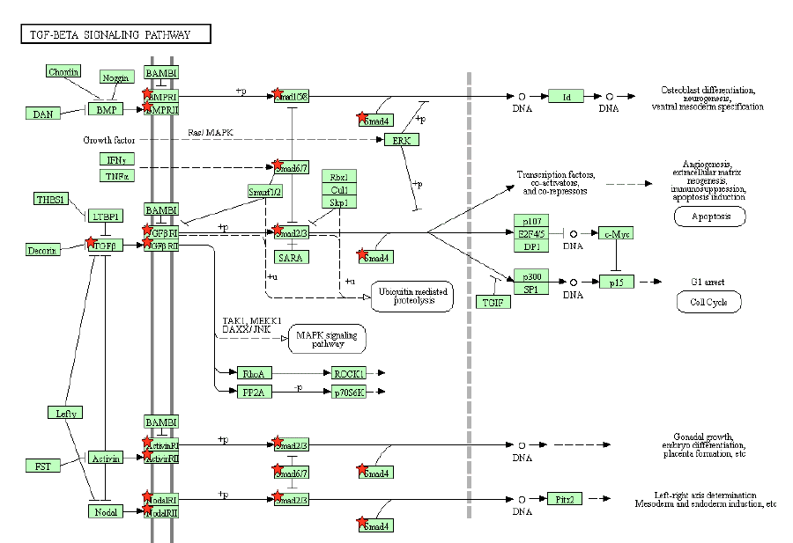
A
B

Figure S4) The potential targets of miR-335 in TGFβ (A) and WNT (B) signaling pathways according to the KEGG pathway. The target genes are marked with red stars.

Table S1) Primer sequences used in this research.
Primer name | sequence
NANOG | Forward: AAAGAATCTTCACCTATGCC  Reverse: GAAGGAAGAGGAGAGACAGT
BRACHYURY | Forward: AATTGGTCCAGCCTTGGAAT  Reverse: CGTTGCTCACAGACCACA
MESP1 | Forward: ACCTTCGAAGTGGTTCCTTG  Reverse: TCCTGCTTGCCTCAAAGTGT
GATA4 | Forward: CAGCAGCGAGGAGATGCGTC  Reverse: GCTGGTCTGTGGAGACTGGC
NKX2-5 | Forward: TCTATCCACGTGCCTACAG  Reverse: CCTCTGTCTTCTCCAGCTC
ISL1 | Forward: TACAAAGTTACCAGCCACC  Reverse: GGAAGTTGAGAGGACATTGA
HCN4 | Forward: GAACAGGAGAGGGTCAAGTCG  Reverse: CATTGAAGACAATCCAGGGTGT
CNX43 | Forward: GCTATGACAAGTCTTTCCCA  Reverse: CAGTTTCTCTTCCTTTCGCA
TNNT2 | Forward: ATGATGCATTTTGGGGGTTA  Reverse: CAGCACCTTCCTCCTCTCAG
MYH6 | Forward: ATTGCTGAAACCGAGAATGG  Reverse: CGCTCCTTGAGGTTGAAAAG
TGFβR-I | Forward: CATTTTTCCCAAGTGCCAGT  Reverse: ACACCCCTAAGCATGTGGAG
TGFβR-II | Forward: TTTGGATGGTGGAAGGTCTC  Reverse: GCAACAGCTATTGGGATGGT
SMAD2 | Forward: CGAGTGGGTAGTGTTCTCAGGG  Reverse: TGGTCAGCTCCTTCTGGTGTG
SMAD3 | Forward: CTTCCTAAGAGTCAAAGTCCCTGC  Reverse: CCTGTGCTGGAACATCATCTCAG
SMAD4 | Forward: AAGTAATGGCTCTGGGTTGGG  Reverse: TCAAACAGCAGAACAAAGATAAGGAA
SMAD7 | Forward: TGTCCAGATGCTGTGCCTTCCT  Reverse: CTCGTCTTCTCCTCCCAGTATG
APC | Forward: TATTACGGAATGTGTCCAGCTTG  Reverse: CCACATGCATTACTGACTATTGTC
AXIN-I | Forward: ATGCAGGAGAGCGTGCAGGTC  Reverse: TGACGATGGATCGCCGTCCTC
C-MYC | Forward: CTCCTACGTTGCGGTCACAC  Reverse: CGGGTCGCAGATGAAACTCT
CCND1 | Forward: CAGAGTGATCAAGTGTGACCC  Reverse: CGTCGGTGGGTGTGCAAGC
GAPDH | Forward: GCCACATCGCTCAGACAC  Reverse: GGCAACAATATCCACTTTACCAG
Hsa-miR-335-3p | Forward: GGGGGTTTTTCATTATTGCTCCTG
Hsa-miR-335-5p | Forward: GGGGTCAAGAGCAATAACGAAAAA
Universal | Reverse: AACTCAAGGTTCTTCCAGTCACG

Table S2) Final list of candidate miRNAs
miRNA | miRBase ID
Hsa-miR-335-3p | MIMAT0004703
Hsa-miR-335-5p | MIMAT0000765
Hsa-miR-3613-3p | MIMAT0017991
Hsa-miR-140-3p | MIMAT0004597
Hsa-miR-186 | MIMAT0004612
Hsa-miR-5590 | MIMAT0022300
Hsa-miR-5582-3p | MIMAT0022280
Hsa-miR-3148 | MIMAT0015021

Table S3) List of potential miR-335-3p target genes related to WNT and TGFβ signaling pathways.
Gene | miR-335-3P/WNT
 | D/C | T/C | O/C
WNT5A | 5/2+3- | 3/1+2- | 4/2+2-
WNT3 | 2/1+1- | 2/2- | 3/3-
WNT16 | 6/3+3- | 1/1- | 3/1-2+
FZD4 | 6/2+4- | 2/1+1- | 5/3+2-
APC | 12/12+ | 5/3+2- | 2/1+1-
GSK3B | 6/6+ | 1/1+ | -
AXIN-1 | - | 1/1+ | 1/1+
DKK-1 | 2/2- | 2/2- | 2/2-
Gene | miR-335-3p/TGFβ
BMPR1B | 6/5+1- | 3/2+1- | 1/1-
BMPR1A | 3/3+ | 3/2+1- | 1/1+
SMAD4 | 4/2+2- | 3/2+1- | 6/3+3-
SMAD2 | - | 3/2+1- | 6/2-4+
SMAD7 | 2+ | 2/2+ | 2/2+

D: DIANA tools, T: Target Scan, O: Other tools including miRMap, StarMir, etc., and C: Conservation status of each MRE (miRNA recognition element). + indicates highly conserved while – marks poorly conserved MREs.

Gene | miR-335-5P/WNT
 | D/C | T/C | O/C
WNT10A | - | 1/1+ | 2/2-
FZD4 | - | - | 2/2-
APC2 | - | - | 2/1+1-
APC | - | 1/1+ | 1/1+
AXIN-1 | - | - | 1/1+
AXIN-2 | - | 1/1- | 2/1+1-
Gene | miR-335-5p/TGFβ
TGFB2 | - | 1/1+ | 1/1+
BMPR2 | - | - | 4/2+2-
BMPR1B | 4/1+3- | - | 3/3-
ACVR2A | - | 1/1+ | 2/2+
SMAD4 | - | 1/1+ | 1/1-
SMAD2 | - | - | 4/1+3-
SMAD5 | - | 1/1+ | 2/2-
Table S4) List of potential miR-335-5p target genes related to WNT and TGFβ signaling pathways.

D: DIANA tools, T: Target Scan, O: Other tools including miRMap, StarMir, etc., and C: Conservation status of each MRE (miRNA recognition element). + indicates highly conserved while – marks poorly conserved MREs.

