Additional file 1

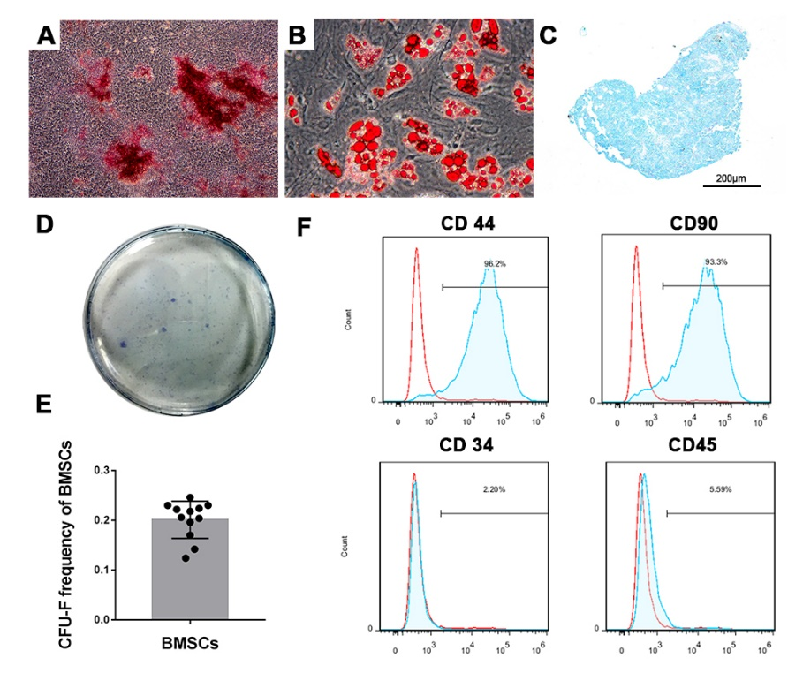
Figure S1. Characterization of BMSCs
A: Mineral nodes stained with Alizarin Red S (Original magnification ×40) B: Fat droplets stained with Oil Red O (Original magnification ×200). C: Proteoglycans were stained with Alcian blue (scale bar=200μm). D: Representative image of cell colonies. E: The colony frequency of BMSCs (n=4, with three replicates each) F: Flow cytometry analysis of BMSC surface markers.

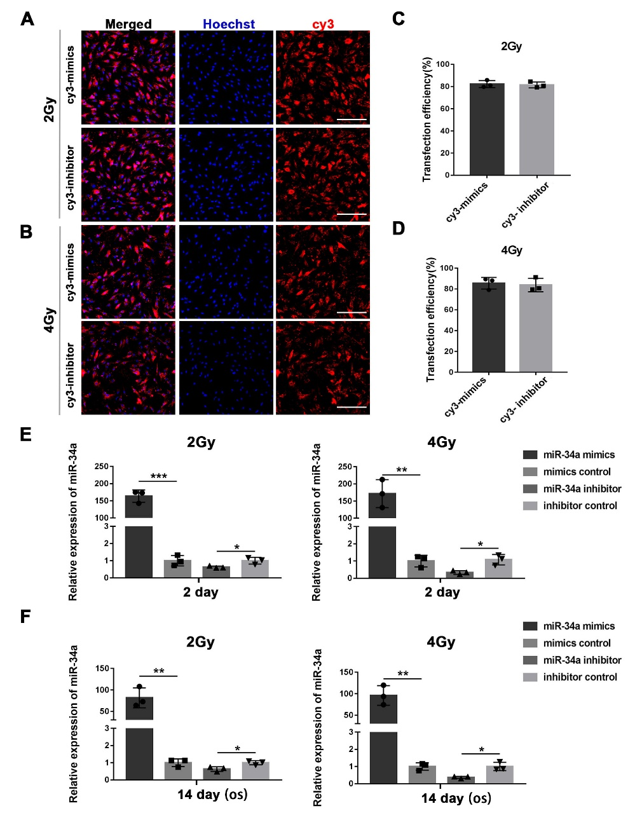
Figure S2. The miRNA transfection efficiency and effect
A, B: The representative images showing the uptake of Cy3-labeled mimics and inhibitor by BMSCs irradiated with 2Gy or 4Gy; scale bar=200μm. C, D: The histograms of Cy3 positive cell percentage. E: miR-34a expression determined by qRT-PCR in the BMSCs 2 days after transfection. F: miR-34a expression determined by qRT-PCR after 14 days of osteoblastic differentiation. Data are shown as mean ± SD, n=3; *p<0.05, **p<0.01, ***p<0.001.

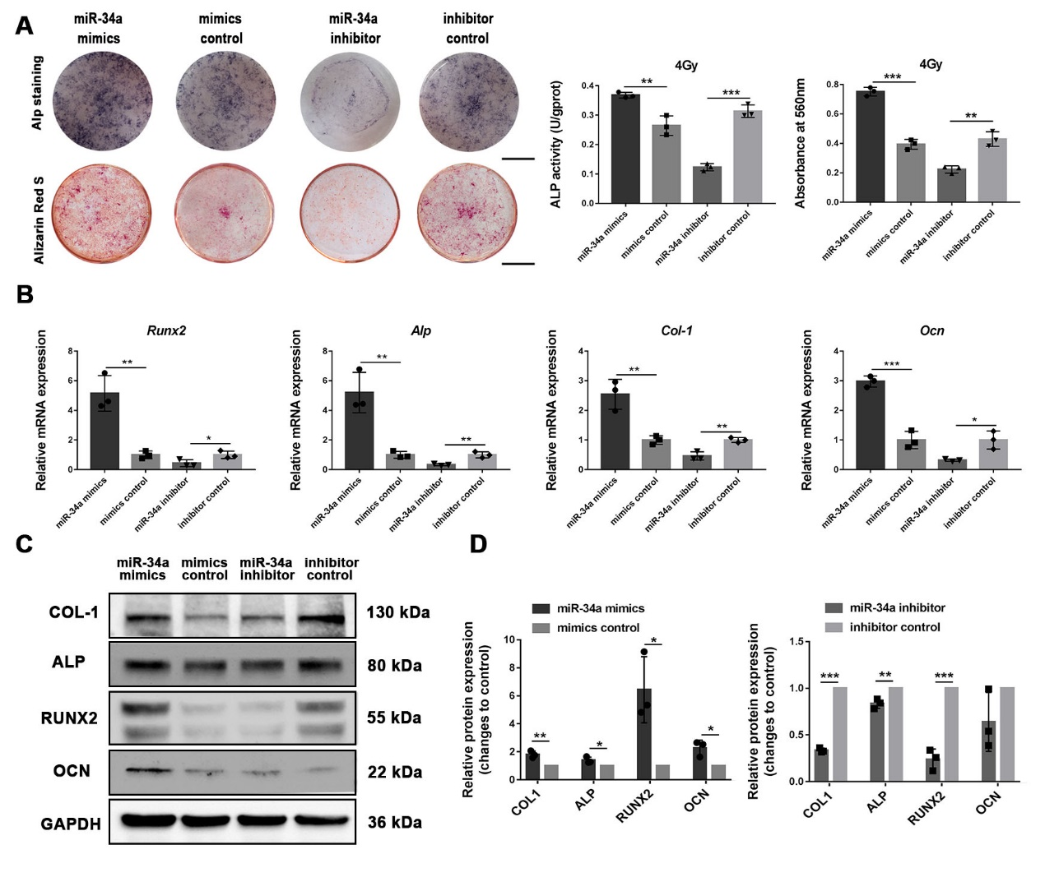
Figure S3. miR-34a overexpression enhanced the osteoblastic differentiation of 4Gy irradiated BMSCs in vitro
A: ALP staining, intracellular ALP activity, Alizarin red staining and the quantitative colorimetric results of Alizarin red staining for BMSCs irradiated with 4Gy after osteogenic induction; scale bar = 1 cm. B: Gene expression of Runx2, Alp, Col-1, and Ocn after 14 days of osteogenic induction. C: Western blot analysis of RUNX2, ALP, COL-1, OCN and GAPDH after 14 days of osteogenic induction. D. The quantitative analysis of the western blot results relative to GAPDH (fold to control). Data are shown as mean ± SD, n=3; *p<0.05, **p<0.01, ***p<0.001.

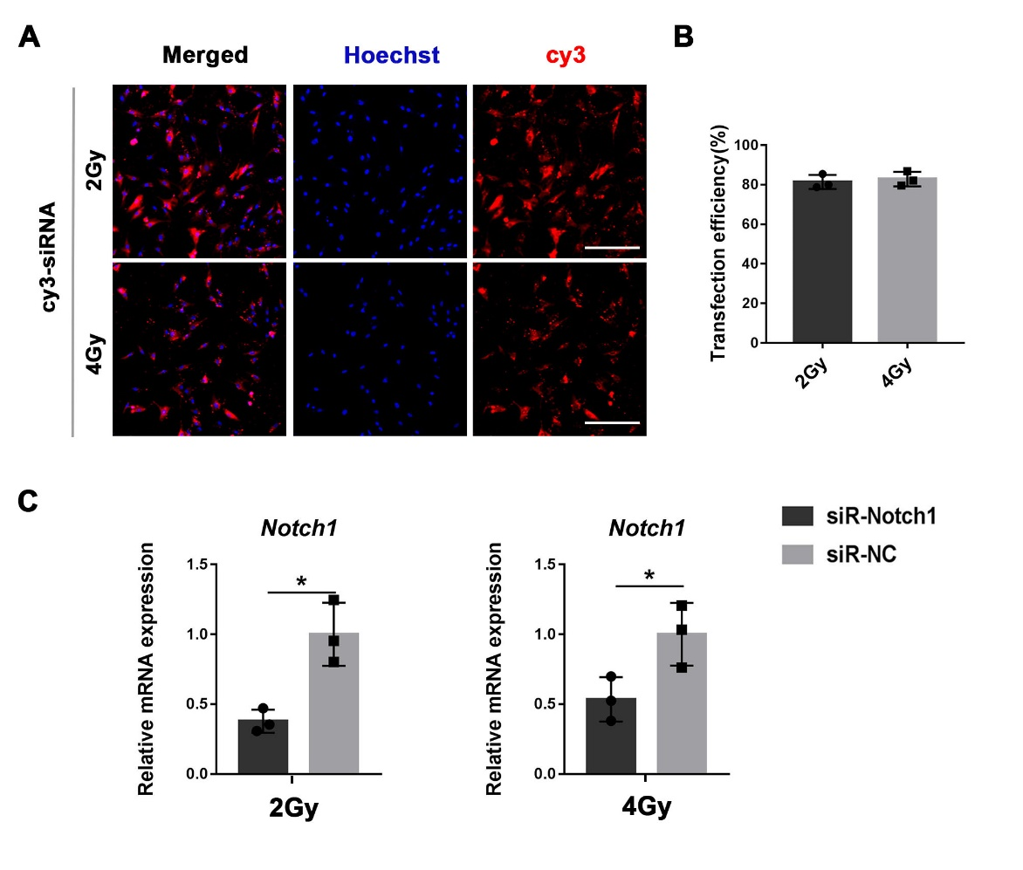
Figure S4. The siRNA transfection efficiency and effect
A: The representative images showing the uptake of Cy3-siRNA by BMSCs irradiated with 2Gy or 4Gy, scale bar=200μm. B: The histograms of Cy3 positive cell percentage. C: Notch1 expression determined by qRT-PCR 2 days after transfection. Data are shown as mean ± SD, n=3; *p<0.05.

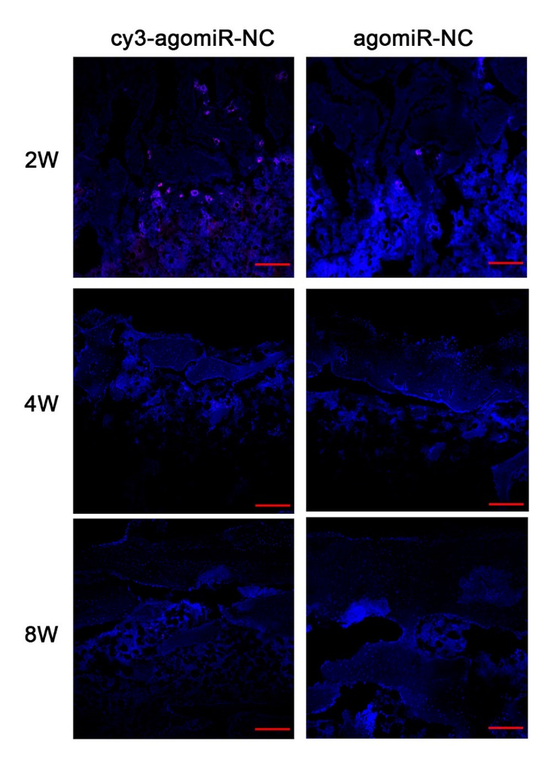
Figure S5. Distribution of agomiR in the bone defect area
The representative images showing the distribution of cy3-labbeled agomiR NC in the bone defect area 2, 4 and 8 weeks after implantation; scale bar=200μm. agomiR NC was used as control.

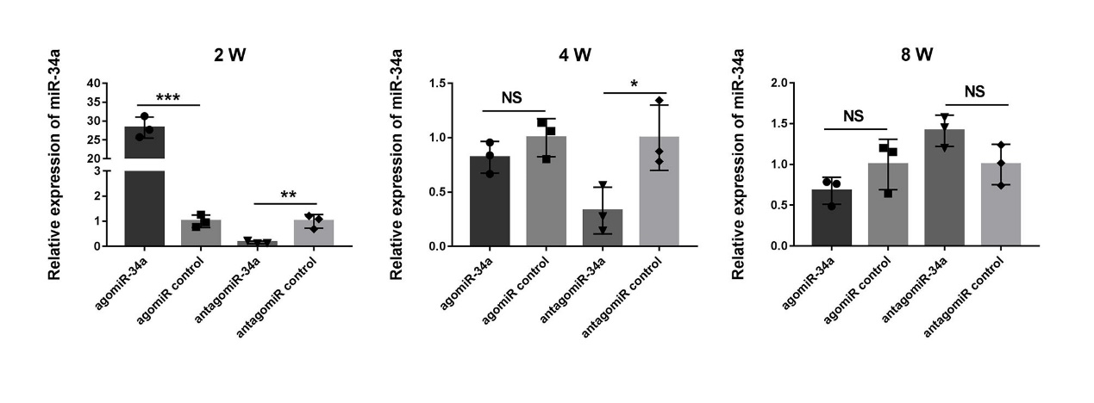
Figure S6. Expression of miR-34a in the newly formed bone after implantation of miRNA delivery hydrogel
qRT-PCR analysis of miR-34a expression in the newly formed bone 2, 4 and 8 weeks after implantation. Data are shown as mean ± SD, n=3; *p<0.05, **p<0.01, ***p<0.001.

