Effect of lentivirus-mediated gene silencing of IFITM3 on the function of differentiated EPC
A
B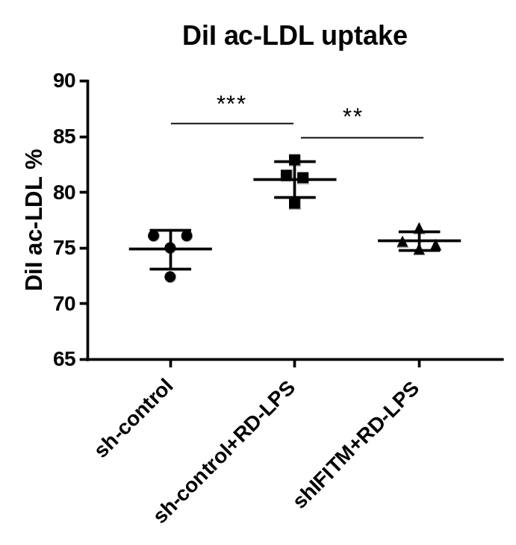

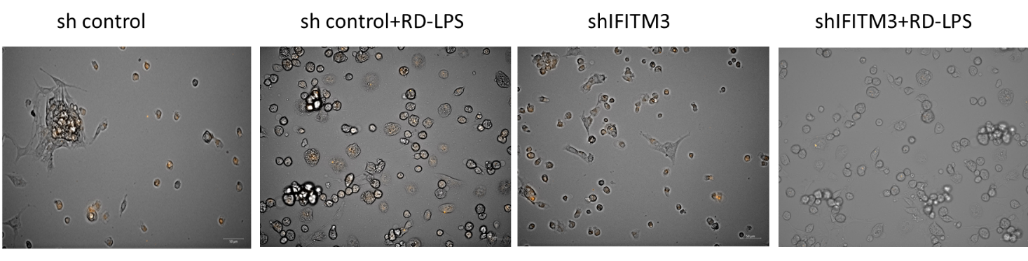
DiI-ac-LDL uptake was measured following 10 days in EGM2 culturing medium in the presence of vehicle PBS or 100 ng/ml RD-LPS and transduced with lentivirus sh-control or lentivirus sh-IFITM3. EPCs were incubated for 4 hours with 1 µg protein/ml Dil-ac-LDL. The cells were washed and analysed by flow cytometry. ***= p<0.001, **=p<0.005 (A). Panel (B) shows representative images taken by fluorescence microscopy (Zeis Celldiscoverer). Objective magnification was 20x.

