SUPPLEMENTARY FILE

Supplementary Table 1. Blood gas parameters during the course of the experiments across the lamb groups
 |  | 1 hour | 6 hours | 12 hours | 24 hours
pH | AGA | 7.30+0.03 | 7.45+0.05 | 7.35+0.1 | 7.36+0.19
 | FGR | 7.27+0.08 | 7.47+0.08 | 7.37+0.1 | 7.33+0.19
 | AGA+UCBC | 7.14+0.10 | 7.39+0.02 | 7.37+0.05 | 7.34+0.06
 | FGR+UCBC | 7.25+0.15 | 7.33+0.10 | 7.29+0.12 | 7.21+0.19
pO₂ (mmHg) | AGA | 38.0+11.8 | 47.3+11.9 | 34.6+7.1 | 39.0+7.9
 | FGR | 35.3+7.2 | 34.9+4.1 | 38.2+9.4 | 41.8+13.5
 | AGA+UCBC | 37.0+5.3 | 45.4+12.3 | 43.7+9.2 | 40.0+5.7
 | FGR+UCBC | 30.4+5.8 | 41.3+13.0 | 42.2+10.7 | 35.3+9.1
pCO₂ (mmHg) | AGA | 51.3+8.9 | 39.8+5.5 | 58.7+15.8 | 45.6+15.2
 | FGR | 52.2+6.6 | 35.1+8.6 | 49.9+7.8 | 37.6+14.6
 | AGA+UCBC | 58.1+15.0 | 44.8+2.7 | 52.0+7.2 | 54.4+10.6
 | FGR+UCBC | 56.1+15.3 | 53.7+15.0 | 59.5+17.3 | 62.3+17.0
Lactate (mmol/L) | AGA | 3.5+0.6 | 2.1+0.7 | 1.6+0.4 | 1.4+7.1
 | FGR | 4.2+1.3 | 3.0+0.5 | 1.8+0.3 | 1.8+3.4
 | AGA+UCBC | 4.6+1.8 | 1.7+0.2 | 1.4+0.3 | 1.3+0.4
 | FGR+UCBC | 4.0+1.9 | 1.9+0.4 | 1.6+0.5 | 2.6+3.1
HCO₃⁻ (mmol/L) | AGA | 27.9+4.0 | 27.5+1.4 | 31.2+2.8 | 24.3+10.4
 | FGR | 23.6+5.1 | 25.5+3.1 | 27.4+3.3 | 15.9+12.4
 | AGA+UCBC | 20.0+4.5 | 26.8+1.9 | 28.6+1.6 | 27.5+4.2
 | FGR+UCBC | 24.8+3.7 | 26.9+5.1 | 28.1+5.5 | 26.3+6.3
Data expressed as mean+SD. No significant differences seen between any lamb groups.
Supplementary Table 2. Ventilation parameters during the course of the experiments across the lamb groups
 |  | 1 hour | 6 hours | 12 hours | 24 hours
Compliance (ml/g/cm H₂O) | AGA | 0.016+0.020 | 0.016+0.020 | 0.018+0.008 | 0.020+0.013
 | FGR | 0.011+0.003 | 0.016+0.000 | 0.011+0.001 | 0.008+0.001
 | AGA + UCBC | 0.013+0.001 | 0.020+0.001 | 0.016+0.001 | 0.013+0.003
 | FGR + UCBC | 0.014+0.002 | 0.016+0.003 | 0.016+0.002 | 0.010+0.003
Peak pressure (cm H₂O) | AGA | 16.8+1.6 | 21.0+1.6 | 21.0+2.6 | 25.0+3.4
 | FGR | 18.6+6.4 | 20.0+3.6 | 19.6+3.4 | 26.0+6.4
 | AGA + UCBC | 21.6+1.7 | 15.8+1.3 | 15.6+0.8 | 21.7+1.9
 | FGR + UCBC | 18.8+1.5 | 19.2+1.4 | 20.5+2.0 | 24.7+1.7
Tidal volume (ml/kg) | AGA | 5.2+0.3 | 4.9+0.3 | 5.0+0.3 | 5.6+0.5
 | FGR | 5.2+0.4 | 5.0+0.1 | 4.6+0.3 | 4.8+1.0
 | AGA + UCBC | 4.9+0.0 | 4.9+0.0 | 4.9+0.1 | 4.9+0.1
 | FGR + UCBC | 5.0+0.0 | 5.0+0.0 | 4.9+0.1 | 4.9+0.1
FiO₂ | AGA | 40.0+11.2 | 22.6+1.0 | 26.0+5.0 | 31.0+10.0
 | FGR | 36.5+10.5 | 22.0+1.2 | 27.6+4.0 | 52.8+15.0
 | AGA + UCBC | 43.1+6.9 | 25.8+4.8 | 21.0+0.0 | 24.0+1.2
 | FGR + UCBC | 35.4+6.8 | 29.5+2.8 | 30.5+3.7 | 48.4+13.4
Data expressed as mean+SD. No significant differences seen between any lamb groups.

Supplementary Figure 1. Tissue oxygenation index as measured (mean+SD) in the lamb groups across the duration of the experiment.

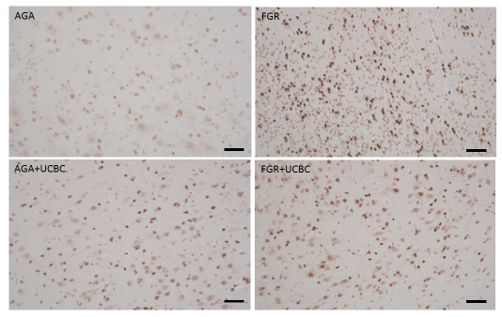

Supplementary Figure 2. Left panel: Representative photomicrographs of cell death seen as apoptotic cells (Caspase-3) in SCWM in lamb groups. Scale bar=50um. Right panel: Quantitative analysis (mean+SD) of Caspase-3 cells across brain regions. 2-way ANOVA analysis applied. No significant differences seen with cell therapy.

