Supplementary Information

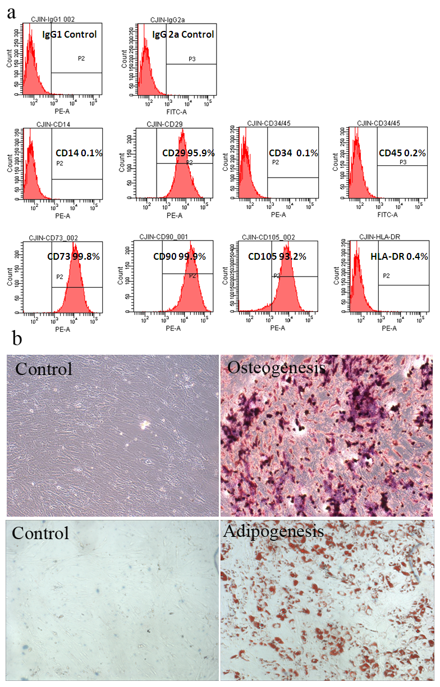
Fig. S1. Characterization of human UC-MSCs. (A) UC-MSCs were positive for CD29, CD73, CD90. CD105 and negative for CD 14, CD34, CD45, HLA-DR. (B) UC-MSCs differentiation to osteocytes (alizarin red S staining) and adipocytes (Oil red O staining).

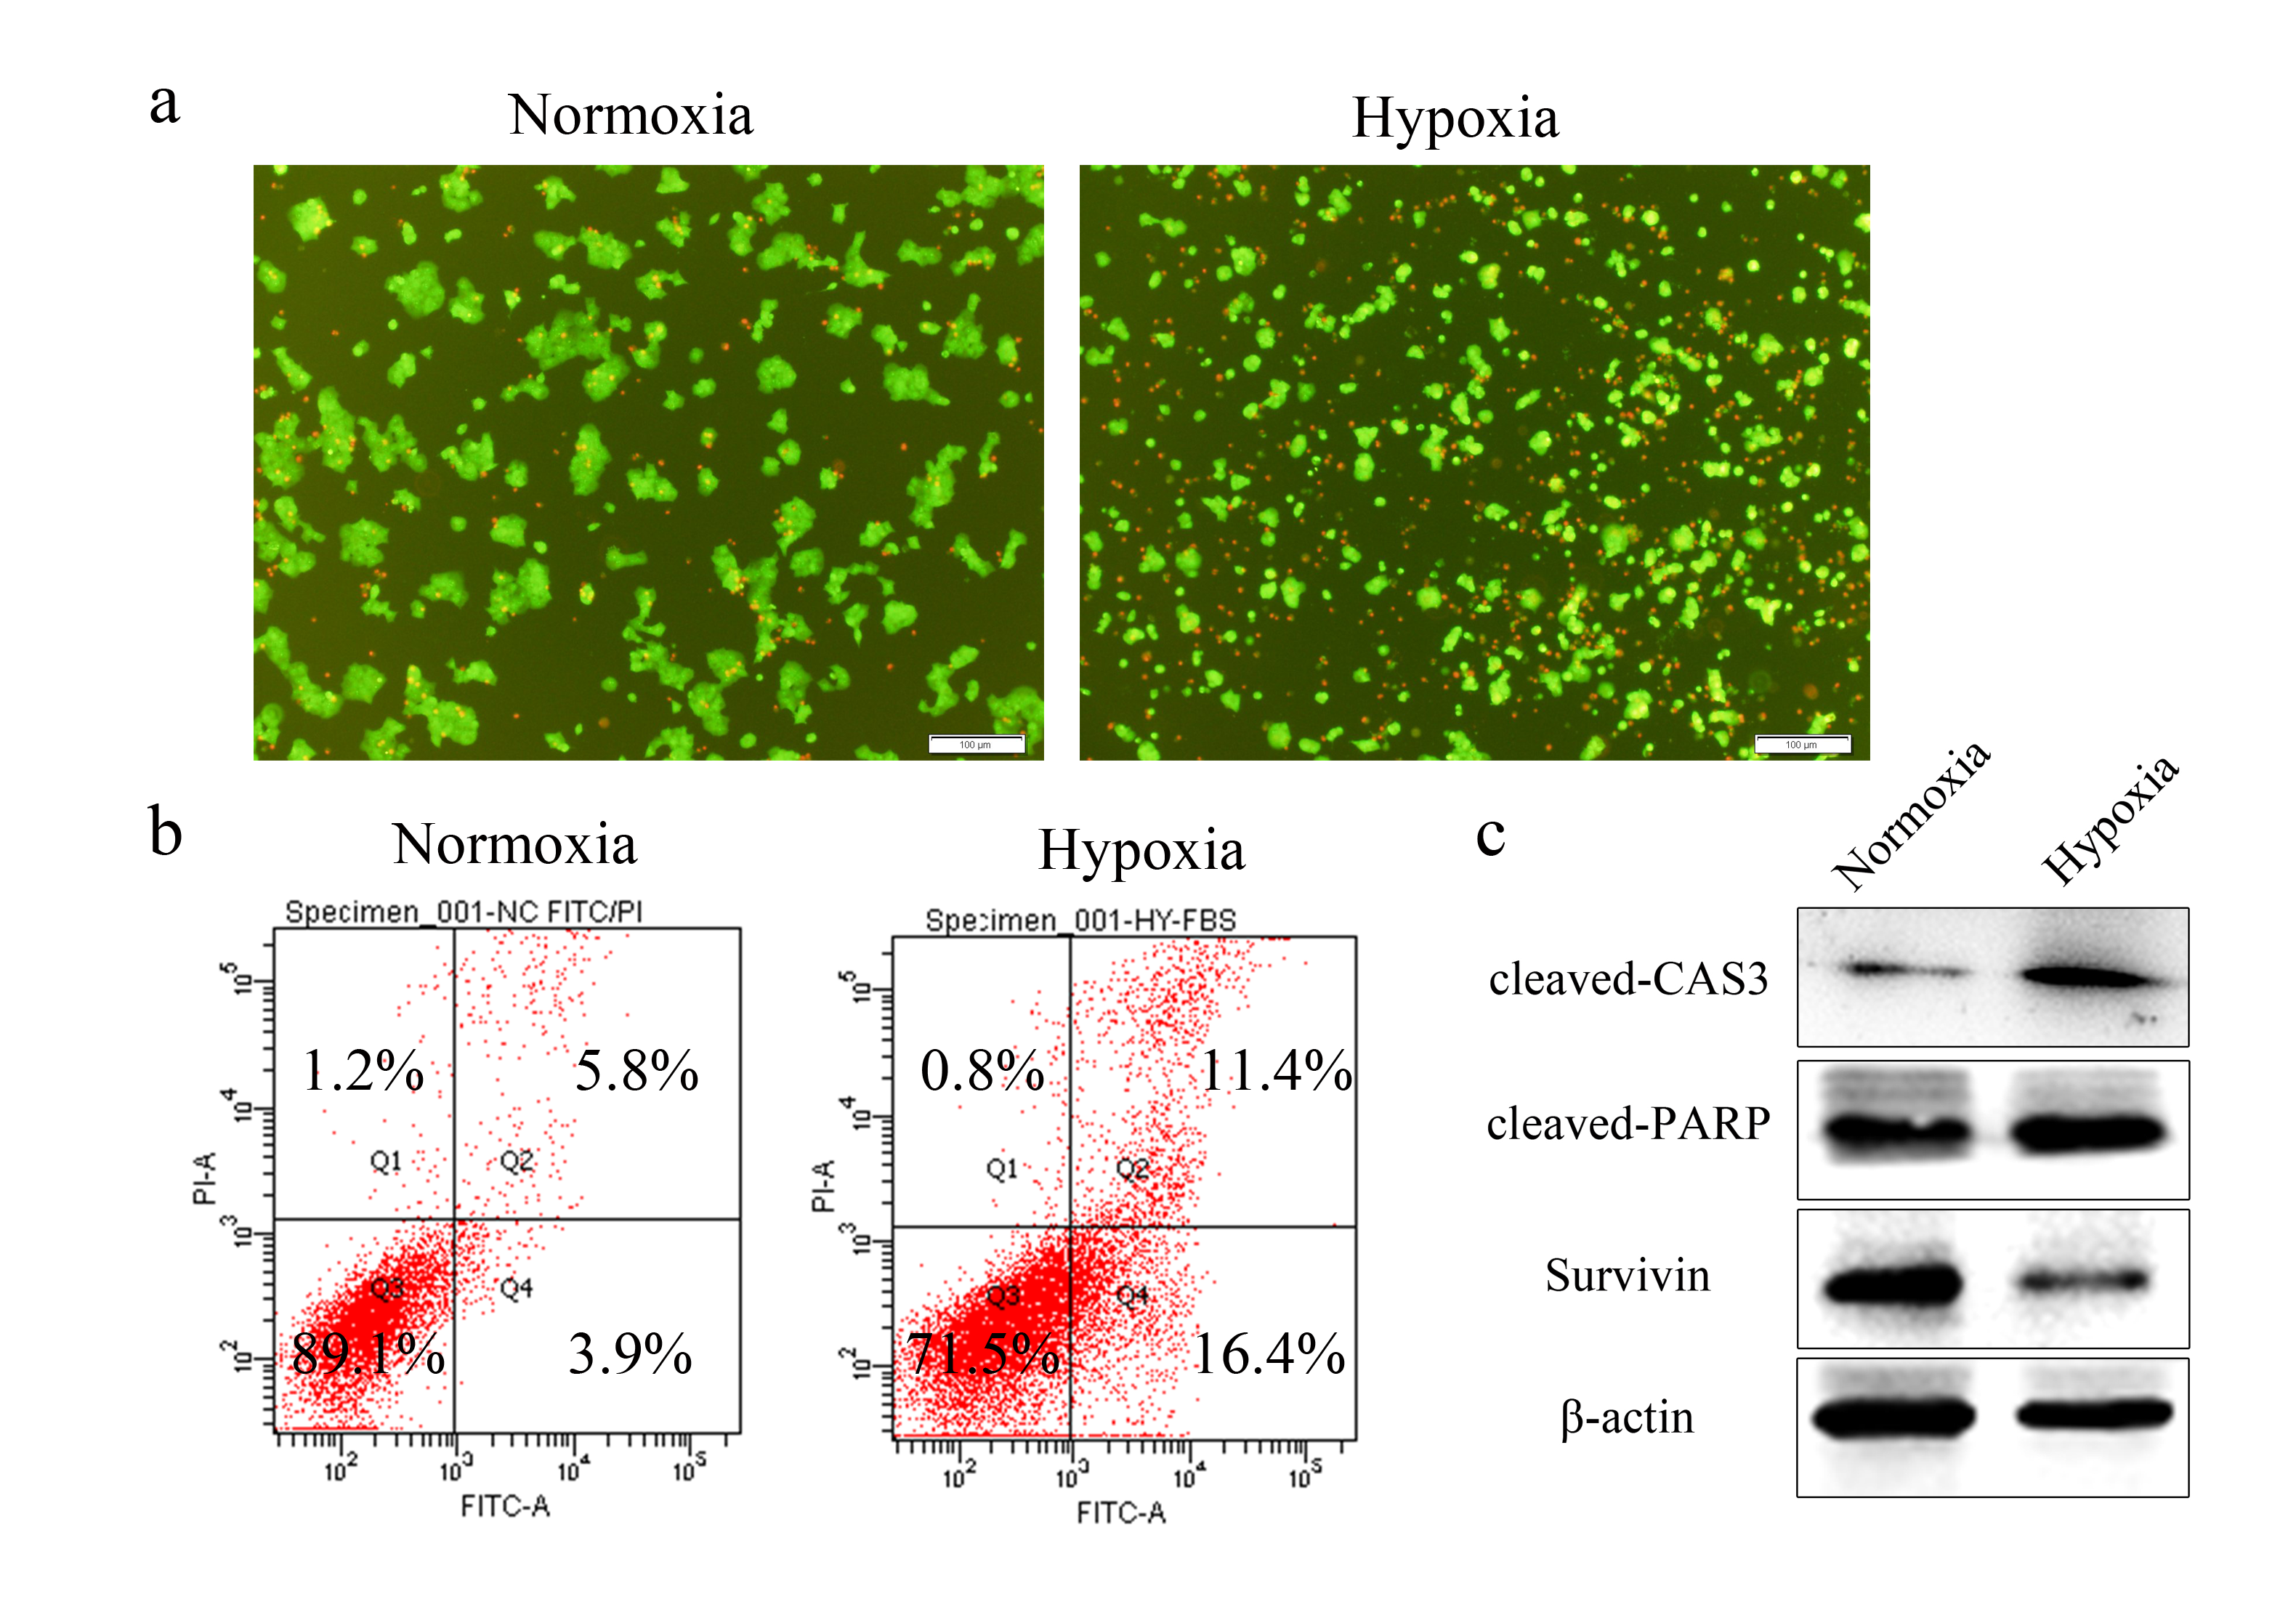

Fig. S2. Hypoxia induces beta cell apoptosis. Beta cells were cultured under normoxic (37 °C, 5% CO₂, 21% O₂) or hypoxic (37 °C, 5% CO₂, 2% O₂) conditions for 48 h. The viability of beta cells was determined by staining with AO/PI (magnification 100×) (A). Cell apoptosis was analysed by an annexin V-FITC/PI apoptosis detection kit and flow cytometry (B). Apoptosis-related proteins were assayed by the WB method (C).
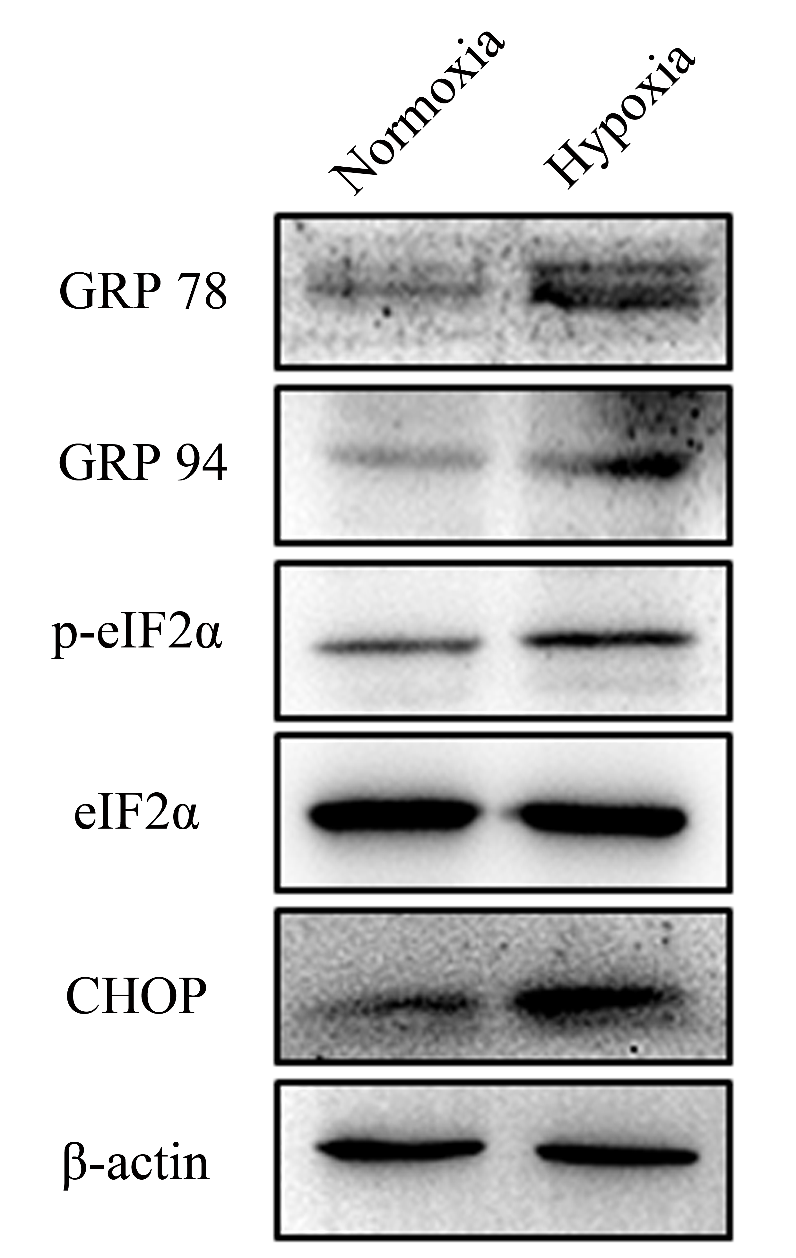

Fig. S3. Hypoxia induces ER stress in beta cells. ER stress-related proteins were detected by WB method. Nor: beta cells culture in normoxia (37 °C, 5% CO₂, 21% O₂); HYP: beta cells cultured in hypoxia (37 °C, 5% CO₂, 2% O₂).

