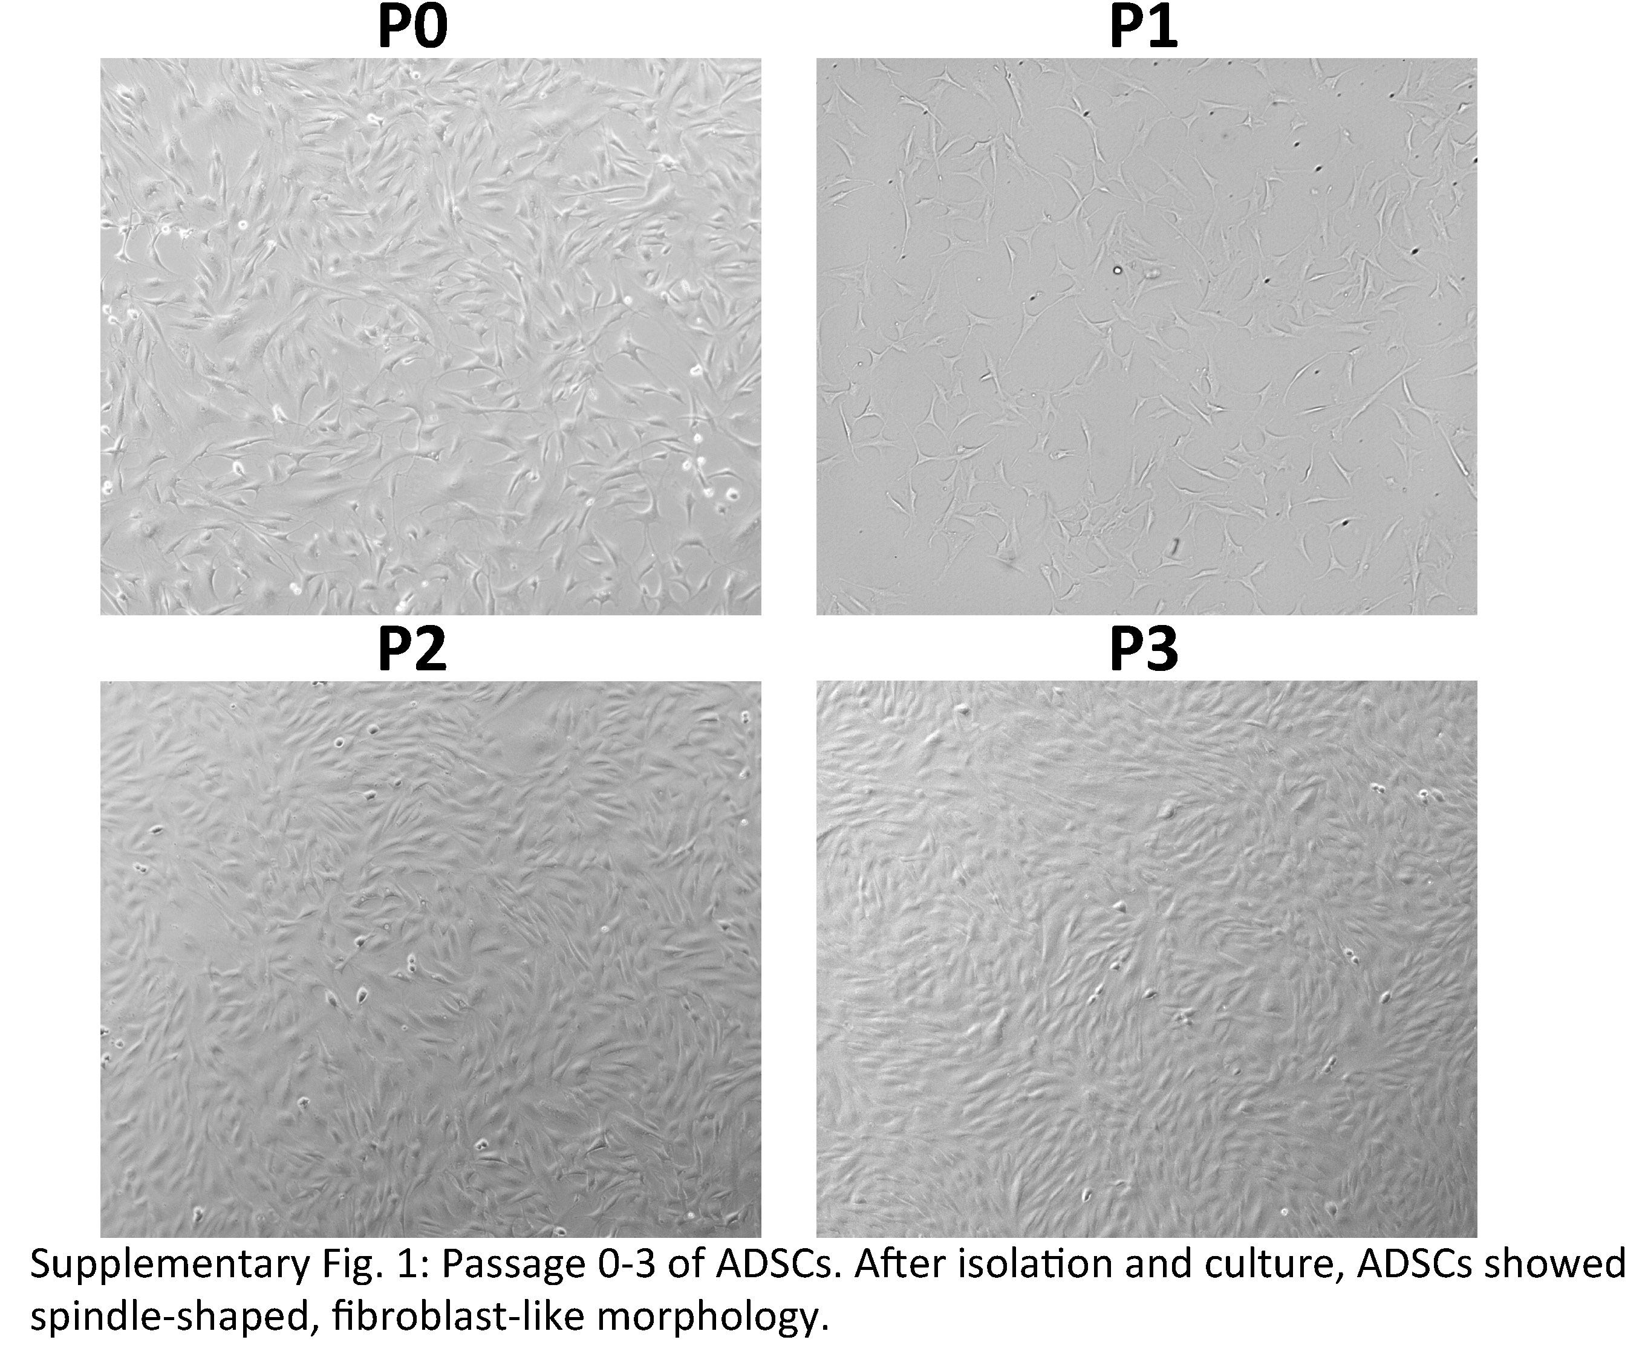

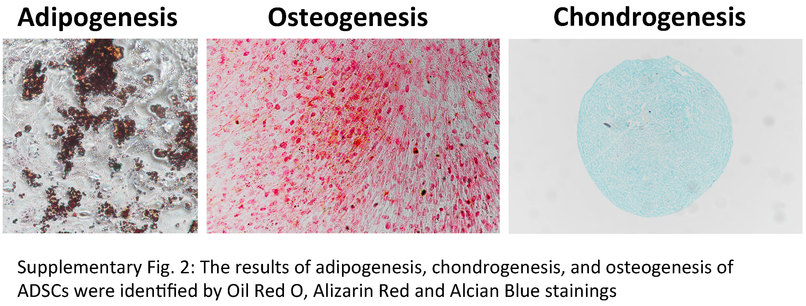

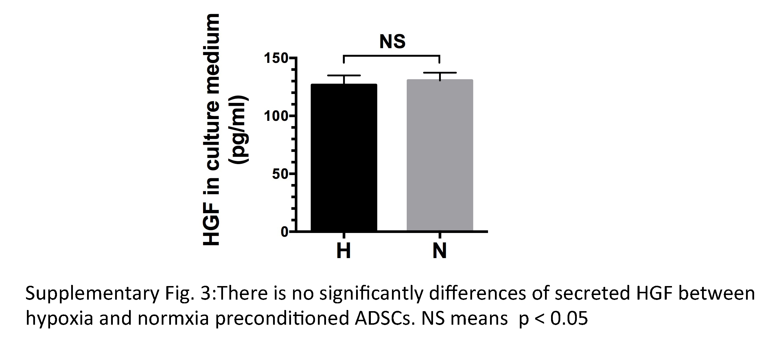

Supplementary table1: List of genes, primers and parameters used for PCR.

Gene | Primer pairs | TM(℃) | Product size (bp)
Human HK2 | 5' ACT GGA CTG GGT TTT GTC TC 3' | 81.3 | 167
 | 5' GGC AAG GGG GAT TAC TAA G 3'
Human VEGFR2 | 5' CAC CAC TCA AAC GCT GAC AT 3' | 83.3 | 82
 | 5' CTC TTC CTC CAA CTG CCA ATA C 3'
Human Hif-1α | 5' ATG CTT ACA CAC AGA AAT GG 3' | 81.8 | 190
 | 5' ACT GAG GTT GGT TAC TGT TG 3'
Human β-actin | 5' AAG GTG ACA GCA GTC GGT T 3' | 84.3 | 195
 | 5' TGT GTG GAC TTG GGA GAG G 3'

