Table S1. Antibodies for immunoblots and immunohistochemistry

Antibodies | Company | Dilution | Catalogue number
GAPDH | Abcam | 1:10000 | ab181603
p- IKKβ (Ser176/180) | Cell Signaling Technology | 1:1000 | 2697
IKKβ | Cell Signaling Technology | 1:1000 | 8943
p-NF-κB (Ser536) | Cell Signaling Technology | 1:1000 | 3033
NF-κB | Cell Signaling Technology | 1:1000 | 8242
p- IKBα(Ser36) | Abcam | 1:5000 | ab133462
IKBα | Abcam | 1:5000 | ab32518
p-TAK1(Ser439) | Abcam | 1:1000 | ab109404
TAK1 | Abcam | 1:5000 | ab109526
p-JNK (Thr183/Tyr185) | Cell Signaling Technology | 1:1000 | 9251
JNK | Cell Signaling Technology | 1:1000 | 9252
p-c-Jun (Ser73) | Cell Signaling Technology | 1:1000 | 9261
c-Jun | Cell Signaling Technology | 1:1000 | 9165
p-p38 (Thr180/Tyr182) | Cell Signaling Technology | 1:1000 | 4511
p38 | Cell Signaling Technology | 1:1000 | 8690
NLRP3 | Adipogen Life Science | 1:1000 (WB)  1:200 (IHC) | AG-20B-0014
Caspase 1 | Santa Cruz Technology | 1:200 | Sc-398715
IL-1β | Cell Signaling Technology | 1:1000 | 31202
F4/80 | Abcam | 1:200 (IHC) | ab6640
CD206 | Abcam | 1:200 (IHC) | ab64693
p-MTOR (Ser2448) | Cell Signaling Technology | 1:1000 | 5536
MTOR | Cell Signaling Technology | 1:1000 | 2983
p-AKT (Ser473) | Abcam | 1:5000 | ab81283
AKT | Abcam | 1:5000 | ab179463
p-STAT6 (Tyr641) | Abcam | 1:1000 | ab28829
STAT6 | Abcam | 1:2000 | ab32520
p-p70 S6K (Thr389) | Cell Signaling Technology | 1:1000 | 9234
p70 S6K | Cell Signaling Technology | 1:1000 | 2708
p-GSK-3β (Ser9) | Cell Signaling Technology | 1:1000 | 5558
GSK-3β | Cell Signaling Technology | 1:1000 | 12456
EP4 | Santa Cruz Technology | 1:200 | sc-55596

Table S2. Sequence of primers used in experiments
Gene | Forward | Reverse
actin | AGTGTGACGTTGACATCCGTA | GCCAGAGCAGTAATCTCCTTCT
Ccl2 | TTAAAAACCTGGATCGGAACCAA | GCATTAGCTTCAGATTTACGGGT
IL-1β | GCAACTGTTCCTGAACTCAACT | ATCTTTTGGGGTCCGTCAACT
iNOS | ACATCGACCCGTCCACAGTAT | CAGAGGGGTAGGCTTGTCTC
TNF-α | GACGTGGAACTGGCAGAAGAG | ACCGCCTGGAGTTCTGGAA
Arg1 | CTCCAAGCCAAAGTCCTTAGAG | GGAGCTGTCATTAGGGACATCA
Mgl1 | TGCAACAGCTGAGGAAGGACTTGA | AACCAATAGCAGCTGCCTTCATGC
Mgl2 | GCATGAAGGCAGCTGCTATTGGTT | TAGGCCCATCCAGCTAAGCACATT
Ym1 | CAGGTCTGGCAATTCTTCTGAA | GTCTTGCTCATGTGTGTAAGTGA
IL10 | GCTATGCTGCCTGCTCTTACT | CCTGCTGATCCTCATGCCA
EP1 | CTTAACCTGAGCCTAGCGGAT | ATGTGCCATTATCGCCTGTTG
EP2 | CAGCTCGGTGATGTTCTCGG | GAGCACCAATTCCGTTACCAG
EP3 | CCGGAGCACTCTGCTGAAG | CCCCACTAAGTCGGTGAGC
EP4 | CCATTCCCGCAGTGATGTTCA | TGCGCGACTTGCACAATACTA

Table S3. Primers of siRNAs
siEP4 | CCATCGTAGTATTGTGCAA

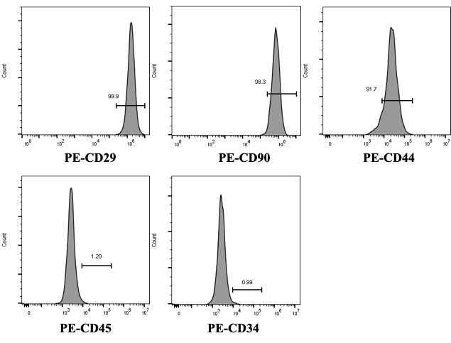
Figure S1: Identification of mesenchymal stem cells (MSCs). Flow cytometry analysis of MSCs. PE, phycoerythrin.
The immunophenotypic characterization by flow cytometry showed positive stromal marker expression (CD29, CD44, and CD90), but little or no hematopoietic marker expression (CD34 and CD45), which means a high purity after the third passage (Fig. S1).

