Supplemental tables

Supplemental table 1: Gene array data for most common cardiac integrins and integrin binding
proteins.
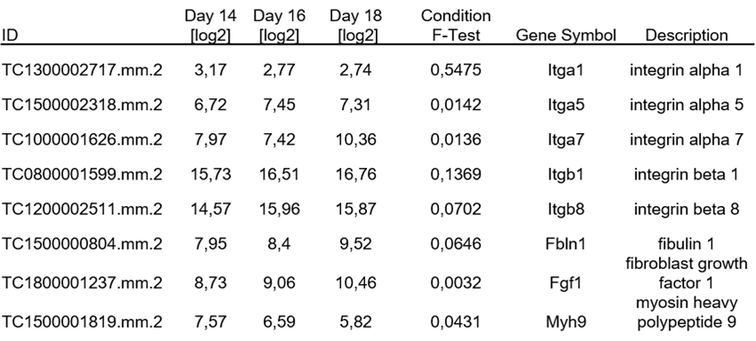

Supplemental table 2: Integrins and integrin binding proteins expression changes.
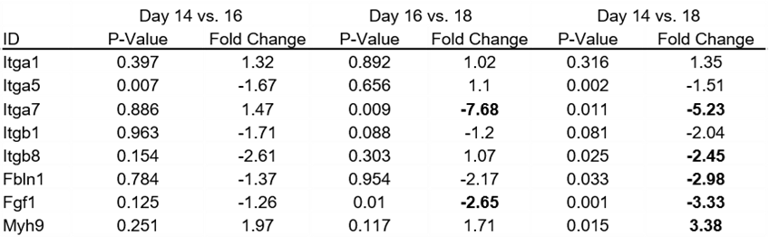

Supplemental table 3: Gene array data for most common cardiac gap junction proteins.
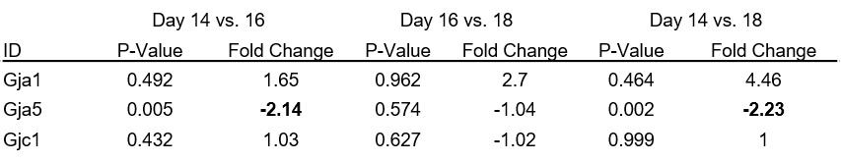
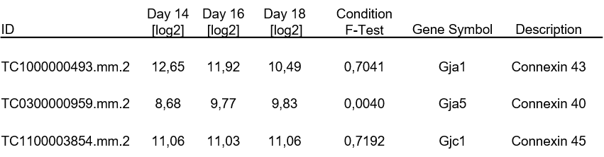
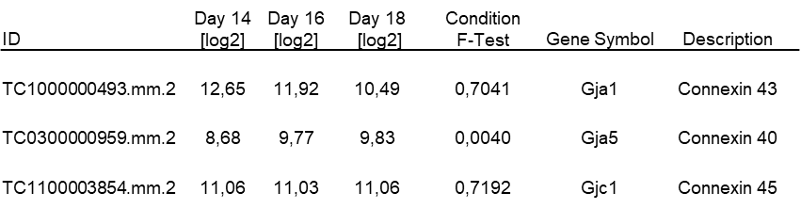

Supplemental table 4: P-values and fold change for gap junction protein expression changes.

Supplemental table 4: Gap junction protein expression changes. 