SUPPLEMENTAL DATA

Supplemental Table
Table S1. Primer sequences used in real-time PCR
Gene name | Primer Sequences
COL1 | Forward: GCCAAGAAGACATCCCTGAAG  Reverse: TGTGGCAGATACAGATCAAGC
COL3 | Forward: CCTGGCTCAAATGGCTCAC  Reverse: CAGGACTGCCGTTATTCCCG
Elastin | Forward: CTTTGGTTCCCCTGTCCCTG  Reverse: ATAAACCCAAAGAGCACACCAAC
Fibronectin | Forward: CAATGTCTACACCGTCCCTGA  Reverse: AGAAGGCTGCTGGAGTTGAAG
MMP-1 | Forward: AAGGTTAGCTTACTGTCACACGCTT  Reverse: CGACTCTAGAAACACAAGAGCAAGA
MMP-2 | Forward: CCAACTACGATGATGAC  Reverse: ACCAGTGTCAGTATCAG
MMP-3 | Forward: TTAAAGACAGGCACTTTTGGCG  Reverse: CCCTCGTATAGCCCAGAACT
MMP-9 | Forward: CCCGGACCAAGGATACAG  Reverse: GGCTTTCTCTCGGTACTG
TIMP-1 | Forward: GCAACTCGGACCTGGTCATAA  Reverse: CGGCCCGTGATGAGAAACT
TIMP-2 | Forward: TCAGAGCCAAAGCAGTGAGC  Reverse: GCCGTGTAGATAAACTCGATGTC
TIMP-3 | Forward: CTTCTGCAACTCCGACATCGT  Reverse: GGGGCATCTTACTGAAGCCTC

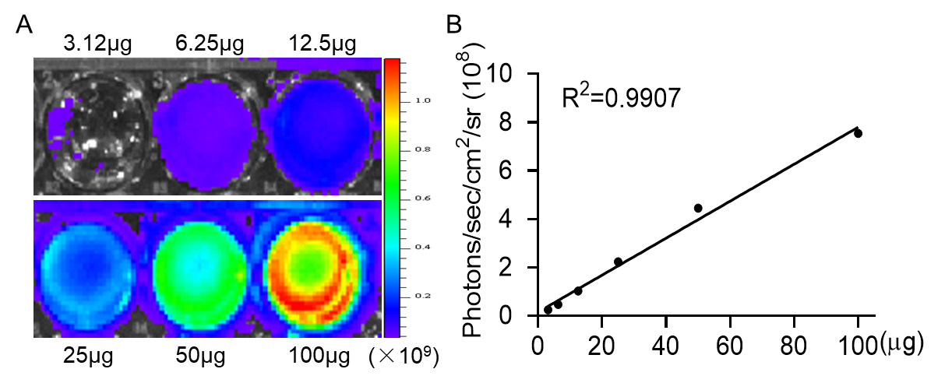
Supplemental Figures & Legend
Figure S1. Bioluminescent labeling of EVs. (A-B) Ex vivo imaging of Gluc-labeled EVs exhibited increasing bioluminescence signals with concentrations of EVs (R²=0.9907).

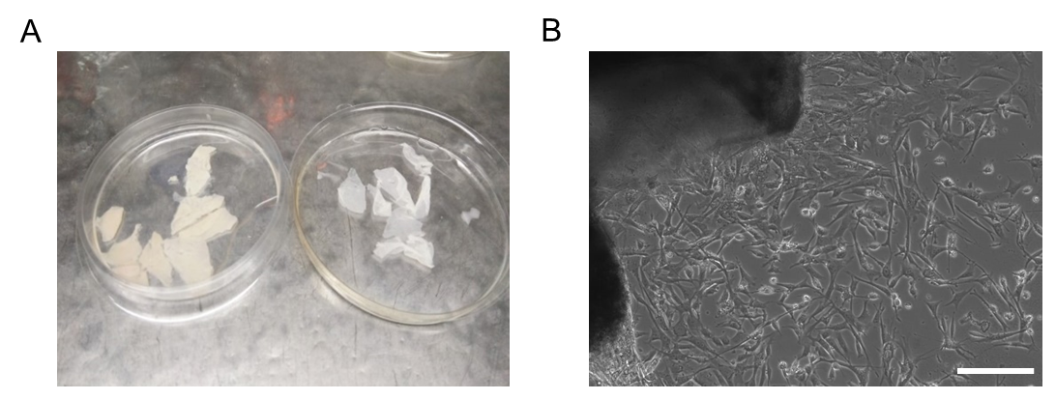
Figure S2. DFLs isolation in vitro. (A) The image showed the separation of dermis (left) and epidermis (right) of newborn mice skin after Dispase II treatment. (B) Representative image showed fibroblasts crawled out from the edges of the skin dermal tissue by tissue-block cultivation. Scale bar, 200 µm.

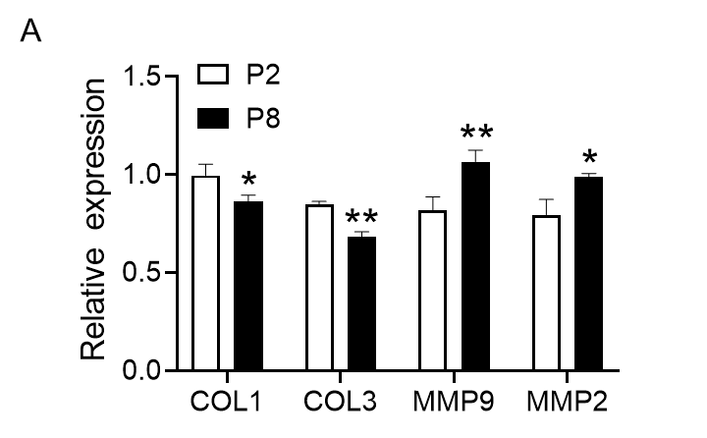
Figure S3. Quantitative statistical results of western blots. (A) Quantification of protein levels normalized to tubulin (n = 3; *P <0.05, **P <0.01 vs P2).

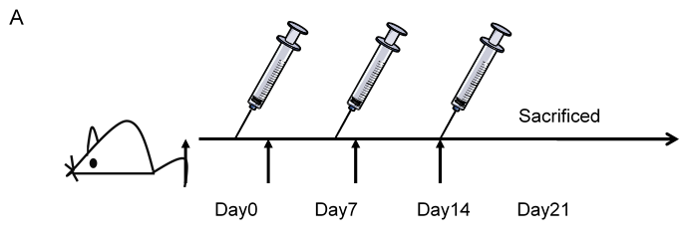
Figure S4: CS-EVs treatment strategy in vivo. Schematic diagram for in vivo study.

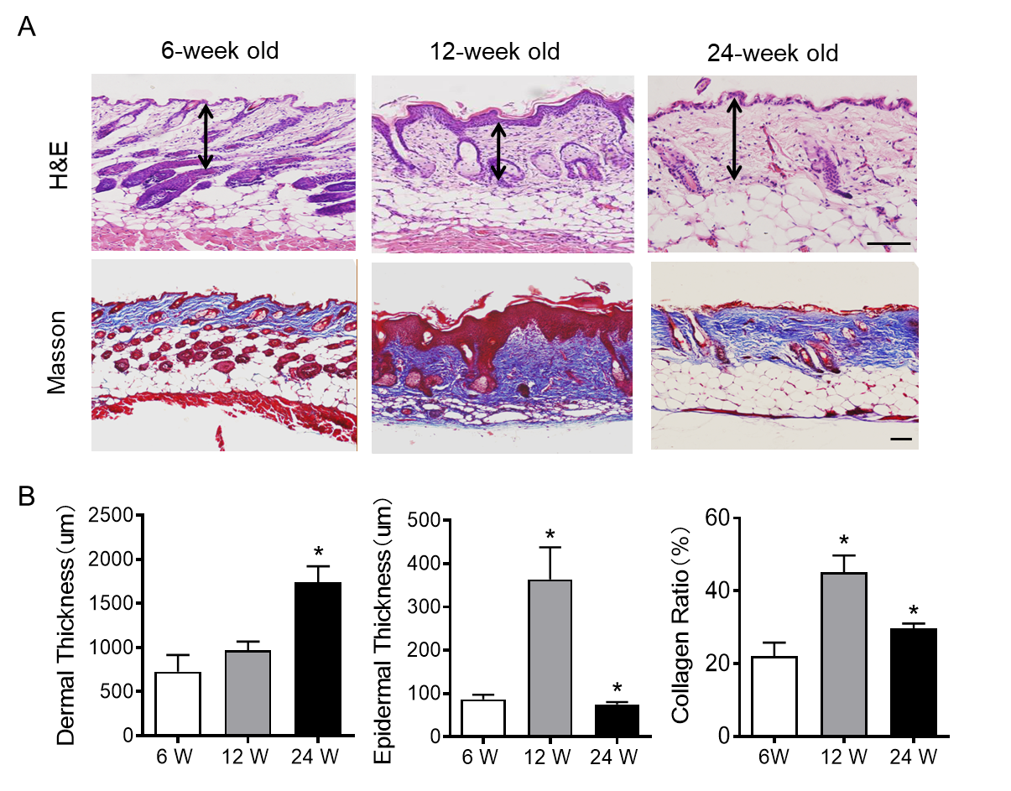
Figure S5. Features of aging skin and young skin tissue. (A) Representative skin sections of mouse at different ages, H&E and Masson trichrome stain. Scale bar, 50 µm. (B) The statistics of mean dermal or epidermal thickness as well as Collagen ratio at the indicated ages. Data are presented as the Mean ± SEM. (n = 5; **P<0.01 vs 12W).

Figure S6. Images of the uncropped immunoblots shown in the main figures. Boxes indicate cropped regions.

