Fig. S2

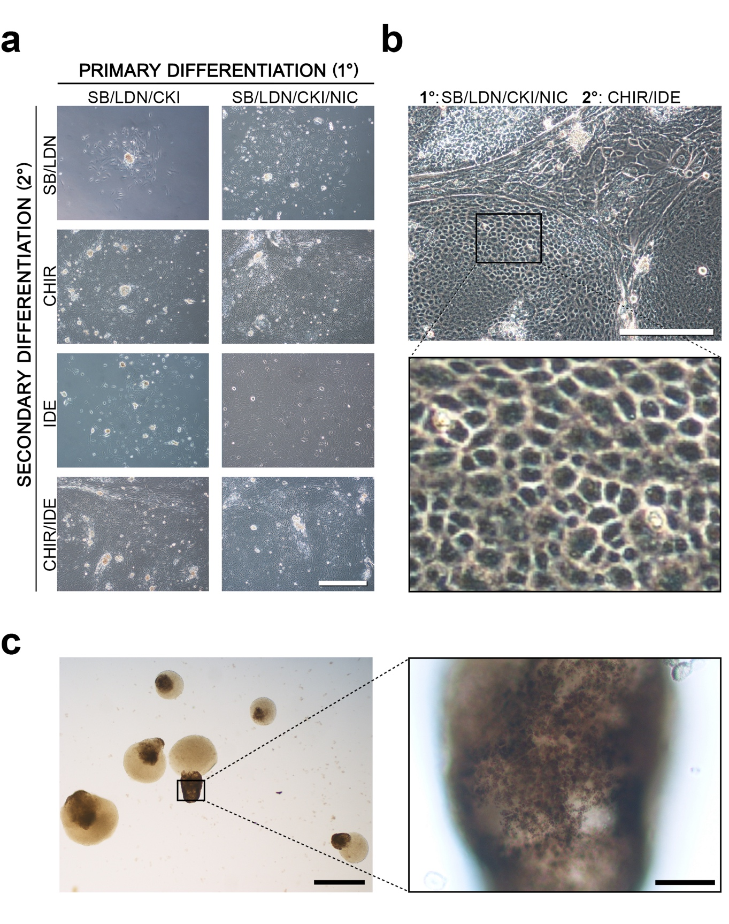

  - Fig. S2 Primary and secondary differentiation conditions designed to drive hESCs to RPEs within 6 days. a) Phase contrast microscopy of hESC-RPE cells obtained under the best combination of small molecules for secondary differentiation by Day 14. The condition includes selected combinations of SB, LDN, CHIR and IDE. Scale = 200μm. b) High magnification image of hESC-RPE cells grown under the best secondary differentiation conditions. Scale = 200μm. c) Image of 3D aggregates in suspension cultures displaying pigmented regions at Day 28. Scale = 400μm. High magnification image depicting polygonal cells with granular pigmentation reminiscent of RPE cells. Scale = 100μm.

