Fig. S3
  - 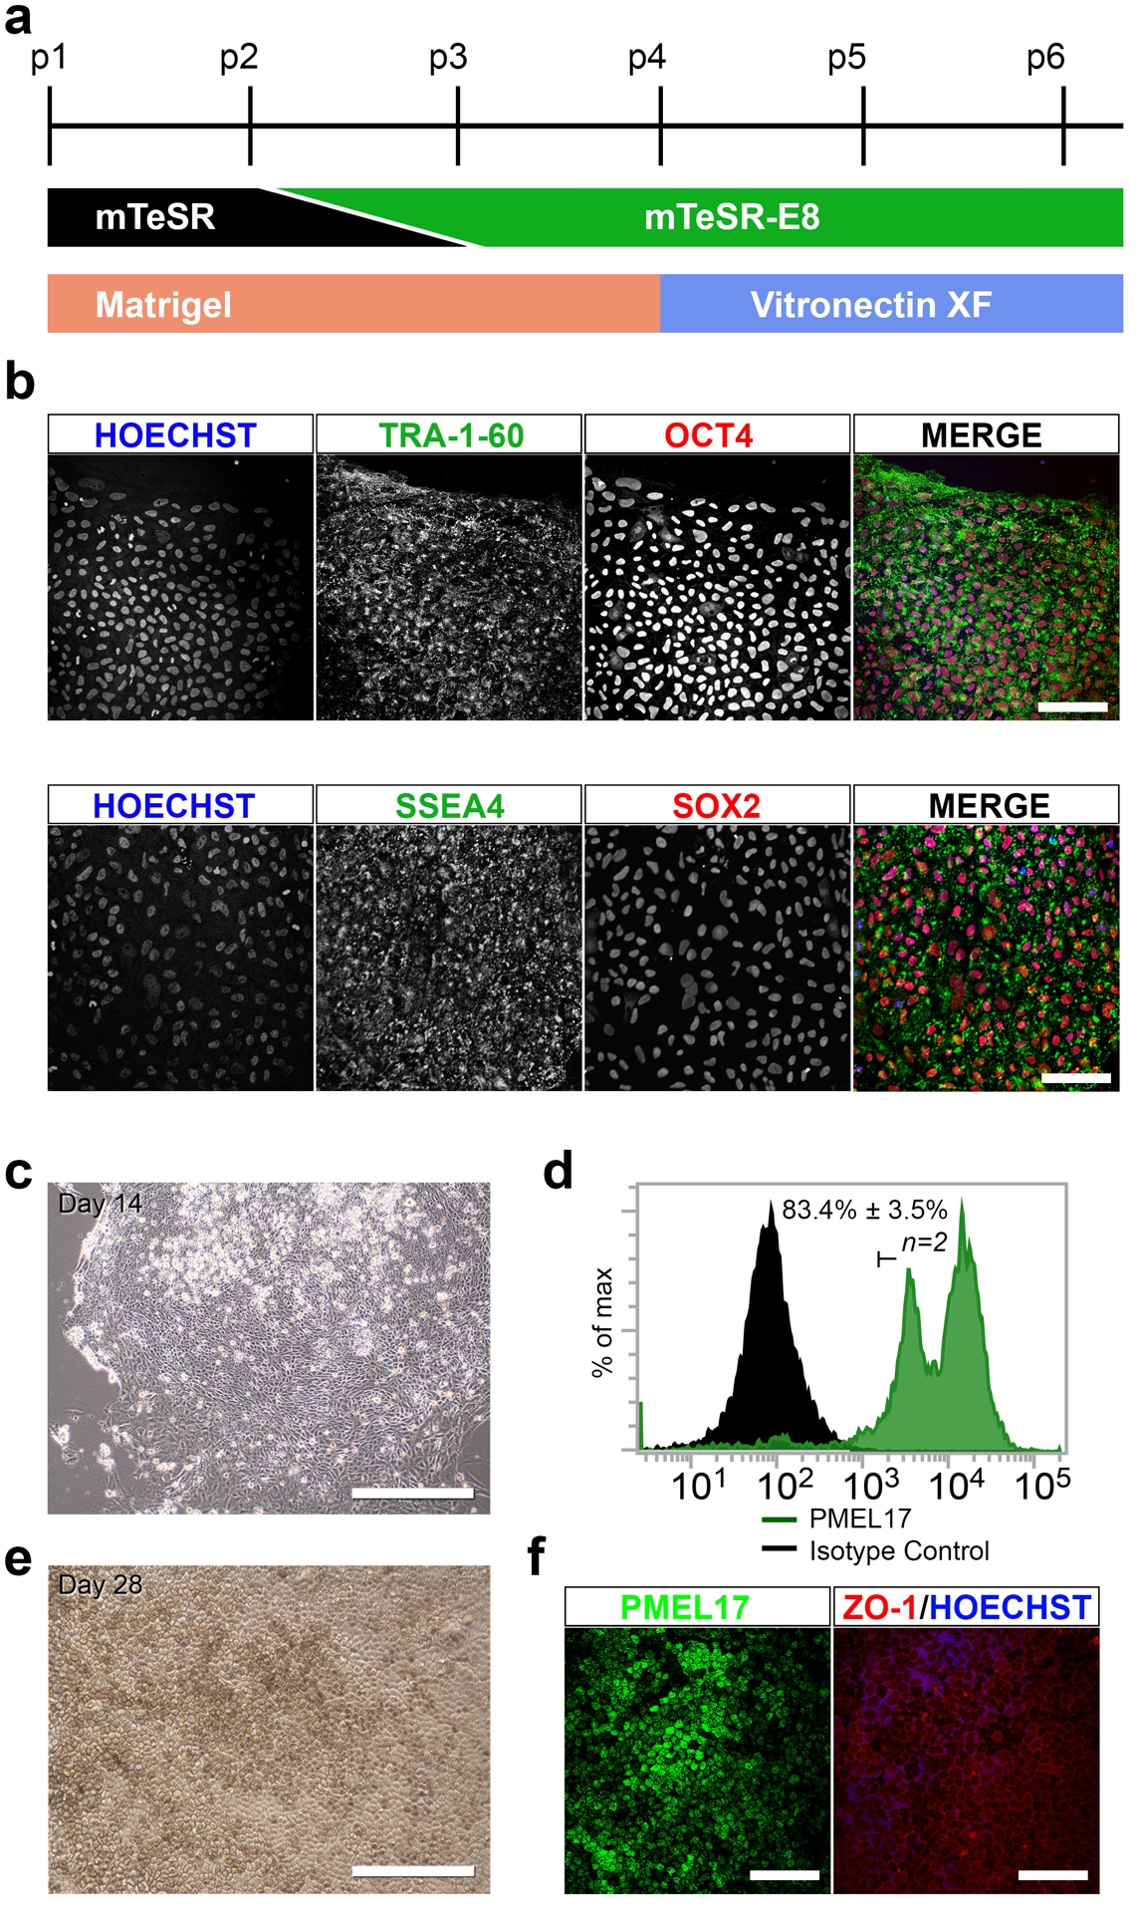

  - Fig. S3 Adaptation of the hESC-RPE cell differentiation protocol to xeno-free conditions. a) A schematic showing the timeline for hESC adaptation to xeno-free (XF) culture conditions. b) Immunofluorescence detection of pluripotency markers OCT4, TRA-1-60, SOX2 and SSEA4 in hESCs grown under xeno-free/defined conditions with Hoechst 33342 staining of nuclei. Scale = 50μm. c) Following differentiation under the protocol developed here, xeno-free hESC-RPE cells appeared in ANEB outgrowths by Day 14. Scale = 100μm. d) Determination of differentiation efficiency at Day 14 by detection of PMEL17 using flow cytometry. e) Photomicrograph of hESC-RPE cells showing cobblestone morphology and pigmentation at Day 28. f) Confirmation of RPE markers PMEL17 and ZO-1 on maturing xeno-free hESC-RPE cells. Scale = 100μm.

