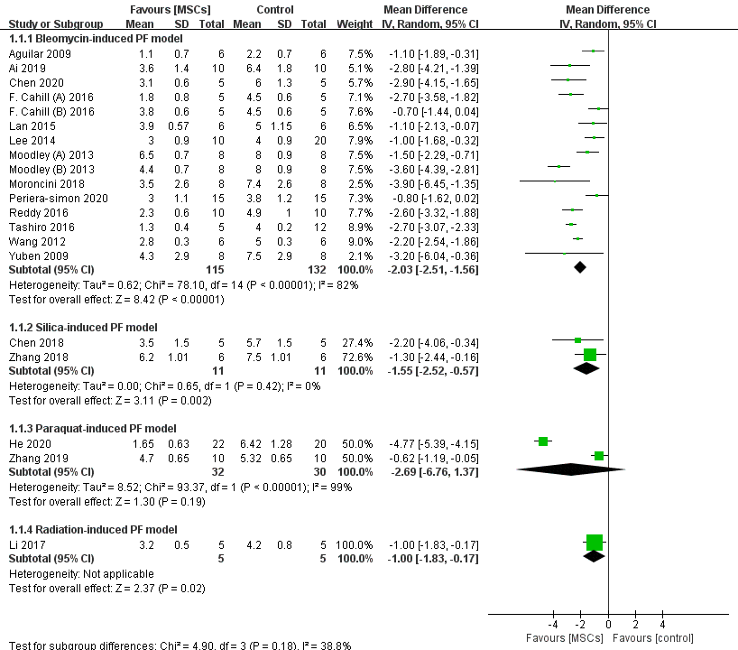

Fig. S1 Forest plot summarizing the relationship between PF models and pulmonary fibrosis scores in preclinical models of PF.

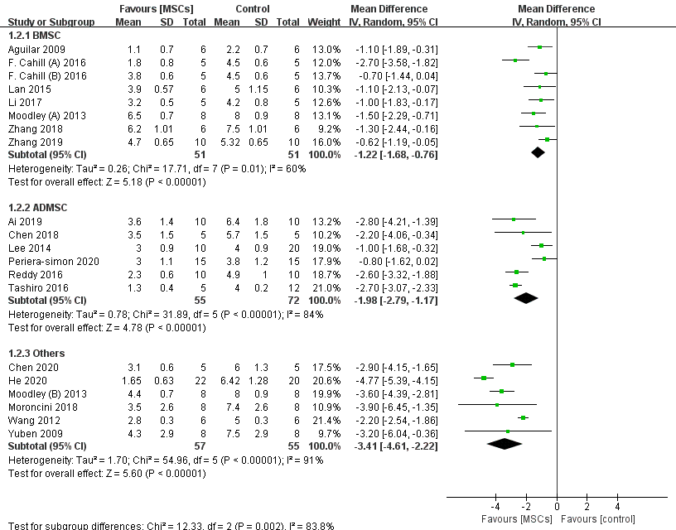

Fig. S2 Forest plot summarizing the relationship between MSCs type and pulmonary fibrosis scores in preclinical models of PF.

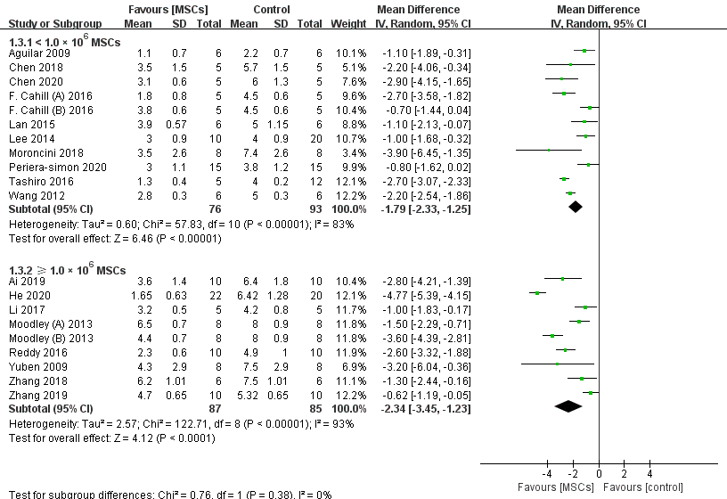
Fig. S3 Forest plot summarizing the relationship between MSCs dose and pulmonary fibrosis scores in preclinical models of PF.

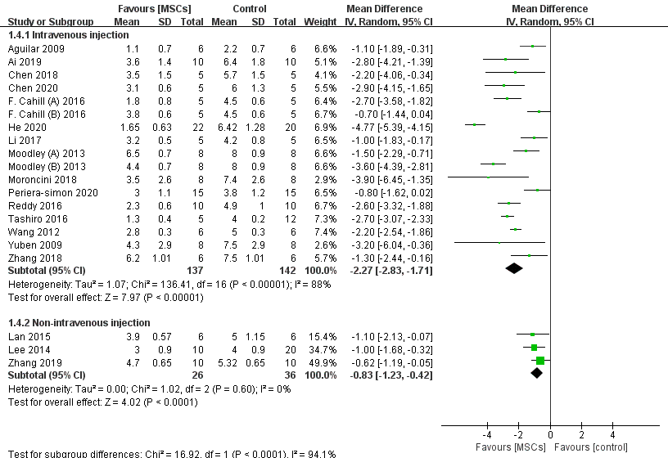
Fig. S4 Forest plot summarizing the relationship between MSCs route and pulmonary fibrosis scores in preclinical models of PF.

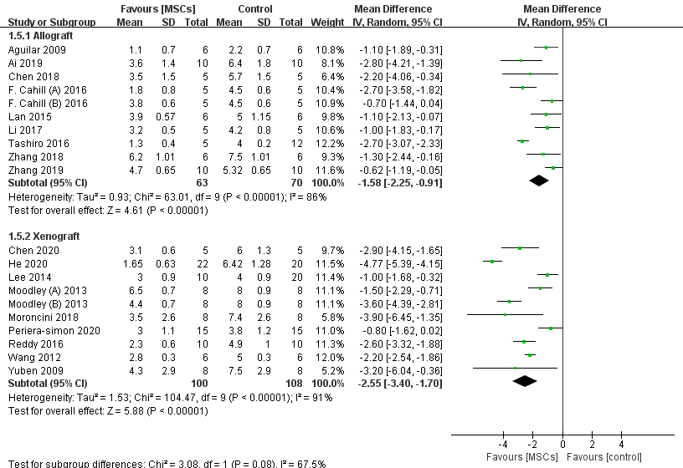
Fig. S5 Forest plot summarizing the relationship between transplant type and pulmonary fibrosis scores in preclinical models of PF.

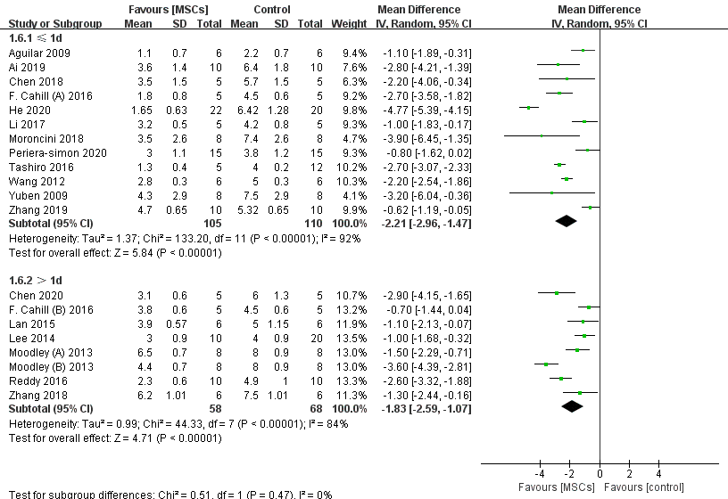
Fig. S6 Forest plot summarizing the relationship between timing of MSCstherapy after PF and pulmonary fibrosis scores in preclinical models of PF.

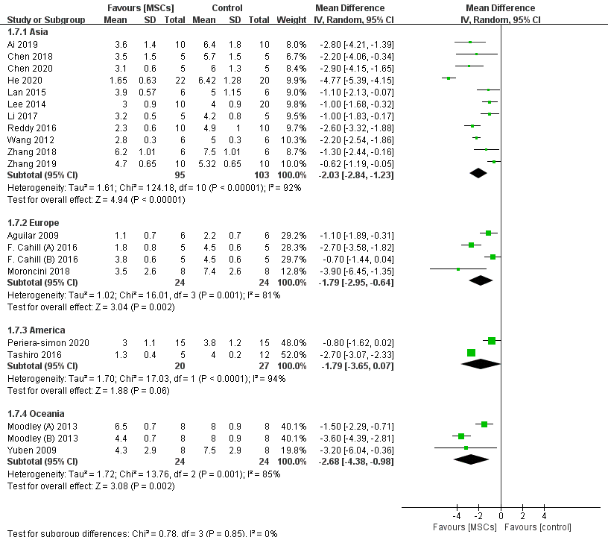

Fig. S7 Forest plot summarizing the relationship between geographic location and pulmonary fibrosis scores in preclinical models of PF.

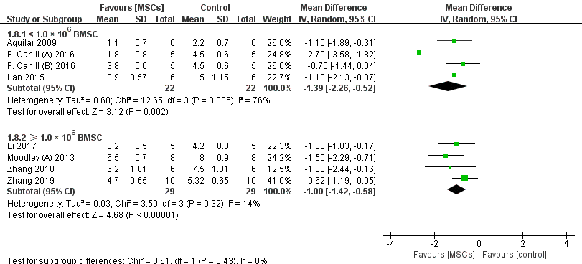
Fig. S8 Forest plot summarizing the relationship between BMSC dose and pulmonary fibrosis scores in preclinical models of PF.

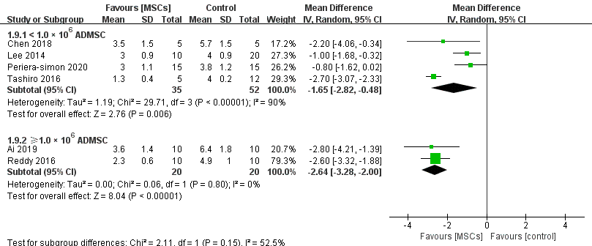
Fig. S9 Forest plot summarizing the relationship between ADMSC dose and pulmonary fibrosis scores in preclinical models of PF.

