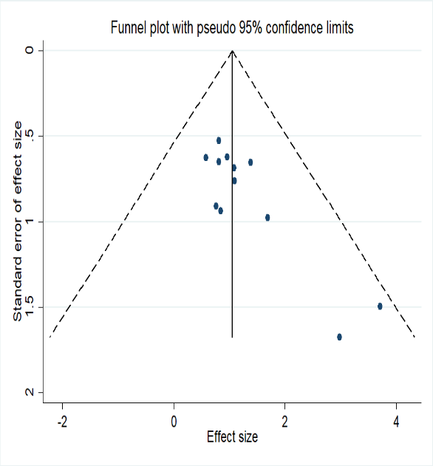
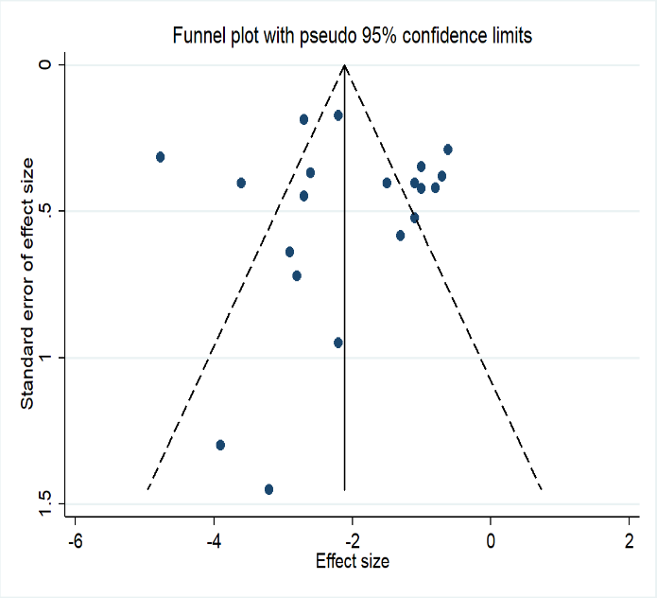
a
b
Fig. S11 Funnel plots for (a) survival rate, (b) pulmonary fibrosis scores.

