Supplemental Files
Biomimetic nerve guidance conduit containing engineered exosomes of Adipose derived stem cells promote peripheral nerve regeneration
Zheng Yang^{1,2†}, Yang Yang^{3†}, Yichi Xu¹, Weiqian Jiang^{1,2}, Yan Shao⁴, Jiahua Xing⁴, Youbai Chen^{1*},Yan Han ^{1*}

* Correspondence: youbaichen@foxmail.com; 13720086335@163.com
†Equal contributors
¹Department of Plastic Surgery, The First Medical Center, Chinese PLA General Hospital, Beijing 100853, China.
²Medical School of Chinese PLA, Chinese PLA General Hospital, Beijing 100853, China.
³PLA 82nd Group Army Hospital, Hebei Baoding 071000, China.
⁴School of Medicine, Nankai University, Tianjin 300071, China.

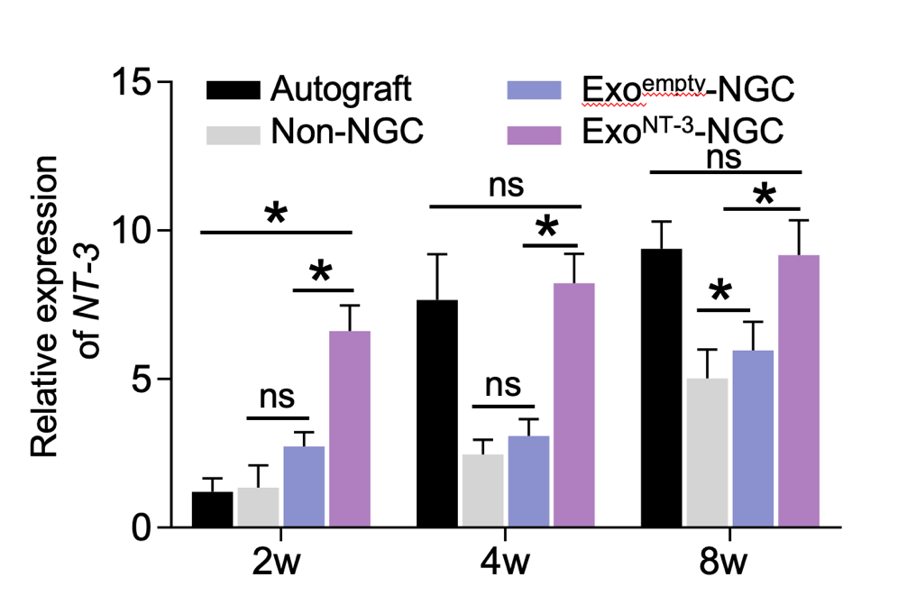
Figure S1. qPCR analysis of NT-3 mRNA expression level in the proximal segment of the transected nerves after 2, 4 and 8 weeks postoperation. Data are presented as mean ± SEM, n = 6 rats per group. *P < 0.05 by one-way ANOVA with post hoc Bonferroni correction.

