Additional file 1
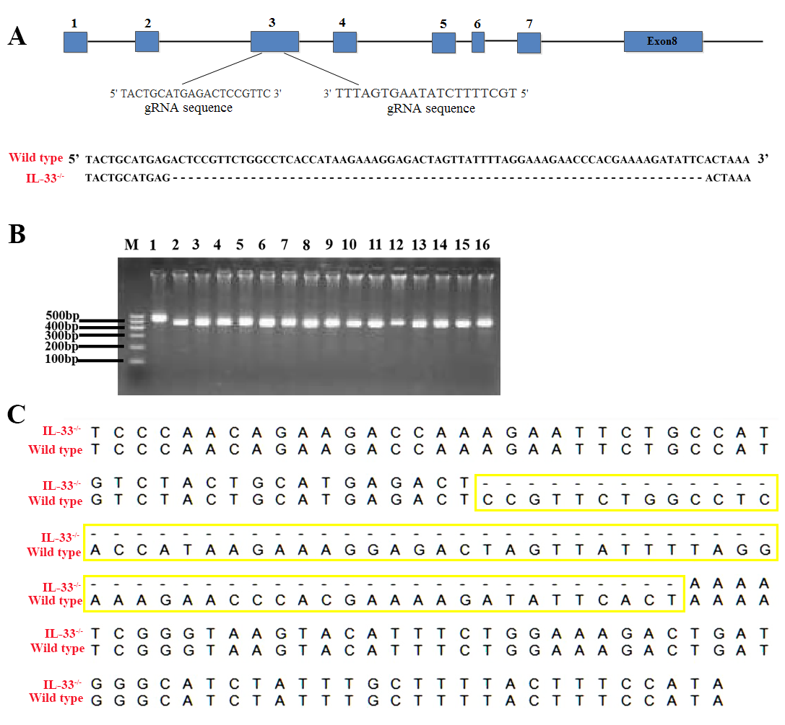
Additional file 1: Generation of IL-33^{-/-} mice by CRISPR/Cas9 tecnology. (A) The strategy of IL-33^{-/-} mice was generated by targeting the exon 3 region. (B) The genotype of IL-33^{-/-} mice was detected by PCR. The first lane named M is DNA marker. The amplification band of wild type is longer than 500bp and IL-33 knock out genotype is 500bp. (C) Genetic sequencing of purified PCR products of wild type and IL-33^{-/-} mice.

