Additional file 3
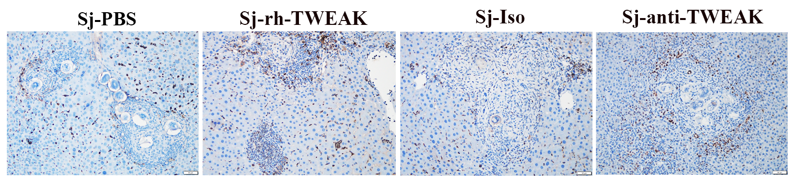
Additional file 3: The proliferation of HPCs didn’t affect the proliferated ability of mature hepatocytes in S. japonicum infection mice. Representative images of Ki67 staining.

