Supporting Information:

Induction of meiosis by embryonic gonadal somatic cells differentiated from pluripotent stem cells
Wang, et al.

The Following Files are Included:

Supplementary Figures and Legends

Supplementary Figures S1-S8

Supplementary Table S1

Supplementary Figures and Legends

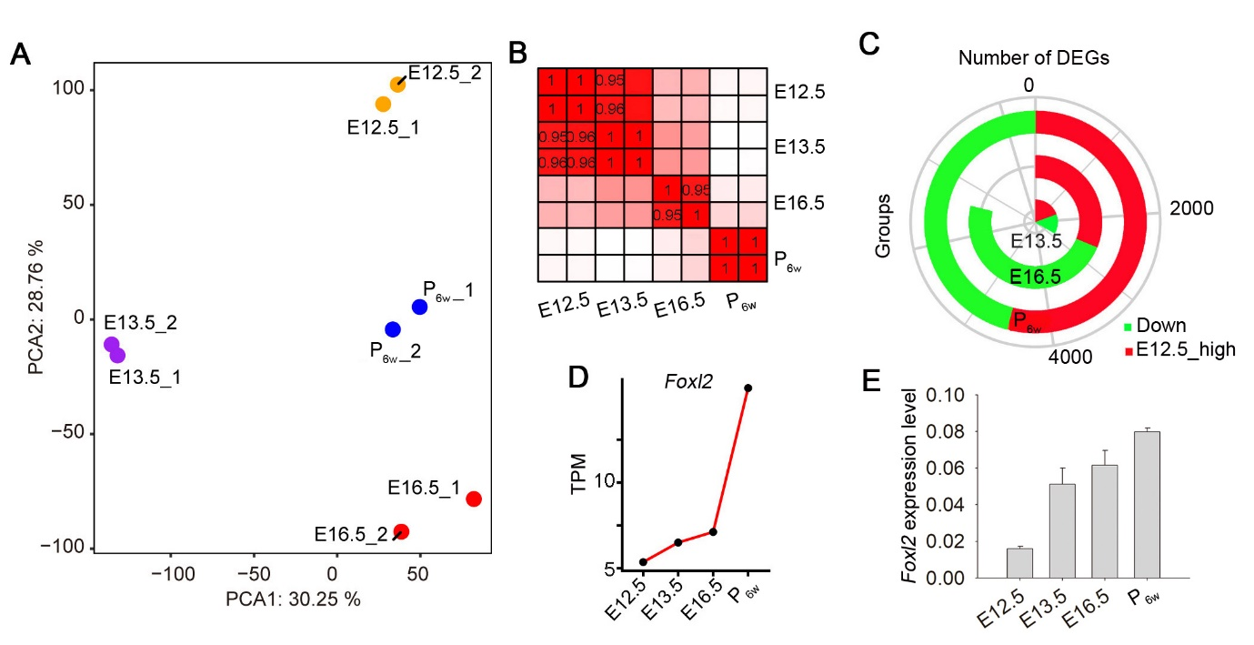

Supplementary Figure S1. Transcriptome analysis of somatic cells at different stages of development.
(A) PCA of E12.5, E13.5, E16.5, P_{6w} showing good repeatability.
(B) Pearson's correlation coefficient graph analysis of E12.5, E13.5, E16.5, and P_{6w}. The value of 1.0 represents the total positive correlation, and 0 represents no correlation between two samples.
(C) Differential expression analysis showing the number of DEGs of E13.5, E16.5, and P_{6w} compared with E12.5. The number of DEGs were gradually increased with the development of gonads.
(D) Line chart showing expression level of Foxl2 in each stage by RNA-seq data.
(E) Foxl2 expression was gradually upregulated during embryonic gonad development.

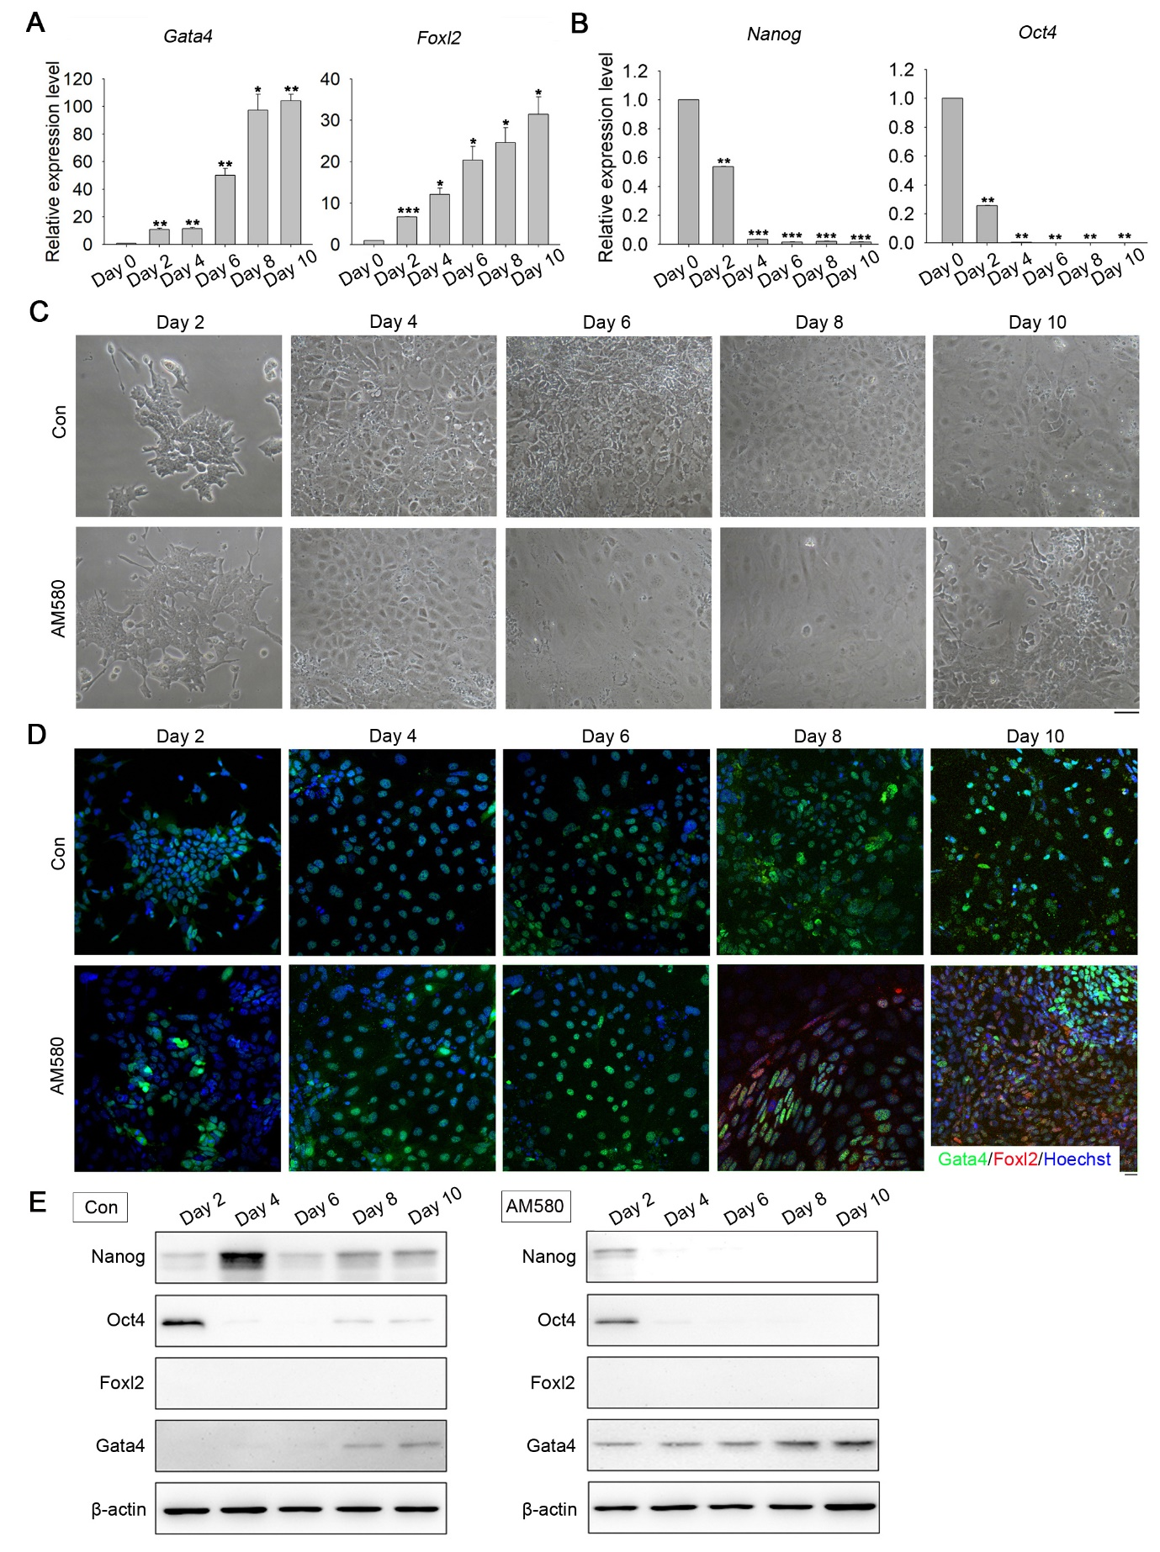

Supplementary Figure S2. AM580 treatment induced expression of Gata4 and of Foxl2 to a lesser extent.
(A) mRNA expression levels of Gata4 and Foxl2 by qPCR in GSCLCs induced by AM580 treatment. Bars = Mean± SEM (n = 3). * P <0.05, ** P <0.01, *** P <0.001.
(B) mRNA expression levels of Nanog and Oct4 by qPCR in GSCLCs induced by AM580 treatment. Bars = Mean± SEM (n = 3). * P <0.05, ** P <0.01, *** P <0.001.
(C) Morphology of GSCLCs induced by Con and AM580 treatment. Scale bar = 100 μm.
(D) Immunostaining of Gata4 and Foxl2 in GSCLCs induced by AM580 treatment. Scale bar = 20 μm.
(E) Protein levels of pluripotency markers (Nanog and Oct4) and E12.5_GSCs markers (Gata4 and Foxl2) in GSCLCs were determined using western blot analysis. β-actin served as a loading control. Left: control group; right: AM580-treated group.

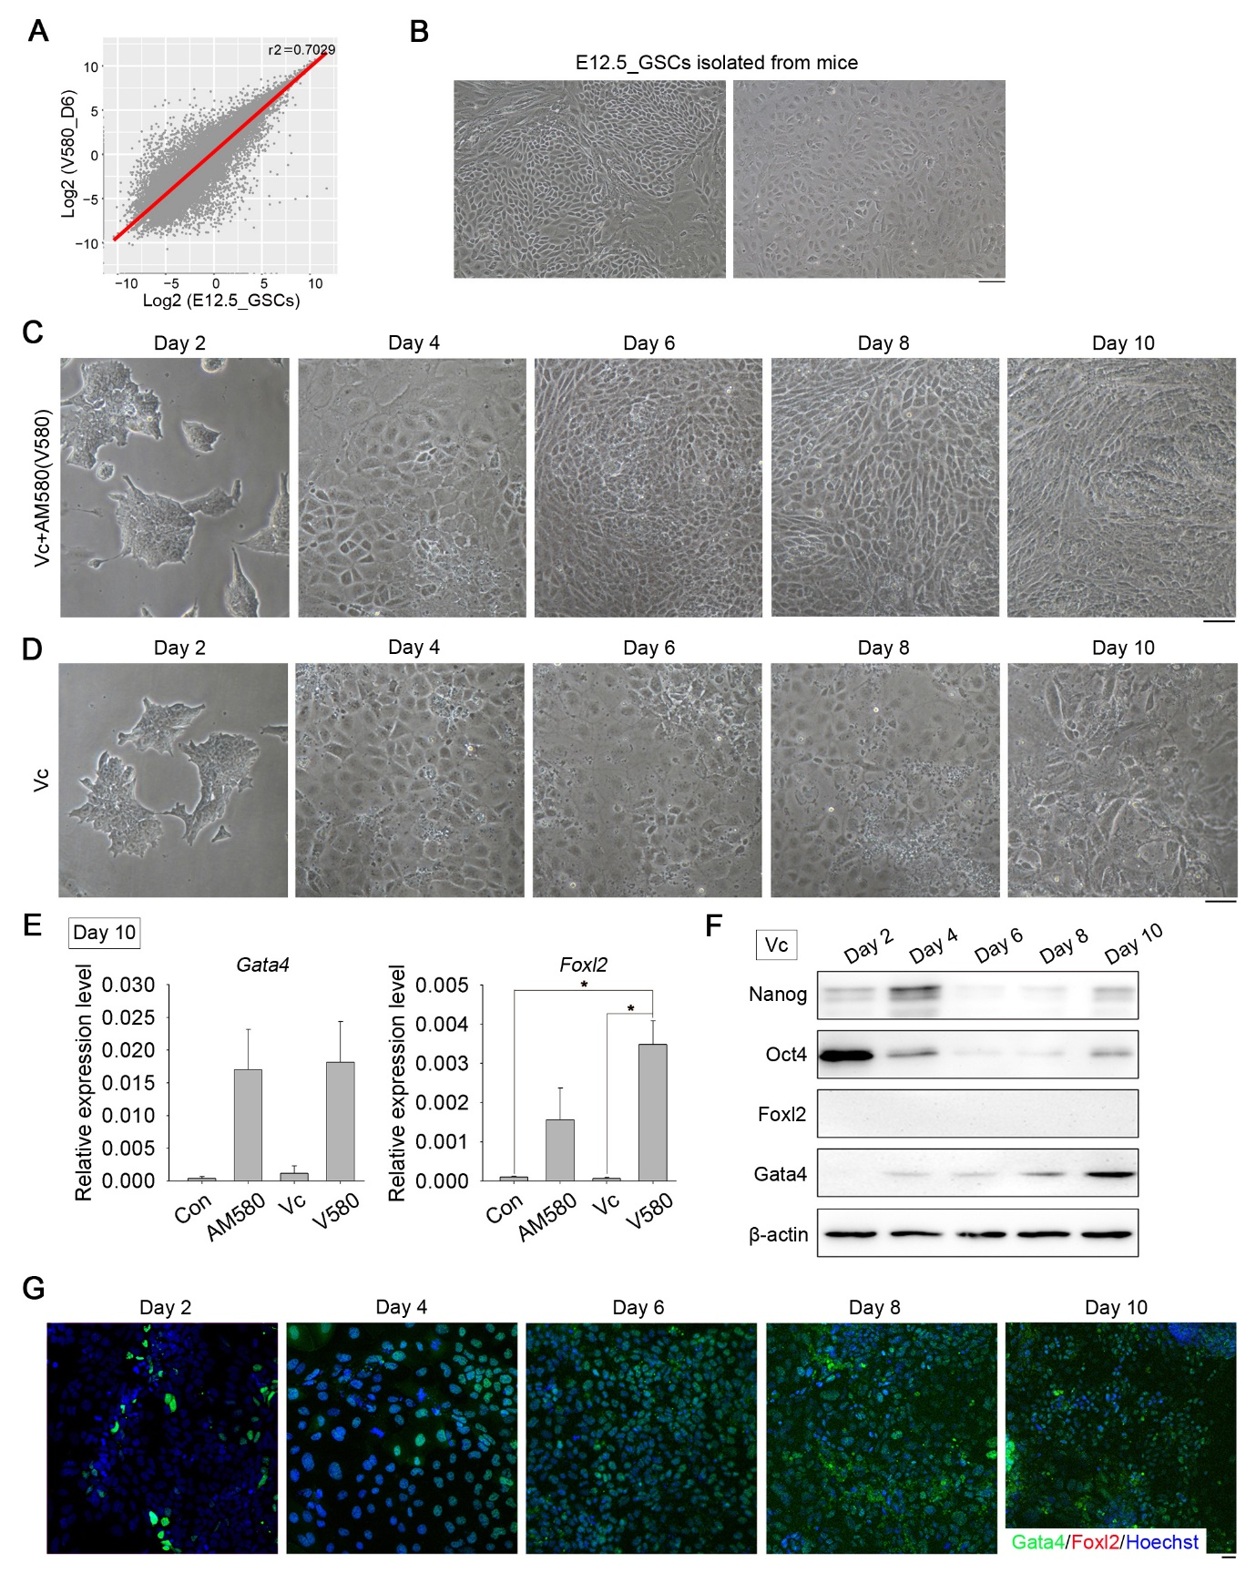
Supplementary Figure S3. Vc alone could not induce Foxl2 expression.
(A) Correlation analysis showed that the similarity of V580_D6 GSCLCs and E12.5_GSCs based on the overall transcriptome reached 70.29%.
(B) Morphology of E12.5_GSCs cultured in a well. Scale bar = 100 μm.
(C) Morphology of GSCLCs induced by V580 treatment. Scale bar = 100 μm.
(D) Morphology of GSCLCs induced by Vc treatment. Scale bar = 100 μm.
(E) Treatment with Vc alone did not induce Foxl2 expression even at day 10, whereas Gata4 was slightly upregulated. Bars = Mean± SEM (n = 3).*, P <0.05, **, P <0.01, ***, P <0.001.
(F) Protein levels of pluripotency markers (Nanog and Oct4) and E12.5_GSCs markers (Gata4 and Foxl2) in GSCLCs induced by Vc treatment, as determined using western blot analysis. β-actin served as a loading control.
(G) Immunostaining of Gata4 and Foxl2 in GSCLCs induced by Vc treatment. Scale bar = 20 μm.
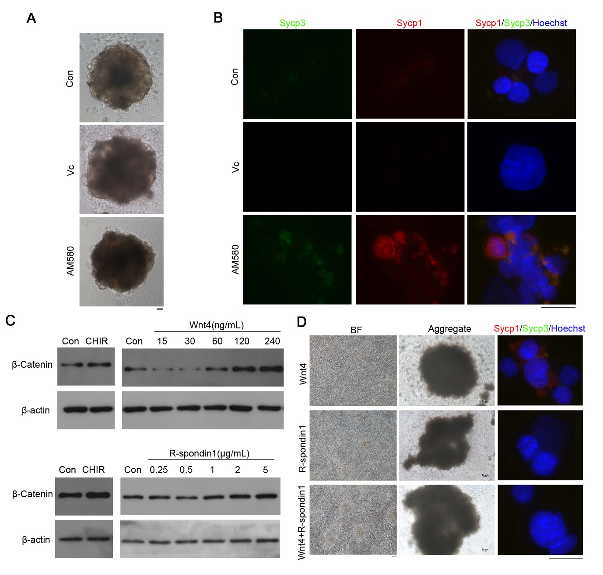Supplementary Figure S4. GSCLCs induced by only Vc, AM580, Wnt4, R-spondin1, or Wnt4+R-spondin1 cannot initiate meiosis.
(A) Morphology of their aggregates induced by Vc or AM580 with E12.5_PGCs. Scale bar = 50 μm. Con: ESCs induced without molecules served as a control. Scale bar = 50 μm.
(B) No Sycp3-positive meiocytes were detected in these groups. Scale bar = 20 μm.
(C) Optimal concentrations of Wnt4 and R-spondin1 for activating the Wnt signaling pathway; 120 ng/mL Wnt4 and 5 μg/mL R-spondin1 were used.
(D) Morphology of GSCLCs induced by Wnt4 and R-spondin1 and their aggregates with PGCs. No Sycp3-positive meiocytes were detected in these groups. Left scale bar = 50 μm, middle scale bar = 50 μm, right scale bar = 20 μm.

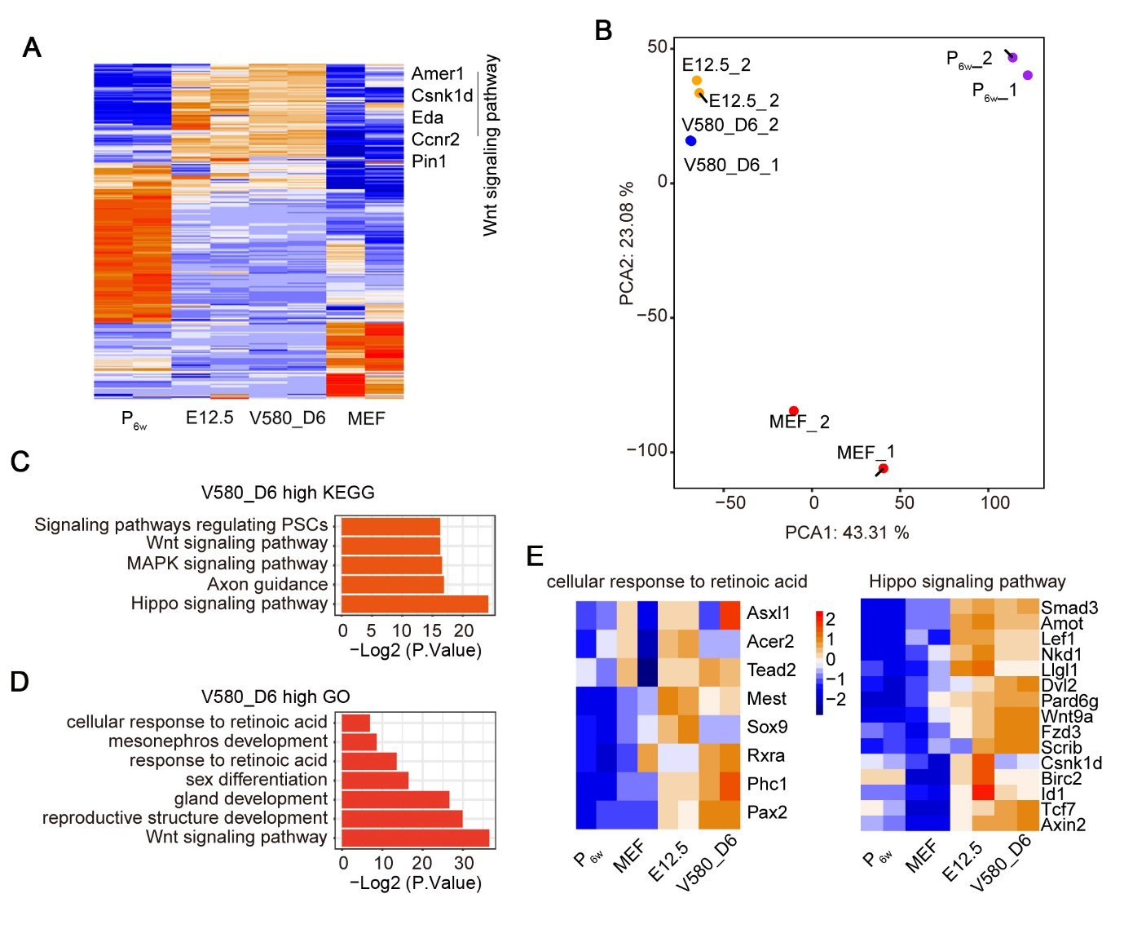
Supplementary Figure S5. The reason why V580_D6 GSCLCs can stimulate normal meiosis progression.
(A) Pheatmap showing DEGs in MEF, V580_D6 GSCLCs, E12.5_GSCs, and P_{6w}.
(B) PCA showing similar expression between E12.5_GSCs and V580_D6 GSCLCs.
(C) KEGG analysis of pathways activated in V580_D6 GSCLCs.
(D) GO terms enriched in V580_D6 GSCLCs.
(E) Similar gene expression patterns in V580_D6 GSCLCs and E12.5_GSCs associated with the cellular response to retinoic acid and the Hippo signaling pathway.
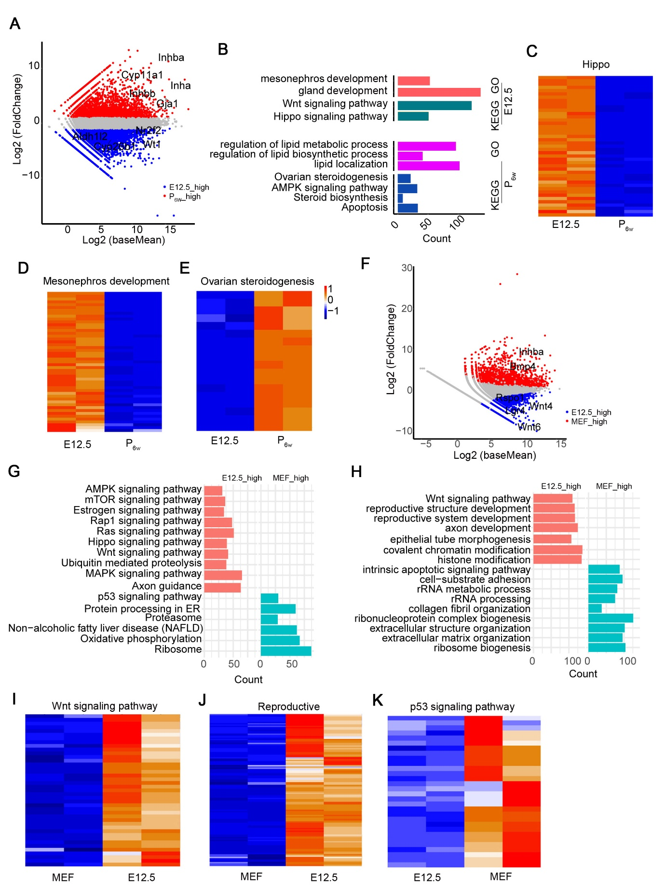
Supplementary Figure S6. Comparison of transcriptomes between P_{6w,} MEF and E12.5_GSCs.
(A) Scatter plot showing DEGs between E12.5 (E12.5_GSCs) and P_{6w}.
(B) KEGG and GO analysis of DEGs between E12.5_GSCs and P_{6w}.
(C-E) Representative GO terms in Hippo signaling, Mesonephros development, Ovarian steroidogenesis.
(F) Scatter plot showing differential gene expression between E12.5_GSCs and MEF.
(G) KEGG analysis of DEGs between E12.5_GSCs and MEF.
(H) GO analysis of DEGs between E12.5_GSCs and MEF.
(I-K) GO terms in Wnt signaling, Reproductive process and p53 signaling pathway.
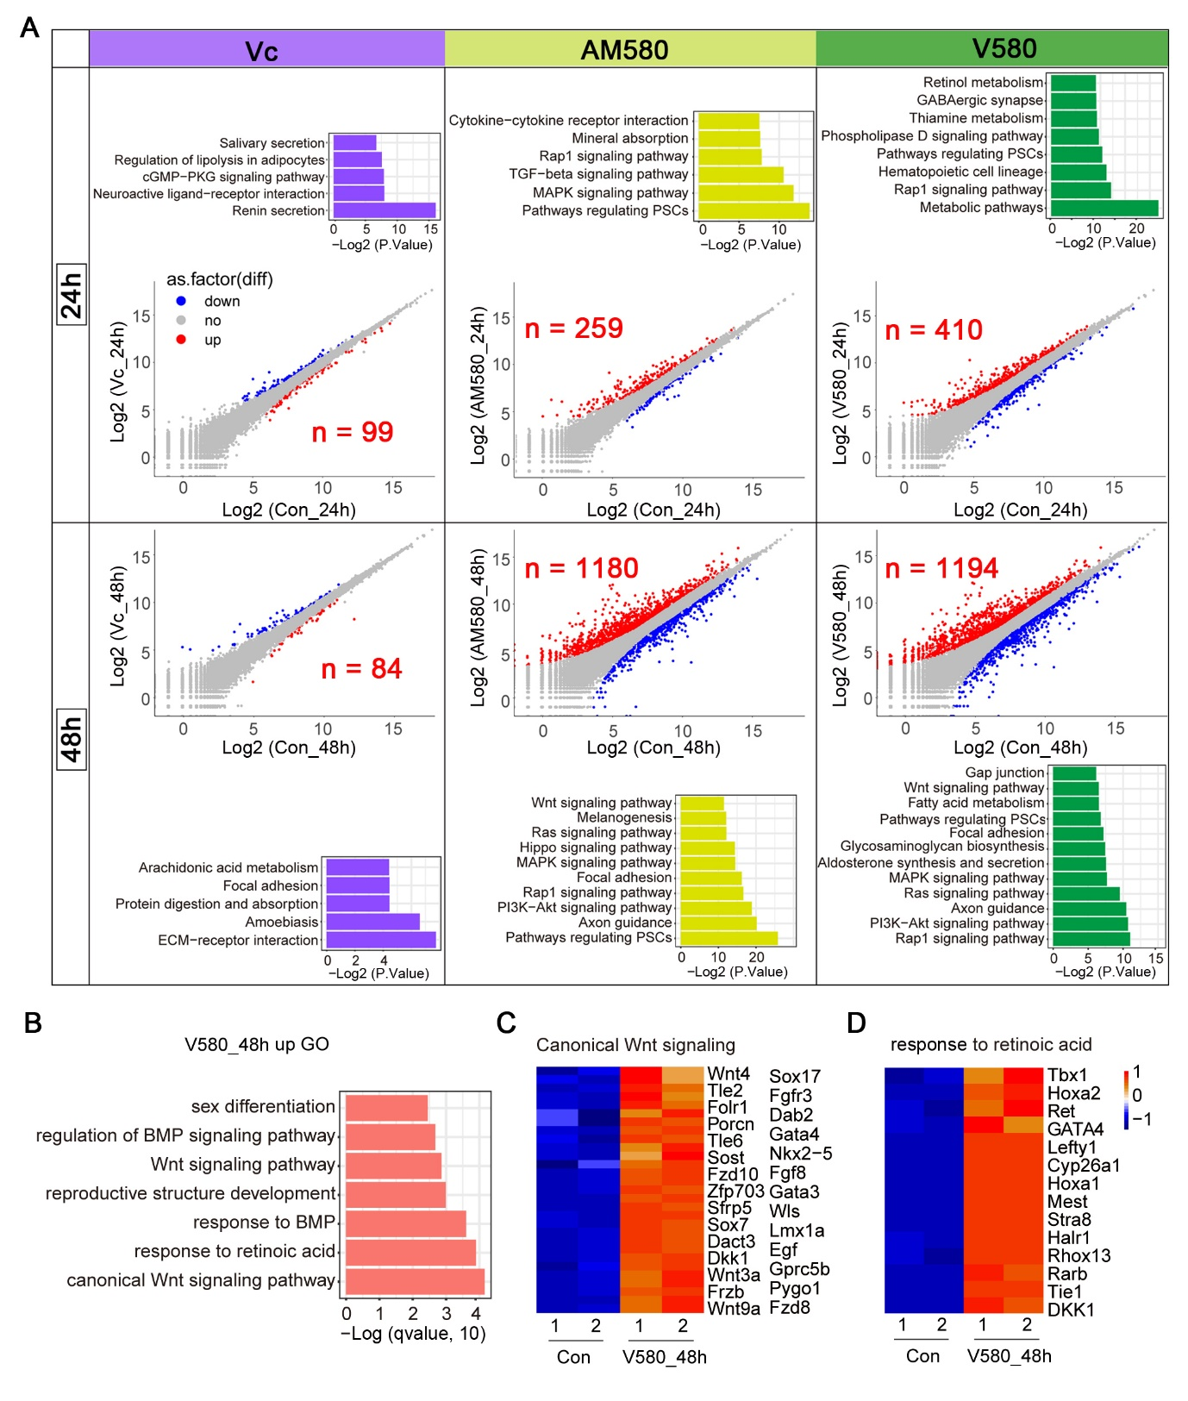
Supplementary Figure S7: Retinoic Acid- and Wnt-related pathways were activated after V580 treatment for 48 h.
(A) Scatterplots for global transcription and KEGG analysis of the upregulated genes. Parallel diagonal lines indicate two-fold threshold for expression differences (P < 0.05).
(B) GO analysis of upregulated genes in V580_48h.
(C) GO terms in Canonical Wnt signaling.
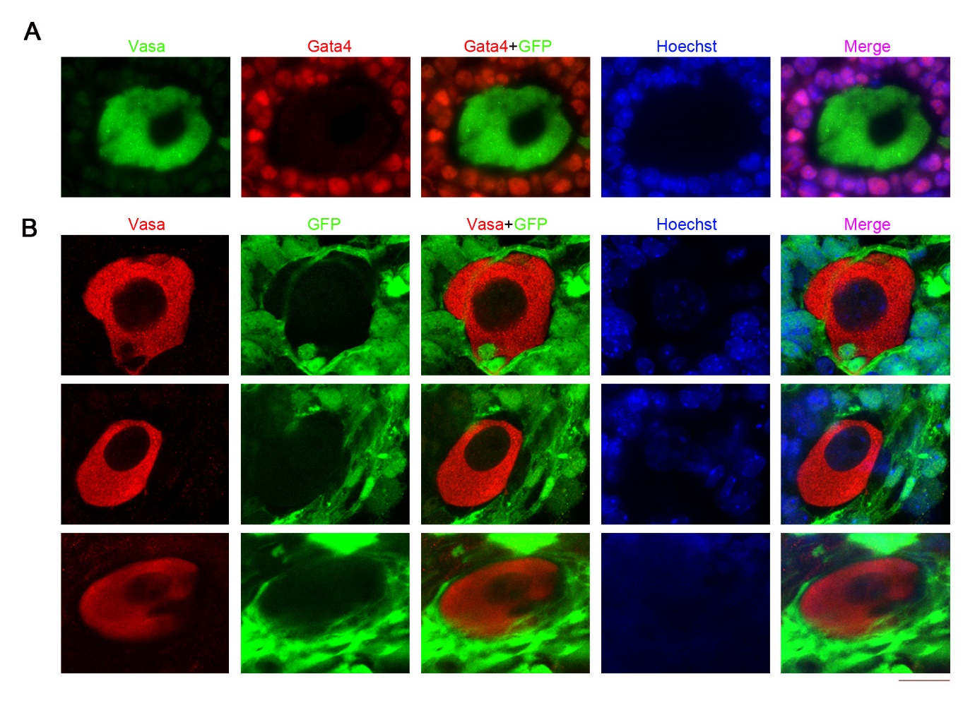
(D) GO terms in response to retinoic acid.
Supplementary Figure S8: Vasa⁺ cells in later developmental stage in Gonad_rOvaries and CD63⁺_rOvaries.
(A) Vasa⁺ cells in later stage in Gonad_rOvaries cultured on Transwell membranes for 21 days. D2+21: cultured in 96 well to form aggregates for 2 days, then cultured on Transwell membranes for another 21 days. Scale bar = 10 μm.
(B) Vasa⁺ cells in CD63⁺_rOvaries can develop to the later stage of ovary development. Scale bar = 10 μm. GFP: GSCLCs.

Supplementary Table S1. Primers for qPCR analysis.
Genes | Forward Primer | Reverse Primer
Gapdh | TCAACAGCAACTCCCACTCTTCCA | ACCACCCTGTTGCTGTAGCCGTAT
Gata4 | GAGCTGGCCTGCGATGTCTGAGTG | AAACGGAAGCCCAAGAACCTGAAT
Foxl2 | ACAACACCGGAGAAACCAGAC | CGTAGAACGGGAACTTGGCTA
Nanog | TTGCTTACAAGGGTCTGCTACT | ACTGGTAGAAGAATCAGGGCT
Oct4 | TTGGGCTAGAGAAGGATGTGGTT | GGAAAAGGGACTGAGTAGAGTGTGG

