SUPPLEMENT MATERIAL

Synergistic regenerative therapy of thin endometrium by human placenta-derived mesenchymal stem cells encapsulated within hyaluronic acid hydrogels
Yifeng Lin^{1†}, Shunni Dong^{2†}, Xiaohang Ye^{1†}, Juan Liu ¹, Jiaqun Li³, Yanye Zhang³, Mixue Tu³, Siwen Wang³, Yanyun Ying³, Ruixue Chen³, Feixia Wang³, Feida Ni³, Jianpen Chen³, Binyang Du²*, Dan Zhang^{1,3}*

¹ Key Laboratory of Women's Reproductive Health of Zhejiang Province and Department of Reproductive Endocrinology, Women's Hospital, Zhejiang University School of Medicine, Hangzhou, Zhejiang 310006, China
² MOE Key Laboratory of Macromolecular Synthesis and Functionalization, Department of Polymer Science & Engineering, Zhejiang University, Hangzhou 310027, China
³ Key Laboratory of Reproductive Genetics (Ministry of Education) and Department of Reproductive Endocrinology, Women's Hospital, Zhejiang University School of Medicine, Hangzhou, Zhejiang 310006, China

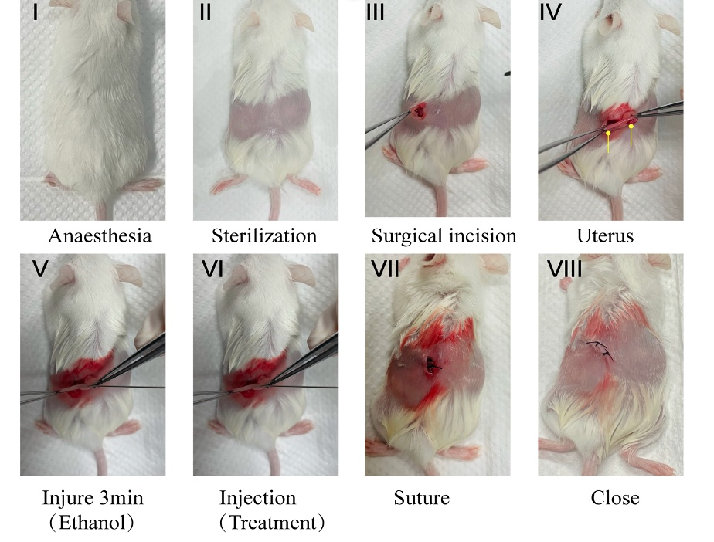

Figure S1. The construction process of the endometrium-injured mouse model. I: mouse anesthesia; II: shaving the back of mouse; III: disinfecting exposed areas; IV: uteri exposure; V: instilling 25 μL ethanol in the uterine cavity and holding 3 min to fully establish the model of thin endometrium; VI: intrauterine instillation of 25 μL treating materials; VII: muscle suture; and VIII: closure of back skin incision.

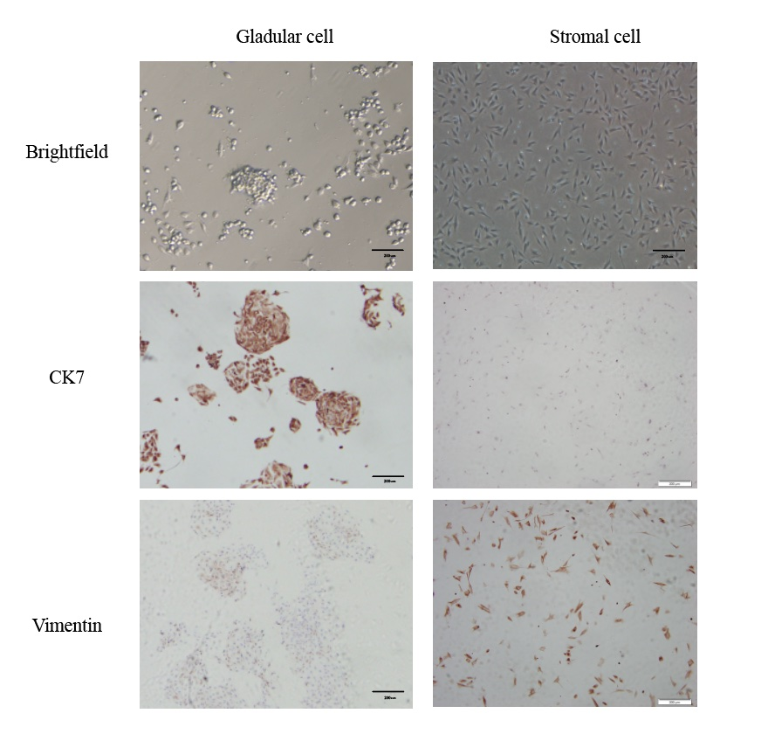

Figure S2. Identification of human primary endometrial gland cells and stromal cells by immunohistochemical staining of CK7 and Vimentin, respectively.

*Corresponding author. E-mail: zhangdan@zju.edu.cn; duby@zju.edu.cn.

