Additional file 1
Table S1 Primer sequences of target genes (mice).
Genes | Primer sequence(5'-3')
β-actin | For: AGTGTGACGTTGACATCCGT
β-actin | Rev: GCAGCTCAGTAACAGTCCGC
IL-10 | For: CAGCTCAGAGGGTTCCCCTA
IL-10 | Rev: CTGGCCACAGTTTTCAGGGA
IL-1β | For: TGGGCCTCAAAGGAAAGAAT
IL-1β | Rev: CAGGCTTGTGCTCTGCTTGT
IL-6 | For: TAGTCCTTCCTACCCCAATTTCC
IL-6 | Rev: TTGGTCCTTAGCCACTCCTTC
TNF-α | For: CCAGACCCTCACACTCAGATC
TNF-α | Rev: CACTTGGTGGTTTGCTACGAC
CD11b | For:GGGTCATTCGCTACGTAATTGG
CD11b | Rev:TGTTCACCAGCTGGCTTAGATG
Arg1 | For:AGACCACAGTCTGGCAGTTG
Arg1 | Rev:CCACCCAAATGACACATAGG
NOS2 | For:ACCTTGGTGAAGGGACTGAG
NOS2 | Rev:TCCGTTCTCTTGCAGTTGAC
F4/80 | For:CTTTGGCTATGGGCTTCCAGTC
F4/80 | Rev:GCAAGGAGGACAGAGTTTATCGTG
CD11c | For: ACGTCAGTACAAGGAGATGTTGGA
CD11c | Rev: ATCCTATTGCAGAATGCTTCTTTACC

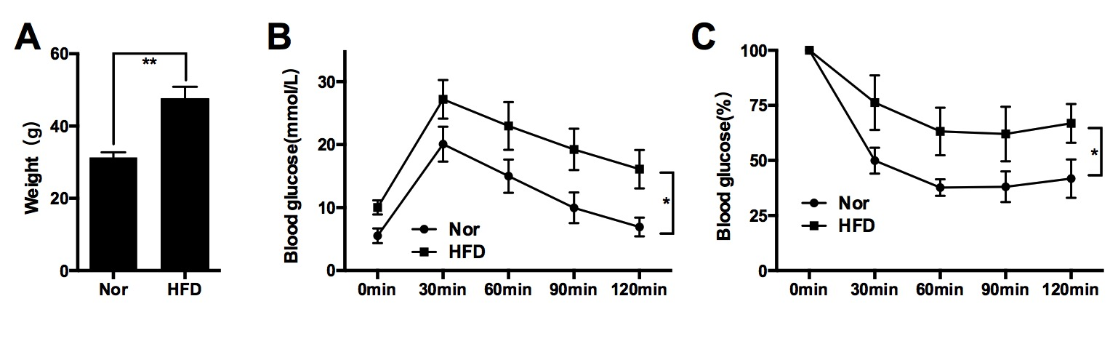
Fig. S1 The induction of obese mice. Eight-week-old male C57BL/6J mice were fed a HFD for 20 weeks to induce obesity. The weight of mice fed with normal diets (Nor group) or high-fat diets (HFD group) for 20 weeks (a). After feeding 20 weeks, glucose tolerance and insulin tolerance were assessed by an IPGTT (b) and IPITT (c), respectively. n = 6-12 mice per group; *P < 0.05, **P < 0.01.

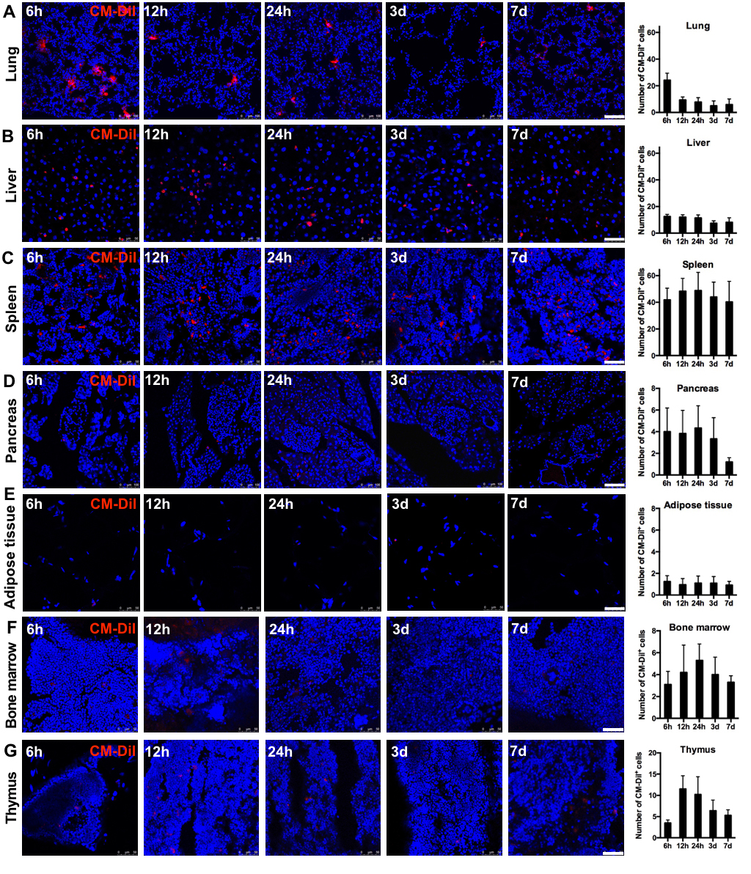
Fig. S2 UC-MSC homing in obese mice. HFD-induced obese mice were intravenously infused with 1×10⁶ UC-MSCs labeled with CM-Dil before infusion. Then, the mice were sacrificed at 6 h, 12 h, 24 h, 3 d and 7 d after UC-MSC infusions. UC-MSC tracking in the lung (a), liver (b), spleen (c), pancreas (d), epididymal adipose tissue (e), bone marrow (f) and thymus (g) was evaluated by confocal laser scanning microscopy. Scale bar, 100 μm (a, d), 50 μm (b, c, e, f, g). Values are presented as the means ± SDs. n = 6 mice per group; *P < 0.05, **P < 0.01.

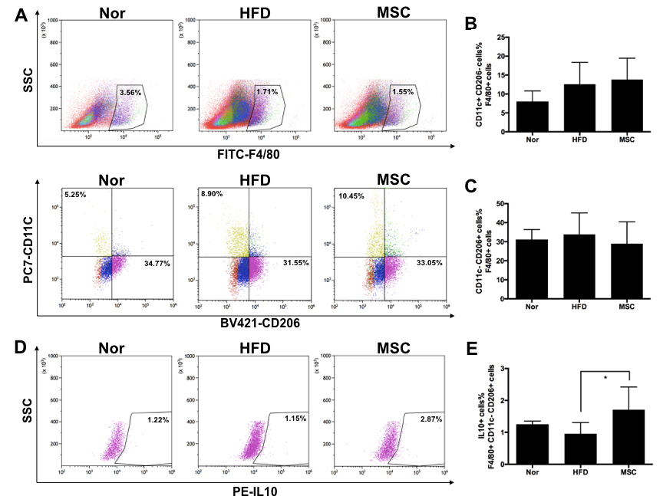Fig. S3 The effect of UC-MSC infusions on macrophages in the spleen. One week after the last UC-MSC infusion, the mice were sacrificed, and the spleen was harvested. Then, splenocytes were extracted from the spleen and detected by flow cytometry. a Freshly obtained splenocytes were incubated with F4/80-FITC, CD11c-PC7, CD206-BV421 and IL-10-PE antibodies. F4/80⁺ cells were selected for CD11c⁺ and CD206⁺ screening. The proportions of CD11c⁺ CD206⁻ and CD11c⁻ CD206⁺ cells are shown in b and c, respectively. d, e The proportion of IL-10⁺ cells among F4/80⁺ CD11c⁻ CD206⁺ cells was detected by flow cytometry.
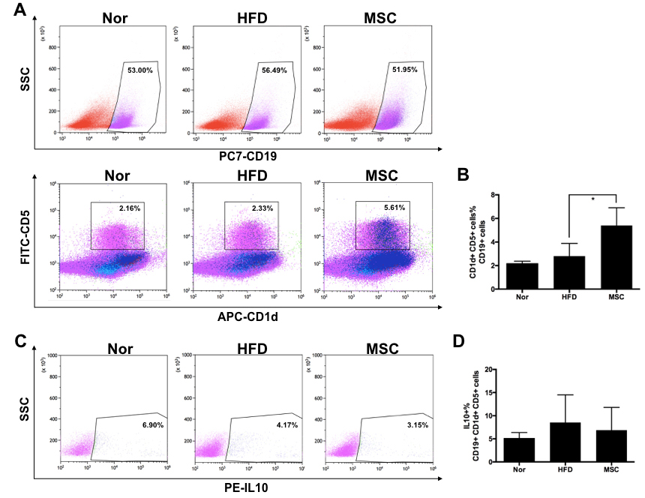Fig. S4 The effect of UC-MSC infusions on B10 cells in the spleen. One week after the last UC-MSC infusion, the mice were sacrificed and the spleen was harvested. Then, splenocytes were extracted from the spleen and detected by flow cytometry. a Freshly obtained splenocytes were incubated with CD19-PC7, CD1d-APC, CD5-FITC and IL-10-PE antibodies. CD19⁺ cells were selected for CD1d ⁺ and CD5⁺ screening. The proportion of CD1d ⁺ CD5⁺cells among CD19⁺ cells is shown in b. c, d The proportion of IL-10⁺ cells among CD19⁺ CD1d ⁺ CD5⁺ cells was detected by flow cytometry. Values are presented as the means ± SDs. n = 6 mice per group; *P < 0.05, **P < 0.01.
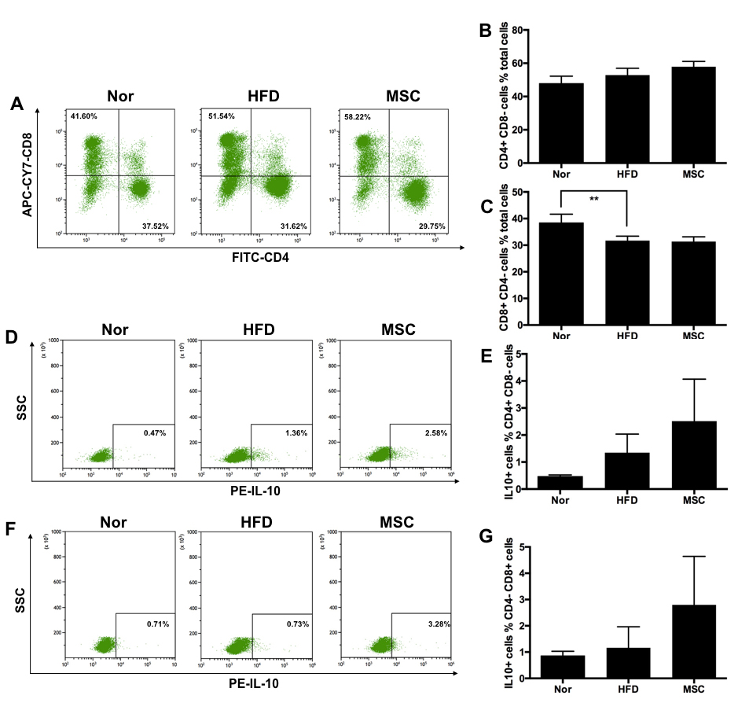Fig. S5 The effect of UC-MSC infusions on CD4⁺ T cells and CD8⁺ T cells in the spleen. One week after the last UC-MSC infusion, the mice were sacrificed and the spleen was harvested. Then, splenocytes were extracted from the spleen and detected by flow cytometry. Freshly obtained splenocytes were incubated with CD3-BV421, CD4-FITC, CD8-APC-CY7 and IL-10-PE antibodies. a The expressions of CD4 and CD8 were detected by flow cytometry. The proportions of CD4⁺CD8⁻ and CD4⁻CD8⁺ cells are shown in b and c, respectively. d, e The proportion of IL-10⁺ cells among CD4⁺ CD8⁻ cells was detected by flow cytometry. f, g The proportion of IL-10⁺ cells among CD4⁻ CD8⁺ cells was detected by flow cytometry. Values are presented as the means ± SDs. n = 6 mice per group; *P < 0.05, **P < 0.01.
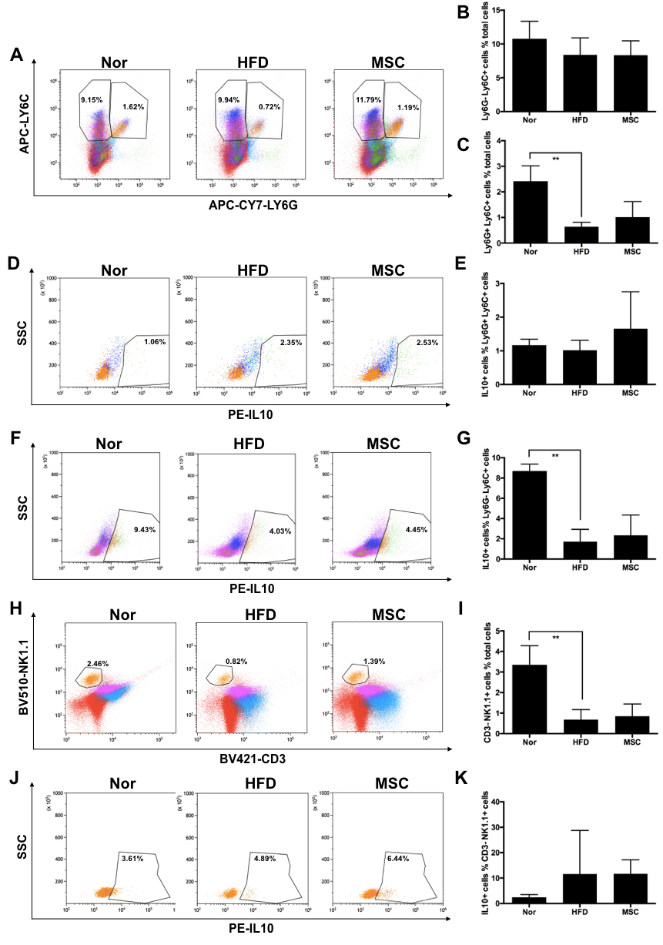Fig. S6 The effect of UC-MSC infusions on monocytes, neutrophils and NK cells in the spleen. One week after the last UC-MSC infusion, the mice were sacrificed and the spleen was harvested. Then, splenocytes were extracted from the spleen and detected by flow cytometry. Freshly obtained splenocytes were incubated with LY6G-APC-CY7, LY6C-APC and IL-10-PE antibodies (a-g). a The expressions of LY6G and LY6C were detected by flow cytometry. The proportion of LY6G⁻LY6C⁺ cells is shown in b. The proportion of LY6G⁺LY6C⁺ cells is shown in c. d, e The proportion of IL-10⁺ cells among LY6G⁺LY6C⁺ cells was detected by flow cytometry. f, g The proportion of IL-10⁺ cells among LY6G⁻LY6C⁺ cells was detected by flow cytometry. Freshly obtained splenocytes were incubated with CD3-BV421, NK1.1-BV510 and IL-10-PE antibodies (h-k). The proportion of CD3⁻ and NK1.1⁺ cells is shown in h and i. The proportion of IL-10⁺ cells among CD3⁻ NK1.1⁺ cells is shown in j and k. Values are presented as the means ± SDs. n = 6 mice per group; *P < 0.05, **P < 0.01.

