FBS vs HPL – P1

COMPARISON 1. FBS 10% vs HPL 10%
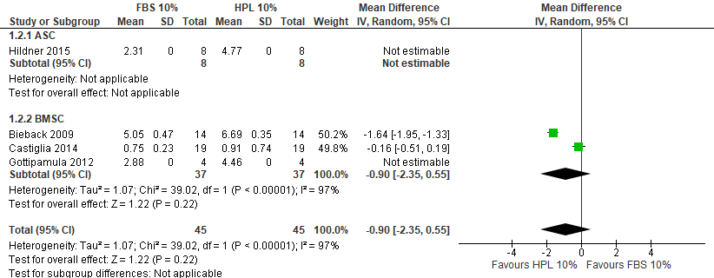

COMPARISON 2. FBS 10% vs HPL 5%
No sufficient studies with available data for meta-analysis.

COMPARISON 3. HPL 10% vs HPL 5%
No sufficient studies with available data for meta-analysis.

FPL VS HPL - P2

COMPARISON 1. FBS 10% vs HPL 10%

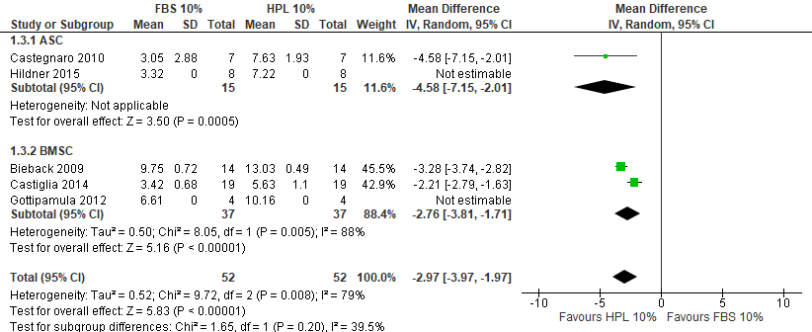

COMPARISON 2. FBS 10% vs HPL 5%
No sufficient studies with available data for meta-analysis.

COMPARISON 3. HPL 10% vs HPL 5%
No sufficient studies with available data for meta-analysis.

FPL VS HPL – P3

COMPARISON 1. FBS 10% vs HPL 10%
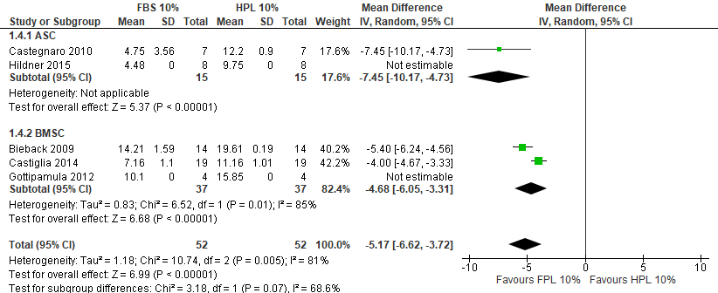

COMPARISON 2. FBS 10% vs HPL 5%
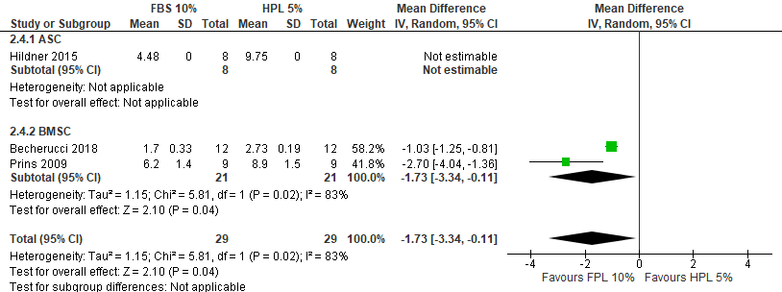

COMPARISON 3. HPL 10% vs HPL 5%
No sufficient studies with available data for meta-analysis.

FPL VS HPL – P4

COMPARISON 1. FBS 10% vs HPL 10%
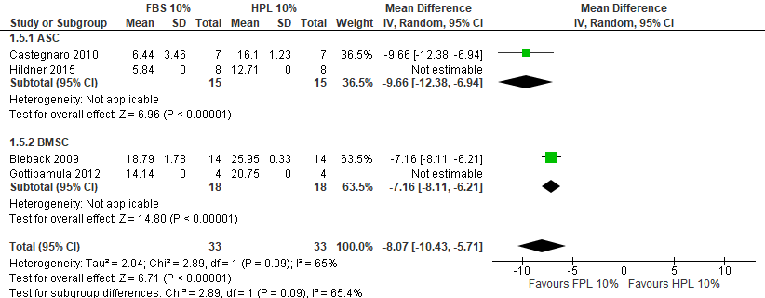

COMPARISON 2. FBS 10% vs HPL 5%
No sufficient studies with available data for meta-analysis.

COMPARISON 3. HPL 10% vs HPL 5%
No sufficient studies with available data for meta-analysis.

FPL VS HPL – P5

COMPARISON 1. FBS 10% vs HPL 10%
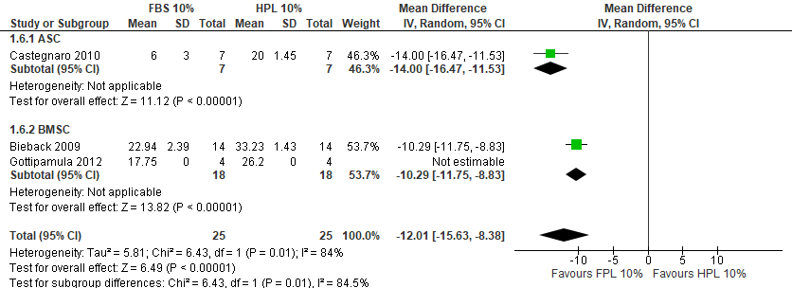

COMPARISON 2. FBS 10% vs HPL 5%
No studies included

COMPARISON 3. HPL 10% vs HPL 5%
No studies included

FPL VS HPL – P7

COMPARISON 1. FBS 10% vs HPL 10%
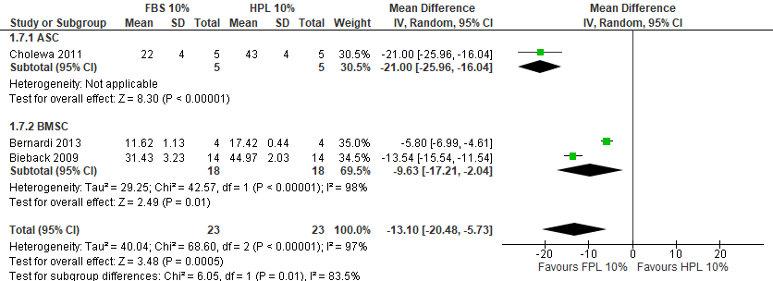

COMPARISON 2. FBS 10% vs HPL 5%
No studies included

COMPARISON 3. HPL 10% vs HPL 5%
No studies included

