Sensitivity analysis

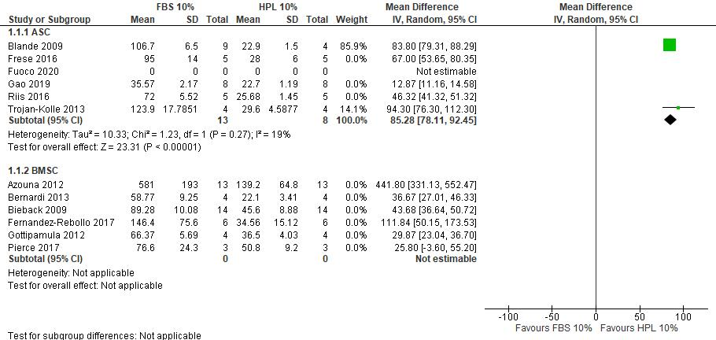
Figure S1. Sensitivity analysis- Forest plot of doubling time for FBS 10% versus HPL 10%. For both BMSCs and ASCs the DT decreased with 10% HPL compared to 10% FBS

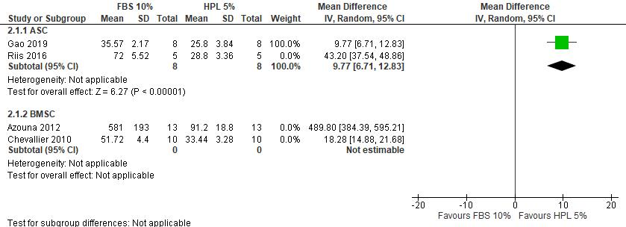
Figure S2. Sensitivity analysis - Forest plot of doubling time for FBS 10% versus HPL 5%. The supplementation with 5% HPL is slightly favored compared to 10% FBS

