Extracellular Vesicles from Hair Follicle-derived Mesenchymal Stromal Cells: Isolation, Characterization and Therapeutic Potential for Chronic Wound Healing
Kevin Las Heras^{1,2}, Félix Royo^{3,4}, Clara Garcia-Vallicrosa³, Manoli Igartua^{1,2,5}, Edorta Santos-Vizcaino^{1,2,5}, Juan M Falcon-Perez*^{,3,4,6} and Rosa Maria Hernandez*^{,1,2,5}

¹NanoBioCel Group, Laboratory of Pharmaceutics, School of Pharmacy (UPV/EHU), 01006 Vitoria-Gasteiz, Spain.
²Bioaraba, NanoBioCel Research Group, Vitoria-Gasteiz, Spain.
³Center for Cooperative Research in Biosciences (CIC bioGUNE), Basque Research and Technology Alliance (BRTA), Exosomes Laboratory, 48160 Derio, Spain
⁴Centro de Investigación Biomédica en Red de Enfermedades Hepáticas y Digestivas (CIBERehd), 28029 Madrid, Spain
⁵Biomedical Research Networking Centre in Bioengineering, Biomaterials and Nanomedicine (CIBER-BBN), 28029 Madrid, Spain.
⁶IKERBASQUE, Basque Foundation for Science, 48013 Bilbao, Spain

* Rosa Maria Hernandez and Juan M. Falcon-Perez equally share credit for senior authorship.
*E-mail addresses rosa.hernandez@ehu.eus and jfalcon@cicbiogune.es

SUPPLEMENTARY INFORMATION
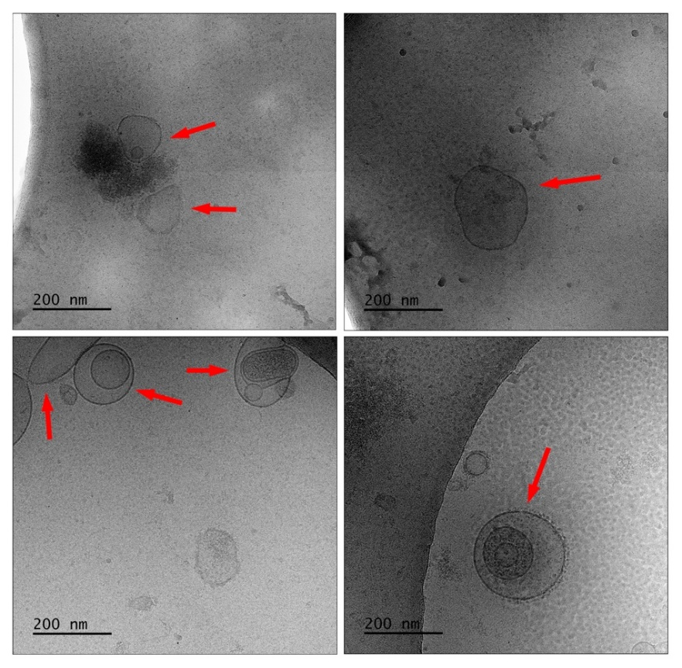
Fig. S1. Cryo-EM images of the diverse heterogeneity of EVs populations
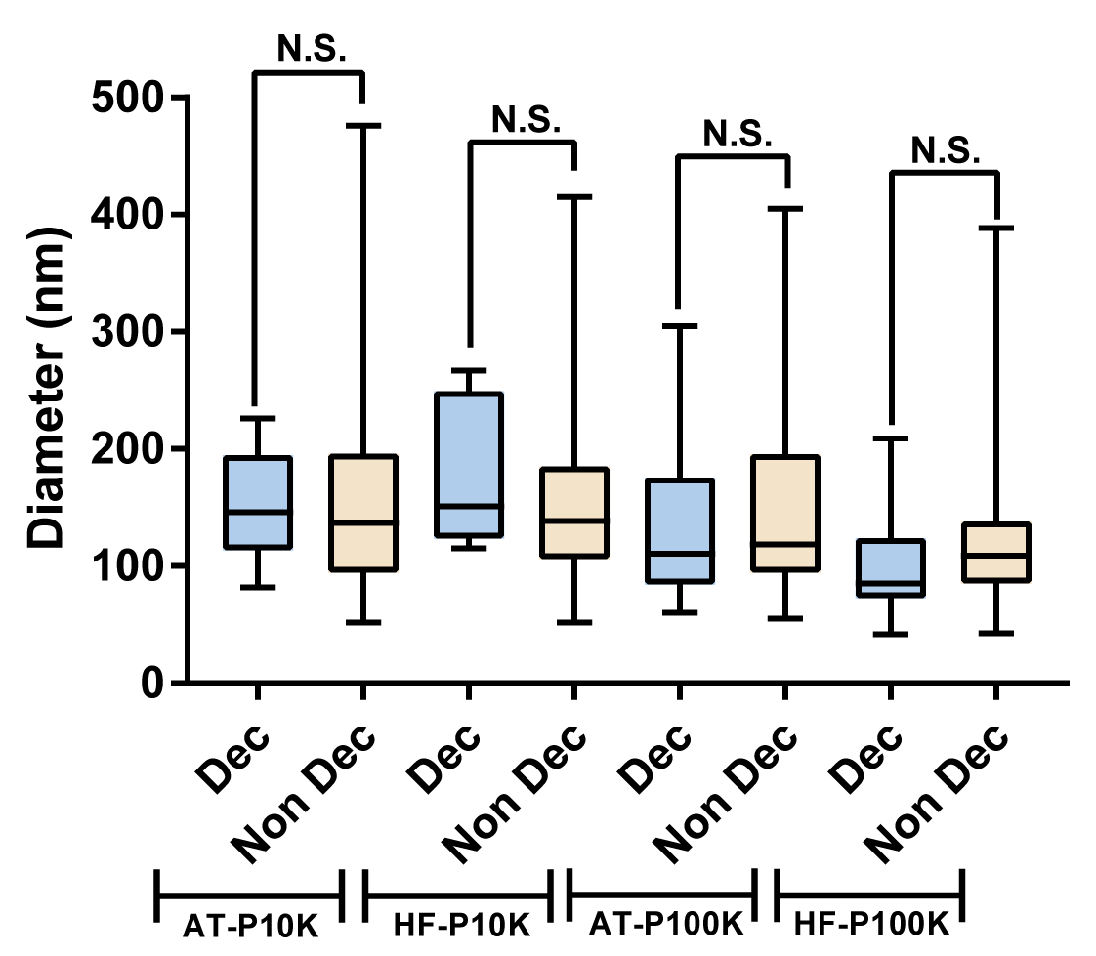
Fig. S2. Comparison in decoration of EVs vs EVs diameter
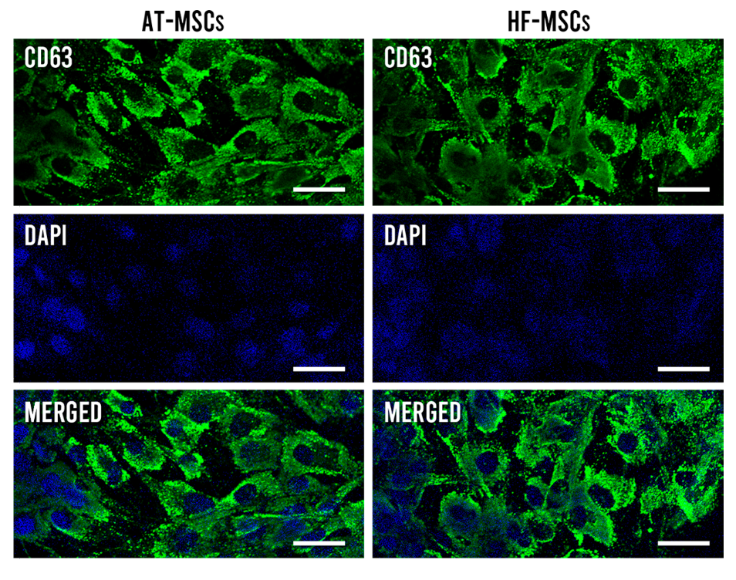
Fig. S3. CD63/DAPI staining of AT-MSCs and HF-MSCs. Scale bars are 40 µm.

Fig. S4. Percentage of positive events according to the flow cytometry study corrected by the number of EVs for each type of EVs and for the different batch preparations.

Fig. S5. CD63 Western Blot extended membrane

