Dppa3 facilitates self-renew of embryonic stem cells by stabilizing of pluripotent factors

Zhao et al.

Supplemental Figures and Legends
Supplemental Figure 1
Supplemental Figure 2
Supplemental Figure 3
Supplemental Figure 4
Supplemental Figure 5

Supplemental Table 1 Dppa3 overexpression sequences.
Supplemental Table 2 Dppa3 knockdown sequences.
Supplemental Table 3 Primer sequences for qPCR

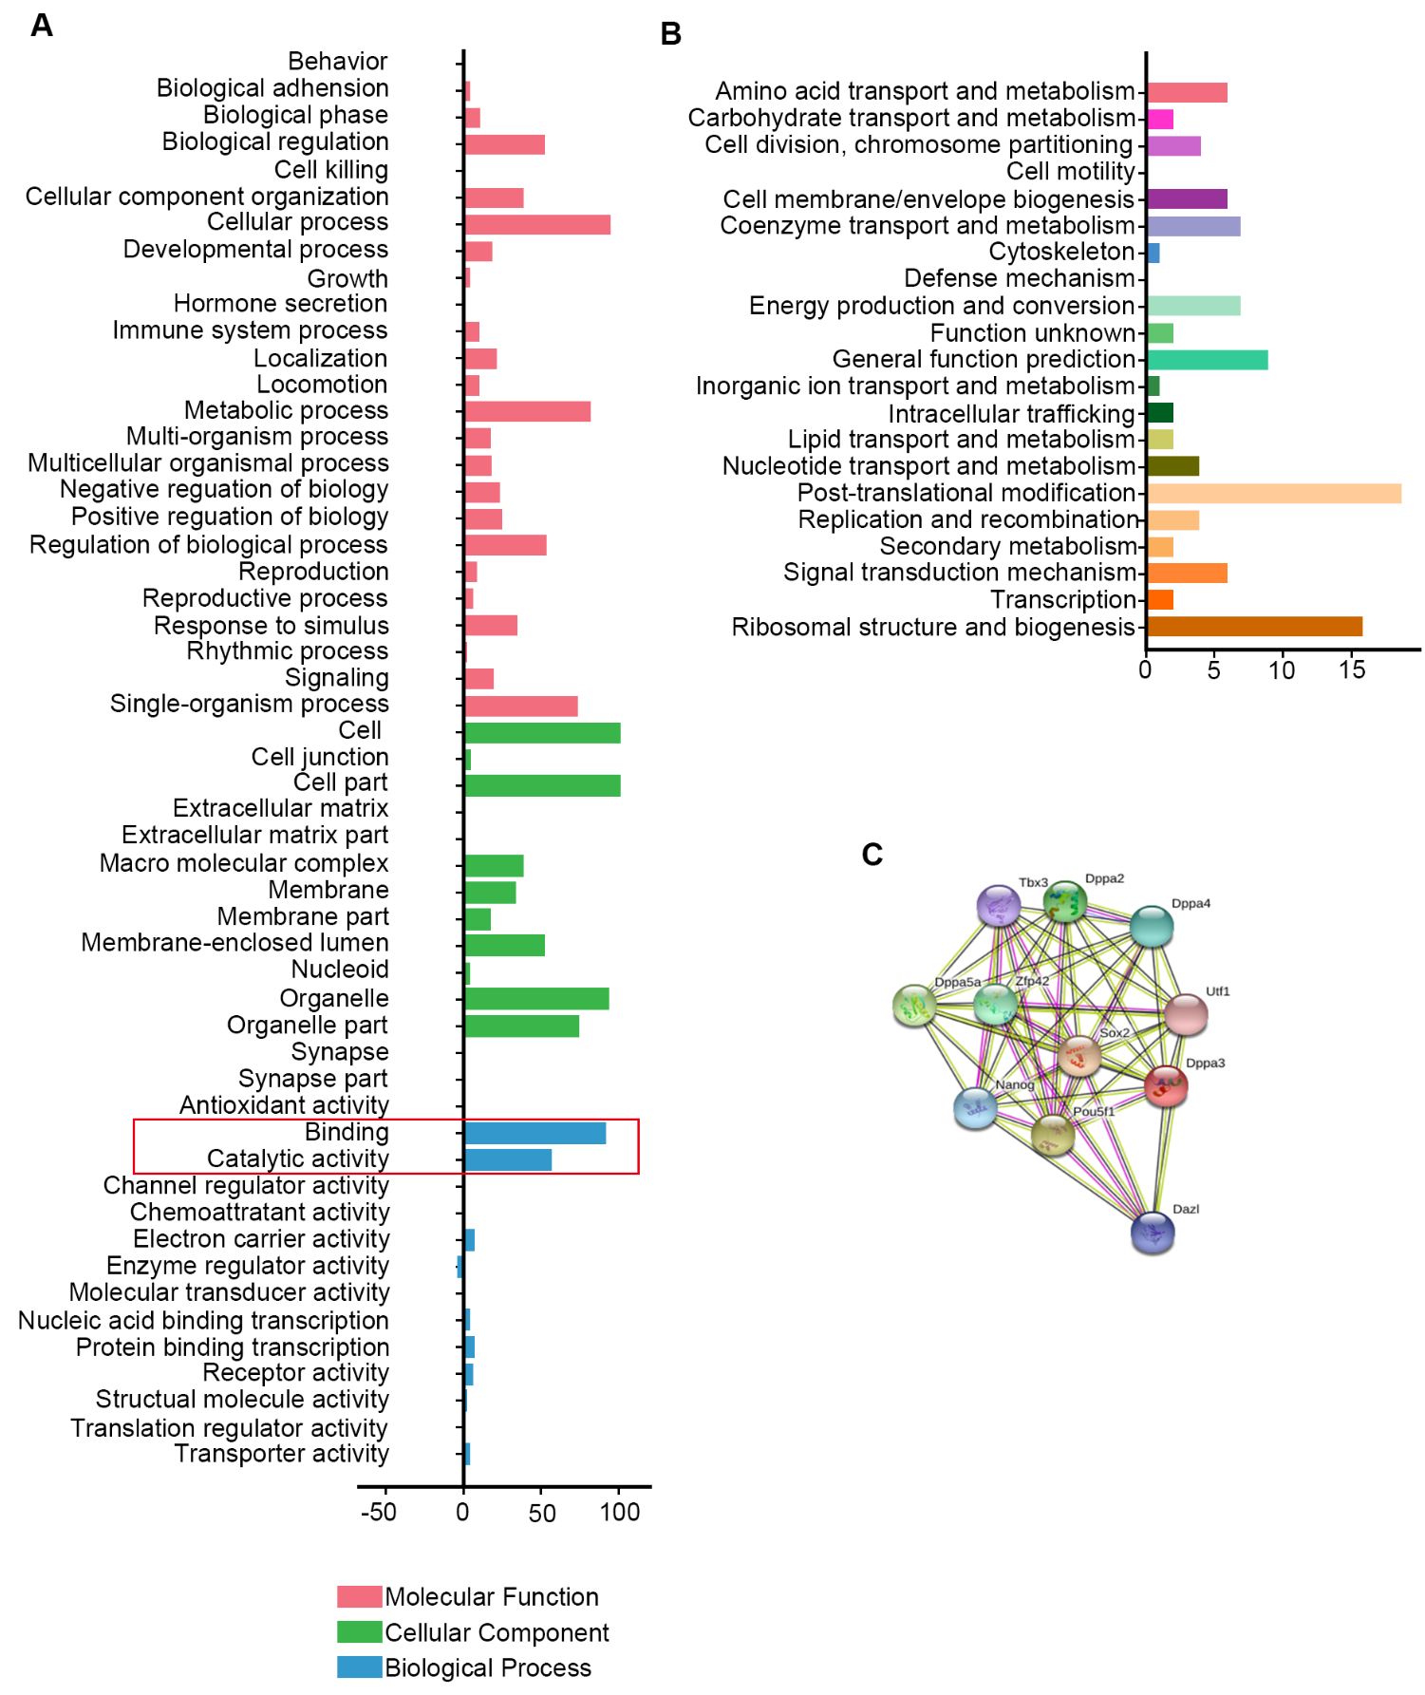
Supplemental Figure 1: The Dppa3-interated proteins are functionally enriched in the ubiquitin proteasome system. A. GO analysis of Dppa3-interacted proteins B. KEGG analysis of Dppa3-interacted proteins. C. Prediction of proteins association with Dppa3 using STRING database.

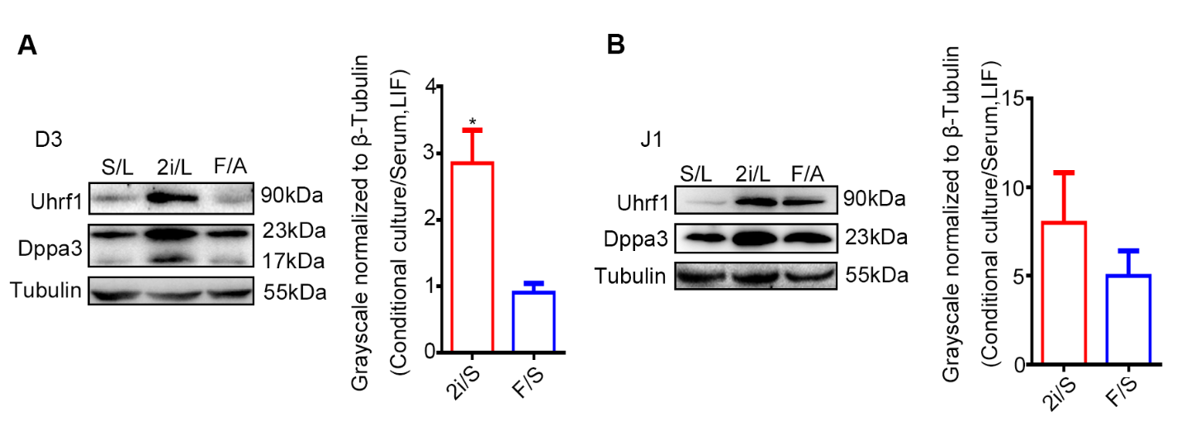 Supplemental Figure 2: The expression levels of Dppa3 and Uhrf1 were increased in naive state ES cells. A and B. The protein levels of Dppa3 and Uhrf1 were analyzed using western blot in D3 ES cell (A) and J1 ES cells (B) with different pluripotent state. Naïve pluripotent state was induced using 2i and LIF (2i/L), and the primed state was induced using FGF2 and Activin A (F/A). Quantification of Uhrf1 protein levels normalized to Tubulin by ImageJ software. The data is presented as mean ± SEM. (n=3, *p < 0.05).
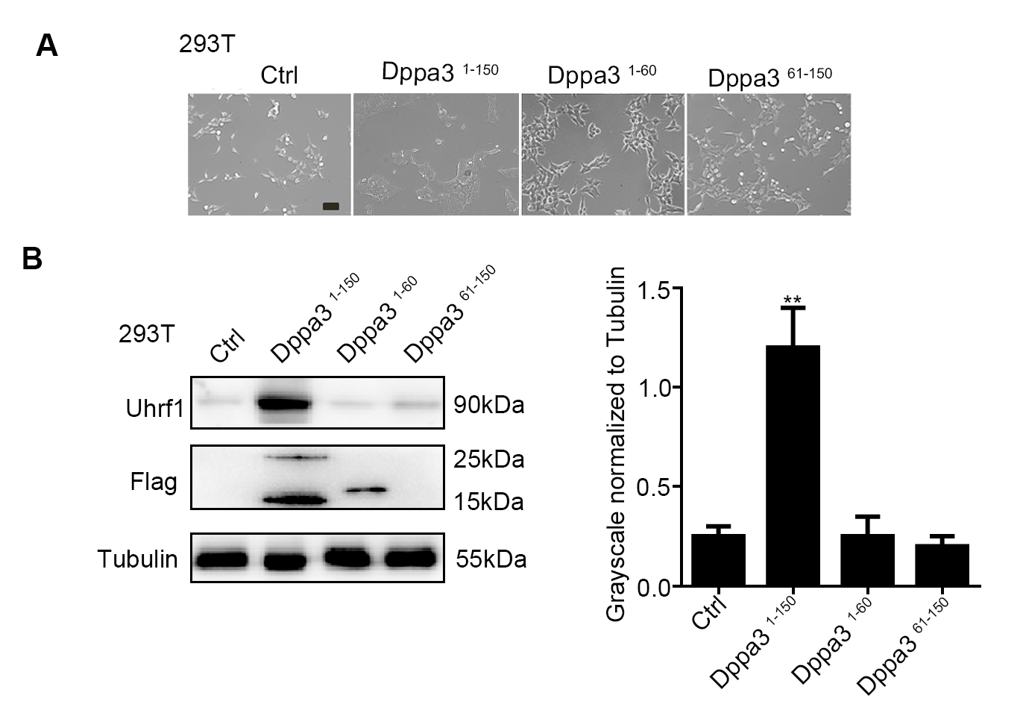
Supplemental Figure 3: Characterization of three different lengths of Dppa3 in 293T cells. A. Morphology of the 293T cells transfected with three different length of Dppa3. Dppa3 ¹⁻¹⁵⁰, Dppa3 ¹⁻⁶⁰ and Dppa3 ⁶¹⁻¹⁵⁰ 293T cells. Scar bar: 100um. B. Left panel: The protein levels of Uhrf1 in 293T were analyzed by western blot. Right panel: Quantification of Uhrf1 protein levels by ImageJ software. The data is presented as mean ± SEM. (n=3, **p < 0.01).

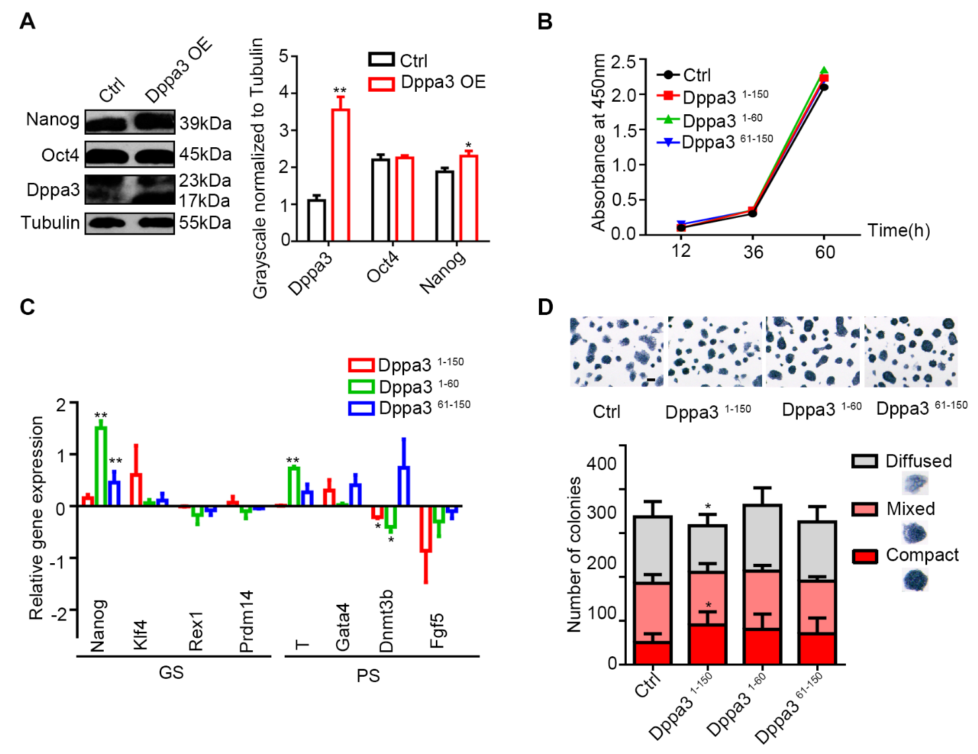
Supplemental Figure 4: Exogenous full length of Dppa3 facilitates the pluripotency maintenance in ES cells. A. Western blot analysis of Nanog and Oct4 levels in Dppa3 overexpression ES cells. Right panel: Quantification of Nanog, Oct4, and Dppa3 protein levels normalized to Tubulin by ImageJ software. The data is presented as mean ± SEM. (n=3, *p < 0.05, **p < 0.01). B. Proliferation of control, Dppa3¹⁻¹⁵⁰, Dppa3¹⁻⁶⁰ and Dppa3⁶¹⁻¹⁵⁰ ES cells were assessed by CCK-8. Data is presented at least three replications. C. Real-time PCR analysis of ground state and primed state-related gene expression in Control, Dppa3¹⁻¹⁵⁰, Dppa3¹⁻⁶⁰ and Dppa3⁶¹⁻¹⁵⁰ ES cells. GS, ground state-related genes; PS, primed state-related genes. The data is presented as mean ± SEM (n=3, *p < 0.05, **p < 0.01). D. Alkaline phosphatase (AP) staining and quantification of AP-positive colonies of control, Dppa3¹⁻¹⁵⁰, Dppa3¹⁻⁶⁰ and Dppa3⁶¹⁻¹⁵⁰ ES cells. Scar bar, 200μm. The data is presented as mean ± SEM. (n=3, *p <0.05).

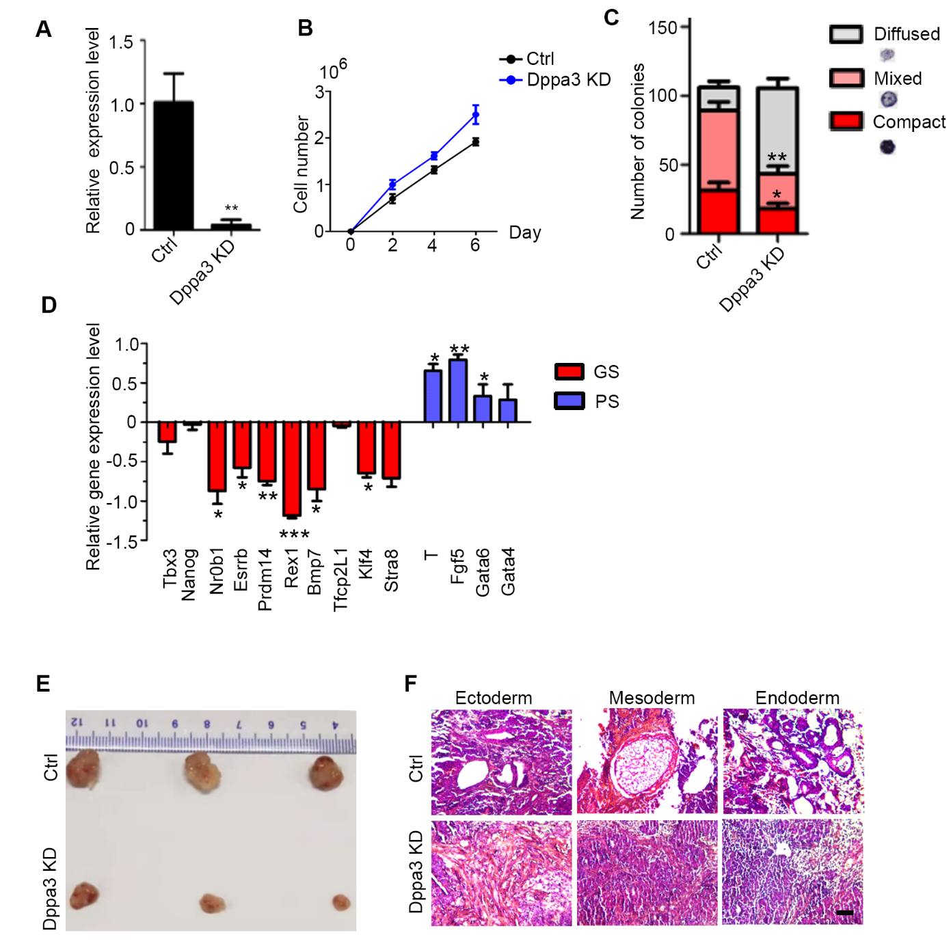
Supplemental Figure 5: Silencing of Dppa3 in ES cells promotes the pluripotency exit. A. Relative expression level of Dppa3 in Dppa3 KD and control ES cells. B. The proliferation of control and Dppa3 knockdown ES cells were assessed by CCK-8. Data is presented at least three replications. C. Quantification of alkaline phosphatase staining (AP) positive colonies of control and Dppa3 KD ES cells. The data is presented as mean ± SEM. (n=3, *p <0.05, **p <0.01). D. Real-time PCR analysis of ground state and primed state-related gene expression in control and Dppa3 KD ES cells. The data is presented as mean ± SEM (n=3, *p < 0.05, **p < 0.01). E. Teratomas derived from Dppa3 knockdown and control ES cells. F. HE staining of teratoma formed from Dppa3 knockdown and control ES cells. Scar bar, 100um.

Supplemental Table 1 Dppa3 overexpression sequences.
Genes | Sequences
Flag-forward | 5’-TCTCAAGCTTAACTAGCTAGCGGACCGACGC-3’
Flag -reverse | 5’-AGAGGTCCCAACCTTATCGTCGTCATCCT-3’
Dppa3 ¹⁻¹⁵⁰-forward | 5’-CCGAGCTAGCTTTTGAGGCT-3’
Dppa3 ¹⁻¹⁵⁰-reverse | 5’-CCCTCGAGATTCTTCCCGATTTTCGCAT-3’
Dppa3 ¹⁻⁶⁰-forward | 5’-CCGAGCTAGCTTTTGAGGCT-3’
Dppa3 ¹⁻⁶⁰-reverse | 5’-TTTTCTCGAGCCGTAGACTGCGCCGGCGTG-3’
Dppa3 ⁶¹⁻¹⁵⁰-forward | 5’-ATGCTAGCATGAACCGCATTGCAGCCGTA-3’
Dppa3 ⁶¹⁻¹⁵⁰-reverse | 5’-CCCTCGAGATTCTTCCCGATTTTCGCAT-3’
Dppa3-forward | 5’-CTTGCTAGCTTTTGAGGCTTCTGCCCATC-3’
Dppa3-reverse | 5’-ATTAGATATCCAGCCAGGGCAGCGTACA-3’

Supplemental Table 2 Dppa3 knockdown sequences.
Genes | Sequences
siDppa3-F | 5’-GATCCGAAATTGTAGATAGGATGCACATTCAAGAGATGTGCATCCTATCTACAATTTCTTTTTTAAGCTTG-3’
siDppa3-R | 5’-AATTCAAGCTTAAAAAAGAAATTGTAGATAGGATGCACATCTCTTGAATGTGCATCCTATCTACAATTTCG-3’
Supplemental Table 3 Primer sequences for qPCR.
Genes | Sequences
Nanog-forward | 5’-GCTCCGCTCCATAACTTCG-3’
Nanog-reverse | 5’-ACCTGGCTTTGCCCTGACT-3’
Klf4-forward | 5’-CACCTACCTGGACAAGGTGC-3’
Klf4-reverse | 5’-TCCGTCTCAAACTTGGTCCG-3’
Rex1-forward | 5’-TCACTGTGCTGCCTCCAAGT-3’
Rex1-reverse | 5’-GGGCACTGATCCGCAAAC-3’
Prdm14-forward | 5’-TGTGTGGTACGGAAATGGCT-3’
Prdm14-reverse | 5’-GGCGTGTACTTCAGGTGCTT-3’
T-forward | 5’-CCGGTGCTGAAGGTAAATGT-3’
T-reverse | 5’-CCTCCATTGAGCTTGTTGGT-3’
Gata4-forward | 5’-GCTATGCATCTCCTGTCACTCAGA-3’
Gata4-reverse | 5’-CCAAGTCCGAGCAGGAATTTGAAG-3’
Gata6-forward | 5’-CTTCTCCTTCTACACAAGCGACCA-3’
Gata6-reverse | 5’-ATACTTGAGGTCACTGTTCTCGGG-3’
Dnmt3b-forward | 5’-GCTATTTGTCTTGAGGCGCT-3’
Dnmt3b-reverse | 5’-AACTTAGAACCCAGGAGACGC-3’
Fgf5-forward | 5’-AGTCAATGGCTCCCACGAAG-3’
Fgf5-reverse | 5’-CCACTCTCGGCCTGTCTTTT-3’
Tbx3-forward | 5’-GCAGTGGATGTCCAAAGTCGTCACT-3’
Tbx3-reverse | 5’-CAGGTAGGTTCGAAAAGTACTGTAA-3’
Nr0b1-forward | 5’-ACCGTGCTCTTTAACCCAGA-3’
Nr0b1-reverse | 5’-CCGGATGTGCTCAGTAAGG-3’
Bmp7-forward | 5’-TACGTCAGCTTCCGAGACCT-3’
Bmp7-reverse | 5’-GGTGGCGTTCATGTAGGAGT-3’
Tfcp2L1-forward | 5’-AGGTGCTGACCTCCTGAAGA-3’
Tfcp2L1-reverse | 5’-GTTTTGCTCCAGCTCCTGAC-3’
Stra8-forward | 5’-GTTTCCTGCGTGTTCCACAAG-3’
Stra8-reverse | 5’-CACCCGAGGCTCAAGCTTC-3’
Esrrb-forward | 5’- CAAGAGAACCATTCAAGGC-3’
Esrrb-reverse | 5’- CATCCCCACTTTGAGGCATTT-3’
18s-forward | 5’-GTAACCCGTTGAACCCCATT-3’
18s-reverse | 5’-CCATCCAATCGGTAGTAGCG-3’

