Additional file 2: Figure S1
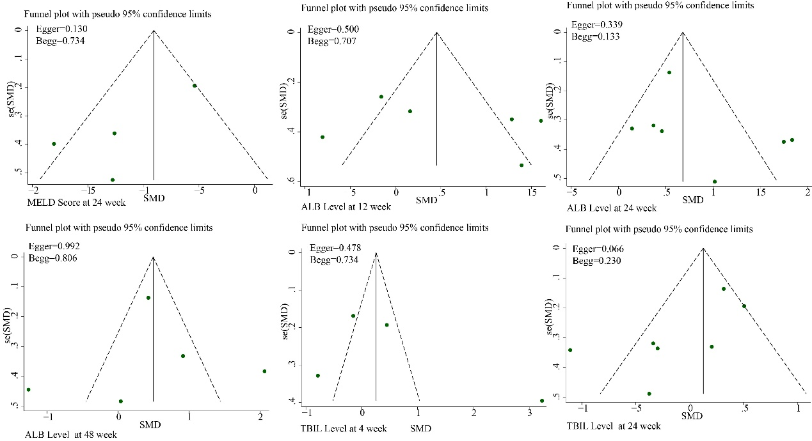
Funnel plots of MELD score at 24 weeks; ALB levels at 12 weeks, 24 weeks, and 48 weeks; TBIL at 4 weeks and 24 weeks; No asymmetry was observed in the funnel plots. No publication bias was found using Egger’s and Begg’s test.

