The Supplemental Figures of DOI: 10.1186/s13287-022-02990-1
Title: Human umbilical cord blood-derived MSCs trans-differentiate into endometrial cells and regulate Th17/Treg balance through NF-κB signaling in rabbit intrauterine adhesions endometrium

The concentration and expression analysis of cytokines in Discussion
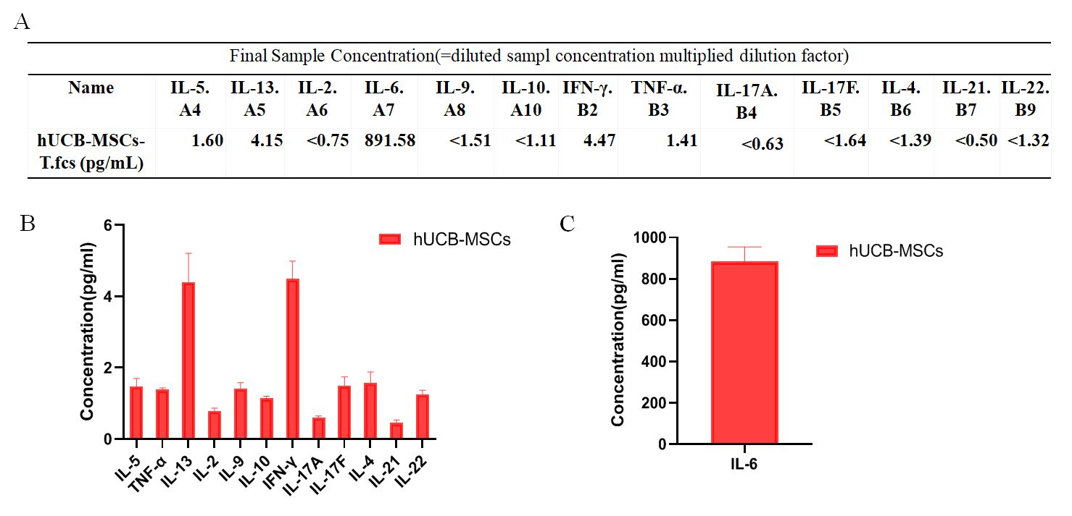
Supplemental Figure 1. Cytokine concentrations of P3 hUCB-MSCs. (A)The table of all cytokine concentrations were detected in the media of P3 hUCB-MSCs. (B-C) The barplot of all cytokine concentrations were detected in the media of P3 hUCB-MSCs.
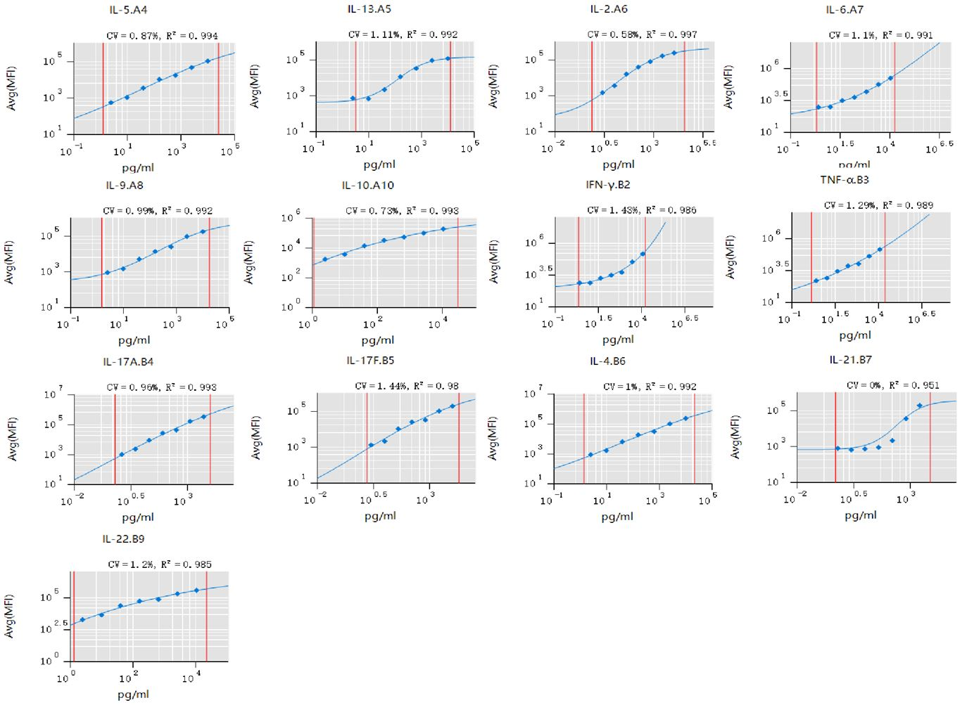
Supplemental Figure 2. Standard Curves of 13 cytokines by flow cytometry.
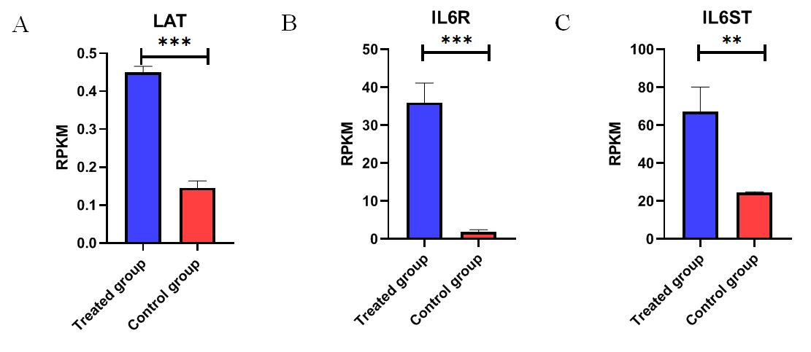
Supplemental Figure 3. The expression of LAT, IL6R and IL6ST detected by RNA sequencing were significantly elevated compared with pre-treatment.

