Supplementary materials to the manuscript “A defined road to tracheal reconstruction: laser structuring and cell support for rapid clinic translation” (Fayzullin et al.)
Table S1 – Immunophenotype of MSC primary cultures (3rd passage)
 | Positive |  |  |  |  | Negative
Markers | CD73 | CD90 | CD105 | CD44 | CD29 | CD34 | CD45 | HLA-DR | CD11b | CD19
% | 96.15 ± 0.40 | 95.45 ± 1.70 | 97.90 ± 2.15 | 99.50 ± 0.25 | 97.70 ± 1.10 | 0.60 ± 0.20 | 0.70 ± 0.10 | 1.20 ± 0.85 | 0.75 ± 0.20 | 0.70 ± 0.35

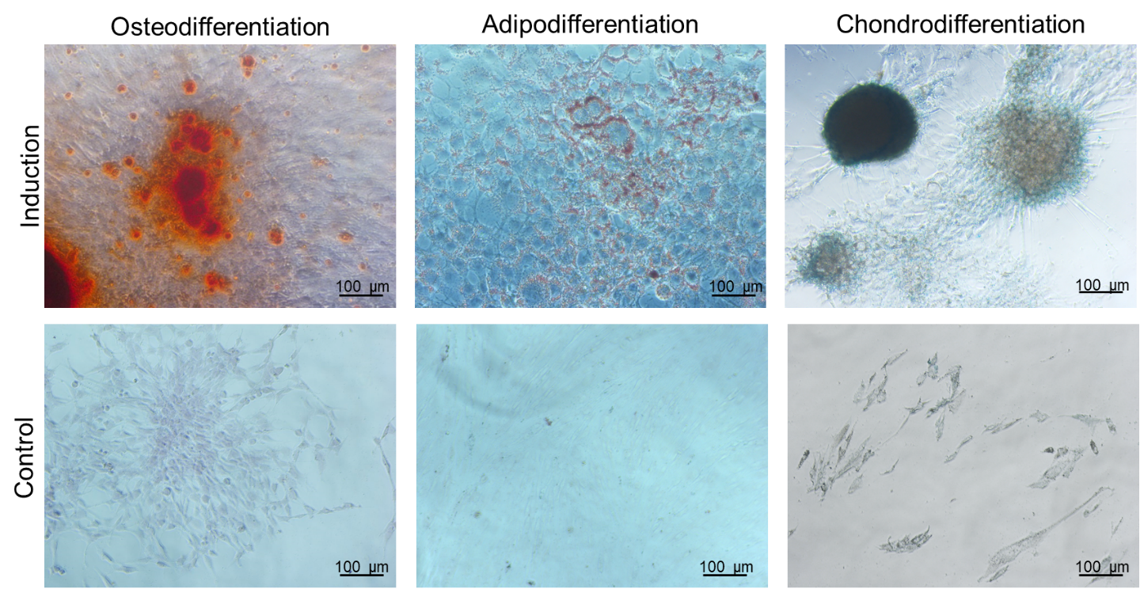
Figure S1. Differentiation of MSC primary cultures in osteogenic, adipogenic, and chondrogenic directions. (Induction – cells cultured in the differentiation medium for 21 days; Control – cells cultured in standard medium for 21 days; Oil red O – adipodifferentiation, Alizarin Red S – osteodifferentiation, Alcian Blue – chondrodifferentiation). Phase contrast microscopy. Scale bar – 100 µm.

