Title page
C/EBPα regulates the fate of bone marrow mesenchymal stem cells and steroid-induced avascular necrosis of the femoral head by targeting the PPARγ signalling pathway

Ping Duan¹, Hanyu Wang¹, Xinzeyu Yi¹, Hao Zhang¹, Hui Chen¹,
Zhenyu Pan^{1*}

Affiliations:
¹ Department of Orthopedics Trauma and Microsurgery, Zhongnan Hospital of Wuhan University, Wuhan 430071, China.

* Corresponding author:
Zhenyu Pan
Department of Orthopedics Trauma and Microsurgery, Zhongnan Hospital of Wuhan University, Wuhan 430071, China
Tel: +86 15337200318
E-mail: soloistp@sina.com

Supplementary Data 1
Primers for quantitative RT-PCR

Gene | Sequence
ACTB-F | AGATCAAGATCATTGCTCCTCCT
ACTB-R | ACGCACCTCAGTAACAGTCC
C/EBPα-F | GACCATCCGCCTTGTGTGTA
C/EBPα-R | CTGACATTGCACAAGGCACC
PPARγ-F | AGCCTTCAAACTCCCTCATGG
PPARγ-R | GAGACATCCCCACAGCAAGG
COL1a1-F | GATGGACTCAACGGTCTCCC
COL1a1-R | CGGCCACCATCTTGAGACTT
HDAC1-F | AGGGAGAAGGAGGTCGCAAG
HDAC1-R | ACTTGGAGAGAAGATGGAGCTG
ALP-F | CACTATGTCTGGAACCGCACT
ALP-R | GGGTCAGTCAGGTTGTTCCG
aP2-F | TGGGGACCTGGAAACTCGT
aP2-R | AGTCCCCTTCTACGCTGATG

Supplementary Data 2
Primers were designed according to the sequence of possible binding sites

Gene Name | Prediction site |  | Primer
PPARγ promoter | Site 1 | F | GATGCCAGAGATAGCACATAGAAC
PPARγ promoter | Site 1 | R | ATCACAAACCCAGGACACACTA
PPARγ promoter | Site 2 | F | CAGTGAGCATTTTCCCATTGAGT
PPARγ promoter | Site 2 | R | CCTGATACCCCCAAATGGAATAAC
PPARγ promoter | Site 3 | F | TGACTGTCTAGGTGACTGGGT
PPARγ promoter | Site 3 | R | TTTGTCTGTCACGCTCCGTC

Supplementary Data 3
Images of BMSCs infected with lentivirus (Under the same field of view)


40X (Bright field) 40X (GFP green fluorescence)

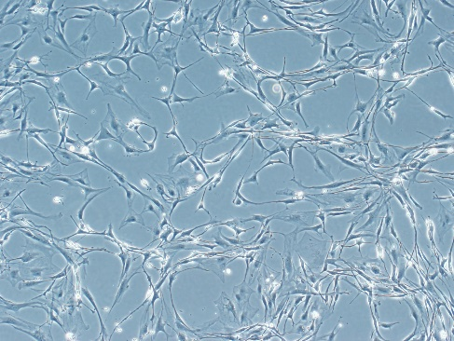
100X (Bright field) 100X (GFP green fluorescence)

Supplementary Data 4
4a Peak map of mutation site

4b The PCR results of overexpression of C/EBPα were in 293T

Supplementary Data 5
5a Western blotting analysis of nuclear protein in femoral head

5b Electrophoretogram of DNA after ultrasonic fragmentation in femoral head

