Stable expression of a truncated TLX variant drives differentiation of induced pluripotent stem cells into self-renewing neural stem cells for production of extracellular vesicles
Mingzhi Xuª , Gang Chenª , Yanan Dongª , Shensi Xiangª, Miaomiao Xueª , Yongxue Liu^{b}, Haijing Song^{c*}, Haifeng Song^{a*}, Yi Wang^{a*}
Additional file 1
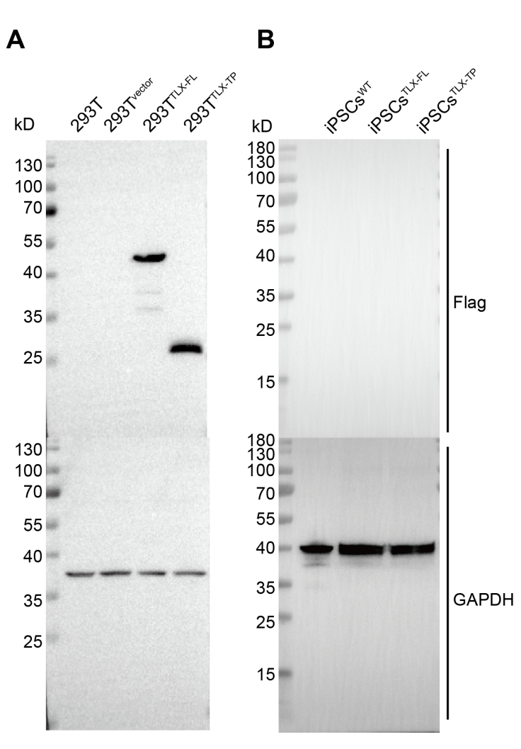
Fig. S1 WB analysis of expressions of flag and GAPDH in TLX over-expressing HEK293T cells (A) and iPSCs (B).
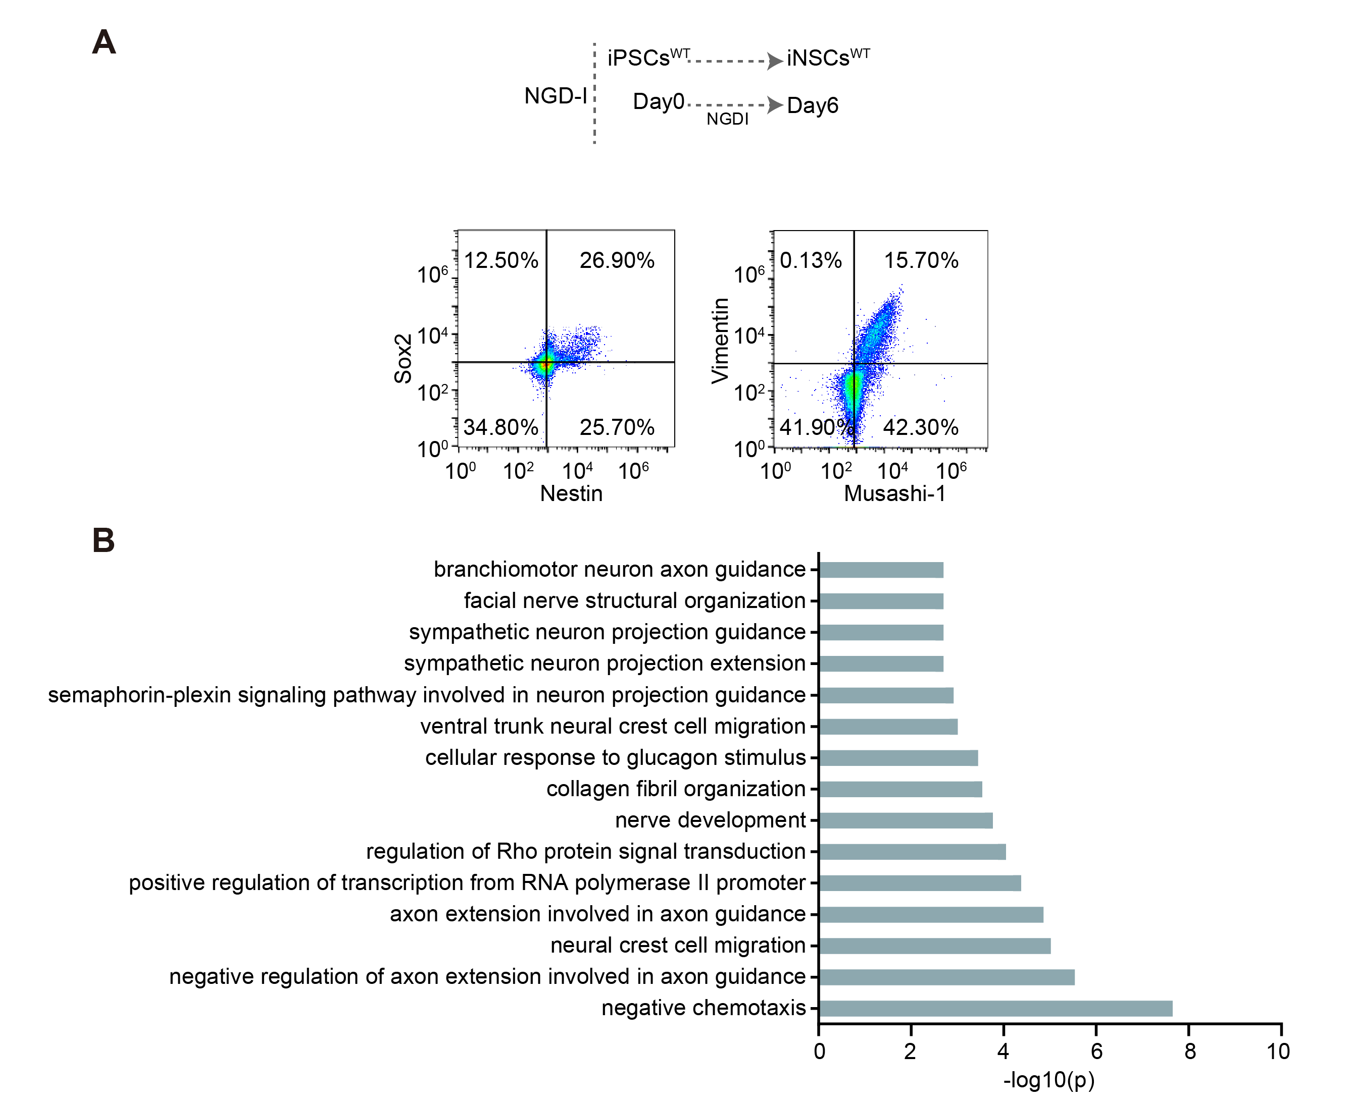
Fig. S2 Induction of differentiation of iPSCs^{WT} into iNSCs^{WT}. A) Detection of expressions of Sox2, Nestin, Vimentin, and Musashi-1 in iPS^{WT} cells cultured in NGD-I medium for 6 days by flow cytometry. B) GO analysis of differential gene expressions between iNSCs^{WT} and iPSCs^{WT} in terms of biological processes.

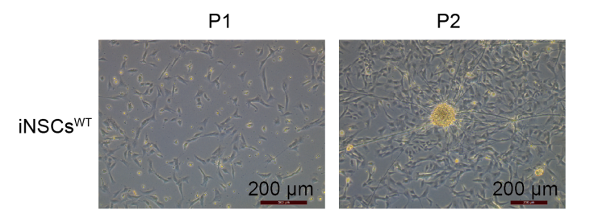
Fig. S3 Morphologies of iNSCs^{WT} at passages 1 and 2.
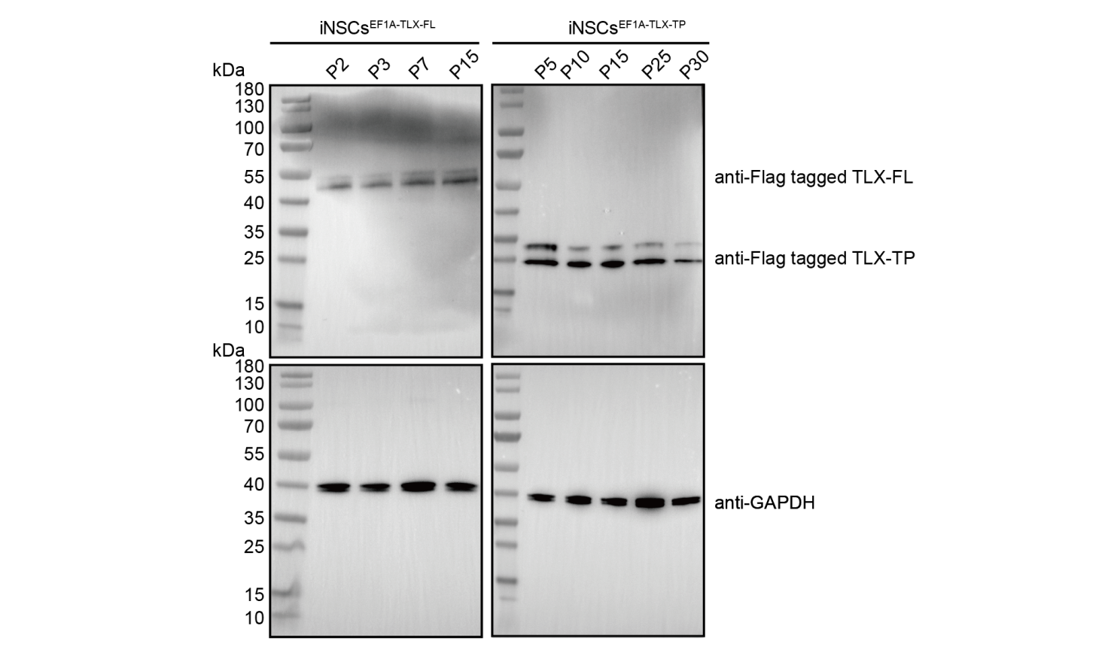
Fig. S4 Expression of Flag and GAPDH in different passages of iNSCs^{EF1a-TLX-FL/TP} detected by Western blot.
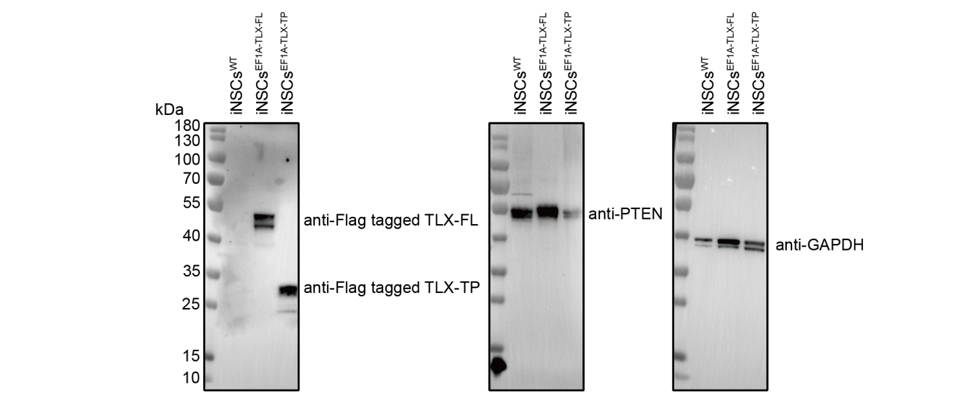
Fig. S5 Protein expressions of Flag, PTEN, and GAPDH determined by Western blot.

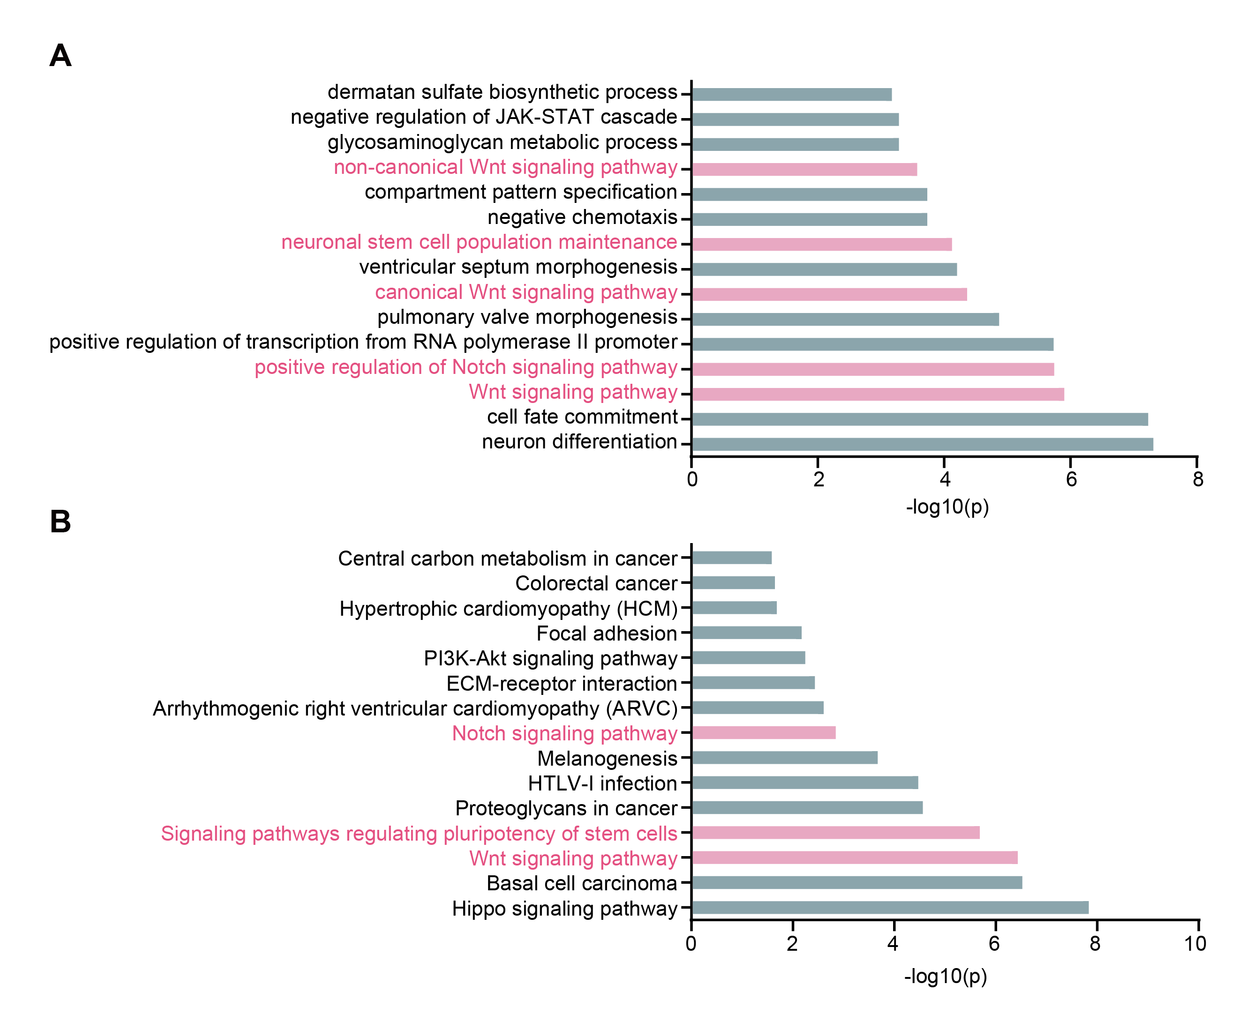
Fig. S6 A) GO analysis, and B) KEGG analysis of differential gene expression profiles of iNSCs^{TLX-TP} versus iNSCs^{TLX-FL} in terms of biological processes.

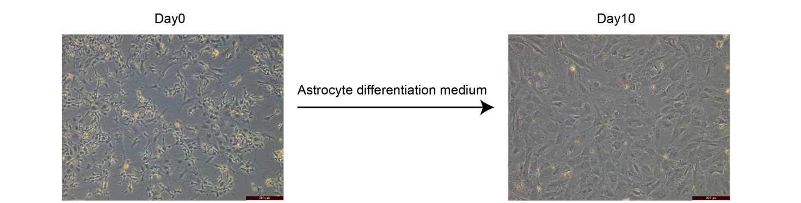
Fig. S7 Cellular apoptosis during induction of iNSCs^{TLX-TP} differentiation into astrocytes.
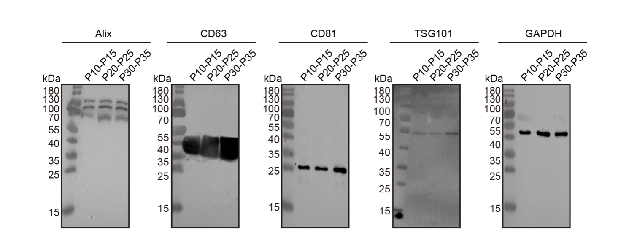
Fig. S8 Immunoblotting of different batches iNSC-EVs for Alix, CD63, CD81, TSG101 and GAPDH expression.
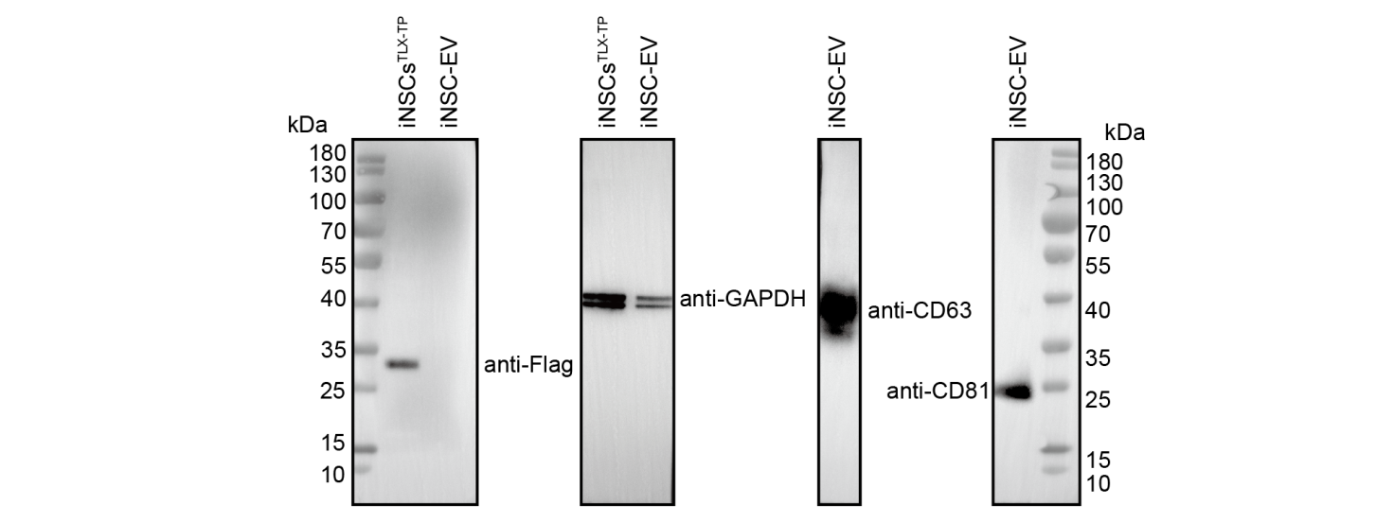
Fig. S9 Immunoblotting of iNSCs^{TLX-TP} or purified iNSC-EVs for Flag, GAPDH, CD63, and CD81 expressions.

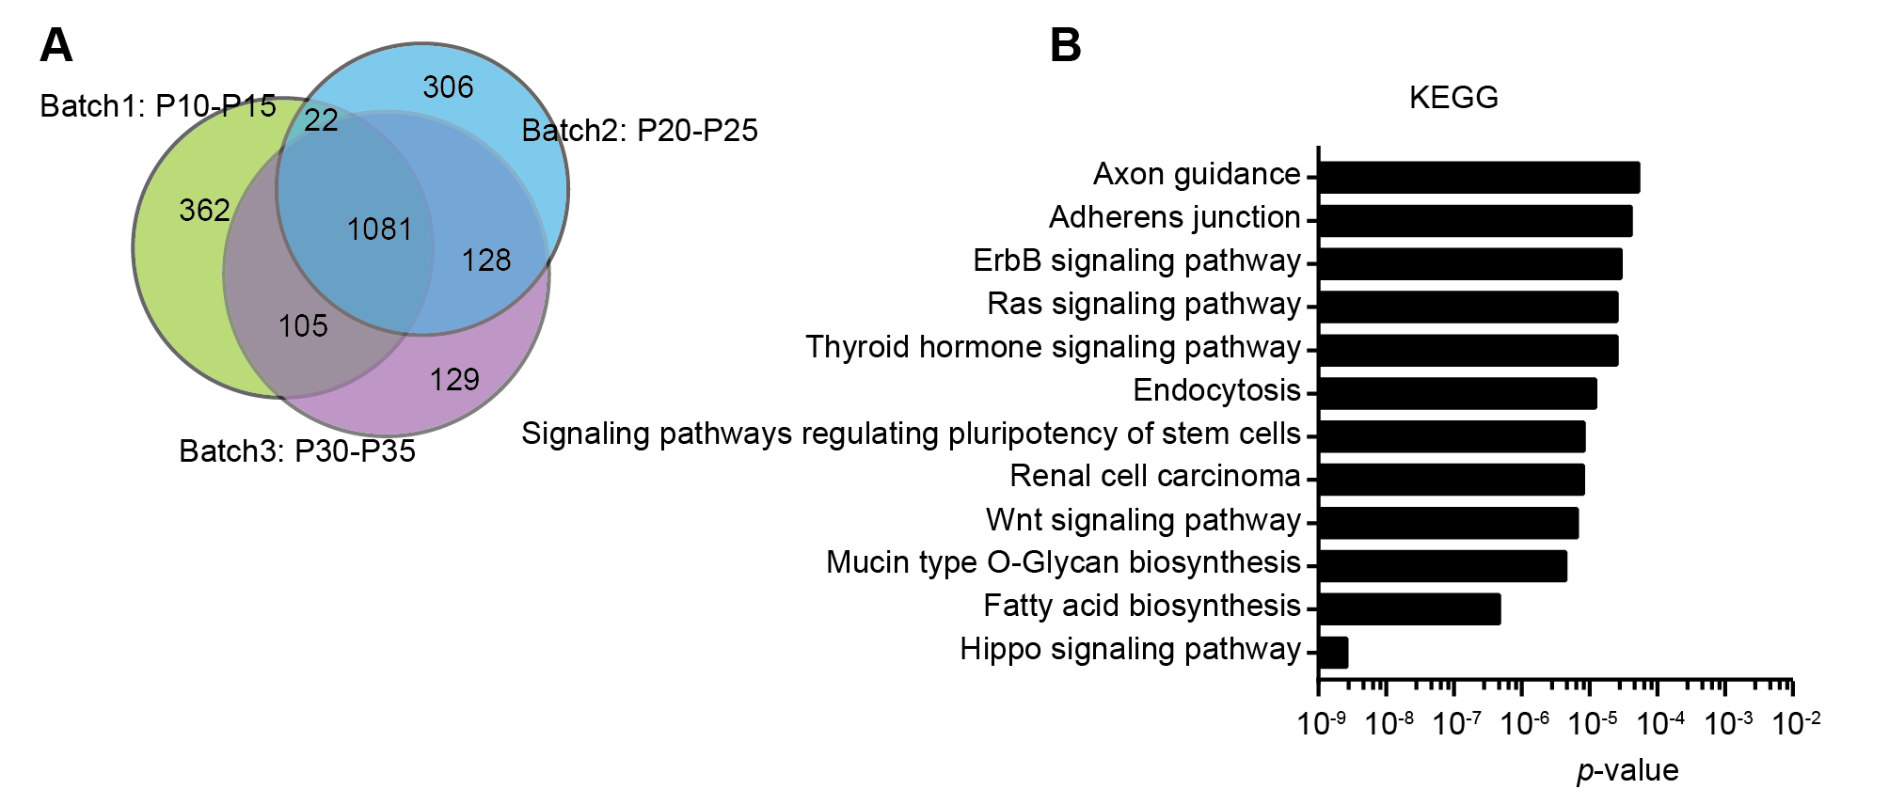
Fig. S10 The results of transcriptomic analysis of three batches iNSC-EVs samples. A) A Venn diagram showing that about 70% of the iNSC-EVs miRNA population were shared among the three iNSC-EVs batches. B) KEGG analysis of 1081 common miRNA.

