Supplementary Information
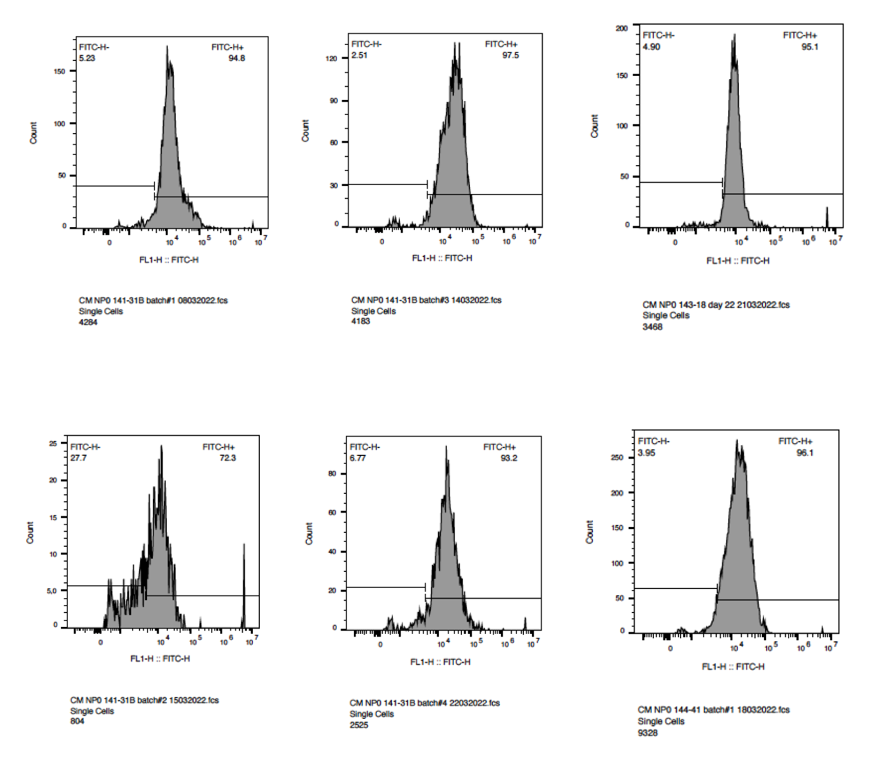
Figure S1: FACS plot shows a representative differentiation of three lines of iPSC-CMs with a high-purity cardiomyocyte population (Average 91,5% ±9,5 ACTN+).

Table S1: Overview of culture Media used during this study.

Name | Media | Supplements
Heparin medium (HM) | DMEM-F12 50/50 (Thermo Fisher Scientific, 31331) | 213 μg mL-1 L-ascorbic acid 2 phosphate (Sigma-Aldrich, A8960-5G)  1:100 Chemically defined lipid concentrate (Thermo Fisher Scientific, 11905031)  1.5 IU mL-1 Heparin (Leo Pharmaceuticals Ltd.)  1% Penicillin-Streptomycin (Gibco, 15-140-122)
Insulin medium (IM) | DMEM-F12 50/50 (Thermo Fisher Scientific, 31331) | 213 μg mL-1 L-ascorbic acid 2 phosphate (Sigma-Aldrich, A8960-5G)  1:100 Chemically defined lipid concentrate (Thermo Fisher Scientific, 11905031)  21 µg mL-1 Human recombinant insulin (Sigma-Aldrich, I9278-5ML)  1% Penicillin/streptomycin (Gibco, 15-140-122)
Purification medium (PM) | RPMI 1640 L-Glutamine without glucose (Gibco, 11879) | 3.5 μM Sodium-dl-Lactate (Sigma-Aldrich, L4263)  213 μg mL-1 L-ascorbic acid 2 phosphate (Sigma-Aldrich, A8960-5G)  1:100 Chemically defined lipid concentrate (Thermo Fisher Scientific 11905031)  21 µg mL-1 Human recombinant insulin (Sigma-Aldrich I9278-5ML)  1% Penicillin/streptomycin (Gibco 15-140-122)
Replating medium (RM) | RPMI 1640 L-Glutamine without glucose (Gibco, 11879) | 5 µM ROCK inhibitor (Sigma-Aldrich, Y0503)  10% KnockOutTM serum replacement (KOSR) (Thermo Fisher Scientific, 10828028)  1% B27® (Gibco, 17504-001)  1% Penicillin/streptomycin (Gibco 15-140-122)
iPSC culture medium | Essential 8TM medium (Gibco A1517001)
Basal maturation medium | DMEM, no glucose (Gibco, Thermo Fisher Scientific 11966025, USA) | 1:100 Chemically defined lipid concentrate (Thermo Fisher Scientific 11905031)  10 mM Galactose (Sigma-Aldrich G0750)1% Penicillin-Streptomycin (Gibco, 15-140-122)
Seahorse culture media | Agilent Technologies/Seahorse Bioscience) | 1% Chemically Defined Lipid Concentrate (Gibco),  4mM L-glutamine (Gibco)  10mM glucose (Agilent, 103577-100)

Table S2: Primer list used for qPCR experiments.
Target gene | Primer name | Sequence (5'-3')
Carnitine Palmitoyltransferase 1B | CPT1B F | CTCCTTTCCTTGCTGAGGTG
Carnitine Palmitoyltransferase 1B | CPT1B R | TCTCGCCTGCAATCATGTAG
Peroxisome Proliferator-Activated Receptor Gamma Coactivator 1-Alpha | PPARGC1A F | GCTTTCTGGGTGGACTCAAGT
 | PPARGC1A R | GAGGGCAATCCGTCTTCATCC
Lactate Dehydrogenase B | LDHB F | TCTGTGACCGCCAATTCTAAGA
Lactate Dehydrogenase B | LDHB R | GCACCAGATTGAGCCGACTC
Inner Mitochondrial Membrane Protein | IMMT F | GTCCTCCGTCCATTGCGAC
Inner Mitochondrial Membrane Protein | IMMT R | GGACCAAGAACCATCTCGAAG
Cardiac Troponin I | TNNI3 F | TTTGACCTTCGAGGCAAGTTT
Cardiac Troponin I | TNNI3 R | CCCGGTTTTCCTTCTCGGTG
Actin Alpha Cardiac Muscle 1 | ACTC1 F | GTCGGGACCTCACTGACTAC
Actin Alpha Cardiac Muscle 1 | ACTC1 R | CAATTTCACGTTCAGCAGTG
Gap Junction Protein Connexin 43 | GJA1 F | TGGTAAGGTGAAAATGCGAGG
Gap Junction Protein Connexin 43 | GJA1 R | GCACTCAAGCTGAATCCATAGAT
Calcium Voltage-Gated Channel Subunit Alpha1 C | CACNA1C F | TAGGCATTGGGGTGAAAGAG
Calcium Voltage-Gated Channel Subunit Alpha1 C | CACNA1C R | GAAGATGATTCCAACGCCAC
Sodium Voltage-Gated Channel Alpha Subunit 5 | SCN5A F | TCTCTATGGCAATCCACCCCA
Sodium Voltage-Gated Channel Alpha Subunit 5 | SCN5A F | GAGGACATACAAGGCGTTGGT
Potassium Voltage-Gated Channel Subfamily Q Member 1 | KCNQ1 F | GACTCTGCTGACACCCATCA
Potassium Voltage-Gated Channel Subfamily Q Member 1 | KCNQ1 R | ACAAAGTACTGCATGCGTCG
Ribosomal Protein L32 | RPL32 F | AGGCATTGACAACAGGGTTC
Ribosomal Protein L32 | RPL32 R | GACGTTGTGGACCAGGAACT
Ryanodine Receptor 2 | RyR2 F | GCGAAGACGAGATCCAGTTC
Ryanodine Receptor 2 | RyR2 R | CTGTTGCCAAATCCTTCTGC
NADH: Ubiquinone Oxidoreductase Subunit V3 | NDUFV3 F | CTGAGCCGTTTGACAACACTA
NADH: Ubiquinone Oxidoreductase Subunit V3 | NDUFV3 R | TGAGGTCTAAGAAGGTGTACGTG
Oxoglutarate Dehydrogenase | OGDH F | GGGCGTGGTATATGAGACCTT
Oxoglutarate Dehydrogenase | OGDH R | TGTGGTGAATCCAATCTGGTTG
Mitochondrially Encoded Cytochrome C Oxidase III | COX3 F | TTGCTCTGACCGAATTAAGCC
Mitochondrially Encoded Cytochrome C Oxidase III | COX3 R | CTCAGTGGCAGGATCGTAGT
Cytochrome C Oxidase Subunit 5B | COX5B F | TGTGAAGAGGACAATACCAGCG
Cytochrome C Oxidase Subunit 5B | COX5B R | CCAGCTTGTAATGGGCTCCAC

Table S3: Antibodies list used for Western Blot, flow cytometry and fluorescent Immunohistochemistry experiments.
Antibody host and target | Reference
Rabbit anti-cardiac Troponin T | Abcam ab45932
Mouse anti-ATP5A | Abcam ab14748, USA
Rabbit anti-tom20 | Santa Cruz sc-11415, FL-145, USA
Mouse anti-α-actinin | Merck A7811, USA
AlexaFluor goat anti-rabbit 568 | Invitrogen A11036
AlexaFluor goat anti-mouse 488 | Invitrogen A11029
Hoechst 33342 | Invitrogen H3570

Figure S2: Cell line dependent small molecules dose titration. iPSC-line-dependent dose response-effect on CMs at day 27 of differentiation (Fig. 2). For further experiments, the cell clone-dependent optimal concentrations (UKKi036-C: AA 2 and 1 μM, GW: 250 and 100 nM; and T3: 200, and 100 nM; UKKi032-C: AA 10 and 5 μM, GW: 1000 and 500 nM; and T3: 400, and 200 nM; UKKi037-C AA 10 and 5 μM, GW: 1000 and 500 nM; and T3 800 and 400 nM – Fig. S2) were used.

Figure S3: AA and GW treatment enhances levels of mitochondrial key enzymes expression. a) OGDH CTRL versus AA, GW, and T3, respectively: 1.110 (0.6000 – 1.800) versus 1.919 (1.285 - 2.375; p= 0.0078) versus 2.608 (2.035 - 2.963. n.s.) versus 2.287 (1.520 - 2.770; p=0.0156); b) NDUFV3 CTRL versus AA, GW, and T3, respectively: 1.037 (0.7100 – 1.400;) versus 1.738 (1,553 – 1.933, p=0,0078), 3.750 (1.738 – 4.390; n.s.). and 2.251 (1.950 – 2.510; p=0.0156); c) COX3 CTRL versus AA. GW. and T3. respectively: 1.187 (0.4200 - 1.830) versus 1.166 (0.8725 - 1.433; p= 0.0234) versus 2.860 (1.918 - 3.753; p=n.s.) versus 2.203 (1.760 - 2.880; p= 0.0156); d) COX5 CTRL versus AA. GW. and T3. respectively: 1.053 (0.7800 - 1.540) versus 2.471 (1.950 - 2.943; p= 0.0078) versus 9.758 (6.838 - 13.52; p=n.s.) versus 2.873 (2.460 - 3.320; p= 0.0156)

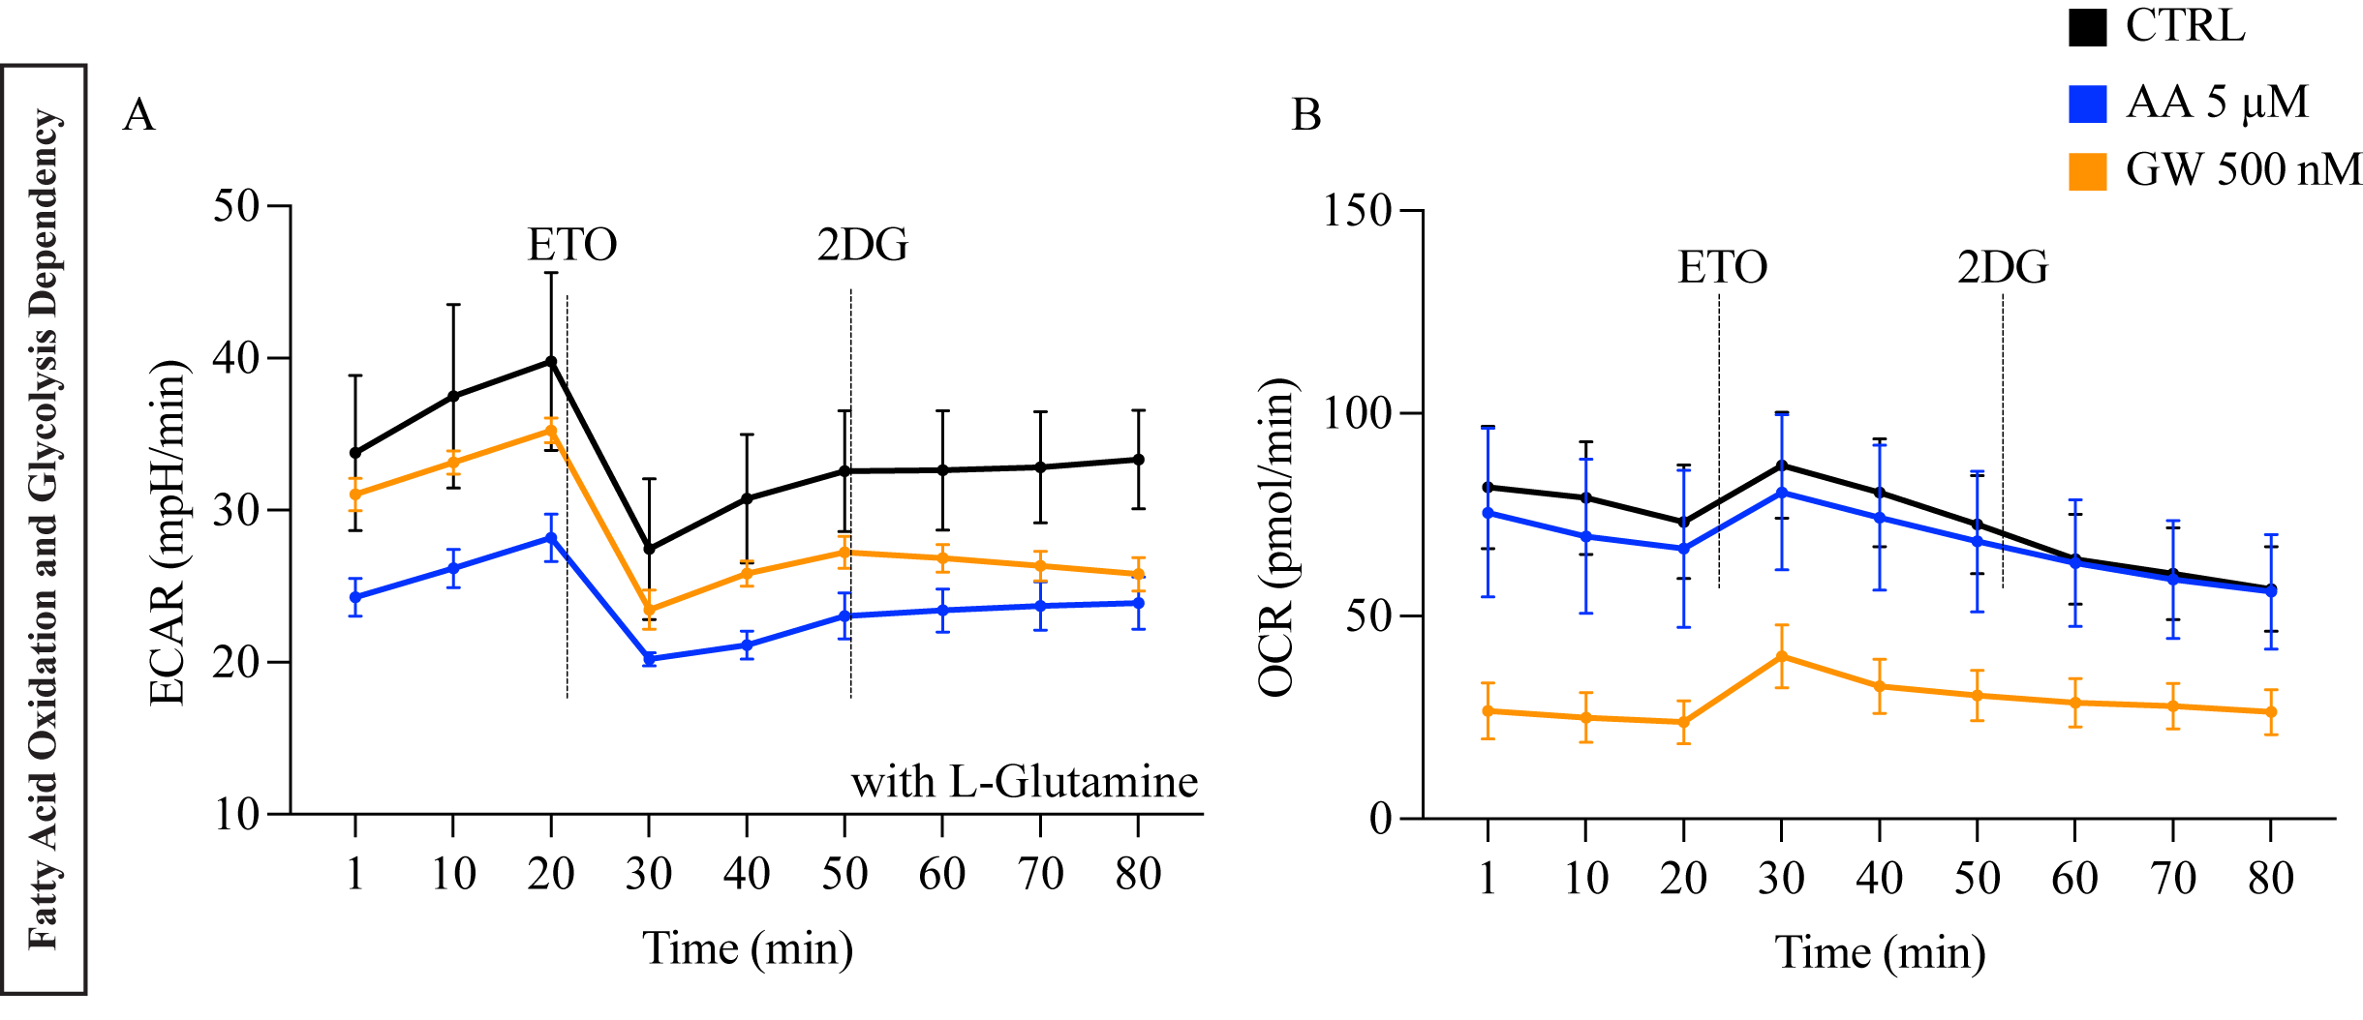
Figure S4: Experiments were performed using day 27 iPSC-CMs line UKKi036-C. (a) Raw extracellular acidification rate (ECAR) of iPSC-CMs cultured in the seahorse medium with L-glutamine. Addition of ETO and 2DG block the FAO and glucose-dependent glycolysis respectively. (b) Raw oxygen consumption rate (OCR) in cells at day 27 of differentiation after sequential administration of ETO and 2DG.

Table S4: Relative DNA content per single nucleus measured on three independent experiments with iPSC lines: UKKi036-C UKKi032-C and UKKi037-C combined n=6-12.
 | 2N |  |  | >2N |  |  | >4N
 | Mean | SD | N | Mean | SD | N | Mean | SD | N
DMSO | 100 | 002 | 900 | 100 | 015 | 900 | 100 | 042 | 600
AA | 100 | 004 | 1800 | 106 | 029 | 1800 | 216 | 179 | 1200
GW | 102 | 002 | 1800 | 090 | 018 | 1800 | 148 | 107 | 1200
T3 | 102 | 004 | 1800 | 095 | 027 | 1800 | 106 | 106 | 1200

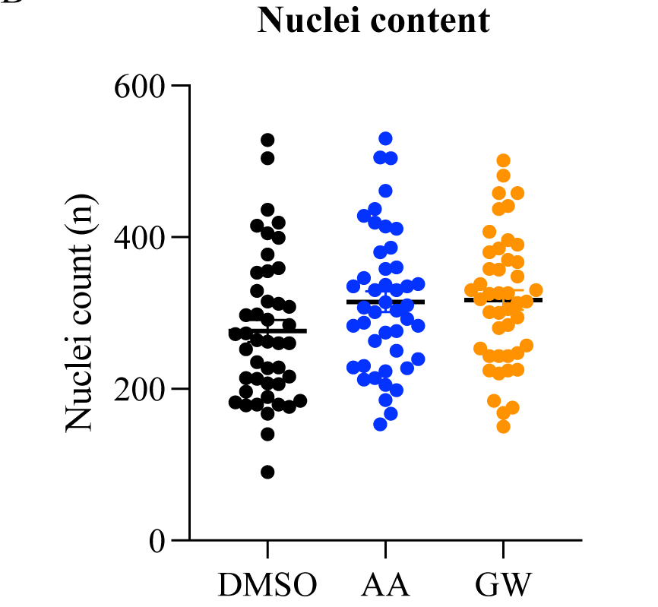
Figure S5: Cell nuclei count per well measured by Hoechst staining and 20X magnification imaging using the Evos microscope and ImageJ show no significant changes in number of nuclei present.
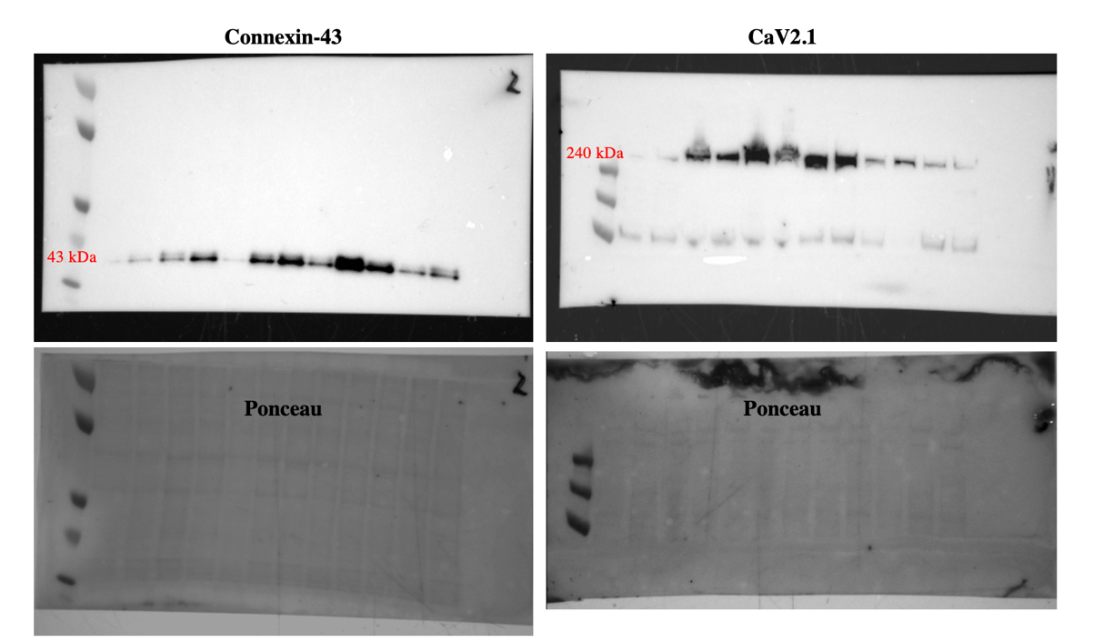

Figure S6: Full-length blots of connexin-43 (left) and CaV1.2 (right) with marker and molecular weight of protein of interest in red. Western blots were performed on pooled proteins from all three cell lines. Equal amount of protein was loaded in each lane. Ponceau staining is shown underneath the Western blot panel as a loading control.

